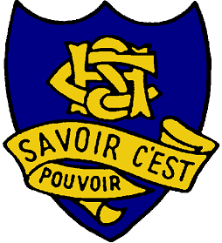  COWRA HIGH SCHOOL  Dowell Street COWRA NSW  Principal: Helene Hamilton  Deputy Principal: Louise Rowston  Deputy Principal: Megan Robinson  Deputy Principal: Anthony Hamer | PO Box 72  COWRA NSW 2794  Telephone: (02) 6342 1766  Facsimile: (02) 6342 1578  Email: cowra-h.school@det.nsw.edu.au  Web: https://cowra-h.schools.nsw.gov.au

Special Religious Education Participation Letter
A feature of the public education system in NSW is the opportunity to provide time in class for education in ethics, faith and morality from a religious or non-religious perspective at the choice of parents.
The school website: https://cowra-h.schools.nsw.gov.au provides information on these options to support parent/carer choice.
A parent/carer may at any time notify the school in writing that they wish to change their decision. Students will continue the same arrangement as the previous year, unless a parent/carer has requested a change in writing.
For more information about Special Religious Education (SRE) and Special Education in Ethics (SEE), including the list of approved providers, please visit: https://education.nsw.gov.au/teaching-and-learning/curriculum/learning-across-the-curriculum/religion-and-ethics
If your preferred SRE or SEE option is not available please contact the approved provider. Students not attending SRE or SEE are given supervised alternative meaningful activities.
The following options are available at Cowra High School for Year 7 & 8 students only. Please choose one.
SRE Options
Please check this box if you do not wish your child to attend SRE. Your child will participate in alternative meaningful activities.

Or

Please check this box if you do wish your child to attend combined Christian SRE.

Student name: _____________________________________ Year: _____________
Signature of parent/carer:_____________________________ Date: _____________

