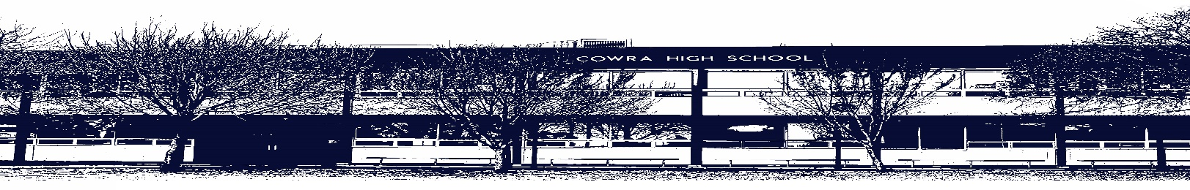

Assessment Notification – Common Cover Sheet
Higher School Certificate Assessment Task Cover Sheet

Name: Year: Date:

Subject: Teacher:

Assessment Task Number (As per Assessment Policy booklet): Assessment Task Title:
Assessment Weighting: %

Date Distributed: Date Due:
All Higher School Certificate Assessment Tasks, other than In Class tasks, must be handed in at the library between 8.30am and 8.55am (before the first morning bell) on the due date. Zero marks if the Assessment Task is submitted late, unless an Illness/ Misadventure or application for extension form has been submitted.

Comments by Teacher:

Assessment Criteria/Marking Rubric:

Attach copy given to you when task was distributed.

Higher School Certificate Assessment Submission Receipt

Student’s Name: Assessment Task Title:

Date receipted to Student:

Student’s Signature:

Teacher’s Signature:

Subject Name: Class Title:

This form is located: https://cowra-h.schools.nsw.gov.au and then to the assessment tab.

