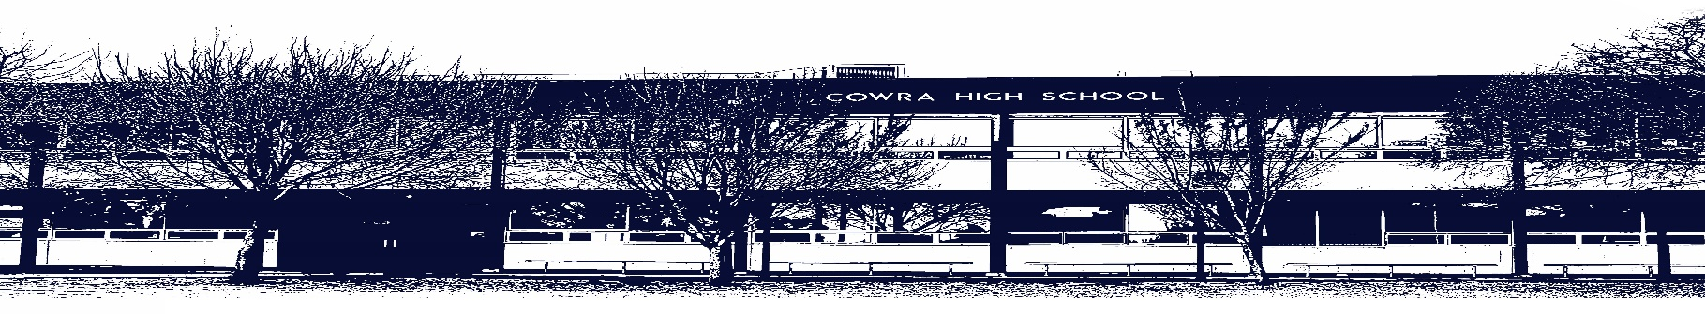

COWRA HIGH SCHOOL

ASSESSMENT TASK COVER SHEET

This sheet must be attached to the front of your Assessment Task and submitted to your class teacher on or before the due date.

Student’s Name: _________________________________________
Course: Stage 6 – English Advanced HSC
Assessment Task: Textual Conversations Podcast
Date Due: Monday Week 9, Term 1
Date Received: _______________
Extension granted _____ days
Other circumstances ~ documents attached

I certify:
- This assignment is entirely my own work and all borrowed material has been acknowledged
- The material contained in this assignment has not previously been submitted for assessment in any formal course of study
- I retain in my possession a copy of this assignment
- I understand that late assignments will be penalised unless an extension has been granted by Deputy Principal - Curriculum

Student’s Signature: ____________________________

-------------------------------------------------------------------------------------------------------------------------------
COWRA HIGH SCHOOL
Assessment Task (Student’s Copy)
Student’s Name:
Course: English Advanced
Teacher: Rowston

Assessment Task received by: _________________________________________
Signature: _________________________________________
Date: ______________________ Time: ______________________

Please detach this if the Assessment Task has been handed in
to the office and give to student to keep for their own records.

COWRA HIGH SCHOOL
Year 12 Assessment Task
NAME: |  |  | CLASS: Advanced |  |  | TEACHER: Rowston
COURSE: English Advanced |  | TASK No: 2 |  |  | Unit: Module A: Textual Conversations
DATE DUE: Monday 22nd March 2021 |  |  |  |  |  | TIME DUE: In class
MARK: | WEIGHT: 25% |  |  | PRESENTATION: Podcast Transcript
SYLLABUS OUTCOMES:

EA12-3 critically analyses and uses language forms, features and structures of texts justifying appropriateness for specific purposes, audiences and contexts and evaluates their effects on meaning
EA12-6 investigates and evaluates the relationships between texts
EA12-7 evaluates the diverse ways texts can represent personal and public worlds and recognises how they are valued
EA12-8 explains and evaluates nuanced cultural assumptions and values in texts and their effects on meaning

DESCRIPTION OF TASK:
Having studied William Shakespeare’s The Tempest in conversation with Margaret Atwood’s Hag-Seed, your task is to write a podcast transcript. This should be of an imagined conversation between William Shakespeare and Margaret Atwood.
In the transcript discuss the effect of how context has been a dynamic influence on the representation of the text. Also focus your transcript on the revenge motif in the textual conversation between Shakespeare’s The Tempest and Margaret Atwood’s Hag-Seed.
Follow the conventions of a podcast; introductions and contextual grounding, emotive and descriptive language, interjections etc
Your transcript should be approximately 1500 words.

You will be assessed on your ability to:

- think imaginatively, creatively, interpretively and critically
- effectively communicate in a range of modes: viewing, representing, speaking, listening, viewing, reading and writing
- use language and structure to shape meaning according to purpose, audience and context

MARKING CRITERIA:

Marking Criteria | Mark
- Demonstrates insightful understanding of how composers are influenced by another text’s concepts and values  - Skilfully evaluate the relationships between texts and contexts  - Supports arguments with judiciously selected, detailed reference to a wide range of aspects of the texts, including language forms and features.  - Skilfully constructs a realistic podcast transcript, demonstrating sophisticated control of language and structure, including language forms and features appropriate to audience and purpose. | 17-20
- Demonstrates a well-developed understanding of how composers are influenced by another text’s concepts and values  - Effectively evaluate the relationships between texts and contexts  - Supports arguments with appropriately selected, detailed reference to a range of aspects of the texts, including language forms and features.  - Effectively constructs a podcast transcript, demonstrating well developed control of language and structure, including language forms and features appropriate to audience and purpose. | 13-16
- Demonstrates understanding of how composers are influenced by another text’s concepts and values  - Evaluate the relationships between texts and contexts  - Supports arguments with relevant references to aspects of the texts, including language forms and features.  - Constructs a podcast transcript, demonstrating a sound control of language and structure, including some language forms and features appropriate to audience and purpose. | 9-12
- Demonstrates some understanding of how composers are influenced by another text’s concepts and values  - Describes the relationships between texts and contexts  - Supports arguments with some general references to aspects of the text/s, including language forms and features.  - Attempts to constructs a podcast transcript, demonstrating inconsistent control of language appropriate to audience and purpose. | 5-8
- Demonstrates some understanding of how composers are influenced by other texts  - Makes limited reference to specific aspects of the text, relying instead on generalisations and textual recount  - Writing and structure of text demonstrate little awareness of audience and control of language and structure. | 1-4
- Non-serious attempt | 0

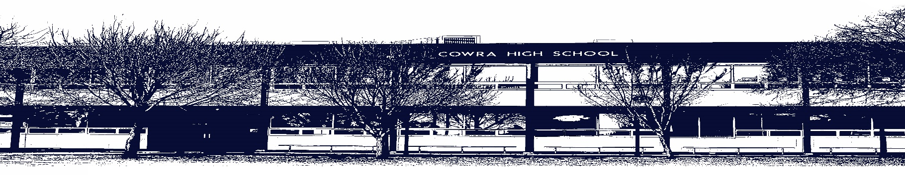
COWRA HIGH SCHOOL

Assessment Task Submission Policy

Submission of assessment tasks by students must follow faculty guidelines. There are basically four types of assessment tasks:

- In Class Assessment Tasks ~ these tasks are supervised by the class teacher and collected by the class teacher at the conclusion of the assessment task. It is the responsible of the student who miss in class assessment tasks to contact the Head Teacher of that faculty.

- Formal Examinations ~ at the conclusion of any formal examination the assessment task papers are to be collected and returned to the relevant faculty teacher.

- Major Projects / Pieces of Work ~ these items, due to their size, are usually kept in the appropriate faculty location. Major works and projects should be kept in safe locations that minimises the risk of damage. Any assessment task would be submitted directly to the teacher. A receipt for the task will be issued to students.

- Take Home Assessment Tasks ~ these are tasks that students are required to complete by a due date. Students should follow faculty submission guidelines regarding submission of these tasks.

Guidelines for the Submission of Assessment Tasks

- When an assessment task is issued, the information provided to students will include:
- a clear statement of what the task involves and what the expectations of the student are
- an explanation of the marking criteria / outcomes to be assessed
- the due date of submission
- an assessment task submission cover sheet ~ see attached

- Teachers should record the names of all students issued with the assessment task on a roll/class list and have the student acknowledge receipt of the assessment task by getting them to sign next to their name.

- Students must take their assessment task to the class teacher. They must be signed in on the class roll and keep their receipt

- All students must keep a copy of their assessment task.

Illness and Misadventure Appeals

If a student fails to submit an assessment task by the due date and has a legitimate reason than normal illness and misadventure procedures will apply.

REQUEST FOR ASSESSMENT EXTENSION PROCEDURE

Assessment extensions will only be granted in exceptional circumstances. All requests need to be made in writing using the extension request form. In seeking an extension discuss your request with your teacher/Head Teacher at least three (3) days before the due date with work already completed.

Forms for Illness/Misadventure and Extension can be accessed on the
Cowra High School Website.

