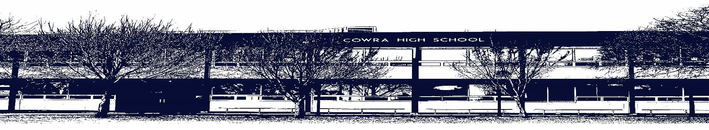

COWRA HIGH SCHOOL

ASSESSMENT TASK COVER SHEET

This sheet must be attached to the front of your Assessment Task and submitted to your class teacher on or before the due date.

Student’s Name: _________________________________________
Course: English Standard - HSC
Assessment Task: Extended Response
Date Due: Monday Week 9, Term 1 2021
Date Received: _______________
□ Extension granted _____ days
□ Other circumstances ~ documents attached

I certify:
- This assignment is entirely my own work and all borrowed material has been acknowledged
- The material contained in this assignment has not previously been submitted for assessment in any formal course of study
- I retain in my possession a copy of this assignment
- I understand that late assignments will be penalised unless an extension has been granted by Deputy Principal - Curriculum

Student’s Signature: ____________________________

✂-------------------------------------------------------------------------------------------------------------------------------
COWRA HIGH SCHOOL
Assessment Task (Student’s Copy)
Student’s Name: _________________________________________
Course: English Standard - HSC
Teacher: Perkins / Beattie / Tait

Assessment Task received by: _________________________________________
Signature: _________________________________________
Date: ______________________ Time: ______________________
Please detach this if the Assessment Task has been handed in
to the office and give to student to keep for their own records.

COWRA HIGH SCHOOL
Year 12 Assessment Task
NAME: |  |  | CLASS: |  |  | TEACHER: Perkins / Beattie / Tait
COURSE: English Standard |  | TASK No: 2 |  |  | Unit: Module A – Henry Lawson
DATE DUE: Monday 22nd March (Week 9, Term 1) |  |  |  |  |  | TIME DUE: In class
MARK: 20 | WEIGHT: 25% |  |  | PRESENTATION: Extended Response
SYLLABUS OUTCOMES:

EN12-1 independently responds to and composes complex texts for understanding, interpretation, critical analysis, imaginative expression and pleasure
EN12-7 explains and evaluates the diverse ways texts can represent personal and public worlds
EN12-8 explains and assesses cultural assumptions in texts and their effects on meaning

DESCRIPTION OF TASK:

“Through his varied methods of narration, Henry Lawson invites the reader to share in human emotions.”

To what extent do you believe Henry Lawson constructs language to shape our perceptions of culture? In your response you should refer to TWO stories.

The stories are:
- The Drover’s Wife
- The Union Buries Its Dead
- Shooting the Moon
- Our Pipes
- The Loaded Dog
Your extended response should be approximately 1000 – 1200 words
You will be assessed on your ability to;

- Demonstrate understanding of how ideas about language, identity and culture are expressed through texts.
- Demonstrate understanding of how language is used to shape meaning about individuals and/or cultural groups.
- Organise, develop and express your ideas using language appropriate to audience, purpose and form
MARKING CRITERIA:

Marking Criteria | Mark
- Provides a detailed analysis of how language forms and features are used to shape Australian identity in Henry Lawson’s short stories.  - Composes a skilful response based on relevant, detailed textual knowledge with specific reference to the given quote  - Organises, develops and expresses ideas using skilful language appropriate to audience, purpose and form | 17 – 20
- Provides some analysis of how language forms and features are used to shape Australian identity in Henry Lawson’s short stories.  - Composes an effective response based on relevant, sound textual knowledge with reference to the given quote  - Organises, develops and expresses ideas using effective language appropriate to audience, purpose and form. | 13 – 16
- Presents an adequate description of how some language forms and features are used to shape Australian identity in Henry Lawson’s short stories.  - Presents a response based on relevant, adequate textual knowledge with some acknowledgement of the given quote  - Expresses ideas adequately using language competent appropriate to audience, purpose and form | 9 – 12
- Describes aspects of the text with some reference to language, identity and culture  - Presents a response based on some textual knowledge with limited reference to the given quote.  - Attempts to organise a basic response | 5 – 8
- Attempts to describe aspects of the text  - Attempts to reference textual knowledge  - Response is limited | 1 – 4

Marker Comments:

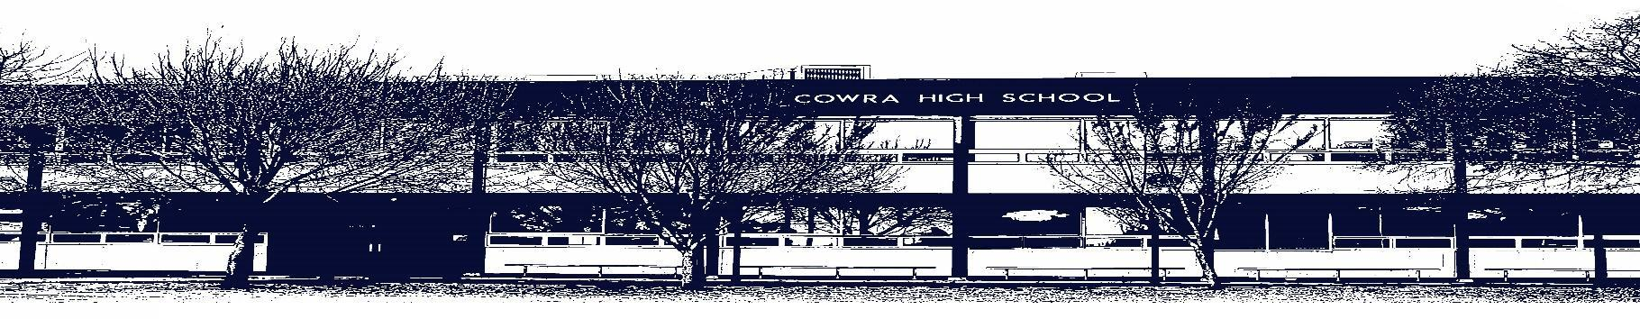

COWRA HIGH SCHOOL

Assessment Task Submission Policy

Submission of assessment tasks by students must follow faculty guidelines. There are basically four types of assessment tasks:

- In Class Assessment Tasks ~ these tasks are supervised by the class teacher and collected by the class teacher at the conclusion of the assessment task. It is the responsible of the student who miss in class assessment tasks to contact the Head Teacher of that faculty.

- Formal Examinations ~ at the conclusion of any formal examination the assessment task papers are to be collected and returned to the relevant faculty teacher.

- Major Projects / Pieces of Work ~ these items, due to their size, are usually kept in the appropriate faculty location. Major works and projects should be kept in safe locations that minimises the risk of damage. Any assessment task would be submitted directly to the teacher. A receipt for the task will be issued to students.

- Take Home Assessment Tasks ~ these are tasks that students are required to complete by a due date. Students should follow faculty submission guidelines regarding submission of these tasks.

Guidelines for the Submission of Assessment Tasks

- When an assessment task is issued, the information provided to students will include:
- a clear statement of what the task involves and what the expectations of the student are
- an explanation of the marking criteria / outcomes to be assessed
- the due date of submission
- an assessment task submission cover sheet ~ see attached

- Teachers should record the names of all students issued with the assessment task on a roll/class list and have the student acknowledge receipt of the assessment task by getting them to sign next to their name.

- Students must take their assessment task to the class teacher. They must be signed in on the class roll and keep their receipt

- All students must keep a copy of their assessment task.

Illness and Misadventure Appeals

If a student fails to submit an assessment task by the due date and has a legitimate reason than normal illness and misadventure procedures will apply.

REQUEST FOR ASSESSMENT EXTENSION PROCEDURE

Assessment extensions will only be granted in exceptional circumstances. All requests need to be made in writing using the extension request form. In seeking an extension discuss your request with your teacher/Head Teacher at least three (3) days before the due date with work already completed.

Forms for Illness/Misadventure and Extension can be accessed on the
Cowra High School Website.

