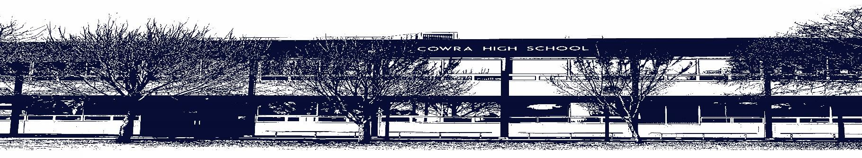
`

COWRA HIGH SCHOOL

ASSESSMENT TASK COVER SHEET

This sheet must be attached to the front of your Assessment Task and submitted to your class teacher on or before the due date.

Student’s Name: _________________________________________
Course: Stage 6 – Year 12 Visual Arts
Assessment Task: Written Research Essay
Date Due:
Date Received: _______________
□ Extension granted _____ days
□ Other circumstances ~ documents attached

I certify:
- This assignment is entirely my own work and all borrowed material has been acknowledged
- The material contained in this assignment has not previously been submitted for assessment in any formal course of study
- I retain in my possession a copy of this assignment
- I understand that late assignments will be penalised unless an extension has been granted by Deputy Principal - Curriculum

Student’s Signature: ____________________________

✂-------------------------------------------------------------------------------------------------------------------------------
COWRA HIGH SCHOOL
Assessment Task (Student’s Copy)
Student’s Name: _________________________________________
Course: Stage 6 – Visual Arts
Teacher: J. Peade

Assessment Task received by: _________________________________________
Signature: _________________________________________
Date: ______________________ Time: ______________________

Please detach this if the Assessment Task has been handed in
to the office and give to student to keep for their own records.
COWRA HIGH SCHOOL
Stage 6 – Year 12 Assessment Task
NAME: |  |  | CLASS: 12VA |  | TEACHER: J Peade
COURSE: Visual Arts |  | TASK No: 2 |  | Unit: Critical/Historical Studies
DATE DUE: Week 9, 23rd March 2020 |  |  |  |  | TIME DUE: In class
MARK: /25 | WEIGHT: 20%
SYLLABUS OUTCOMES:

H7: applies their understanding of practice in art criticism and art history
H8: applies their understanding of the relationships among the artist, artwork, world and audience

Written Research Essay

Discuss how artists’ ideas and intentions are communicated to the audience through the use of materials.
Word count: 1000 min-1500 max

In your answer, refer to specific artists and artworks. Include all references from research. Use correct essay structure with introduction, body, conclusion AND correct paragraphing.

MARKING CRITERIA

CRITERIA | MARK
- Presents a comprehensive and sustained discussion of how artists’ ideas and intentions are communicated to the audience through the use of materials.  - Explains the significance of examples to strongly support a discussion that addresses all aspects of the question  - Presents complex and logical points of view that reveal a highly developed understanding of the visual arts | 21-25
- Presents a thorough and well-reasoned discussion of how artists’ ideas and intentions are communicated to the audience through the use of materials.  - Explains examples to support a discussion that addresses most aspects of the question  - Presents logical points of view that reveal a developed understanding of the visual arts | 16-20
- Presents a general discussion of how artists’ ideas and intentions are communicated to the audience through the use of materials.  - Explains examples to support a discussion that addresses some aspects of the question  - Presents logical points of view that reflect some understanding of the visual arts | 11-15
- Presents an uneven and/or superficial description of how artists’ ideas and intentions are communicated to the audience through the use of materials.  - Describes examples in obvious ways to connect with some aspects of the question  - Presents inconsistent points of view that reflect a foundational understanding of the visual arts | 6-10
- Attempts to address some aspects of the question  - May offer examples that are not always be relevant or addressed  - Presents unsupported points of view that reflect a limited understanding of the visual arts | 1-5
- Non-Submission | 0

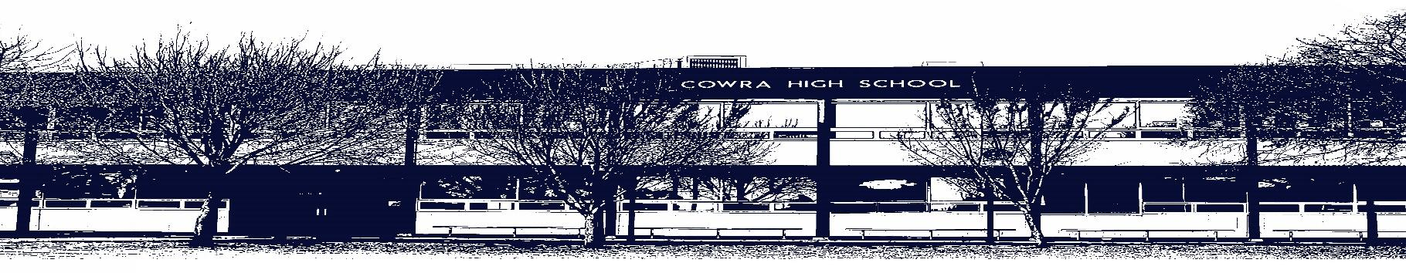

COWRA HIGH SCHOOL

Assessment Task Submission Policy

Submission of assessment tasks by students must follow faculty guidelines. There are basically four types of assessment tasks:

- In Class Assessment Tasks ~ these tasks are supervised by the class teacher and collected by the class teacher at the conclusion of the assessment task. It is the responsible of the student who miss in class assessment tasks to contact the Head Teacher of that faculty.

- Formal Examinations ~ at the conclusion of any formal examination the assessment task papers are to be collected and returned to the relevant faculty teacher.

- Major Projects / Pieces of Work ~ these items, due to their size, are usually kept in the appropriate faculty location. Major works and projects should be kept in safe locations that minimises the risk of damage. Any assessment task would be submitted directly to the teacher. A receipt for the task will be issued to students.

- Take Home Assessment Tasks ~ these are tasks that students are required to complete by a due date. Students should follow faculty submission guidelines regarding submission of these tasks.

Guidelines for the Submission of Assessment Tasks

- When an assessment task is issued, the information provided to students will include:
- a clear statement of what the task involves and what the expectations of the student are
- an explanation of the marking criteria / outcomes to be assessed
- the due date of submission
- an assessment task submission cover sheet ~ see attached

- Teachers should record the names of all students issued with the assessment task on a roll/class list and have the student acknowledge receipt of the assessment task by getting them to sign next to their name.

- Students must take their assessment task to the class teacher. They must be signed in on the class roll and keep their receipt

- All students must keep a copy of their assessment task.

Illness and Misadventure Appeals

If a student fails to submit an assessment task by the due date and has a legitimate reason than normal illness and misadventure procedures will apply.

REQUEST FOR ASSESSMENT EXTENSION PROCEDURE

Assessment extensions will only be granted in exceptional circumstances. All requests need to be made in writing using the extension request form. In seeking an extension discuss your request with your teacher/Head Teacher at least three (3) days before the due date with work already completed.

Forms for Illness/Misadventure and Extension can be accessed on the
Cowra High School Website.

