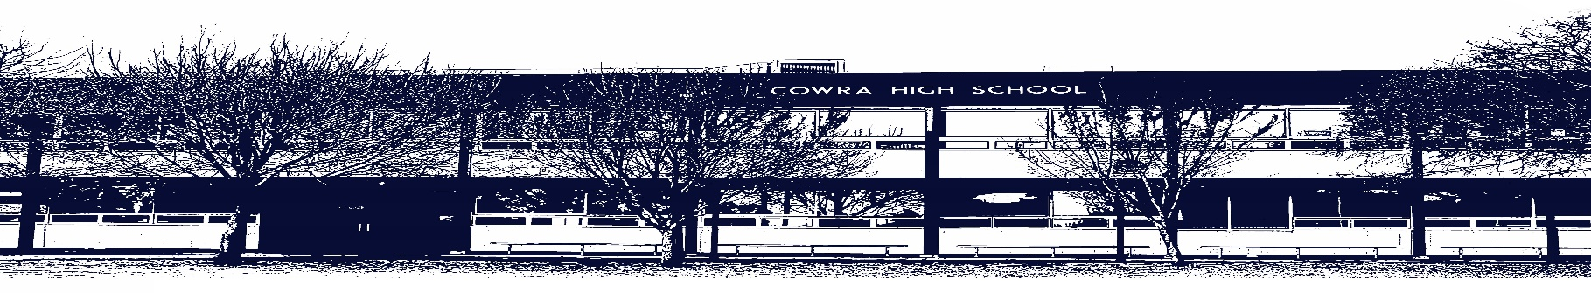

COWRA HIGH SCHOOL

ASSESSMENT TASK COVER SHEET

This sheet must be attached to the front of your Assessment Task and submitted to your class teacher on or before the due date.

Student’s Name: _________________________________________
Course: Stage 6 English Advanced
Assessment Task: Module C – Craft of Writing
Date Due: Tuesday Week 5, Term 2 - 18th May 2020
Date Received: _______________
Extension granted _____ days
Other circumstances ~ documents attached

I certify:
- This assignment is entirely my own work and all borrowed material has been acknowledged
- The material contained in this assignment has not previously been submitted for assessment in any formal course of study
- I retain in my possession a copy of this assignment
- I understand that late assignments will be penalised unless an extension has been granted by Deputy Principal - Curriculum

Student’s Signature: ____________________________

-------------------------------------------------------------------------------------------------------------------------------
COWRA HIGH SCHOOL
Assessment Task (Student’s Copy)
Student’s Name: _________________________________________
Course: Stage 6 English Advanced
Teacher: Rowston

Assessment Task received by: _________________________________________
Signature: _________________________________________
Date: ______________________ Time: ______________________

Please detach this if the Assessment Task has been handed in
to the office and give to student to keep for their own records.

COWRA HIGH SCHOOL
Year 12 Assessment Task
NAME: |  |  | CLASS: 12 |  |  | TEACHER: Perkins
COURSE: English Advanced |  | TASK No: 3 |  |  | Unit: Module C - Craft of Writing
DATE DUE: Week 5 Tuesday 18th May 2020 |  |  |  |  |  | TIME DUE: 3:15pm
MARK: /20 | WEIGHT: 25% |  |  | PRESENTATION: Composition and reflection  statement
SYLLABUS OUTCOMES: A Student:

EA12-3 critically analyses and uses language forms, features and structures of texts justifying appropriateness for
specific purposes, audiences and contexts and evaluates their effects on meaning
EA12-5 thinks imaginatively, creatively, interpretively, critically and discerningly to respond to, evaluate and compose
texts that synthesise complex information, ideas and arguments
EA12-9 reflects on, evaluates and monitors own learning and refines individual and collaborative processes as an
independent learner

DESCRIPTION OF TASK:

For this Craft of Writing assessment task, you must complete ONE of the options. Below are examples of the styles of questions you can expect to find in your written HSC examination. You need only complete ONE for marking. Please read each task carefully and look at the appropriate marking criteria. Look carefully at the value of the question to guide your writing. You should write no more than 1500 words in total. Select the question carefully to ensure that you can best showcase your writing skills.

Question 1
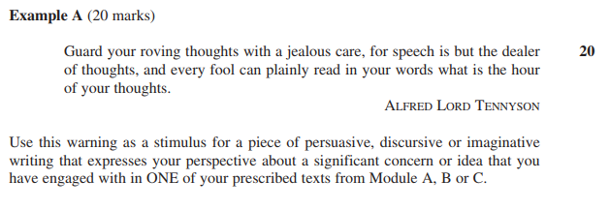

OR

Question 2

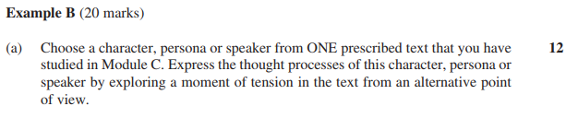

OR

Question 3

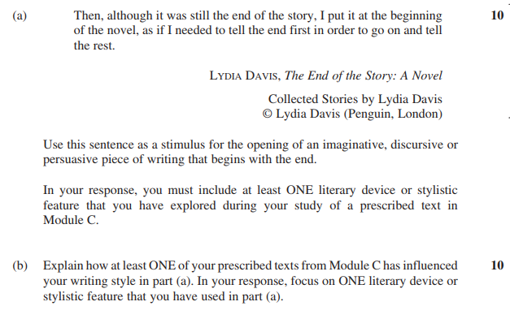

You will be assessed on your ability to:

- Craft language to address the demands of the question
- Use language appropriate to audience, purpose and context to deliberately shape meaning.

MARKING CRITERIA – Question 1

Criteria | Marks
- Composes an engaging piece of writing that responds to the question skilfully  - Crafts language skilfully to convey a perspective / ideas / emotion appropriate to the question  - Demonstrates skilful control of language and structure appropriate to audience, purpose, context and selected form | 17-20
- Composes a piece of writing that responds to the question effectively  - Crafts language effectively to convey a perspective / ideas / emotion appropriate to the question  - Demonstrates effective control of language and structure appropriate to audience, purpose, context and selected form | 13-16
- Composes a sound piece of writing that responds to the question satisfactorily  - Uses language competently to convey a perspective / ideas / emotion appropriate to the question  - Demonstrates sound control of language and structure appropriate to audience, purpose, context and selected form | 9-12
- Composes a limited piece of writing that responds to the question simply  - Uses language variably to convey a perspective / ideas / emotion appropriate to the question  - Demonstrates variable control of language and structure | 5-8
- Attempts to compose a piece of writing with some relevance to the question  - Demonstrates limited control of language | 1-4

MARKING CRITERIA - Question 2

Criteria | Marks
- Composes an engaging piece of writing that responds to the question skilfully  - Uses a range of language devices skilfully to create a voice  - Demonstrates skilful control of language and structure appropriate to audience, purpose, context and selected form | 10 - 12
- Composes an engaging piece of writing that responds to the question effectively  - Uses language devices effectively to create a voice  - Demonstrates effective control of language and structure appropriate to audience, purpose, context and selected form | 7 - 9
- Composes a piece of writing that responds to the questions simply  - Uses some language devices to create voice  - Demonstrates variable control of language and structure appropriate to audience, purpose, contact and selected form | 4 - 6
- Composes a piece of writing that has some relevance to the question  - Demonstrates limited control of language | 1 - 3

Criteria | Marks
- Provides a comprehensive justification of their writing decisions in part (a)  - Demonstrates effective control of evaluative language | 7 - 8
- Provides sound justification of their writing decisions in part (a)  - Demonstrates sound control of evaluative language | 5 - 6
- Provides a simple justification about their writing decisions in part (a)  - Demonstrates limited control of evaluative language | 3 - 4
- Provides some relevant information about their writing in part (a) | 1 - 3

MARKING CRITERIA – Question 3

Criteria | Marks
- Composes an engaging piece of writing that responds to the question skilfully  - Uses at least ONE language device or stylistic feature skilfully  - Demonstrates skilful control of language and structure appropriate to audience, purpose, context and selected form | 9 – 10
- Composes an engaging piece of writing that responds to the question effectively  - Uses at least ONE language device or stylistic feature effectively  - Demonstrates effective control of language and structure appropriate to audience, purpose, context and selected form | 7 - 8
- Composes a piece of writing that responds to the question adequately  - Uses at least ONE language device or stylistic feature  - Demonstrates sound control of language and structure appropriate to audience, purpose, context and selected form | 5 - 6
- Composes a piece of writing that attempts to respond to the question  - Demonstrates variable control of language | 3 – 4
- Attempts to compose a piece of writing that has minimal relevance to the question | 1 - 2

Criteria | Marks
- Provides a comprehensive explanation of how at least ONE of the prescribed texts from Module C has influenced their writing style  - Provides an effective explanation of the impact of a language device or stylistic feature in their piece of writing for part (a)  - Demonstrates effective control of evaluative language | 9 – 10
- Provides a considered explanation of how at least ONE of the prescribed texts from Module C has influenced their style of writing  - Provides a considered explanation of the impact of a language device or stylistic feature in their piece of writing for part (a)  - Demonstrates sound control of evaluative language | 7 - 8
- Provides a limited explanation of how at least ONE of the prescribed texts from Module C has influenced their writing style  - Provides a simple explanation of the impact of a language device or stylistic feature in their piece of writing for part (a)  - Demonstrates variable control of evaluative language | 5 - 6
- Provides a description or recount of how at least ONE of the prescribed texts from Module C has influenced their writing style  - Provides a description of a language device or stylistic feature  - Demonstrates limited control of evaluative language | 3 – 4
- Provides some relevant information about their writing | 1 - 2

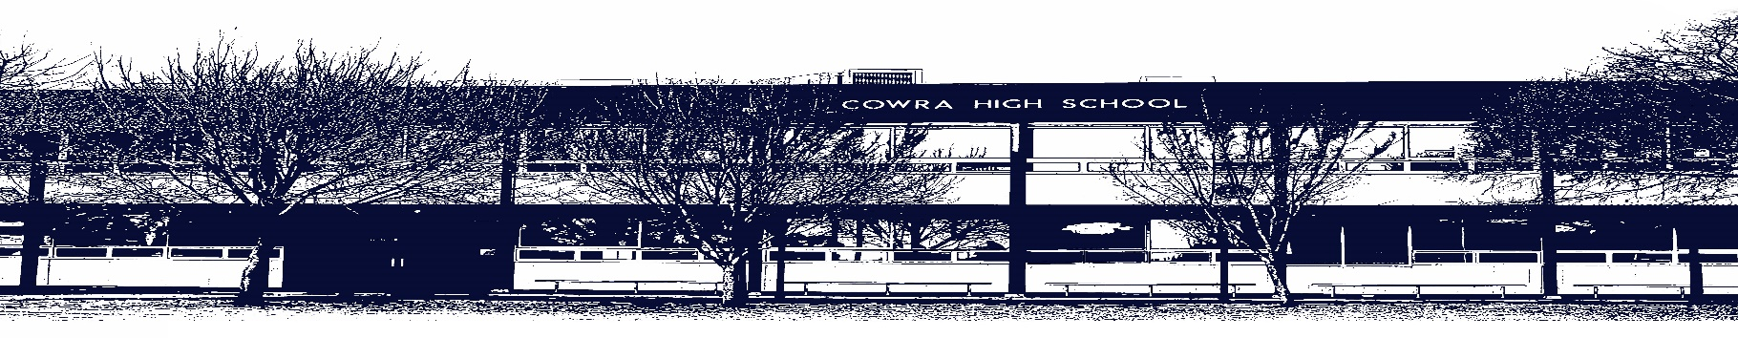

COWRA HIGH SCHOOL

Assessment Task Submission Policy

Submission of assessment tasks by students must follow faculty guidelines. There are basically four types of assessment tasks:

- In Class Assessment Tasks ~ these tasks are supervised by the class teacher and collected by the class teacher at the conclusion of the assessment task. It is the responsible of the student who miss in class assessment tasks to contact the Head Teacher of that faculty.

- Formal Examinations ~ at the conclusion of any formal examination the assessment task papers are to be collected and returned to the relevant faculty teacher.

- Major Projects / Pieces of Work ~ these items, due to their size, are usually kept in the appropriate faculty location. Major works and projects should be kept in safe locations that minimises the risk of damage. Any assessment task would be submitted directly to the teacher. A receipt for the task will be issued to students.

- Take Home Assessment Tasks ~ these are tasks that students are required to complete by a due date. Students should follow faculty submission guidelines regarding submission of these tasks.

Guidelines for the Submission of Assessment Tasks

- When an assessment task is issued, the information provided to students will include:
- a clear statement of what the task involves and what the expectations of the student are
- an explanation of the marking criteria / outcomes to be assessed
- the due date of submission
- an assessment task submission cover sheet ~ see attached

- Teachers should record the names of all students issued with the assessment task on a roll/class list and have the student acknowledge receipt of the assessment task by getting them to sign next to their name.

- Students must take their assessment task to the class teacher. They must be signed in on the class roll and keep their receipt

- All students must keep a copy of their assessment task.

Illness and Misadventure Appeals

If a student fails to submit an assessment task by the due date and has a legitimate reason than normal illness and misadventure procedures will apply.

REQUEST FOR ASSESSMENT EXTENSION PROCEDURE

Assessment extensions will only be granted in exceptional circumstances. All requests need to be made in writing using the extension request form. In seeking an extension discuss your request with your teacher/Head Teacher at least three (3) days before the due date with work already completed.

Forms for Illness/Misadventure and Extension can be accessed on the
Cowra High School Website.

