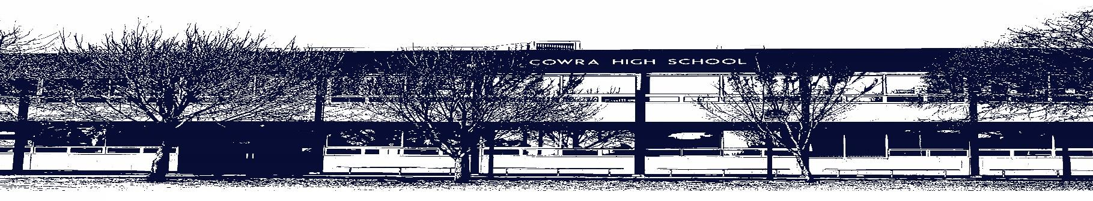

COWRA HIGH SCHOOL

ASSESSMENT TASK COVER SHEET

This sheet must be attached to the front of your Assessment Task and submitted to your class teacher on or before the due date.

Student’s Name: _________________________________________
Course: Stage 6 – Year 12 English Extension 1
Assessment Task: Critical Response
Date Due: Tuesday 18th May, 2021 – Term 2, Week 5
Date Received: _______________
□ Extension granted _____ days
□ Other circumstances ~ documents attached

I certify:
- This assignment is entirely my own work and all borrowed material has been acknowledged
- The material contained in this assignment has not previously been submitted for assessment in any formal course of study
- I retain in my possession a copy of this assignment
- I understand that late assignments will be penalised unless an extension has been granted by Deputy Principal - Curriculum

Student’s Signature: ____________________________

✂-------------------------------------------------------------------------------------------------------------------------------
COWRA HIGH SCHOOL
Assessment Task (Student’s Copy)
Student’s Name: _________________________________________
Course: Stage 6 – Year 12 English Extension 1
Teacher: Rowston

Assessment Task received by: _________________________________________
Signature: _________________________________________
Date: ______________________ Time: ______________________

Please detach this if the Assessment Task has been handed in
to the office and give to student to keep for their own records.

COWRA HIGH SCHOOL
Stage 6 – Year 12 Assessment Task
NAME: |  |  | CLASS: 12 Extension 1 |  |  | TEACHER: Rowston
COURSE: English Extension 1 |  | TASK No: 3 |  |  | Unit: Elective: Worlds of Upheaval
DATE DUE: Tuesday 18th May 2021 - Term 2 Week 5 |  |  |  |  |  | TIME DUE: 3:15pm
MARK: /30 | WEIGHT: 40% |  |  | PRESENTATION: Extended response and panel discussion
SYLLABUS OUTCOMES:

EE12-1 demonstrates and applies insightful understanding of the dynamic, often subtle, relationship between text, purpose, audience and context, across a range of modes, media and technologies
EE12-2 analyses and experiments with language forms, features and structures of complex texts, discerningly evaluating their effects on meaning for different purposes, audiences and contexts
EE12-3 independently investigates, interprets and synthesises critical and creative texts to analyse and evaluate different ways of valuing texts in order to inform and refine response to and composition of sophisticated texts
EE12-4 critically evaluates how perspectives, including the cultural assumptions and values that underpin those perspectives, are represented in texts

DESCRIPTION OF TASK:

Part 1: Critical Response

In periods of upheaval, texts have the potential to prompt reflection and challenge social values and structures.
To what extent does this statement align with your study of Beckett’s Waiting for Godot and Shelley’s Frankenstein? In your response you must also include at least ONE related text.
Your response should be between 1200 – 1500 words.

Part 2: Related Text Discussion
Students are to participate in a round table conversation, discussing their exploration of their related text and its context. Students will also be required to reflect on how they have reconsidered and appraised their values in light of the Worlds of Upheaval module.
Discussions will be hosted by the teacher, who will ask some of the following suggested questions:
- How has your related text represented a period of change and upheaval?
- What is the impact of the context on your related text?
- Why did you choose your related text?
- In what ways are forms and features used to challenge literary conventions in your related text?
- What connections have you found between your related and set texts?
- Un what ways has the Module inspired you to consider the potential of texts to activate change?
Students are expected to ask clarifying questions, respond and engage with other students’ ideas, and to challenge or support others’ opinions.

MARKING CRITERIA

Critical Response Marking Criteria
Marking Criteria | Mark
- Constructs a sophisticated response to the question, demonstrating an informed and critical perspective on the prescribed and related texts.  - Demonstrates sophisticated analysis of language forms and features with a range of consistent, effective and judiciously selected textual references.  - Demonstrates highly developed control of language and structure to express complex ideas. | 13-15
- Demonstrates a well-developed response to the question, demonstrating an informed and critical perspective on the prescribed and related texts.  - Demonstrates effective analysis of language forms and features with a range of consistent and judiciously selected textual references.  - Demonstrates developed control of language and structure to express complex ideas. | 10-12
- Demonstrates a competent response to the question, demonstrating an informed perspective on the prescribed and related texts.  - Demonstrates sound analysis of language forms and features with a range of relevant textual references.  - Demonstrates sound control of language and structure to express complex ideas. | 7-9
- Demonstrates a limited response to the question, attempting to demonstrate an informed perspective.  - Demonstrates limited analysis of language forms and features with some textual references.  - Demonstrates limited control of language and/or structure. | 4-6
- Demonstrates a limited response to the question.  - Demonstrates minimal analysis of language forms and features with little to no textual references.  - Demonstrates minimal control of language and/or structure. | 1-3
- Presents nothing of relevance to the task | 0

Panel Discussion Marking Criteria

Marking Criteria | Mark
- Demonstrates sophisticated ability to make complex connections between texts and concepts.  - Demonstrates insightful reflection on and evaluation of their personal engagement with texts, ideas and values.  - Demonstrates highly developed ability to engage verbally with complex ideas through questioning, responding and elaborating on contributions of others. | 13-15
- Demonstrates well-developed ability to make complex connections between texts and key ideas.  - Demonstrates thoughtful reflection on and evaluation of their personal engagement with texts, ideas and values.  - Demonstrates well developed ability to engage with complex ideas through questioning, responding and elaborating on contributions of others. | 10-12
- Demonstrates sound ability to make connections between texts and key ideas.  - Demonstrates sound reflection on and evaluation of their engagement with texts, ideas and values.  - Demonstrates sound ability to engage with ideas through questioning and responding. | 7-9
- Demonstrates limited ability to make connections between texts and key ideas.  - Demonstrates limited reflection on their engagement with texts, ideas and/or values.  - Demonstrates limited ability to engage with ideas through questioning and/or responding. | 4-6
- Makes little to no attempt to make connections between texts and key ideas.  - Makes little to no attempt to reflect on their engagement with texts, ideas and/or values  - Makes little to no attempt to engage with ideas through questioning or responding. | 1-3
- Presents nothing of relevance to the task. | 0

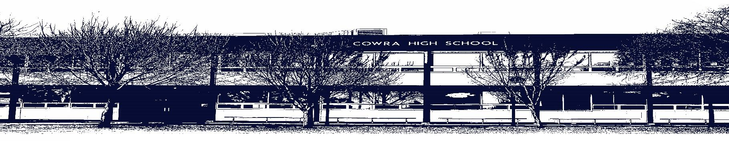

COWRA HIGH SCHOOL

Assessment Task Submission Policy

Submission of assessment tasks by students must follow faculty guidelines. There are basically four types of assessment tasks:

- In Class Assessment Tasks ~ these tasks are supervised by the class teacher and collected by the class teacher at the conclusion of the assessment task. It is the responsible of the student who miss in class assessment tasks to contact the Head Teacher of that faculty.

- Formal Examinations ~ at the conclusion of any formal examination the assessment task papers are to be collected and returned to the relevant faculty teacher.

- Major Projects / Pieces of Work ~ these items, due to their size, are usually kept in the appropriate faculty location. Major works and projects should be kept in safe locations that minimises the risk of damage. Any assessment task would be submitted directly to the teacher. A receipt for the task will be issued to students.

- Take Home Assessment Tasks ~ these are tasks that students are required to complete by a due date. Students should follow faculty submission guidelines regarding submission of these tasks.

Guidelines for the Submission of Assessment Tasks

- When an assessment task is issued, the information provided to students will include:
- a clear statement of what the task involves and what the expectations of the student are
- an explanation of the marking criteria / outcomes to be assessed
- the due date of submission
- an assessment task submission cover sheet ~ see attached

- Teachers should record the names of all students issued with the assessment task on a roll/class list and have the student acknowledge receipt of the assessment task by getting them to sign next to their name.

- Students must take their assessment task to the class teacher. They must be signed in on the class roll and keep their receipt

- All students must keep a copy of their assessment task.

Illness and Misadventure Appeals

If a student fails to submit an assessment task by the due date and has a legitimate reason than normal illness and misadventure procedures will apply.

REQUEST FOR ASSESSMENT EXTENSION PROCEDURE

Assessment extensions will only be granted in exceptional circumstances. All requests need to be made in writing using the extension request form. In seeking an extension discuss your request with your teacher/Head Teacher at least three (3) days before the due date with work already completed.

Forms for Illness/Misadventure and Extension can be accessed on the
Cowra High School Website.

