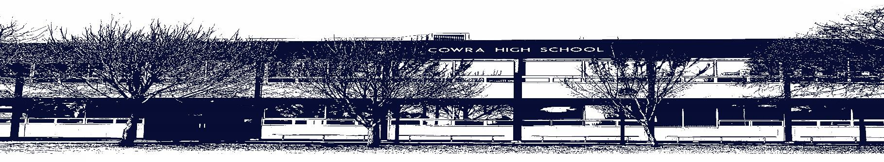

COWRA HIGH SCHOOL

ASSESSMENT TASK COVER SHEET

This sheet must be attached to the front of your Assessment Task and submitted to your class teacher on or before the due date.

Student’s Name: _________________________________________
Course: Stage 6 English Standard
Assessment Task: Module C – Craft of Writing
Date Due: Tuesday Week 5, Term 2 May 18th
Date Received: _______________
□ Extension granted _____ days
□ Other circumstances ~ documents attached

I certify:
- This assignment is entirely my own work and all borrowed material has been acknowledged
- The material contained in this assignment has not previously been submitted for assessment in any formal course of study
- I retain in my possession a copy of this assignment
- I understand that late assignments will be penalised unless an extension has been granted by Deputy Principal - Curriculum

Student’s Signature: ____________________________

✂-------------------------------------------------------------------------------------------------------------------------------
COWRA HIGH SCHOOL
Assessment Task (Student’s Copy)
Student’s Name: _________________________________________
Course: Stage 6 English Standard
Teacher: Perkins/Beattie/Tait

Assessment Task received by: _________________________________________
Signature: _________________________________________
Date: ______________________ Time: ______________________

Please detach this if the Assessment Task has been handed in
to the office and give to student to keep for their own records.

COWRA HIGH SCHOOL
Year 12 Assessment Task
NAME: |  |  | CLASS: 12 Standard |  |  | TEACHER: Perkins/Beattie/Tait
COURSE: English Standard |  | TASK No: 3 |  |  | Unit: Module C - Craft of Writing
DATE DUE: Week 5, Tuesday May 18th |  |  |  |  |  | TIME DUE: 3:15pm
MARK: /20 | WEIGHT: 25% |  |  | PRESENTATION: Composition and Reflection  Statement
SYLLABUS OUTCOMES: A Student:

EN12-3 analyses and uses language forms, features and structures of texts and justifies their appropriateness for purpose, audience and context and explains effects on meaning
EN12-5 thinks imaginatively, creatively, interpretively, analytically and discerningly to respond to and compose texts that include considered and detailed information, ideas and arguments
EN12-9 reflects on, assesses and monitors own learning and refines individual and collaborative processes as an independent learner

DESCRIPTION OF TASK:
For this Craft of Writing assessment task, you have the choice to write an imaginative, discursive or persuasive piece of writing.
You are also required to write a reflection statement. You should write no more than 1200 words for both parts combined.

You will be assessed on your ability to:

- Craft language to address the demands of the question
- Use language appropriate to audience, purpose and form to shape meaning.

Question 1 (20 marks)
Part (a) 10 marks
Create a piece of imaginative, discursive or persuasive writing that features one of the following as a significant place or event.
You may choose to write in any textual form you choose, for example a speech, a feature article, an essay, a letter to the editor, a narrative or other text type after discussions with your teacher.

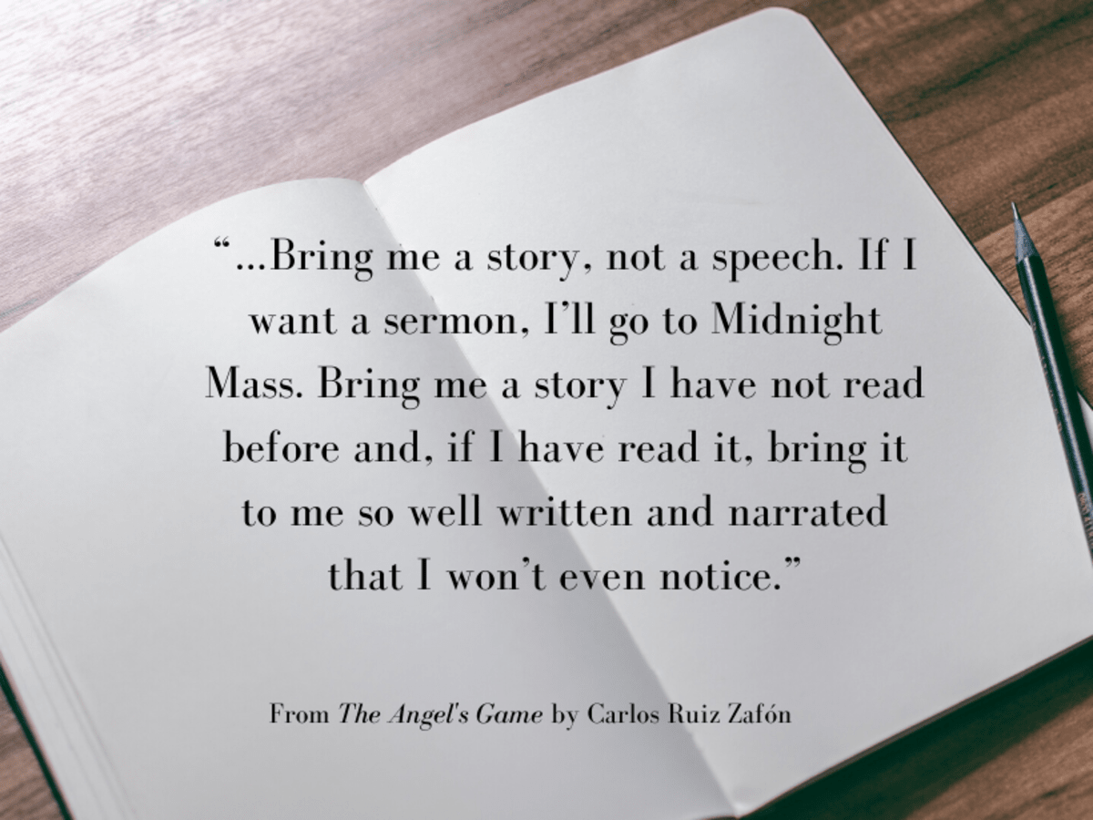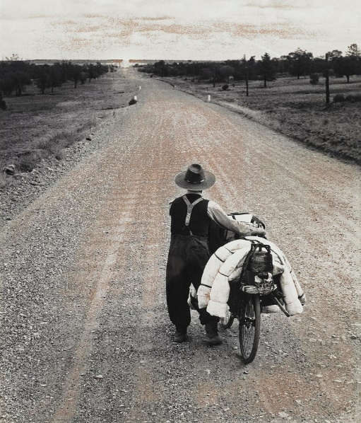

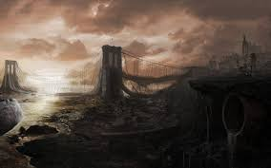

Part (b) 10 marks

Write a reflection in which you discuss how the stylistic choices you made in part (a) were influenced by what you have learned about how to create effective writing through the study of one of your prescribed texts in Module C.
Your teacher will provide you with a model for how to compose your reflection statement

The prescribed texts are:

• Prose Fiction – Ray Bradbury, The Pedestrian
– Peter Carey, Report on the Shadow Industry
– Catherine Cole, Home
– Stephen King, Crouch End
– Melissa Lucashenko, Dreamers

• Nonfiction – Helen Garner, Dear Mrs Dunkley
– George Orwell, The Sporting Spirit
– Sylvia Plath, A Comparison
– Sarah Vowell, What He Said There

• Speeches – Linda Burney, First speech to the House of Representatives as
Member for Barton
– Steve Jobs, How to Live Before You Die
– Paul Keating, Funeral Service of The Unknown Australian Soldier
– J K Rowling, The Fringe Benefits of Failure and the Importance of
Imagination

• Poetry – Carol Chan, Popcorn
– Robert Frost, Stopping By Woods on a Snowy Evening
– Les Murray, An Absolutely Ordinary Rainbow
– Judith Wright, The Surfer

• Performance
Poetry – Luka Lesson, May your pen grace the page

MARKING CRITERIA

Criteria – Creative Writing | Marks
- Composes an engaging piece of writing that effectively uses ONE image to inspire a setting in their writing  - Uses a range of language devices or stylistic features effectively to convey an understanding of a place or event  - Demonstrates effective control of language and structure appropriate to audience, purpose, context and selected form | 9 - 10
- Composes an interesting piece of writing that competently uses ONE image to inspire a setting in their writing  - Uses a range of language devices or stylistic features competently to convey an understanding of a place or event  - Demonstrates competent control of language and structure appropriate to audience, purpose, context and selected form | 7 - 8
- Composes a piece of writing that responds to the question adequately  - Uses some descriptive language to convey a place or event  - Demonstrates variable control of language and structure appropriate to audience, purpose, context and selected form | 5 - 6
- Composes a piece of writing that attempts to convey an experience  - Demonstrates limited control of language | 3 – 4
- Attempts to compose a piece of writing that has some relevance to the question | 1 - 2

Teacher comment:

Criteria - Reflection | Marks
- Provides a detailed appraisal of the effectiveness of their own writing in addressing the requirements of the question  - Effectively assesses the use of a range of language devices or stylistic features for a particular purpose  - Demonstrates effective control of evaluative language | 9 - 10
- Appraises the effectiveness of their own writing in addressing the requirements of the question  - Assesses the effect of using a language device or stylistic feature for a particular purpose  - Demonstrates sound control of evaluative language | 7 - 8
- Explains features of their own writing in addressing the requirements of the question  - Describes the effect of using a language device and/or stylistic feature for a particular purpose  - Demonstrates variable control of evaluative language | 5 - 6
- Describes how their own writing addresses the requirements of the question  - Describes the use of language  - Demonstrates limited control of language | 3 - 4
- Provides some relevant information about their writing | 1 - 2

Teacher comment:

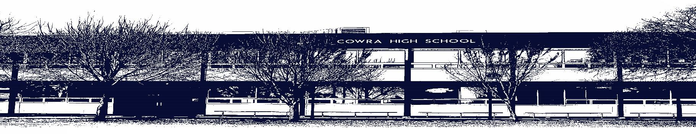

COWRA HIGH SCHOOL

Assessment Task Submission Policy

Submission of assessment tasks by students must follow faculty guidelines. There are basically four types of assessment tasks:

- In Class Assessment Tasks ~ these tasks are supervised by the class teacher and collected by the class teacher at the conclusion of the assessment task. It is the responsible of the student who miss in class assessment tasks to contact the Head Teacher of that faculty.

- Formal Examinations ~ at the conclusion of any formal examination the assessment task papers are to be collected and returned to the relevant faculty teacher.

- Major Projects / Pieces of Work ~ these items, due to their size, are usually kept in the appropriate faculty location. Major works and projects should be kept in safe locations that minimises the risk of damage. Any assessment task would be submitted directly to the teacher. A receipt for the task will be issued to students.

- Take Home Assessment Tasks ~ these are tasks that students are required to complete by a due date. Students should follow faculty submission guidelines regarding submission of these tasks.

Guidelines for the Submission of Assessment Tasks

- When an assessment task is issued, the information provided to students will include:
- a clear statement of what the task involves and what the expectations of the student are
- an explanation of the marking criteria / outcomes to be assessed
- the due date of submission
- an assessment task submission cover sheet ~ see attached

- Teachers should record the names of all students issued with the assessment task on a roll/class list and have the student acknowledge receipt of the assessment task by getting them to sign next to their name.

- Students must take their assessment task to the class teacher. They must be signed in on the class roll and keep their receipt

- All students must keep a copy of their assessment task.

Illness and Misadventure Appeals

If a student fails to submit an assessment task by the due date and has a legitimate reason than normal illness and misadventure procedures will apply.

REQUEST FOR ASSESSMENT EXTENSION PROCEDURE

Assessment extensions will only be granted in exceptional circumstances. All requests need to be made in writing using the extension request form. In seeking an extension discuss your request with your teacher/Head Teacher at least three (3) days before the due date with work already completed.

Forms for Illness/Misadventure and Extension can be accessed on the
Cowra High School Website.

