Cowra High School

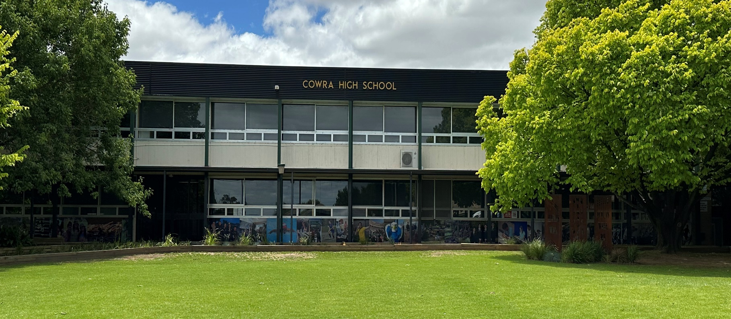

GUIDE FOR

NEW STUDENTS

2023

Knowledge is Power

## 

[Type a quote from the document or the summary of an interesting point. You can position the text box anywhere in the document. Use the Drawing Tools tab to change the formatting of the pull quote text box.]

**CONTENTS**

**ACKNOWLEDGEMENT** 3

**WELCOME TO COWRA HIGH SCHOOL** 4

**COWRA HIGH SCHOOL CONTACT DETAILS** 4

**SENIOR EXECUTIVE STAFF** 5

**STUDENT ADVISERS** 6

**GENERAL INFORMATION** 7

**FACULTY HEAD TEACHERS** 7

**WHEN YOU ARRIVE AT SCHOOL** 8

**ROLL MARK, ABSENCES AND LATE ARRIVALS** 8

**SCHOOL BAGS AND BELONGINGS** 8

**FINDING YOUR WAY AROUND THE SCHOOL** 9

**SCHOOL MAP** 10

**BELLS** 11

**LEAVING THE SCHOOL GROUNDS** 11

**WELLBEING AT COWRA HIGH SCHOOL** 12

**STUDENT WELLBEING NETWORK** 13

**CURRICULAR & EXTRA CURRICULAR TEACHING AND ACTIVITIES** 13

**RESPECT AND RESPONSIBILITY AT COWRA HIGH SCHOOL** 14

**MOBILE PHONE POLICY** 15

**THE RESPONSIBILITY OF PARENTS/CAREGIVERS** 16

**HOW PARENTS CAN HELP YOU AND YOUR SCHOOL** 16

Parent/Teacher Evenings 16

Canteen 16

Parents and Citizens' Association Meeting 17

**SCHOOL COUNSELLOR** 17

**SCHOOL FEES** 17

Voluntary Contributions 17

Subject Fees 18

**PLAYGROUND RULES** 18

**SCHOOL UNIFORM** 19

**STUDENT ASSISTANCE SCHEME** 20

**SICKNESS/FIRST AID** 20

**SPORT** 20

**A HISTORY OF THE CAMDEN - COWRA SPORTING EXCHANGE** 21

**LANGUAGES AND STUDENT EXCHANGE OPPORTUNITIES** 22

Cowra-Seikei Student Exchange 22

Short Term Exchange Opportunities 23

**COWRA HIGH SCHOOL PBL MERIT SCHEME** 24

**IMPORTANT DATES** 25

**USEFUL WEBSITES** 25

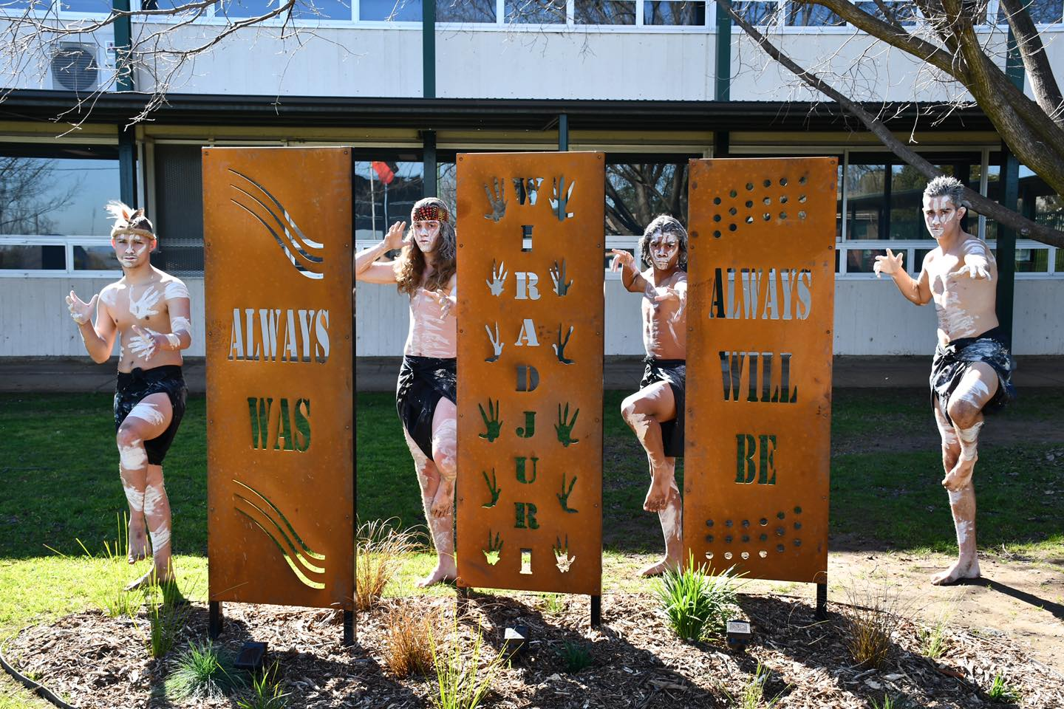

# **ACKNOWLEDGEMENT**

Cowra High School is located on the ancestral lands of the Wiradjuri people, the traditional custodians. We recognise their unique ongoing spiritual connection to this land and their rich contribution to this region.

Cowra High School is committed to developing a deeper understanding of Aboriginal and Torres Strait Islander culture as a path to reconciliation and a positive future.

We pay our respects to our Elders, both past and present and acknowledge our continued role in nurturing the next generation of emerging leaders.

# 

# **WELCOME TO COWRA HIGH SCHOOL**

You are now part of our school and we welcome you here on your first day. It will be up to you to make the best of your opportunities whether it is educationally, socially, culturally or in the sporting arena. You will find this booklet very helpful in guiding you through the first few weeks. We suggest that you read it carefully and carry it with you while you are learning about your new school. Please ask your parents/caregivers to read it also as they too will find it very useful.

# **COWRA HIGH SCHOOL CONTACT DETAILS**

**Address:** Dowell Street

COWRA NSW 2794

**Postal Address:** PO Box 72

COWRA NSW 2794

**Telephone:**  6342 1766

**Email:** [cowra-h.school@det.nsw.edu.au](mailto:cowra-h.school@det.nsw.edu.au)

**Website:** <https://cowra-h.schools.nsw.gov.au/>

# 

# **SENIOR EXECUTIVE STAFF**

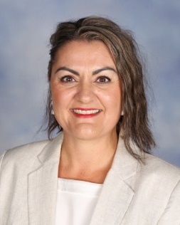

**Principal:** Mrs Helene Hamilton

**Email:** helene.hamilton@det.nsw.edu.au

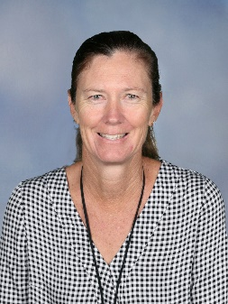

**Deputy Principal:** Ms Megan Robinson

**Email:** megan.killick@det.nsw.edu.au

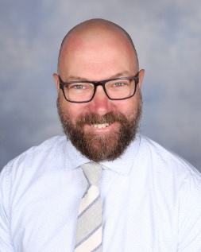

**Deputy Principal:** Mr Anthony Hamer

**Email:** anthony.hamer@det.nsw.edu.au

# **STUDENT ADVISERS**

Remember that we are your Year Advisers and that we are here to help you whenever we can, so please don’t hesitate in coming to see us if you are having some problems. Our staffrooms are listed below:

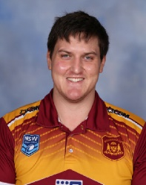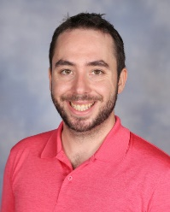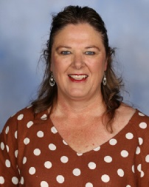

**Year 7 Adviser:** Mr Jason Ewing-Jarvie

HSIE Staffroom D block (upper level)

**Year 8 Adviser:** Mr Blake Duncombe

HSIE Staffroom D Block (upper level)

**Year 9 Adviser:** Mr Angus Bates

English/CAPA Staffroom A Block (lower level)

**Year 10 Adviser:** Mrs Louise Rowston

Health Hub – library in A block (upper level)

**Year 11 Adviser:** TBA

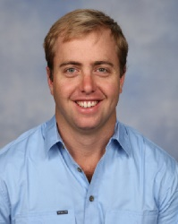

**Year 12 Adviser:** Mr Kyle Mugridge

TAS Staffroom B Block (lower level)

# **GENERAL INFORMATION**

|  |  |
| --- | --- |
| **School Motto:** | Savoir C'est Pouvoir  (Knowledge is Power) |
| **Colours** | Blue and gold |
| **Houses:** | Named after Australian trees  Brigalow (RED)  Kurrajong (YELLOW)  Myall (BLUE)  Wandoo (GREEN) |

# **FACULTY HEAD TEACHERS**

|  |  |
| --- | --- |
| **English/CAPA** | Mrs Melinda Rowston |
| **Mathematics/Science:** | Mrs Elicia Yates |
| **HSIE:** | TBA |
| **Learning and Support:** | Mr Sean Leyland |
| **PDHPE:** | Mr Tim Berry |
| **TAS** | Ms Hollie Noble |
| **Literacy & Numeracy:** | Ms Di St Clair |

# **WHEN YOU ARRIVE AT SCHOOL**

You are not permitted to enter the school grounds until **8:30am** when the bell rings. Until the next bell at **8:55am** you must remain in the playground areas or use the Health Hub. You may also pay for school fees and excursions at the office receipting window from **8:30am**.

# **ROLL MARK, ABSENCES AND LATE ARRIVALS**

At **8:55am** you must go to the quad for Morning Muster and line up with your roll group. The notices for the day will be read out and your uniform will be checked.

If you arrive late to Morning Muster please make sure that you let your roll call teacher know so they can mark you present. If you arrive after Morning Muster, please report to the office to sign in and organise a late note. You will be marked absent from school for that day if you do not get a late note. A note must be brought from home if you are late for school.

Absences from school must be explained with a note (or a phone call) from a parent/caregiver – please include your name, your year, date you were away & the reason you were absent. The note should be brought to school **on the day you return** and must be given to your roll call teacher during the roll call period. Alternatively absences can be explained via the Cowra High School App or the school website.

# **SCHOOL BAGS AND BELONGINGS**

At Cowra High School you will be responsible for your own belongings. **You will need to ensure they are kept secure and safe from damage.**

You will be asked to leave your bags outside some specialist rooms – mainly those that contain lots of equipment. Lockers are available for hire – check with the front office regarding availability.

# **FINDING YOUR WAY AROUND THE SCHOOL**

#### A Block is the main administration block which includes:–

|  |  |  |
| --- | --- | --- |
| General office | Principal’s office | Common Room |
| Aboriginal Education Officer | Photocopying room | Senior toilets |
| School foyer | Science laboratories | Learning Hub |
| Library/Health Hub | English/CAPA staffroom | Careers |
| General classrooms | Deputies Office |  |

**B Block** includes Design & Technology rooms, Food Technology & Hospitality Rooms, Music & Art rooms plus general classrooms. The TAS staffroom is situated downstairs.

**C Block** is the canteen area with junior boys and girls toilets upstairs and classroom C1.

**D Block** includes three Science laboratories and general classrooms. The PDHPE staffroom is downstairs and Mathematics/Science, Humanities and Learning & Support staffrooms are upstairs.

**Demountable Area** includes the Ceramics annexe, Industrial Arts workshop, the Learning & Support unit and the Agriculture plot.

**Hall** is next to the basketball courts and includes the auditorium, performance workshop, and boys and girls change rooms. It is used for many functions including assemblies, school socials, presentation ceremonies & performances, as well as PDHPE, music and drama lessons.

All teachers and students know that it is difficult to find your way around when you arrive at a new school, so if you are not sure where to go, then **ask someone for help**.

# **SCHOOL MAP**

TTC

C1

# **BELLS**

A bell rings at the end of each lesson. However, your teacher for that lesson will decide when you may leave the classroom. A bell also rings half way through lunch because many activities are held during Lunch 1 or Lunch 2.

**A continuous slow rising sound indicates an emergency.** Carefully follow the instructions your teacher gives you – there will be practice drills for emergency situations which will help you understand the situation more clearly.

**Repeated short blasts of a fast rising sound indicate a lockdown.** This means that all students are to be supervised inside a room.

# **LEAVING THE SCHOOL GROUNDS**

Sometimes there are special reasons for you to leave the school grounds – to obtain permission to do that you must bring a note from your parent/caregiver explaining the reason for leaving and the time. You must take it to the front office in A Block before Morning Muster and you will be issued with a Permission to Leave School slip. This slip is then taken to the office to sign out. If you return later in the day you must sign back in.

***It is very important that the school staff***

***know exactly where you are at all times.***

**Cowra High School Newsletter**

Our newsletter is published 2 x Term. The link to the newsletter is emailed to every student and parent/caregivers who have provided us with their email address. The email address is requested on the enrolment form, however, it needs to be updated by notifying the school office. The newsletter can also be accessed on the Cowra High School website at https://cowra-h.schools.nsw.gov.au.

The newsletter will keep you informed of current activities happening within the school as well as issues discussed at P&C meetings.

# 

# **WELLBEING AT COWRA HIGH SCHOOL**

Schools have a pivotal role to play in connecting character development in children and young people to individual and collective wellbeing, which in the longer term will shape the values and attitudes of the society in which they live.

Teachers play an important role in providing learning experiences and opportunities that develop and shape the character and wellbeing of children and young people.

Experiences that develop character by promoting mindfulness (self-regulation and behaviour), curiosity, courage, resilience, ethics and leadership benefit children and young people as they grow and develop.

Schools focus on giving children and young people voice, being active learners and developing strong character qualities that will enable them to succeed, thrive and contribute positively throughout life.

The Wellbeing Framework for NSW public schools contextualises wellbeing to individual students, school settings and local school communities. The concept that wellbeing is dynamic and is integral to learning is vital to embedding it in the complex multi-dimensional work of schools.

The Department of Education commitment to wellbeing is for our schools to support students to connect, succeed and thrive at each stage of their development and learning; to provide opportunities that are age rigorous, meaningful and dignified; and to do this in the context of individual and shared responsibility underpinned by productive relationships that support students to learn.

Schools will be supported to focus on the development of quality teaching, learning and engagement. Local decision-making will invigorate school communities. Highly effective leadership will deliver on this commitment for every member of the school community.

# 

# **STUDENT WELLBEING NETWORK**

|  |  |
| --- | --- |
| * Aboriginal Education Officer | * School Counsellor |
| * Aboriginal In-class Tutor Program | * Special Support Class |
| * Aboriginal Mentoring Programs | * Sporting Coaches |
| * Sista Speak | * Student Assistance Scheme |
| * Bro Speak | * ‘10% on Top’ Scheme |
| * Celebrating Difference Program | * Teachers – Advice & Interviews |
| * Peer Support Scheme | * Year 7 Orientation |
| * Year Student Advisers |  |

|  |  |
| --- | --- |
| **CURRICULAR & EXTRA CURRICULAR TEACHING AND ACTIVITIES** | |
| * Aboriginal Cultural Programs | * Band |
| * Careers Adviser | * Choir |
| * Excursions | * Community Involvement |
| * Sport | * Debating |
| * Learning and Support Teachers | * Sporting Teams (State Knockout, Camden) |
| * Student Leadership Council (SLC) | * Work Experience |
| * Dance Program | * Website, Facebook or School App |
| * Junior AECG | * Lions Youth of the Year |
| * School Spectacular | * Seikei Exchange |
| * Girri Girri Program 7/8 & 9/10 |  |

# **RESPECT AND RESPONSIBILITY AT COWRA HIGH SCHOOL**

Everyone in the Cowra High School community has a right to feel safe at school, to be treated fairly by students and staff, to participate fully in school activities and to speak out and receive support when problems occur. We share the responsibility for each other’s wellbeing.

The Feel Safe Policy targets bullying, harassment and discrimination. This means any behaviour, (verbal, physical or emotional that causes someone to feel unhappy or unsafe), name calling, teasing, hitting, shoving, taking or damaging property and forcing others to do something they don't want to are all examples of bullying and harassment. This also includes the use of emails or text messages which hurts another.

Serious complaints of harassment and discrimination (such as racism, homophobic or sexism) will be dealt with according to Department of Education guidelines.

**Students**

*If you feel intimidated or unsafe in class, in the playground or on your way to or from school, you should:*

* Let the person know that what they are saying or doing is annoying you and you would like them to stop.
* If you can’t talk to the person or the harassment continues tell a staff member or an adult you trust.

Following a discussion with you, a staff member will help to solve the problem. If the problem continues, report it again.

*If you bully or harass other members of the school community, you will find that the following may happen:*

* You will be informed that what you are saying or doing is annoying and be asked to stop.
* Your actions will be reported to a staff member.
* A record will be kept of your unacceptable behaviour.
* Your parents/caregivers will be informed.
* Normal disciplinary procedures will occur eg. loss of privileges, placement on discipline level, suspension or expulsion.
* The Principal will refer the matter to the police.

*Remember bullying will not be tolerated at our school. Let's keep our school safe for everyone.*

***Remember you have the right to feel safe.***

# **MOBILE PHONE POLICY**

As part of a review of the electronic devices policy at Cowra High School and in response to emerging research, Cowra High School has acknowledged the need for an update of its management of student mobile phone use. The purpose of this information is to provide students, parents, carers, staff and community members a simple process to reduce angst and confusion.

Cowra High School now has a “not seen, not heard” approach to mobile phones. This means that phones and/or ear pieces must be off and out of sight during all learning times. The aim of this approach to management is to empower students to make good choices in an autonomous fashion.

Current research informs us that when an individual has their phone on their person they can suffer the following:

• Lower concentration

• Increased fear of missing out

• Reduced memory

• Altered views of reality

• Increased stress and anxiety

Our school is committed to providing the very best possible educational opportunities for our students and as such, we are asking for parent and carer support to ensure our students do not have their mobile phone on during any learning time. All electronic devices are only to be used if explicit permission is given by the teacher in charge.

**NO warnings for mobile device misuse will be given to students.** The following process will occur if a student is unable to abide by the updated policy:

**During all learning time**

**(including roll call, assemblies, meetings and study periods)**

• Mobile phone and/or ear piece - NOT SEEN / NOT HEARD

• Mobile phones may be used appropriately before school, after school, and during recess and lunch breaks.

**Mobile phone seen and/or heard**

• Blue slip or Head Teacher/Deputy Principal intervention

• Phone handed in to the front administration office

**Collection of phone**

• Mobile phone can only be collected from the front administration office by a parent or carer

**Repeated confiscation of phone**

• Further discipline through Cowra High School discipline procedures

Further communication regarding updates to Cowra High School digital device procedures is available on the school website and in the school newsletter. Please contact the school on 63421766 or via email cowra-h.school@det.nsw.edu.au if you require further information.

# **THE RESPONSIBILITY OF PARENTS/CAREGIVERS**

Parents/caregivers and teachers share a commitment to provide opportunities for students to take responsibility for their actions and to have responsible input into the nature and content of their learning.

The school is not by itself responsible for developing socially acceptable behaviour by students. This is a shared responsibility of parents/caregivers and students in partnership with teachers.

# **HOW PARENTS CAN HELP YOU AND YOUR SCHOOL**

The following pages contain information that will be of interest to parents/caregivers in particular. You are also encouraged to read it so that you understand many of the support areas that operate at our school.

Parents can show interest in their children's work by providing a place for homework to be done. All children appreciate some praise where genuine effort has been shown.

As part of the support scheme of the school the following opportunities are provided and we would appreciate your attendance.

## Parent/Teacher Evenings

These are held on a regular basis throughout the year. Interviews are booked via Sentral, parent log on in details will be provided prior to the Parent Teacher evening.

## Canteen

An excellent ‘healthy school canteen’ is operated in our school at which students may buy recess and lunch daily. Fresh salads, sandwiches, fruit, and hot meals are available daily over the counter as well as an assortment of in house, freshly made, baking and snacks.

Students wishing to order their lunches may do so by leaving an order at the Canteen by recess each day, or alternatively, online by emailing our canteen staff, at [caroline.sullivan5@det.nsw.edu.au](mailto:caroline.sullivan5@det.nsw.edu.au) before 11:30am.

CHS canteen is P&C operated and therefore relies on the support of Parent Volunteers. The school would be most appreciative of your help as a voluntary worker in the canteen. Please contact Caroline Sullivan on (02) 6342 1766 during school hours, any help would be of assistance.

## Parents and Citizens' Association Meeting

Held Thursday week 8 of each term at 5:30pm in the CHS Health Hub.

# **SCHOOL COUNSELLOR**

There are times students or their parents/caregivers need assistance from the School Counsellor. This person can assist students and families with their educational, social and emotional needs. Parents can contact the School Counsellor directly or request an appointment through the Principal or Year Advisers.

School teachers can also request a referral to the School Counsellor after consultation with the parents/caregivers.

Students can also self-refer to the counsellor by reporting to the office and requesting an appointment to see the counsellor. The School Counsellor’s office is upstairs in the Hub.

# **SCHOOL FEES**

## Voluntary Contributions

Voluntary Contribution: Years 7 and 8 $62

Years 9 and 10 $72

Years 11 and 12 $82

## Subject Fees

There is a subject contribution in Years 7 & 8 for Combined Art/Technology and Science.

Elective subjects in Years 9/10 and Years 11/12 may attract a subject fee. This fee is necessary to pay for consumables that your son/daughter uses. Assistance is available if you are experiencing financial difficulties. All enquiries will be treated confidentially.

***Please pay these subject fees promptly***

# **PLAYGROUND RULES**

**Entry and exit** - ***students should not enter or leave school via the gates to the Upper or Lower car parks.*** Students are not to enter the school until 8.30am and they must leave the school at 3.15pm. Students who catch buses are supervised on the front lawn until their bus leaves. Students in the immediate surrounds of the school before and after school will be expected to follow normal school rules.

**Quadrangle -** Handball only can be played in the main quadrangle. Throwing of balls or any other ball games is not permitted in the quadrangle (except during organised sport or PE lessons).

**Canteen area** - Ball games are not to be played in the canteen area. Students must wait for canteen service behind the marked line and only the student being served should be at the canteen window counter.

**Hockey and Rugby fields -** Only students playing ball games or under staff supervision are allowed on these fields. Tackling or grabbing is not allowed while playing on the fields before school or at recess and lunchtimes.

**Basketball courts -** Students may play basketball or handball on the courts. Other ball games are not allowed.

**Hall -** Students are not to enter the Hall or Performance Workshop unless they are under the supervision of a teacher. All bags are to be left outside.

**Wednesday Afternoon Staff Meeting Times**

Students will be supervised in the quad. Students who have not left the school or who have not been picked up by 2.20pm are to remain in the quad until 3.15pm.

**Out of Bounds**

Students are only allowed in A Block if they are going to the Library/Health Hub or front office, seeing a teacher or using their locker.

Before school, the area below the Lower car park, hockey & rugby fields and synthetic courts are out of bounds to students.

Synthetic court ~ ball games. No bags on the surface, no food or drink within fenced boundary.

Hayshed and attached grass area ~ Year 7 area only for Term 1.

# **SCHOOL UNIFORM**

Items of uniform can be purchased from Mr Embroidery, Central West Uniforms and Shoes 4 You.

An open meeting of the Cowra High community voted to have a school uniform, so the Principal is responsible for ensuring that students comply with these requirements as part of the "Fair Discipline Code". Parents/caregivers are therefore strongly encouraged to purchase the correct items for the uniform and ensure that they are worn by their son/daughter every day.

Uniform is checked during Morning Muster - students out of uniform are recorded and monitored with continued failure to wear correct school uniform resulting in loss of privileges. If students have good reason to be out of uniform on a particular day they should bring an explanatory note to the roll class teacher.

**Please ensure all items of uniform are clearly labeled with your child’s name.**

Cowra High School has a range of pre-loved items of uniform. Please see Learning Hub staff for what is available and any donations of unwanted uniforms are greatly appreciated.

# 

# **STUDENT ASSISTANCE SCHEME**

Students needing financial assistance with uniform, stationery or elective fees may apply to the Student Assistance Scheme. Application forms are available from the front office. Students receiving other forms of government assistance are not eligible for this scheme.

# **SICKNESS/FIRST AID**

Occasionally some students are injured or become sick at school. Cowra High School has fully trained first aid staff who help in these cases.

Any student who is sick or injured must first get a note from their class teacher (except at lunch or recess) and then go to the front office, and a first aid staff member will be contacted.

**No medication is given to students** (including Paracetamol) and as far as possible parents are contacted and asked to take sick and injured students home.

Students should not have medications at school unless they are prescribed for taking during school hours, in which case they should be left with one of the medication administrators who are located in the Learning and Support unit in D Block. The only exception is asthma sprays & EpiPens, which should be carried by students who need them at all times.

The school needs to be aware of any medical problems so that we can act appropriately when and if necessary.

# 

# **SPORT**

**General**

* School sport is compulsory for years 7-10.
* Sports for each student are displayed on the sports noticeboard in the canteen. You should check these lists every week.
* Your rights and responsibilities as a student are exactly the same on sport occasions as any other school activity.
* Year 7 participate in year group sport for Terms 1, 2 & 3 all on Cowra High campus.
* If participating in a fee paying sport, money is to be paid each Wednesday eg. bus fare, court hire

**Absence**

* Absence from sport is the same as absence from class/school.
* Give a written note from your parent/caregiver explaining why you will be absent from sport to the front office before 8.55am.
* When you leave school, sign out at the office and present your leave early slip.

**Injury and Sickness**

* A non-physical activity will be offered to students with long term illness.

**Venues**

* Sport is held either on school grounds or at locations throughout Cowra township.
* If the sport is at a venue other than Cowra High, students will catch buses under supervision to the venue.

**Uniform**

* Students are to wear correct sports uniform
* Students are encouraged to wear hats, protective sunglasses and sunscreen when playing sport outdoors ~ it is advisable to also carry a drink bottle of water.

# **A HISTORY OF THE CAMDEN - COWRA SPORTING EXCHANGE**

The Robert Montgomery Memorial Shield this year celebrates its 49th year.  This makes it one of the longest running sporting exchanges in Australia.  Many thousands of young people have benefited from this wonderful sporting event, and lifelong friendships have been forged.

In the early 1970s, Mr Paul Montgomery, an English teacher at Camden High School had the idea that a sporting competition with another school over a period of 3 days would be a wonderful way of forging valuable links between students from different backgrounds.

With the Principal, Mr Phillip Patterson, it was decided that the school should be a rural school of comparable size and approximately a four hour distance from Camden.  This would make the travelling time manageable while still providing enough distance to make the enterprise adventurous for the students.

Letters were sent to a number of schools and Cowra was eventually chosen as the perfect school with which to establish the competition.  In 1972, the first exchange occurred with Cowra students travelling to Camden for the inaugural games.

It was decided at this stage to name the competition in honour of the late Robert Montgomery who had been the Deputy Principal at Camden High from 1969-1970.

Forty nine years later, the games continue to provide many students with wonderful sporting, cultural and social experiences.  This is the result of the continued commitment of all staff at both schools, and particularly the team coaches and the chief organisers.  In recent years, Mr Steve Johnstone and Mr Tim Berry from Cowra High and Mrs Anna-Lisa Reeves and Justin Garland from Camden High have spent a great deal of time & effort ensuring these games continue to flourish.

May the Robert Montgomery Shield continue to provide these wonderful opportunities for the young people of Cowra and Camden for many years to come.​

# **LANGUAGES AND STUDENT EXCHANGE OPPORTUNITIES**

Cowra High School has had a history of teaching languages to a high standard in the region and is continuing this tradition moving forward. Currently, students are able to study Japanese face-to-face and have the option of selecting it for senior study as full 2-unit academic course. Students will also be able to study other languages via distance education with support from trained languages teacher. This respect of languages education over the years has been nurtured by one of the school’s greatest achievements – The Cowra-Seikei Student Exchange.

## Cowra-Seikei Student Exchange

The Cowra-Seikei Student Exchange is the longest running exchange program in NSW and in 2020, the exchange program will have been in place for 50 years.

Students are able to apply to become a long-term exchange student at Seikei High School, located in the heart of Tokyo. Whilst in Tokyo, students will be housed by trusted Seikei High School families and live the daily life of a normal

Japanese High School student. They are able to participate in club activities, go on excursions to other parts of Japan with exchange students from around the globe, hang out with friends in the city and be immersed in Japanese language and culture.

The other way the Cowra High school community can participate in the exchange program is to host the Japanese student who come to the school every year as part of this exchange. In the same way the Cowra High School students who travel to Japan for a year are hosted by trustworthy members of the Seikei High School community, so too must the Japanese students who come to Australia. Being able to share the Australian way of life is incredibly rewarding. You also gain another member of your family for a term and will likely have some free accommodation and a meal if you ever travelled to Japan!

## Short Term Exchange Opportunities

**Japan Trip**

The short term exchange to Japan has occurred at Cowra High School for many years. It is a cultural exchange that has no prerequisite to applying to go on other than an open mind to a foreign culture. This exchange usually falls on the spring holidays in Australia, students fly to Japan. Once they arrive, students spend 1 week traveling around the country and exploring fantastic cultural sites like Nara, Kyoto, Hiroshima and so much more. After a week of traveling with their teachers, students are hosted by a Japanese family for the rest of their trip. They attend Seikei High School for the remaining weekdays of their exchange and get to experience life as a Japanese High School student before returning back to Australia just in time to start Term 4.

# 

# **COWRA HIGH SCHOOL PBL MERIT SCHEME**

BE RESPECTFUL ~ BE RESPONSIBLE

BE REWARDED

**Bronze Eagles are awarded for:**

* active participation during the school day
* improved effort and application in class
* outstanding effort in classwork or assignments
* excellent achievement in school or community pursuits
* consistent effort to achieve potential
* compliance with school rules and teacher directions
* positive interactions with others
* the wearing of full school uniform
* regular attendance

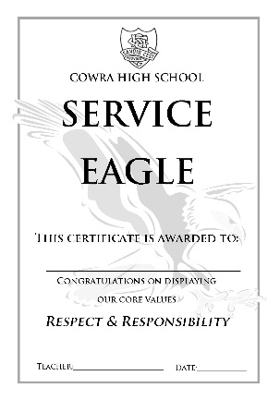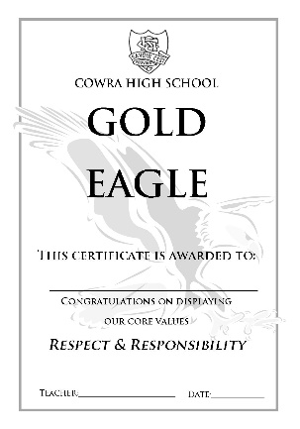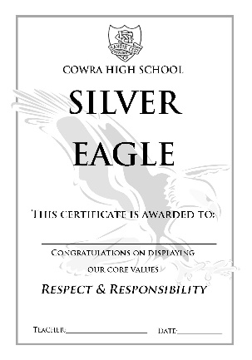

Achieve 2 Gold Eagles and a Service Eagle and you receive the Cowra High School Gold/Silver/Bronze Medallion

**=**



**Gold / Silver /**

**Bronze**

**Medallion**

A Service Eagle is achieved by representing the school, in community & school activities. You can earn a Service Eagle at any time, not just after Gold Awards.

**× 2 +**

When you achieve 3 Silver Eagles, you qualify for a Gold Eagle

**× 3**

**× 10**

[Type a quote from the document or the summary of an interesting point. You can position the text box anywhere in the document. Use the Drawing Tools tab to change the formatting of the pull quote text box.]

**A Service Eagle is achieved by representing the school in Community and School activities. You can earn a Service Eagle at any time, not just after Gold Awards.**

**When you achieve**

**3 Silver Eagles,**

**you qualify for a**

**Gold Eagle.**

**When you achieve**

**3 Silver Eagles,**

**you qualify for a**

**Gold Eagle.**

**When you achieve**

**3 Silver Eagles,**

**you qualify for a**

**Gold Eagle.**

# **IMPORTANT DATES**

**School resumes in 2023 as follows:**

Friday 28 - Monday 31 January ~ Staff only

Tuesday 1 February ~ Years 7, 11 & 12 students

Wednesday 2 February ~ All students

**Term Dates 2023** (all dates inclusive)

Wednesday 28 January - Friday 8 April

Tuesday 26 April - Friday 1 July

Monday 18 July - Friday 23 September

Monday 10 October – Tuesday 20 December

# **USEFUL WEBSITES**

**Cowra High School**

https://cowra-h.schools.nsw.gov.au/

**NSW Department of Education & Communities**

[www.dec.nsw.edu.au](http://www.dec.nsw.edu.au)

**NESA**

<http://educationstandards.nsw.edu.au/wps/portal/nesa/home>

**Sentral**

<https://www.sentral.com.au/>

**NOTES**