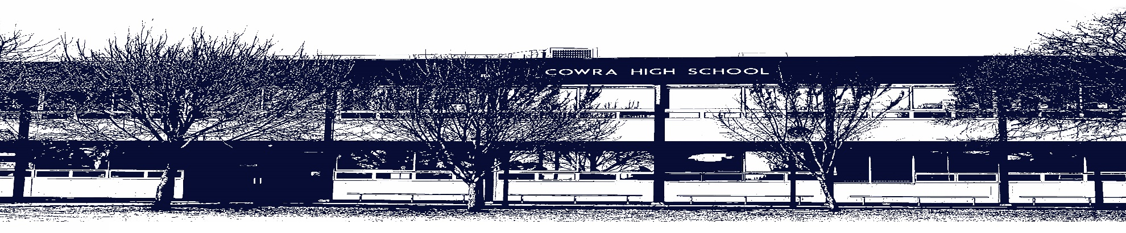

Application for Extension

Name: Year: Date:

Subject: Teacher:

Assessment Task Number (As per Assessment Policy booklet):

Assessment Task Title:

I apply for an extension based on the consideration of the following factors which may affect my performance in this Assessment Task. (Documentary evidence must be provided, except in exceptional circumstances)

In applying for this special consideration, I assure the Principal that I am not seeking unfair advantage over
other students in this course.

Student’s Signature: Parent/Guardian’s Signature:
Recommendation of Teacher/Head Teacher:

Signature of Teacher/Head Teacher: ………………………………………………………………………..

-------------------------------------------------------------------------------------------------------------------------------------------
Recommendation of Assessment Committee: Application for Extension Subject/Course: Assessment Task Number:
Assessment Task Title:

Principal/Deputy Principal: Date:

This form is located: https://cowra-h.schools.nsw.gov.au/and then to the assessment tab.

