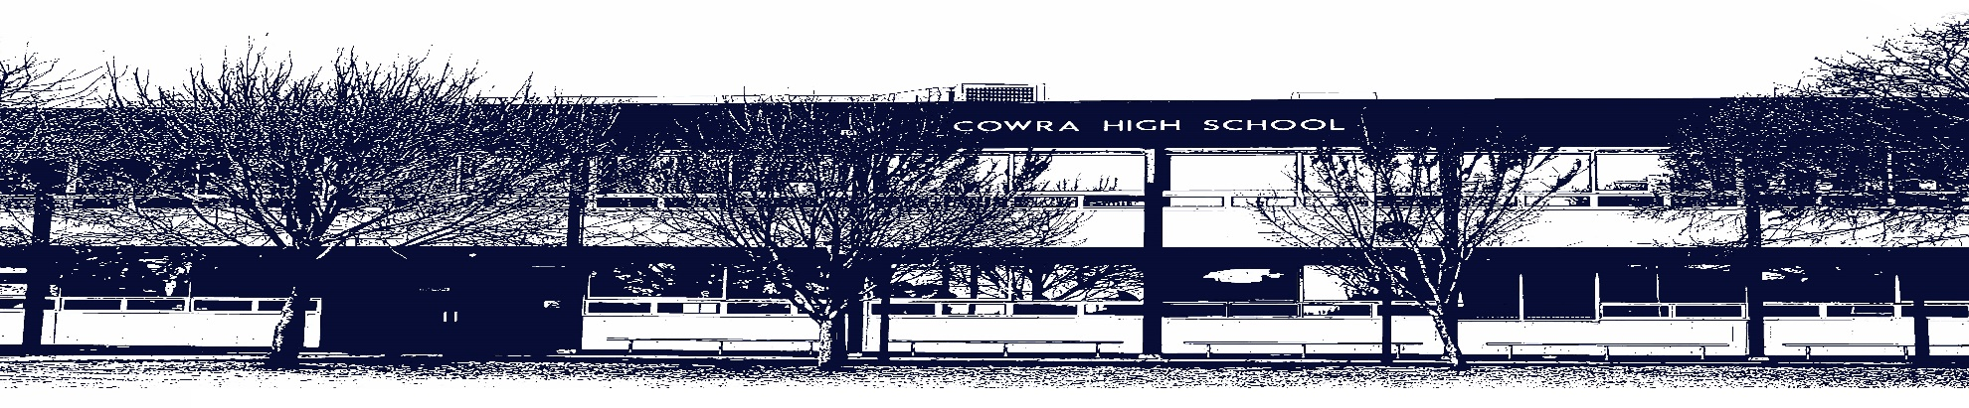

COWRA HIGH SCHOOL

Assessment Task Cover Sheet

This sheet must be attached to the front of your Assessment Task and submitted to your class teacher on or before the due date.

Student’s Name: _________________________________________
Course: _________________________________________
Assessment Task: _________________________________________
Date Due: _______________
Date Received: _______________
Extension granted _____ days
Other circumstances ~ documents attached

I certify:
- This assignment is entirely my own work and all borrowed material has been acknowledged
- The material contained in this assignment has not previously been submitted for assessment in any formal course of study
- I retain in my possession a copy of this assignment
- I understand that late assignments will be penalised unless an extension has been granted by Deputy Principal - Curriculum

Student’s Signature: ____________________________

-------------------------------------------------------------------------------------------------------------------------------
COWRA HIGH SCHOOL
Assessment Task (Student’s Copy)
Student’s Name: _________________________________________
Course: _________________________________________
Teacher: _________________________________________

Assessment Task received by: _________________________________________
Signature: _________________________________________
Date: ______________________ Time: ______________________

Please detach this if the Assessment Task has been handed in
to the office and give to student to keep for their own records.

This form is located: https://cowra-h.schools.nsw.gov.au/and then to the assessment tab.

