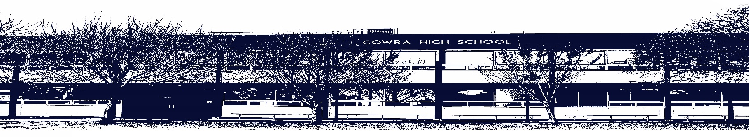

COWRA HIGH SCHOOL

ASSESSMENT TASK COVER SHEET

This sheet must be attached to the front of your Assessment Task and submitted to your class teacher on or before the due date.

Student’s Name: _________________________________________
Course: English Extension
Assessment Task: Imaginative Writing and Reflection Statement
Date Due: Monday Week 10, Term 1
Date Received: _______________
Extension granted _____ days
Other circumstances ~ documents attached

I certify:
- This assignment is entirely my own work and all borrowed material has been acknowledged
- The material contained in this assignment has not previously been submitted for assessment in any formal course of study
- I retain in my possession a copy of this assignment
- I understand that late assignments will be penalised unless an extension has been granted by Deputy Principal - Curriculum

Student’s Signature: ____________________________

-------------------------------------------------------------------------------------------------------------------------------
COWRA HIGH SCHOOL
Assessment Task (Student’s Copy)
Student’s Name: _________________________________________
Course: English Extension
Teacher: Burrell

Assessment Task received by: _________________________________________
Signature: _________________________________________
Date: ______________________ Time: ______________________

Please detach this if the Assessment Task has been handed in
to the office and give to student to keep for their own records.
COWRA HIGH SCHOOL
English Extension Assessment Task
NAME: |  |  | CLASS: |  |  | TEACHER: Burrell
COURSE: English Extension |  | TASK No: 1 |  |  | Unit: Power and Morality
DATE DUE: Monday 29th March, Week 10 |  |  |  |  |  | TIME DUE: During class
MARK: /25 | WEIGHT: 30% |  |  | PRESENTATION: Imaginative Writing and  Reflection Statement
SYLLABUS OUTCOMES:

EE11-2 analyses and experiments with language forms, features and structures of complex texts, evaluating their effects on meaning in familiar and new contexts
EE11-3 thinks deeply, broadly and flexibly in imaginative, creative, interpretive and critical ways to respond to, compose and explore the relationships between sophisticated texts
EE11-6 reflects on and assesses the development of independent learning gained through the processes of research, writing and creativity

DESCRIPTION OF TASK:

Part 1: Creative Writing – Task Description

Use one of the images provided as the basis for the setting of an original imaginative piece that explores the nature of power and morality. Your final piece must be no more than 1500 words.

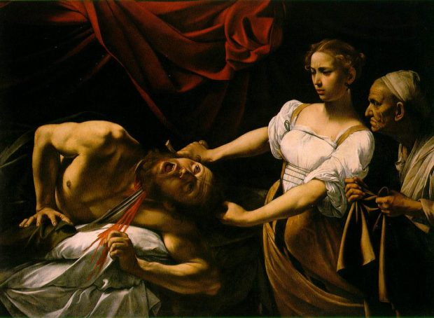

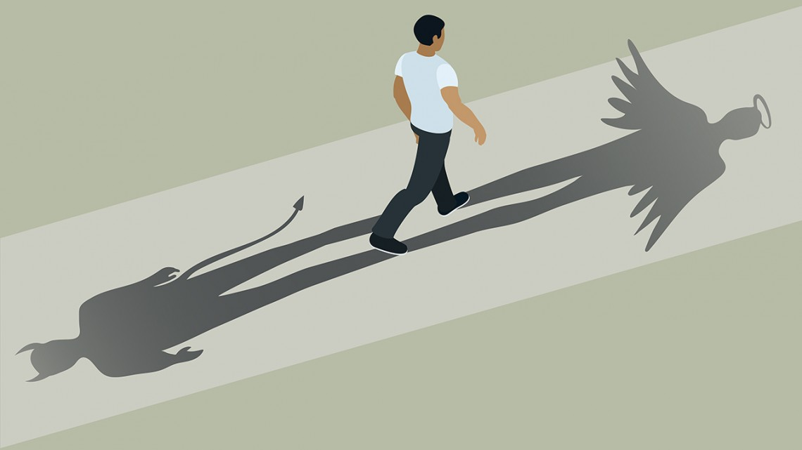

Part 2: Drafting and Peer Feedback – Task Description

This task is designed to help students plan, draft, edit and publish a high quality piece of creative writing.
Alongside the creative piece, students are also required to submit:
- detailed plans for their creative piece
- at least one earlier draft of their work
- the ‘Feedback Sheet’ completed by someone other than a teacher

Through responding to and composing a wide range of complex texts and through the critical study of texts, students will develop knowledge, understanding and skills in order to:
- articulate and communicate understanding through speaking, listening, reading, writing, viewing and representing
- craft language to shape meaning and express imaginative, creative, interpretive and critical responses to a range of texts
- express imaginative, creative, interpretive and critical ideas based on sophisticated analysis and theorising about complex texts and values
- express understanding of how cultural, historical and social contexts are represented in critical and creative texts
- reflect upon and evaluate their own processes of learning and creativity.

MARKING CRITERIA:

Marking criteria | Marks
- Demonstrates sophisticated ability to craft a creative piece of writing that insightfully explores the nature of power and morality  - Skilfully integrates the chosen image into the construction of setting  - Demonstrates sophisticated control of language, including skilful use of a wide range of language forms and features | 21-25
- Demonstrates well-developed ability to craft a creative piece of writing that effectively explores the nature of power and morality  - Effectively uses the chosen image in the construction of setting  - Demonstrates well-developed control of language, including effective use of a range of language forms and features | 16-20
- Demonstrates sound ability to craft a creative piece of writing that explores the nature of power and morality  - References the chosen image in the construction of setting  - Demonstrates sound control of language, including some use of language forms and features | 11-15
- Demonstrates developing ability to craft a creative piece of writing that relates to the nature of power and morality  - Attempts to reference the chosen image, possibly not evident in the construction of setting  - Demonstrates developing control of language, possibly including limited use of language forms and features | 6-10
- Demonstrates limited ability to craft a creative piece of writing, possibly without reference to the nature of power and morality  - Little to no attempt to reference the chosen image  - Demonstrates limited control of language, possibly relying on simplistic language forms and features | 1-5
- Presents nothing of relevance to the task | 0

Feedback Sheet

When students receive regular feedback, it gives them the opportunity to develop and refine their written responses. As such, student are asked to nominate a person that they trust to read and edit their writing. This ‘editor’ doesn’t have to be someone who is perfect in the subject of English. Instead it should be someone who cares about the student and is willing to give them a helping hand.

The editor is encouraged to do two things. Firstly, it would be helpful if they could make corrections directly on the piece of writing with a red pen. The following code may help with this process:

- Spelling: circle and correct misspelled words
- Punctuation: add punctuation marks or circle punctuation that has been used incorrectly
- Grammar and expression: use a ‘wriggly’ line to underline sentences that are repetitive, contain incorrect grammar or sound awkward.
- New paragraph: use a square bracket to indicate where a new paragraph should start
- Additional details: Use an arrow to add additional words or details

Secondly, the editor is encouraged to fill in the following table;

Feedback | Needs attention | Good Work | Very Strong | Comments or suggestions
The story is interesting and engaging
The reader follows along with without getting 'lost' or confused
The story is believable and authentic; not clichéd
The key character(s) are believable and show complexity and/or personal growth
The narrative clearly deals with the nature of power and morality & clearly relates to one of the stimuli
Descriptive language is used to make the reader to imagine the characters, settings and events
The sentences flow, moving well from one to the next. There are a variety of sentence types
The paragraphs are well structured and vary in length
There are few errors in grammar, punctuation and spelling

What do you think they have done well?

What can they do to improve and develop their response?

Editors, please fill in the details below:

Students name:
Editor’s name:
Relationship to student:
Date edited:
Signature of editor:

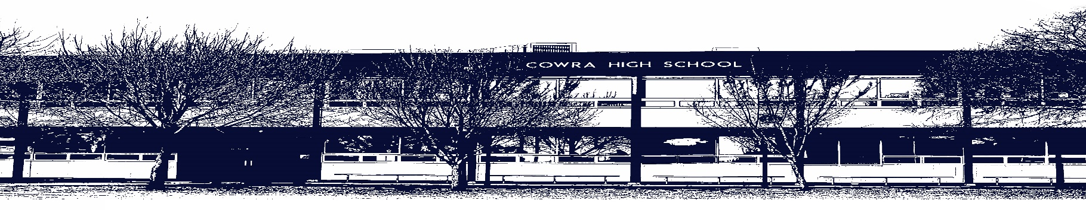

COWRA HIGH SCHOOL

Assessment Task Submission Policy

Submission of assessment tasks by students must follow faculty guidelines. There are basically four types of assessment tasks:

- In Class Assessment Tasks ~ these tasks are supervised by the class teacher and collected by the class teacher at the conclusion of the assessment task. It is the responsible of the student who miss in class assessment tasks to contact the Head Teacher of that faculty.

- Formal Examinations ~ at the conclusion of any formal examination the assessment task papers are to be collected and returned to the relevant faculty teacher.

- Major Projects / Pieces of Work ~ these items, due to their size, are usually kept in the appropriate faculty location. Major works and projects should be kept in safe locations that minimises the risk of damage. Any assessment task would be submitted directly to the teacher. A receipt for the task will be issued to students.

- Take Home Assessment Tasks ~ these are tasks that students are required to complete by a due date. Students should follow faculty submission guidelines regarding submission of these tasks.

Guidelines for the Submission of Assessment Tasks

- When an assessment task is issued, the information provided to students will include:
- a clear statement of what the task involves and what the expectations of the student are
- an explanation of the marking criteria / outcomes to be assessed
- the due date of submission
- an assessment task submission cover sheet ~ see attached

- Teachers should record the names of all students issued with the assessment task on a roll/class list and have the student acknowledge receipt of the assessment task by getting them to sign next to their name.

- Students must take their assessment task to the class teacher. They must be signed in on the class roll and keep their receipt

- All students must keep a copy of their assessment task.

Illness and Misadventure Appeals

If a student fails to submit an assessment task by the due date and has a legitimate reason than normal illness and misadventure procedures will apply.

REQUEST FOR ASSESSMENT EXTENSION PROCEDURE

Assessment extensions will only be granted in exceptional circumstances. All requests need to be made in writing using the extension request form. In seeking an extension discuss your request with your teacher/Head Teacher at least three (3) days before the due date with work already completed.
Forms for Illness/Misadventure and Extension can be accessed on the
Cowra High School Website.

