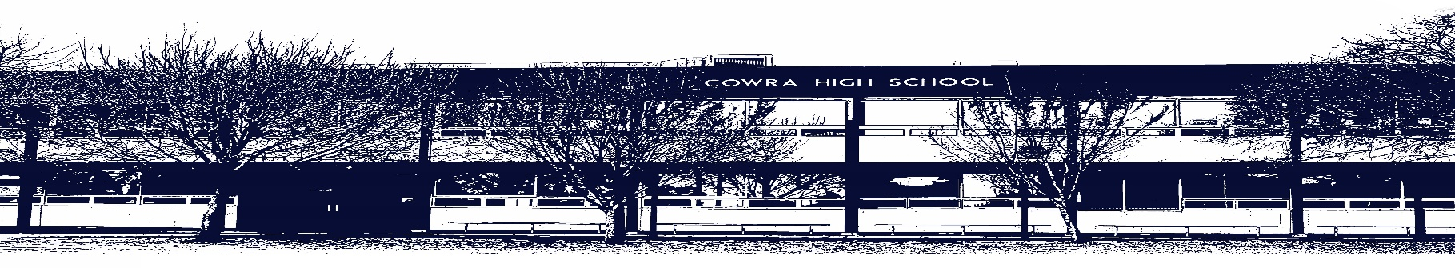

COWRA HIGH SCHOOL

ASSESSMENT TASK COVER SHEET

This sheet must be attached to the front of your Assessment Task and submitted to your class teacher on or before the due date.

Student’s Name: _________________________________________
Course: English Standard - Preliminary
Assessment Task: Narrative and Reflection Statement
Date Due: Monday Week 10, Term 1
Date Received: _______________
Extension granted _____ days
Other circumstances ~ documents attached

I certify:
- This assignment is entirely my own work and all borrowed material has been acknowledged
- The material contained in this assignment has not previously been submitted for assessment in any formal course of study
- I retain in my possession a copy of this assignment
- I understand that late assignments will be penalised unless an extension has been granted by Deputy Principal - Curriculum

Student’s Signature: ____________________________

-------------------------------------------------------------------------------------------------------------------------------
COWRA HIGH SCHOOL
Assessment Task (Student’s Copy)
Student’s Name: _________________________________________
Course: English Standard - Preliminary
Teacher: Rowston / Tait / Beattie

Assessment Task received by: _________________________________________
Signature: _________________________________________
Date: ______________________ Time: ______________________
Please detach this if the Assessment Task has been handed in
to the office and give to student to keep for their own records.

COWRA HIGH SCHOOL
Year 11 Assessment Task
NAME: |  |  | CLASS: 11 Standard |  |  | TEACHER: Rowston/Tait/Beattie
COURSE: English Standard |  | TASK No: 1 |  |  | Unit: Reading to Write
DATE DUE: Monday 29th March (Week 10, Term 1) |  |  |  |  |  | TIME DUE: Period 1
MARK: /30 | WEIGHT: 30% |  |  | PRESENTATION: Imaginative Writing and  Reflection Statement
SYLLABUS OUTCOMES:

EN11-3 analyses and uses language forms, features and structures of texts, considers appropriateness for purpose, audience and context and explains effects on meaning
EN11-4 applies knowledge, skills and understanding of language concepts and literary devices into new and different contexts
EN11-5 thinks imaginatively, creatively, interpretively and analytically to respond to and compose texts that include considered and detailed information, ideas and arguments
EN11-9 reflects on, assesses and monitors own learning and develops individual and collaborative processes to become an independent learner

DESCRIPTION OF TASK:

Part A: Imaginative Writing

This term in the module ‘Reading to Write’, you have explored a variety of extracts as well as a prescribed text. Drawing from these, you have been asked to contribute to a literary anthology entitled, ‘Australian Voices’. You are to compose an imaginative narrative of approximately 750 – 1000 words, inspired by either a setting, character, or an experience from a text studied in class.

Your imaginative piece should;
- craft language effectively to engage an audience
- demonstrate skilful use of a wide range of language forms and features in order to shape meaning. This may include: metaphor, similes, alliteration, assonance, imagery, personification, hyperbole etc.
- use controlled and well-developed sentences that express precise meaning
- demonstrate control of language and grammar, appropriate to audience, purpose and context

Part B: Reflection

You are to compose and submit a 500 word reflection statement on the process of composition and learning. In your reflection, you are to address the following;
- Provide a brief synopsis of your story
- Explain how at least ONE text studied in class impacted and shaped the stylistic choices, language, and form of your piece.
- Identify some of the techniques you used and explain why they are effective
- Comment on how the content studied in class has influenced your writing

You should assess the quality of your imaginative piece by reflecting on the following;
- How did I effectively use language features and/ or form to engage the audience?
- How did I achieve this?
- In what ways did I vary my sentences, and control punctuation and grammar in order to enhance the meaning of my work?
- What creative writing strategies did I use in my composition? How did I refine skills in using these strategies?
- What additional readings assisted the development of my writing skills and techniques and how did they do this?

MARKING CRITERIA:

Part A: Imaginative Writing | Marks
- Highly engaging composition.  - Ideas or concept represented are evocative and appropriate to audience, purpose and form and are explored in an insightful or perceptive manner  - Highly skilful employment of form, language and literary technique to convey meaning | 13 - 15
- Engaging composition.  - Ideas or concept represented are interesting and appropriate to audience purpose and form and are explored in a considered and thoughtful manner  - Skilful employment of form, language and literary techniques to convey meaning | 10 – 12
- Sound composition with some interesting elements  - Ideas are promising and generally appropriate to audience purpose and form, exploration is sound but not executed with depth or insight  - Substantial employment of form, language and literary techniques to convey meaning | 7 – 9
- Attempts to create a composition  - Some interesting ideas evident, perhaps not fully formed or lacking depth or integrity in execution  - Attempts appropriate use of form and use of literary techniques to convey meaning | 4 – 6
- Attempts to compose a response  - Ideas are limited  - Use of form and language is limited | 0 - 3

Marker Comments:

Part B: Reflection Statement | Marks
- Composes a perceptive extended reflective response in academic register, demonstrating control of language: using forms, features and structures appropriate to purpose and audience.  - Demonstrates an insightful understanding of the way language is employed to create meaning in creative texts.  - Demonstrates a highly skilful ability to reflect on, monitor and evaluate learning experiences and to employ a range of collaborative and independent learning strategies to achieve the aim of the composition. | 13 - 15
- Composes a considered extended reflective response that reaches for academic register, demonstrating control of language: using forms, features and structures appropriate to purpose and audience.  - Demonstrates a well-developed understanding of the way language is employed to create meaning in creative texts.  - Demonstrates a skilful ability to reflect on, monitor and evaluate learning experiences and to employ a range of collaborative and independent learning strategies to achieve the aim of the composition. | 10 - 12
- Composes a sound extended reflective response that demonstrates sound control of language generally using forms, features and structures appropriate to purpose and audience.  - Demonstrates a developed understanding of the way language is employed to create meaning.  - Demonstrates a sound ability to reflect on experiences and to employ a range of learning strategies to achieve the aim of the composition. | 7 - 9
- Composes a sound extended reflective response that demonstrates sound control of language generally using forms, features and structures appropriate to purpose and audience.  - Demonstrates a developing understanding of the processes employed in the creative composition.  - Demonstrates a limited ability to reflect on experiences. | 4 – 6
- Attempts to compose a response  - Use of form and language is limited | 0 - 3

Marker Comments:

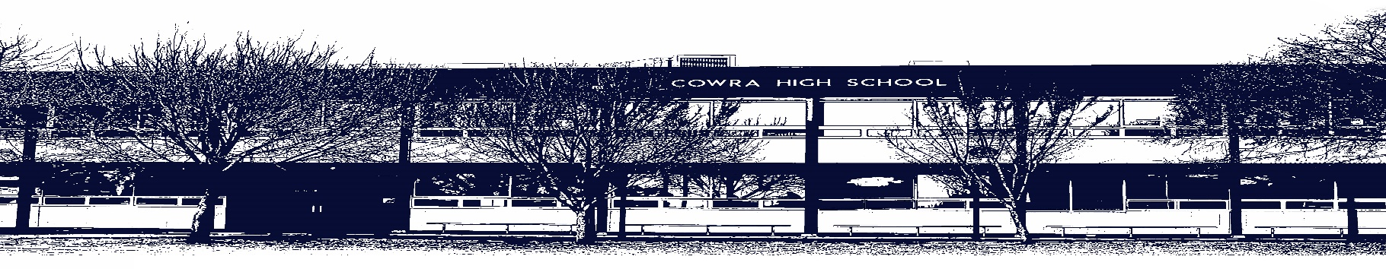

COWRA HIGH SCHOOL

Assessment Task Submission Policy

Submission of assessment tasks by students must follow faculty guidelines. There are basically four types of assessment tasks:

- In Class Assessment Tasks ~ these tasks are supervised by the class teacher and collected by the class teacher at the conclusion of the assessment task. It is the responsible of the student who miss in class assessment tasks to contact the Head Teacher of that faculty.

- Formal Examinations ~ at the conclusion of any formal examination the assessment task papers are to be collected and returned to the relevant faculty teacher.

- Major Projects / Pieces of Work ~ these items, due to their size, are usually kept in the appropriate faculty location. Major works and projects should be kept in safe locations that minimises the risk of damage. Any assessment task would be submitted directly to the teacher. A receipt for the task will be issued to students.

- Take Home Assessment Tasks ~ these are tasks that students are required to complete by a due date. Students should follow faculty submission guidelines regarding submission of these tasks.

Guidelines for the Submission of Assessment Tasks

- When an assessment task is issued, the information provided to students will include:
- a clear statement of what the task involves and what the expectations of the student are
- an explanation of the marking criteria / outcomes to be assessed
- the due date of submission
- an assessment task submission cover sheet ~ see attached

- Teachers should record the names of all students issued with the assessment task on a roll/class list and have the student acknowledge receipt of the assessment task by getting them to sign next to their name.

- Students must take their assessment task to the class teacher. They must be signed in on the class roll and keep their receipt

- All students must keep a copy of their assessment task.

Illness and Misadventure Appeals

If a student fails to submit an assessment task by the due date and has a legitimate reason than normal illness and misadventure procedures will apply.

REQUEST FOR ASSESSMENT EXTENSION PROCEDURE

Assessment extensions will only be granted in exceptional circumstances. All requests need to be made in writing using the extension request form. In seeking an extension discuss your request with your teacher/Head Teacher at least three (3) days before the due date with work already completed.

Forms for Illness/Misadventure and Extension can be accessed on the
Cowra High School Website.

