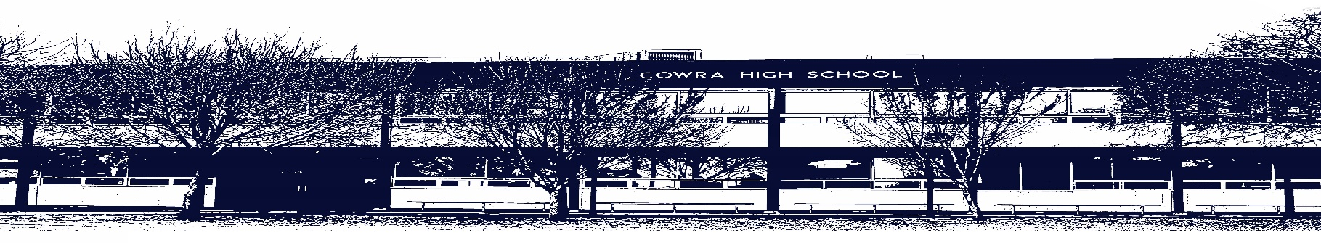

COWRA HIGH SCHOOL

ASSESSMENT TASK COVER SHEET

This sheet must be attached to the front of your Assessment Task and submitted to your class teacher on or before the due date.

Student’s Name: _________________________________________
Course: English Studies - Preliminary
Assessment Task: Portfolio
Date Due: Term 3, Monday Week 8
Date Received: _______________
Extension granted _____ days
Other circumstances ~ documents attached

I certify:
- This assignment is entirely my own work and all borrowed material has been acknowledged
- The material contained in this assignment has not previously been submitted for assessment in any formal course of study
- I retain in my possession a copy of this assignment
- I understand that late assignments will be penalised unless an extension has been granted by Deputy Principal - Curriculum

Student’s Signature: ____________________________

-------------------------------------------------------------------------------------------------------------------------------
COWRA HIGH SCHOOL
Assessment Task (Student’s Copy)
Student’s Name: _________________________________________
Course: English Studies - Preliminary
Teacher: Sullivan

Assessment Task received by: _________________________________________
Signature: _________________________________________
Date: ______________________ Time: ______________________

Please detach this if the Assessment Task has been handed in
to the office and give to student to keep for their own records.
COWRA HIGH SCHOOL
Year 11 Assessment Task
NAME: |  |  | CLASS: |  |  | TEACHER: Sullivan
COURSE: English Studies |  | TASK No: 3 |  |  | Unit: Portfolio from all modules
DATE DUE: Monday Week 8, Term 3 |  |  |  |  |  | TIME DUE: Period 4
MARK: 20 | WEIGHT: 40% |  |  | PRESENTATION: Portfolio of classwork
SYLLABUS OUTCOMES: A Student:

ES11-3 gains skills in accessing, comprehending and using information to communicate in a variety of ways
ES11-4 composes a range of texts with increasing accuracy and clarity in different forms
ES11-6 uses appropriate strategies to compose texts for different modes, media, audiences, contexts and purposes
ES11-7 represents own ideas in critical, interpretive and imaginative texts
ES11-8 identifies and describes relationships between texts

DESCRIPTION OF TASK:

Preliminary English Studies requires Year 11 students to complete and present a portfolio which demonstrates their ongoing work throughout the year. Class time will have been allocated for each individual task, but it is your responsibility to finalise each piece through a draft, editing and publishing process.

Each of the following pieces of work must be presented in a display folder. Remember this is a culmination of work and is a requirement of NESA. Each piece must be presented in order for you to successfully meet the requirements of preliminary English.

Your portfolio will have in it;

- Poster on workplace safety (Term 1)
- Resume (Term 1)
- Narrative (Term 1)
- Sports Campaign (Term 2)
- Reflection and Annotation (Term 2)
- Essay on key text (Term 2)
- Visual Representation on what it means to be Australian (Term 3)
- Poetry Analysis (Term 3)
- Interview Questions and Answers (Term 3)

You will be assessed on your ability to:

- compose a range of texts for various audiences, purposes and contexts
- express ideas with clarity and accuracy
- use a variety of language forms and features to organise and present your work.

MARKING CRITERIA:

A student: | Mark range
- demonstrates a well-developed ability to apply the conventions of a variety of types of texts to compose responses  - displays effective control of language in a variety of sustained texts  - demonstrates well-developed skills in using a variety of language and structural features to present information. | 17–20
- demonstrates a sound ability to apply the conventions of a variety of types of texts to compose responses  - displays sound control of language in a variety of sustained texts  - demonstrates competent skills in using language and structural features to present information. | 13–16
- demonstrates a developing ability to apply the conventions of a variety of types of texts to compose responses  - displays some control of language in a variety of sustained texts  - demonstrates developing skills in using language and structural features to present information. | 9–12
- demonstrates a basic ability to apply the conventions of some types of texts to compose responses  - displays variable control of language in a variety of texts  - demonstrates basic skills in using some language and structural features to present information. | 5–8
- demonstrates a limited ability to apply the conventions of some types of texts to compose some responses  - displays minimal control of language in a limited variety of texts  - demonstrates elementary skills in using a limited range of language and structural features to present information. | 1–4

Areas of strength

Areas that require further development

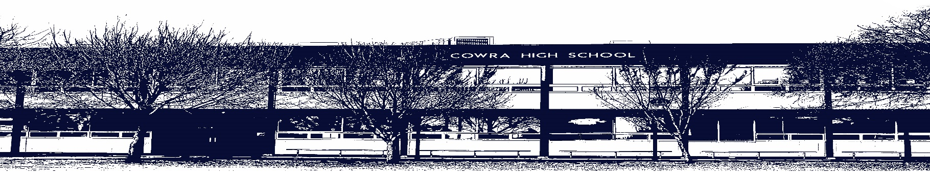
COWRA HIGH SCHOOL

Assessment Task Submission Policy

Submission of assessment tasks by students must follow faculty guidelines. There are basically four types of assessment tasks:

- In Class Assessment Tasks ~ these tasks are supervised by the class teacher and collected by the class teacher at the conclusion of the assessment task. It is the responsible of the student who miss in class assessment tasks to contact the Head Teacher of that faculty.

- Formal Examinations ~ at the conclusion of any formal examination the assessment task papers are to be collected and returned to the relevant faculty teacher.

- Major Projects / Pieces of Work ~ these items, due to their size, are usually kept in the appropriate faculty location. Major works and projects should be kept in safe locations that minimises the risk of damage. Any assessment task would be submitted directly to the teacher. A receipt for the task will be issued to students.

- Take Home Assessment Tasks ~ these are tasks that students are required to complete by a due date. Students should follow faculty submission guidelines regarding submission of these tasks.

Guidelines for the Submission of Assessment Tasks

- When an assessment task is issued, the information provided to students will include:
- a clear statement of what the task involves and what the expectations of the student are
- an explanation of the marking criteria / outcomes to be assessed
- the due date of submission
- an assessment task submission cover sheet ~ see attached

- Teachers should record the names of all students issued with the assessment task on a roll/class list and have the student acknowledge receipt of the assessment task by getting them to sign next to their name.

- Students must take their assessment task to the class teacher. They must be signed in on the class roll and keep their receipt

- All students must keep a copy of their assessment task.

Illness and Misadventure Appeals

If a student fails to submit an assessment task by the due date and has a legitimate reason than normal illness and misadventure procedures will apply.

REQUEST FOR ASSESSMENT EXTENSION PROCEDURE

Assessment extensions will only be granted in exceptional circumstances. All requests need to be made in writing using the extension request form. In seeking an extension discuss your request with your teacher/Head Teacher at least three (3) days before the due date with work already completed.

Forms for Illness/Misadventure and Extension can be accessed on the
Cowra High School Website.

