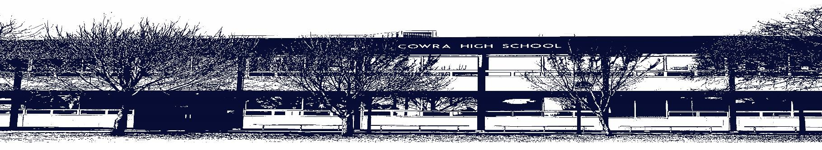
Wee

COWRA HIGH SCHOOL

ASSESSMENT TASK COVER SHEET

This sheet must be attached to the front of your Assessment Task and submitted to your class teacher on or before the due date.

Student’s Name: _________________________________________
Course: _________________________________________
Assessment Task: Industry study _________________________________________
Date Due: Week 2 Term 3_______________
Date Received: _______________
□ Extension granted _____ days
□ Other circumstances ~ documents attached

I certify:
- This assignment is entirely my own work and all borrowed material has been acknowledged
- The material contained in this assignment has not previously been submitted for assessment in any formal course of study
- I retain in my possession a copy of this assignment
- I understand that late assignments will be penalised unless an extension has been granted by Deputy Principal - Curriculum

Student’s Signature: ____________________________

✂-------------------------------------------------------------------------------------------------------------------------------
COWRA HIGH SCHOOL
Assessment Task (Student’s Copy)
Student’s Name: _________________________________________
Course: _________________________________________
Teacher: _________________________________________

Assessment Task received by: _________________________________________
Signature: _________________________________________
Date: ______________________ Time: ______________________

Please detach this if the Assessment Task has been handed in
to the office and give to student to keep for their own records.

COWRA HIGH SCHOOL
Year 11 Industrial Technology (Prelim) Assessment Task
NAME: Industry Study |  | CLASS: IT Timber |  |  |  | TEACHER: Mr Mugridge
COURSE: Industrial Technology Timber |  |  | TASK No: 2 |  | Unit: Prelim Major Project and Folio
DATE DUE: Week 2 Term 3- 19/7/21 |  |  |  |  |  | TIME DUE: 3:15PM
MARK: | WEIGHT: 60% |  |  | PRESENTATION: Practical Task and Folio
SYLLABUS OUTCOMES: A Student:

P1.2 identifies appropriate equipment, production and manufacturing techniques, including new and developing technologies

P3.3 demonstrates appropriate design principles in the production of projects

P4.2 demonstrates competency in using relevant equipment, machinery and processes

P5.1 uses communication and information processing skills

P5.2 uses appropriate documentation techniques related to the management of projects

DESCRIPTION OF TASK:

In preparation for the Major Design Project, students have been researching and investigating appropriate solutions in relation to their projects. Areas of investigation have included material and joint selection, industry processes and safe work practices. This information will form a part of the students Major Design Folio which will be submitted for marking on completion of their projects.
Year 11 Industrial Technology – Timber
Major Project and Design Folio Requirements
This assessment task is made up of two sections, related to the project you have selected for your Major Design Project. Your design folio is a major part of your work, and will accompany your final project, counting towards your final marks.
What to Include
- Title page Student name, project name and due date
- Statement of intent – Why are you building this project? I.e. I intent to construct a glass trophy case to display a number of trophy’s I have accumulated over the years. The intention is to display a range of practical and orginisational skills to demonstrate my level of craftsmanship
- Constraints-What are the restrictions? I.e. time / financial
- Research –
- Include ideas generation from various sources i.e.
- Internet research, pictures of other designs, and how they have influenced your design.
- Selection of timbers/ materials
- Tools and uses/ industry methods
- Joints/ Joining techniques required to complete the task.
- Components i.e. hinge’s, handles.
- Finishes types of finish, appropriate method.
- Drawings/sketches – Include at least 3 sketches/drawings on A4 paper of designs you like. You may wish to combine features of a number of designs you find to create your own.
- Steps of Production – Include a numerical record of all steps involved in the production process, including the tools/equipment you used and any other necessary information including an ongoing evaluation.
- Cutting list – Include a cutting list for all materials you required for your project
- Finance plan- Costing list for all materials you required for your project
- Timeline plan/ Gant chart- A predetermined timeline guide to ensure your project does not fall behind.
- Orthographic/ Pictorial drawing – Include your finished orthographic and pictorial drawing of your project (include adjustments/alterations made)
- Construction Describe the characteristics of appropriate materials and joints which will be used in the production of your Major Design Project, and justify its selection. Using their researched knowledge and planning students are to construct their Major project.
- Evaluation – Upon completion write a 200 word reflection/ Evaluation drawing from your ongoing evaluation.

MARKING GUIDELINES:

Practical Project
Production | 40-33 | 32-25 | 24-17 | 16-9 | 8-1
Quality of the product | Student presents a practical project that demonstrates excellent craftsmanship, accurate measuring, free of gaps between joins and no evidence of marking eg. Pencil or adhesives, free from scratching. Project is square, straight and true and is appropriately finished. | Student presents a practical project that demonstrates a high level of craftsmanship, accurate measuring, with minimal gaps between joins and little evidence of marking eg. Pencil or adhesives, free from scratching. Project is square with appropriate finish. | Student presents a practical project that demonstrates sound craftsmanship, some small gaps between joins and relatively mark free. Project is appropriately finished and evidence of attempting to create a square project. | Student presents a practical project that demonstrates developing craftsmanship, inconsistency in measurement creating gaps between joins and clear evidence of marking. Project is appropriately finished. | Student presents an attempt of the task, inaccurate in measurement, is marked with pencil, adhesive or scratched and has gaps in joinery. May or may not be joined but demonstrates some joinery.
Evidence of a range of skills | Student demonstrates excellent knowledge, understanding and an extensive range of skills when using a multitude of software application and production techniques. These skills are consolidated and appropriately documented using a range of methods in the accompanying portfolio. | Student demonstrates high-level knowledge, understanding and skills when using many software applications and production techniques. These skills are reflected and appropriately documented using the accompanying portfolio. | Student demonstrates a sound understanding and range of skills when using many software applications and production techniques. These skills are reflected and somewhat documented using the accompanying portfolio. | Student demonstrates a basic understanding and range of skills when using software applications and production techniques. | Student demonstrates little understanding when using software applications and production techniques.
Use of appropriate materials, components, processes and technologies | Student demonstrates thorough understanding of the impact that material selection has on the production of the practical work, does so to engage in more challenging production processes and employs the use of new and emerging technologies in the production of practical projects. | Student uses an understanding of the impact that material selection has on the production of the practical work, uses this understanding in the selection of production processes and employs technologies in the production of practical projects. | Student demonstrates sound understanding materials and components and this reflects the selection of processes and use of technology in the production of the projects. | Student demonstrates some understanding of materials, components and processes and utilises little use of technology in the production of the projects. | Students practical work reflects little understanding of the interrelationship between materials, components, processes and the impact of new and emerging technologies.
Links between planning and production | Practical work has extensive evidence of the link between design and production and student thoroughly analyses, synthesizes, justifies and evaluates the stages of production reflecting construction and documentation through the accompanying portfolio. | Students practical work has a high correlation between planning evidenced within the folio and the production of the project. Student synthesizes and justifies methods in construction and has an evaluation of work. | Student demonstrates a sound understanding of the synthesis of practical work with the planning demonstrated through the accompanying portfolio. Selection and justification of choices and an evaluation provided. | Student has a basic understanding of the need to produce and follow planning documentation and has followed this to produce their project. | Little evidence of student linking planning to production and is reflected in the lack of supporting documentation.
Evidence of practical problem solving | Student has identified and carefully considered problems encountered during the production phase and has researched/investigated several solutions before applying the appropriate method. Evidence clearly documented in the accompanying folio. | Students has applied an appropriate solution to a problem and has justified this in the accompanying folio. | Students has successfully applied problem solving skills which were identified in the production and has been documented in the accompanying folio. | Limited evidence of problems throughout the production of the project and only basic problem solving. | Solutions to problems are inappropriate for the task presented. No evidence of justification of solutions.

Project Folio
Design, Management and Communication | 20 - 18 | 18- 15 | 15 - 10 | 10 - 7 | 7 - 0
Statement of Intent | Clarifies the intent of the project and clearly outline the explanation of what the desired outcome should be and why | Clarifies the intent of the project with an explanation of what the desired outcome should be and why | Student provides a description of what the project is and why | Student provided an outline of what they intend making | Identification of the project
Selection and Justification | Comprehensive and extensive justification of tools, materials and processes. | Thorough justification of tools, materials and processes. | Lists most tools and materials and justifies their use. | Lists some tools and materials with a basic justification of their use. | Limited or no selection and justification
Timelines and Finance Plans | Develops, applies and evaluates comprehensive and appropriate timeline and finance plans | Develops and applies appropriate timeline and finance plans | Proposes timeline and finance plans | Timeline and finance plans are without sufficient detail | Timelines and finance plans are either not appropriate or not evident
Construction Sequence (Procedure) | Comprehensive and cohesive production steps supported with images and annotations | Thorough list of production steps supported with images. | Lists most production steps and includes some images. | Lists some production steps with limited images. | Limited record of production
Presentation Skills/ICT Skills | Demonstrates a wide range of presentation skills and techniques, including ICT skills, appropriate to the development of the major project | Demonstrates a range of presentation skills and techniques, including ICT skills, most of which are appropriate to the development of the major project | Demonstrates some presentation skills and techniques, including ICT skills, most of which are appropriate to the development of the major project | Demonstrates limited presentation skills and techniques appropriate to the development of the major project | Little evidence of presentation skills and techniques appropriate to the development of the major project

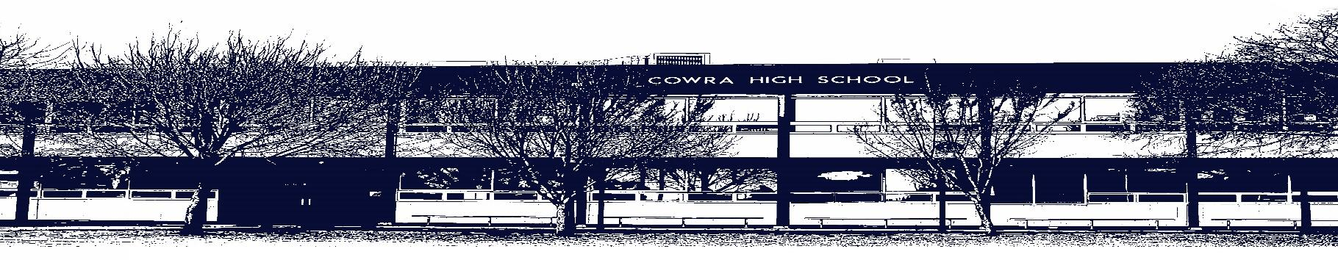

COWRA HIGH SCHOOL

Assessment Task Submission Policy

Submission of assessment tasks by students must follow faculty guidelines. There are basically four types of assessment tasks:

- In Class Assessment Tasks ~ these tasks are supervised by the class teacher and collected by the class teacher at the conclusion of the assessment task. It is the responsible of the student who miss in class assessment tasks to contact the Head Teacher of that faculty.

- Formal Examinations ~ at the conclusion of any formal examination the assessment task papers are to be collected and returned to the relevant faculty teacher.

- Major Projects / Pieces of Work ~ these items, due to their size, are usually kept in the appropriate faculty location. Major works and projects should be kept in safe locations that minimises the risk of damage. Any assessment task would be submitted directly to the teacher. A receipt for the task will be issued to students.

- Take Home Assessment Tasks ~ these are tasks that students are required to complete by a due date. Students should follow faculty submission guidelines regarding submission of these tasks.

Guidelines for the Submission of Assessment Tasks

- When an assessment task is issued, the information provided to students will include:
- a clear statement of what the task involves and what the expectations of the student are
- an explanation of the marking criteria / outcomes to be assessed
- the due date of submission
- an assessment task submission cover sheet ~ see attached

- Teachers should record the names of all students issued with the assessment task on a roll/class list and have the student acknowledge receipt of the assessment task by getting them to sign next to their name.

- Students must take their assessment task to the class teacher. They must be signed in on the class roll and keep their receipt

- All students must keep a copy of their assessment task.

Illness and Misadventure Appeals

If a student fails to submit an assessment task by the due date and has a legitimate reason than normal illness and misadventure procedures will apply.

REQUEST FOR ASSESSMENT EXTENSION PROCEDURE

Assessment extensions will only be granted in exceptional circumstances. All requests need to be made in writing using the extension request form. In seeking an extension discuss your request with your teacher/Head Teacher at least three (3) days before the due date with work already completed.

Forms for Illness/Misadventure and Extension can be accessed on the
Cowra High School Website.

