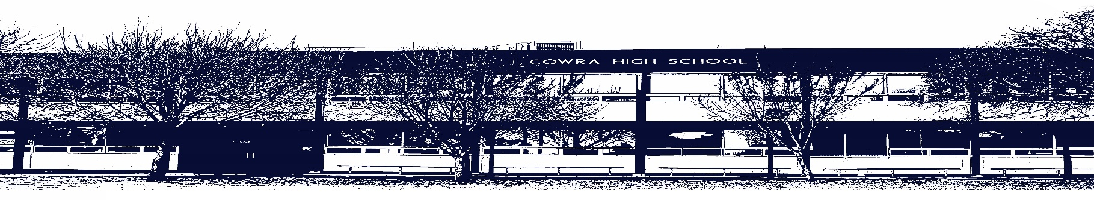

COWRA HIGH SCHOOL

ASSESSMENT TASK COVER SHEET

This sheet must be attached to the front of your Assessment Task and submitted to your class teacher on or before the due date.

Student’s Name: _________________________________________
Course: 11 Modern History
Assessment Task: 1: The Decline and Fall of the Romanov Dynasty
Date Due: Thursday 11th March 2021
Date Received: _______________
Extension granted _____ days
Other circumstances ~ documents attached

I certify:
- This assignment is entirely my own work and all borrowed material has been acknowledged
- The material contained in this assignment has not previously been submitted for assessment in any formal course of study
- I retain in my possession a copy of this assignment
- I understand that late assignments will be penalised unless an extension has been granted by Deputy Principal - Curriculum

Student’s Signature: ____________________________

-------------------------------------------------------------------------------------------------------------------------------
COWRA HIGH SCHOOL
Assessment Task (Student’s Copy)
Student’s Name: _________________________________________
Course: 11 Modern History
Teacher:

Assessment Task received by: _________________________________________
Signature: _________________________________________
Date: ______________________ Time: ______________________

Please detach this if the Assessment Task has been handed in
to the office and give to student to keep for their own records.
COWRA HIGH SCHOOL
Year 11 Assessment Task
NAME: |  |  | CLASS: 11MH |  |  | TEACHER:
COURSE: Preliminary Modern History |  | TASK No: 1 |  |  | Unit: The Decline and Fall of the Romanov Dynasty
DATE DUE: Thursday 11th March 2021 |  |  |  |  |  | TIME DUE: End of period 3.
MARK: /30 | WEIGHT: 30% |  |  | PRESENTATION: In class assessment task
SYLLABUS OUTCOMES: A Student:
MH11-1 describes the nature of continuity and change in the modern world
MH11-2 proposes ideas about the varying causes and effects of events and developments
MH11-3 analyses the role of historical features, individuals, groups and ideas in shaping the past
MH11-4 accounts for the different perspectives of individuals and groups
MH11-9 communicates historical understanding, using historical knowledge, concepts and terms, in appropriate and well-structured forms.

DESCRIPTION OF TASK:

You are required to compose an extended written response during one lesson.

Your extended response will address the following question:

Was the fall of the Romanov Dynasty inevitable? Discuss the factors that led to the downfall of Nicholas II and the Romanov Dynasty.

There are two parts to this assessment:

- Design a concept map of no more than two pages that summarises the key causes of the downfall of the Romanov Dynasty. Your concept map should include:

- details of key events, individuals, groups and ideas
- the cause and effect of events and developments during the Romanov Dynasty
- details of sources you can use as evidence to support your ideas.

- Write an extended response that answers the question above. This extended response must include:
- An introduction
- At least 4 to 5 paragraphs in the body of your response
- A conclusion

You will be able to refer to your concept map when composing your extended response.

Both your concept map and your extended response will be collected at the end of the in-class assessment.

MARKING CRITERIA:

- Concept Map

Criteria: | Mark:
- All key concepts and ideas related to the downfall of Nicholas II and the Romanov Dynasty are included in the concept map and are factual.  - Clear causes and effects recorded. | 5
- 1 or 2 important concepts and ideas related to the downfall of Nicholas II and the Romanov Dynasty are missing from the concept map, but what is included is factual.  - Clear causes and effects recorded. | 4
- 3 or 4 important concepts and ideas related to the downfall of Nicholas II and the Romanov Dynasty are missing from the concept map. Most concepts and ideas are factual.  - Some causes and effects recorded. | 3
- The concept map includes basic details which are correct and are related to the downfall of Nicholas II and the Romanov Empire.  - Limited causes and effects recorded. | 2
- The concept map includes ideas and concepts that are incorrect.  - No causes and effects recorded. | 1
- No concept map submitted for marking. | 0
- Extended Response

Criteria: | Mark:
- Answers the question providing a clear explanation of the factors that led to the downfall of Nicholas II and the Romanov Dynasty.  - The extended response demonstrates a comprehensive understanding of the issues raised in the question.  - The response includes extensive and accurate historical knowledge and understanding and includes relevant evidence and interpretation.  - Presents a well-structured, logical and cohesive response using appropriate historical terms and concepts. | 21-25
- Answers the question providing a clear explanation of the factors that led to the downfall of Nicholas II and the Romanov Dynasty.  - The extended response demonstrates a sound understanding of the issues raised in the question.  - The response includes detailed and accurate historical knowledge and understanding and includes relevant evidence and interpretation.  - Presents a well-structured response using appropriate historical terms and concepts. | 16-20
- Answers the question with a relevant but descriptive explanation of the factors that led to the downfall of Nicholas II and the Romanov Dynasty.  - The extended response demonstrates an implied understanding of the issues raised in the question.  - The response includes relevant and accurate historical understanding but with little evidence or interpretation.  - Presents a structured response using some historical terms and concepts. | 11-15
- Attempts to answer the question but presents a generalised, mostly relevant descriptive response of the factors that led to the downfall of Nicholas II and the Romanov Dynasty.  - The response provides some historical knowledge and understanding.  - The response includes some appropriate historical terms and/or concepts.  - Response is not structured accurately. | 6-10
- Makes general statements in response to the question and includes limited factors that led to the downfall of Nicholas II and the Romanov Dynasty.  - The response uses some historical terms and concepts.  - The response is not structured accurately. | 1-5
- No attempt made to answer the question. | 0

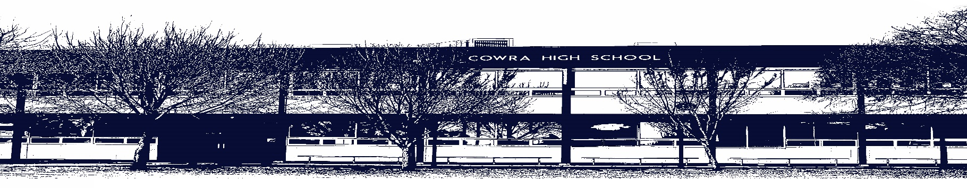

COWRA HIGH SCHOOL

Assessment Task Submission Policy

Submission of assessment tasks by students must follow faculty guidelines. There are basically four types of assessment tasks:

- In Class Assessment Tasks ~ these tasks are supervised by the class teacher and collected by the class teacher at the conclusion of the assessment task. It is the responsible of the student who miss in class assessment tasks to contact the Head Teacher of that faculty.

- Formal Examinations ~ at the conclusion of any formal examination the assessment task papers are to be collected and returned to the relevant faculty teacher.

- Major Projects / Pieces of Work ~ these items, due to their size, are usually kept in the appropriate faculty location. Major works and projects should be kept in safe locations that minimises the risk of damage. Any assessment task would be submitted directly to the teacher. A receipt for the task will be issued to students.

- Take Home Assessment Tasks ~ these are tasks that students are required to complete by a due date. Students should follow faculty submission guidelines regarding submission of these tasks.

Guidelines for the Submission of Assessment Tasks

- When an assessment task is issued, the information provided to students will include:
- a clear statement of what the task involves and what the expectations of the student are
- an explanation of the marking criteria / outcomes to be assessed
- the due date of submission
- an assessment task submission cover sheet ~ see attached

- Teachers should record the names of all students issued with the assessment task on a roll/class list and have the student acknowledge receipt of the assessment task by getting them to sign next to their name.

- Students must take their assessment task to the class teacher. They must be signed in on the class roll and keep their receipt

- All students must keep a copy of their assessment task.

Illness and Misadventure Appeals

If a student fails to submit an assessment task by the due date and has a legitimate reason than normal illness and misadventure procedures will apply.

REQUEST FOR ASSESSMENT EXTENSION PROCEDURE

Assessment extensions will only be granted in exceptional circumstances. All requests need to be made in writing using the extension request form. In seeking an extension discuss your request with your teacher/Head Teacher at least three (3) days before the due date with work already completed.

Forms for Illness/Misadventure and Extension can be accessed on the
Cowra High School Website.

