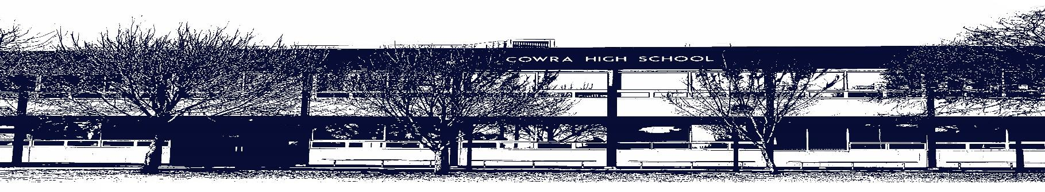

COWRA HIGH SCHOOL

ASSESSMENT TASK COVER SHEET

This sheet must be attached to the front of your Assessment Task and submitted to your class teacher on or before the due date.

Student’s Name: _________________________________________
Course: Year 11 Music 1
Assessment Task: Popular Music
Date Due: 23/03/2021
Date Received: _______________
□ Extension granted _____ days
□ Other circumstances ~ documents attached

I certify:
- This assignment is entirely my own work and all borrowed material has been acknowledged
- The material contained in this assignment has not previously been submitted for assessment in any formal course of study
- I retain in my possession a copy of this assignment
- I understand that late assignments will be penalised unless an extension has been granted by Deputy Principal - Curriculum

Student’s Signature: ____________________________

✂-------------------------------------------------------------------------------------------------------------------------------
COWRA HIGH SCHOOL
Assessment Task (Student’s Copy)
Student’s Name: _________________________________________
Course: Year 11 Music 1
Teacher: K. Smith

Assessment Task received by: _________________________________________
Signature: _________________________________________
Date: ______________________ Time: ______________________

Please detach this if the Assessment Task has been handed in
to the office and give to student to keep for their own records.

COWRA HIGH SCHOOL
Year 11 Assessment Task
NAME: |  | TEACHER: K Smith
COURSE: Music 1 Preliminary |  | TASK No: 1 | Unit: Popular Music
DATE DUE: 23/3/2020 |  | DATE RECEIVED:
MARK: 25 | WEIGHT: 25%  Performance: 10%  Musicology: 15% | PRESENTATION: Performance and Musicology (Viva Voce)
SYLLABUS OUTCOMES:
P1 - performs music that is characteristic of the topics studied.
P4 - recognises and identifies the concepts of music and discusses their use in a variety of musical styles.
P6 - observes and discusses concepts of music in works representative of the topics studied.
P9 - performs as a means of self-expression and communication.
Task: Performance and Musicology (Viva Voce)
Performance:
Complete a Performance (instrument and/or voice) reflecting the topic “Popular Music”. Performances should be no longer than 5 minutes. You may perform by yourself, with accompaniment, or as part of an ensemble; however, you will be marked on only your part in the performance only.
Viva Voce:
Complete a Viva Voce on the topic “How do composers of Popular music use the concepts of music?” Choose a piece of popular music to analyse, and present this analysis in an 8-minute Viva Voce. Musical examples should be used to support observations.
Choosing pieces:
Ideally, your preparation for the two components of this task will complement each other. This means your research and analysis for the viva voce should help inform your performance interpretation and learning to perform a piece in the style should give you an insight into the style which you can discuss in your viva voce.

For this reason, you are encouraged to choose the same piece for both the performance and Viva voce.

Marking Criteria: Performance | Marks
- Demonstrates highly-developed technical skills incorporating technical fluency, technical facility, intonation and articulation appropriate to the chosen repertoire.  - Demonstrates perceptive stylistic understanding through performing repertoire using articulation, dynamics and expressive techniques.  - Performs with a well-developed sense of personal expression, demonstrated by the use of appropriate expressive techniques and a sensitivity to the chosen style  - Demonstrates a highly-developed understanding of solo/ensemble techniques including understanding of the role of soloist/ensemble member, communication with accompanist/ensemble and issues of balance | 9 – 10
- Demonstrates competent technical skills incorporating technical fluency, technical facility, intonation and articulation appropriate to the chosen repertoire  - Demonstrates stylistic understanding through performance of the chosen repertoire using articulation, dynamics and expressive techniques  - Performs with a sense of personal expression, demonstrated by the use of expressive techniques and sensitivity to the chosen style  - Demonstrates a competent understanding of solo/ensemble techniques including understanding of the role of soloist/ensemble member, communication with accompanist/ensemble and issues of balance | 7 – 8
- Demonstrates sound technical skills. Some problems in maintaining technical fluency and technical facility are evident as are inconsistencies in intonation  - Demonstrates a sense of stylistic understanding through performance of the chosen repertoire. The articulation and/or dynamics and/or expressive techniques may not be consistently appropriate to the chosen style  - Performs the chosen repertoire with a sense of musical expression, with an attempt to incorporate expressive techniques appropriate to the chosen style  - Demonstrates a sound, although not consistent understanding of solo/ensemble techniques including understanding of the role of soloist/ensemble member, communication with accompanist/ensemble and issues of balance | 5 – 6
- Demonstrates some basic technical skill, although there are frequent inconsistencies in technical fluency, technical facility, and intonation  - Demonstrates a basic stylistic understanding. Articulation and/or dynamics and/or expressive techniques are not consistently appropriate to the chosen style  - Performs the chosen repertoire with little sense of musical expression  - Demonstrates a limited awareness of the performer’s role as a soloist/ensemble member, which may be evident through lack of communication and balance in the ensemble or with the accompanist | 3 – 4
- Demonstrates very limited technical skills  - Demonstrates little evidence of stylistic understanding of the chosen style  - Performs the chosen repertoire with little or no sense of musical expression  - Demonstrates little or no awareness of the performer’s role as a soloist/ensemble member | 1 – 2
- Non-attempt | 0

Marking Criteria: Musicology | Marks
- Discussion has a clear and consistent musicological focus  - Demonstrates a perceptive understanding of the chosen topic  - Demonstrates high level aural awareness and understanding of musical concepts and their relationship to the chosen topic  - Supports the discussion with relevant musical examples | 13 - 15
- Discussion has a musicological focus  - Demonstrates a detailed understanding of the chosen topic  - Demonstrates thorough aural awareness and understanding of musical concepts and their relationship to the chosen topic  - Supports the discussion with relevant musical examples | 10 - 12
- Discussion has a musicological focus but may be inconsistent  - Demonstrates a generally sound understanding of the chosen topic although there may be some inaccuracies  - Demonstrates some aural awareness and ability to discuss the use of musical concepts in the chosen topic  - Presents relevant musical examples | 7 – 9
- Makes an attempt to provide a musicological focus in the discussion  - Demonstrates basic understanding of the chosen topic  - Demonstrates basic aural awareness and skill in discussing the musical concepts  - Presents some musical examples | 4 – 6
- Discussion lacks a musicological focus  - Demonstrates limited understanding of the chosen topic  - Demonstrates limited aural awareness and skill in discussing the musical concepts in the repertoire studied  - Uses irrelevant or inappropriate musical examples | 1 – 3
- Non-attempt | 0

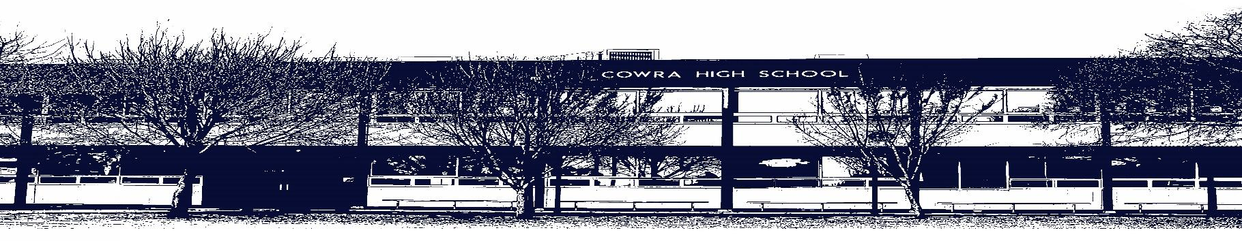

COWRA HIGH SCHOOL

Assessment Task Submission Policy

Submission of assessment tasks by students must follow faculty guidelines. There are basically four types of assessment tasks:

- In Class Assessment Tasks ~ these tasks are supervised by the class teacher and collected by the class teacher at the conclusion of the assessment task. It is the responsible of the student who miss in class assessment tasks to contact the Head Teacher of that faculty.

- Formal Examinations ~ at the conclusion of any formal examination the assessment task papers are to be collected and returned to the relevant faculty teacher.

- Major Projects / Pieces of Work ~ these items, due to their size, are usually kept in the appropriate faculty location. Major works and projects should be kept in safe locations that minimises the risk of damage. Any assessment task would be submitted directly to the teacher. A receipt for the task will be issued to students.

- Take Home Assessment Tasks ~ these are tasks that students are required to complete by a due date. Students should follow faculty submission guidelines regarding submission of these tasks.

Guidelines for the Submission of Assessment Tasks

- When an assessment task is issued, the information provided to students will include:
- a clear statement of what the task involves and what the expectations of the student are
- an explanation of the marking criteria / outcomes to be assessed
- the due date of submission
- an assessment task submission cover sheet ~ see attached

- Teachers should record the names of all students issued with the assessment task on a roll/class list and have the student acknowledge receipt of the assessment task by getting them to sign next to their name.

- Students must take their assessment task to the class teacher. They must be signed in on the class roll and keep their receipt

- All students must keep a copy of their assessment task.

Illness and Misadventure Appeals

If a student fails to submit an assessment task by the due date and has a legitimate reason than normal illness and misadventure procedures will apply.

REQUEST FOR ASSESSMENT EXTENSION PROCEDURE

Assessment extensions will only be granted in exceptional circumstances. All requests need to be made in writing using the extension request form. In seeking an extension discuss your request with your teacher/Head Teacher at least three (3) days before the due date with work already completed.

Forms for Illness/Misadventure and Extension can be accessed on the
Cowra High School Website.

