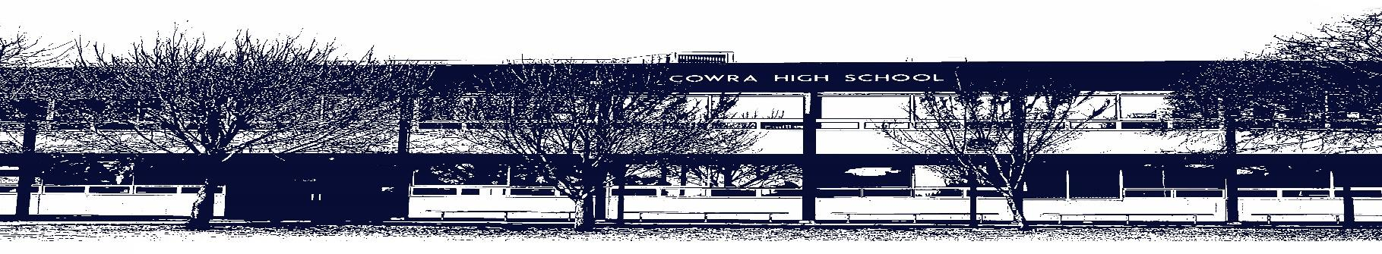

COWRA HIGH SCHOOL

ASSESSMENT TASK COVER SHEET

This sheet must be attached to the front of your Assessment Task and submitted to your class teacher on or before the due date.

Student’s Name: _________________________________________
Course: Stage 6 – Year 11 English Advanced
Assessment Task: Multimodal Task
Date Due: Monday Week 10, 21st June 2021
Date Received: _______________
□ Extension granted _____ days
□ Other circumstances ~ documents attached

I certify:
- This assignment is entirely my own work and all borrowed material has been acknowledged
- The material contained in this assignment has not previously been submitted for assessment in any formal course of study
- I retain in my possession a copy of this assignment
- I understand that late assignments will be penalised unless an extension has been granted by Deputy Principal - Curriculum

Student’s Signature: ____________________________

✂-------------------------------------------------------------------------------------------------------------------------------
COWRA HIGH SCHOOL
Assessment Task (Student’s Copy)
Student’s Name: _________________________________________
Course: Stage 6 – Year 11 English Advanced
Teacher: Perkins

Assessment Task received by: _________________________________________
Signature: _________________________________________
Date: ______________________ Time: ______________________

Please detach this if the Assessment Task has been handed in
to the office and give to student to keep for their own records.

COWRA HIGH SCHOOL
Stage 6 – Year 11 Assessment Task
NAME: |  |  | CLASS: 11 Advanced |  |  | TEACHER: Perkins
COURSE: English Advanced |  | TASK No: 2 |  |  | Unit: Module A – Narratives that Shape  our World
DATE DUE: Monday 21st June 2021 Week 10 |  |  |  |  |  | TIME DUE: 3:15pm
MARK: /20 | WEIGHT: 40% |  |  | PRESENTATION: Multimodal Presentation –  Google Site
SYLLABUS OUTCOMES:

EA11-1 responds to, composes and evaluates complex texts for understanding, interpretation, critical analysis, imaginative expression and pleasure
EA11-2 uses and evaluates processes, skills and knowledge required to effectively respond to and compose texts in different modes, media and technologies
EA11-3 analyses and uses language forms, features and structures of texts considering appropriateness for specific purposes, audiences and contexts and evaluates their effects on meaning
EA11-5 thinks imaginatively, creatively, interpretively and critically to respond to, evaluate and compose texts that synthesise complex information, ideas and arguments
EA11-7 evaluates the diverse ways texts can represent personal and public worlds and recognises how they are
valued

DESCRIPTION OF TASK:

This term you have been evaluating how narratives shape texts and influence response. Through studying narratives in a range of diverse textual forms, you have come to appreciate that our understanding of the world is organised by how composers draw on narrative.

Knowing this, you have been asked to create a multimodal website for the incoming Year 11 cohort that provides them with the answers to the following focus questions;

- How is storytelling a universal element of human experience?
- What are the conventions of narrative and how are they crafted to tell stories that have characters with a tendency to self destruction?
- How do the composers of these framed and unreliable narratives use their created worlds to comment upon and reflect their own contexts?
- How do these narratives have the potential to shape our perceptions of our world, and challenge existing structures and practices?
- How and why do stories resonate with their audiences across time?

In the completion of this task, you should focus on the TWO texts you have studied this term – The Great Gatsby and The Wolf Of Wall Street. You should present this information in the form of a google site. Feel free to include images, clips, music and sound to enhance your website and engage your younger audience. Class discussion will ensue regarding suitable ideas and creation of the site.
MARKING CRITERIA

17 – 20 | - Composes a skilful digital resource that integrates elements including images, sound and video clips.  - Demonstrates skilful control of language & structure appropriate to audience, purpose, context and form.  - Skilfully addresses the focus questions, providing supporting material skilfully selected from at least TWO prescribed texts. This could include character analysis, exploration of thematic concerns and analysis of techniques present.
13 - 16 | - Composes an effective digital resource that integrates elements including images, sound and video clips.  - Demonstrates effective control of language & structure appropriate to audience, purpose, context and form.  - Effectively addresses the focus questions, providing supporting material carefully selected from at least TWO prescribed texts. This could include character analysis, exploration of thematic concerns and analysis of techniques present.
9 - 12 | - Composes a sound digital resource that integrates elements including images, sound and video clips.  - Demonstrates sound control of language & structure appropriate to audience, purpose, context and form.  - Addresses the focus questions, providing supporting material selected from at least TWO prescribed texts. This could include character analysis, exploration of thematic concerns and analysis of techniques present.
5 - 8 | - Attempts to compose a digital resource that integrates elements including images, sound and video clips.  - Attempts to control language & structure appropriate to audience, purpose, context and form.  - Attempts to address the focus questions, providing some supporting material.
0 – 4 | - Attempts to compose a response  - Demonstrates elementary control of language  - Presents a limited understanding of the texts set for study

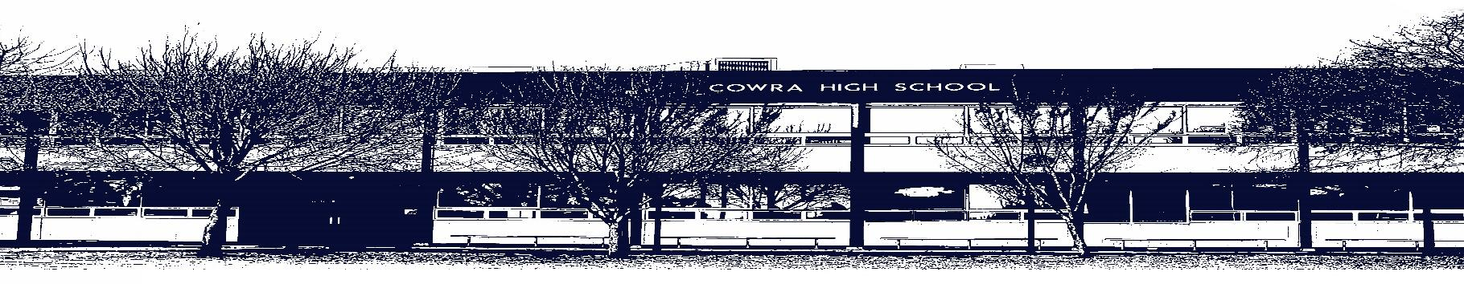

COWRA HIGH SCHOOL

Assessment Task Submission Policy

Submission of assessment tasks by students must follow faculty guidelines. There are basically four types of assessment tasks:

- In Class Assessment Tasks ~ these tasks are supervised by the class teacher and collected by the class teacher at the conclusion of the assessment task. It is the responsible of the student who miss in class assessment tasks to contact the Head Teacher of that faculty.

- Formal Examinations ~ at the conclusion of any formal examination the assessment task papers are to be collected and returned to the relevant faculty teacher.

- Major Projects / Pieces of Work ~ these items, due to their size, are usually kept in the appropriate faculty location. Major works and projects should be kept in safe locations that minimises the risk of damage. Any assessment task would be submitted directly to the teacher. A receipt for the task will be issued to students.

- Take Home Assessment Tasks ~ these are tasks that students are required to complete by a due date. Students should follow faculty submission guidelines regarding submission of these tasks.

Guidelines for the Submission of Assessment Tasks

- When an assessment task is issued, the information provided to students will include:
- a clear statement of what the task involves and what the expectations of the student are
- an explanation of the marking criteria / outcomes to be assessed
- the due date of submission
- an assessment task submission cover sheet ~ see attached

- Teachers should record the names of all students issued with the assessment task on a roll/class list and have the student acknowledge receipt of the assessment task by getting them to sign next to their name.

- Students must take their assessment task to the class teacher. They must be signed in on the class roll and keep their receipt

- All students must keep a copy of their assessment task.

Illness and Misadventure Appeals

If a student fails to submit an assessment task by the due date and has a legitimate reason than normal illness and misadventure procedures will apply.

REQUEST FOR ASSESSMENT EXTENSION PROCEDURE

Assessment extensions will only be granted in exceptional circumstances. All requests need to be made in writing using the extension request form. In seeking an extension discuss your request with your teacher/Head Teacher at least three (3) days before the due date with work already completed.

Forms for Illness/Misadventure and Extension can be accessed on the
Cowra High School Website.

