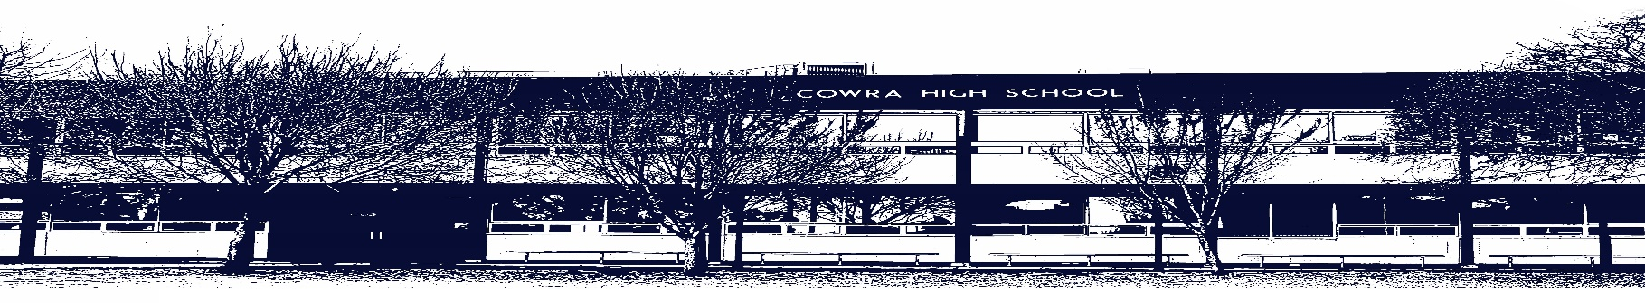

COWRA HIGH SCHOOL

ASSESSMENT TASK COVER SHEET

This sheet must be attached to the front of your Assessment Task and submitted to your class teacher on or before the due date.

Student’s Name: _________________________________________
Course: Stage 6 – Year 11 English Studies
Assessment Task: Multimodal Task
Date Due: Monday Week 10, 21st June 2020
Date Received: _______________
Extension granted _____ days
Other circumstances ~ documents attached

I certify:
- This assignment is entirely my own work and all borrowed material has been acknowledged
- The material contained in this assignment has not previously been submitted for assessment in any formal course of study
- I retain in my possession a copy of this assignment
- I understand that late assignments will be penalised unless an extension has been granted by Deputy Principal - Curriculum

Student’s Signature: ____________________________

-------------------------------------------------------------------------------------------------------------------------------
COWRA HIGH SCHOOL
Assessment Task (Student’s Copy)
Student’s Name: _________________________________________
Course: Stage 6 – Year 11 English Studies
Teacher: Sullivan

Assessment Task received by: _________________________________________
Signature: _________________________________________
Date: ______________________ Time: ______________________

Please detach this if the Assessment Task has been handed in
to the office and give to student to keep for their own records.

COWRA HIGH SCHOOL
Stage 6 – Year 11 Assessment Task
NAME: |  |  | CLASS: 11 Studies |  |  | TEACHER: Sullivan
COURSE: English Studies |  | TASK No: 2 |  |  | Unit: Module E – Playing the Game
DATE DUE: Monday 21st June 2020, Week 10 |  |  |  |  |  | TIME DUE: 3:15pm
MARK: /20 | WEIGHT: 30% |  |  | PRESENTATION: Multimodal Presentation –  Google Site
SYLLABUS OUTCOMES:

ES11-2 identifies and uses strategies to comprehend written, spoken, visual, multimodal and digital texts that have been composed for different purposes and contexts
ES11-3 gains skills in accessing, comprehending and using information to communicate in a variety of ways
ES11-5 develops knowledge, understanding and appreciation of how language is used, identifying specific language forms and features that convey meaning in texts
ES11-9 identifies and explores ideas, values, points of view and attitudes expressed in texts, and considers ways in which texts may influence, engage and persuade
ES11-10 monitors and reflects on aspects of their individual and collaborative processes in order to plan for future
learning

DESCRIPTION OF TASK:

Part A

Working individually, you are to research, develop and present a multimodal presentation on a sports personality of your choice. If you choose to work in a group, all members must participate equally.

- Select an Australian sportsperson (some ideas include Don Bradman, Raylene Boyle, Dawn Fraser, Cathy Freeman, Nova Peris-Kneebone, Sally Pearson, Ellyse Perry, Samantha Kerr, Kurt Fearnley etc).

- Research the following;
- Family history and early life
- Their sporting career
- What are they notable for
- How they have been an ambassador for their selected sport
- Statistics of their achievements
- What have they done after their retirement or how they continue to contribute to sport
- Any other relevant information such as involvement with a charity
- Note sources in the form of a bibliography

- Gather this information and create an engaging presentation for the class. This should be presented using Google Sites. Your Site should include all the information above as well as images and video clips from the news or documentaries that support your information.

- Your group will be required to present your google site to the class. You will need to speak about your chosen personality, making particular note about their successful career. (Remember: you should not just read from your site, but speak fluently and confidently, using eye contact and appropriate pace when presenting.)

Part B

Following your presentation to the class, complete the attached reflection statement sheet.

Overall, you will be assessed on your ability to:

- Speak fluently, maintaining eye contact and appropriate pace.
- Detailed research and analytical skills
- Inclusion of relevant information, noting sources in the form of a bibliography
- Aesthetically pleasing and appropriate layout and design of google site

MARKING CRITERIA

17 – 20 | - Includes relevant and well-researched information and statistics that skilfully presents the chosen personality from a variety of sources  - Communicates information skilfully and demonstrates logic and flow throughout the site. Layout and design are skilful  - Grammar, punctuation and spelling are accurate  - Presents confidentially, maintaining eye contact and appropriate pace  - Reflection is completed skilfully – thoughtful reflection on the overall module
13 - 16 | - Includes relevant information and statistics that effectively convey the chosen personality from a variety of sources  - Communicates information effectively and demonstrates logic and flow throughout the site. Layout and design are effective  - Grammar, punctuation and spelling are mostly correct  - Presents effectively, maintaining eye contact and appropriate pace  - Reflection is completed competently
9 - 12 | - Includes information and statistics soundly  - Communicates information soundly and has appropriate flow throughout site  - Grammar, spelling and punctuation are sound, although some errors may be evident  - Presents soundly, maintaining some eye contact and pace  - Reflection is completed
5 - 8 | - Includes some irrelevant information and statistics  - Layout and design incorporates the information in a limited manner  - Inconsistent use of grammar, spelling and punctuation  - Presents with minimal eye contact and irregular pace
0 – 4 | - Attempts to compose a site  - Demonstrates elementary control of language

Student Evaluation – Name: ___________________________________________________

- In two or three sentences, explain what you believe this unit was about. What were you expected to learn about or learn to do?

- What activities did you enjoy doing in this unit? Why did you find them enjoyable?

- In what ways did the teacher help you to learn new things in this unit?

- Are there any tips you would give future students studying this unit? In other words, do you think there are things you might do differently if you could do this unit again?

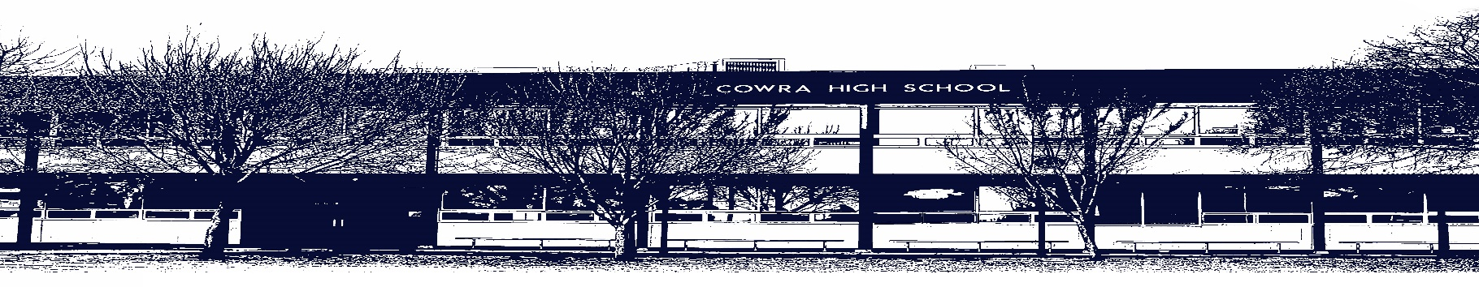

COWRA HIGH SCHOOL

Assessment Task Submission Policy

Submission of assessment tasks by students must follow faculty guidelines. There are basically four types of assessment tasks:

- In Class Assessment Tasks ~ these tasks are supervised by the class teacher and collected by the class teacher at the conclusion of the assessment task. It is the responsible of the student who miss in class assessment tasks to contact the Head Teacher of that faculty.

- Formal Examinations ~ at the conclusion of any formal examination the assessment task papers are to be collected and returned to the relevant faculty teacher.

- Major Projects / Pieces of Work ~ these items, due to their size, are usually kept in the appropriate faculty location. Major works and projects should be kept in safe locations that minimises the risk of damage. Any assessment task would be submitted directly to the teacher. A receipt for the task will be issued to students.

- Take Home Assessment Tasks ~ these are tasks that students are required to complete by a due date. Students should follow faculty submission guidelines regarding submission of these tasks.

Guidelines for the Submission of Assessment Tasks

- When an assessment task is issued, the information provided to students will include:
- a clear statement of what the task involves and what the expectations of the student are
- an explanation of the marking criteria / outcomes to be assessed
- the due date of submission
- an assessment task submission cover sheet ~ see attached

- Teachers should record the names of all students issued with the assessment task on a roll/class list and have the student acknowledge receipt of the assessment task by getting them to sign next to their name.

- Students must take their assessment task to the class teacher. They must be signed in on the class roll and keep their receipt

- All students must keep a copy of their assessment task.

Illness and Misadventure Appeals

If a student fails to submit an assessment task by the due date and has a legitimate reason than normal illness and misadventure procedures will apply.

REQUEST FOR ASSESSMENT EXTENSION PROCEDURE

Assessment extensions will only be granted in exceptional circumstances. All requests need to be made in writing using the extension request form. In seeking an extension discuss your request with your teacher/Head Teacher at least three (3) days before the due date with work already completed.

Forms for Illness/Misadventure and Extension can be accessed on the
Cowra High School Website.

