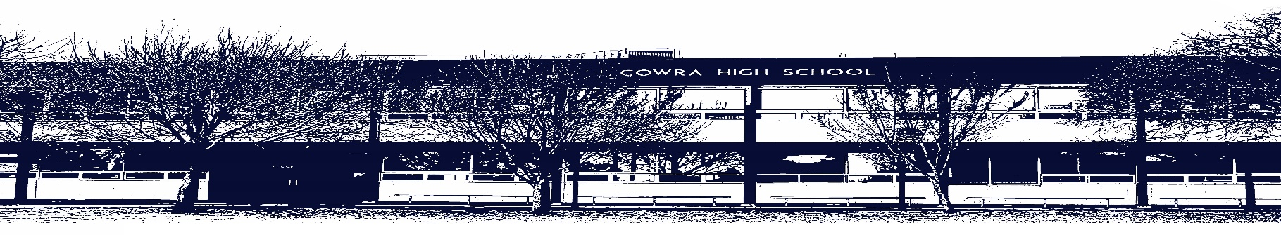

COWRA HIGH SCHOOL

ASSESSMENT TASK COVER SHEET

This sheet must be attached to the front of your Assessment Task and submitted to your class teacher on or before the due date.

Student’s Name: _________________________________________
Course: _________________________________________
Assessment Task: _________________________________________
Date Due: _______________
Date Received: _______________
Extension granted _____ days
Other circumstances ~ documents attached

I certify:
- This assignment is entirely my own work and all borrowed material has been acknowledged
- The material contained in this assignment has not previously been submitted for assessment in any formal course of study
- I retain in my possession a copy of this assignment
- I understand that late assignments will be penalised unless an extension has been granted by Deputy Principal - Curriculum

Student’s Signature: ____________________________

-------------------------------------------------------------------------------------------------------------------------------
COWRA HIGH SCHOOL
Assessment Task (Student’s Copy)
Student’s Name: _________________________________________
Course: _________________________________________
Teacher: _________________________________________

Assessment Task received by: _________________________________________
Signature: _________________________________________
Date: ______________________ Time: ______________________

Please detach this if the Assessment Task has been handed in
to the office and give to student to keep for their own records.

Cowra High School

Preliminary Economics Assessment Task 2
NAME : |  |  |  |  |  | CLASS : |  | Prelim |  | TEACHER : |  |  | S Johnstone
COURSE : |  | Economics |  |  | TASK NO : |  | 2 |  | UNIT : |  | The Australian Economy
DATE DUE : |  |  | Friday June 18th |  |  | TIME DUE : |  |  | 3.15pm
MARK : | /100 |  |  | WEIGHT : | 30% | PRESENTATION: |  |  |  |  |  | Report format
SYLLABUS OUTCOMES: A student:
P1 demonstrates understanding of economic terms, concepts and relationships
P2 explains the economic role of individuals, firms and government in an economy
P5 analyses the relationship between individuals, firms, institutions and government in the Australian economy
P6 explains the role of government in the Australian economy
P7 identifies the nature and causes of economic problems and issues for individuals, firms and governments
P8 applies appropriate terminology, concepts and theories in economic contexts
P9 selects and organises information from a variety of sources for relevance and reliability
P10 communicates economic information, ideas and issues in appropriate forms
P12 works independently and in groups to achieve appropriate goals in set timelines.

DESCRIPTION OF TASK:

Your task is to write a report on the current state of the Australian Economy. Your report must address the following:

- The 2021/2022 Federal Budget – note this budget will be handed down in early May (Fiscal Policy)
- Is this budget predicted to be in deficit or surplus? (1 mark)
- By how much is this budget predicted to be in deficit or surplus? (1 mark)
- How is the 2021/2022 predicted budget outcome different from the 2020/2021 budget outcome? (1 mark)
- Is this 2021/2022 budget expected to be expansionary or contractionary? Why? (2 marks)
- Explain one major federal government initiative contained in this budget. (2 marks)

- Interest Rates (Monetary Policy)
- What is the current official cash (interest) rate? (1 mark)
- What has been the recent trend in interest rate movements (12 months)? (1 mark)
- List any factors influencing the Reserve Bank’s stance on current interest rates. (2 marks)
- Outline one impact a lowering, or raising, of interest rates could have on a particular sector of the economy. (2 marks)
- Is this current cash rate thought to be expansionary or contractionary? Why? (2 marks)

- Economic Growth
- What is the current annual rate of GDP growth? (1 mark)
- What has been the recent trend in GDP growth rates (3 years)? (1 mark)
- List any factors influencing the most recent GDP figures. (2 marks)
- Is the current rate of growth thought to be adequate? Why? (2 marks)
- Inflation (CPI)
- What is the current annual rate of inflation? (1 mark)
- What has been the recent trend in inflation rates (3 years)? (1 mark)
- List any factors influencing the most recent inflation figures. (2 marks)
- What is the RBA’s target for inflation? (1 mark)

- Unemployment
- What is the current rate of unemployment? (1 mark)
- What has been the recent trend in unemployment figures (3 years)? (1 mark)
- List any factors influencing the most recent unemployment figures. (2 marks)

- The Australian Dollar ($A)
- List the current value of the $A against 3 other major currencies. (1 mark)
- What has been the recent trend in the value of the $A (12 months) against the $US? (1 mark)
- List some factors that are influencing the current value of the $A. (2 marks)
- Outline some positive and negative impacts on the Australian economy of the current trend in the value of the $A. (2 marks)
MARKING CRITERIA:

1.
Criteria | Mark
Correctly identifies the 2021/2022 predicted Budget outcome | 1
Correctly identifies the dollar value of the 2021/2022 predicted budget outcome | 1
Correctly identifies the difference in dollars between the 2021/2022 predicted budget outcome and the 2020/2021 budget outcome | 1
Correctly identifies the 2021/2022 budget as being expansionary or contractionary with appropriate reasoning | 2
Correctly identifies the 2021/2022 budget as being expansionary or contractionary without appropriate reasoning | 1
Clearly explains the main features of one major federal government initiative contained in this budget | 2
Indicates some features of one major federal government initiative contained in this budget | 1

2.
Criteria | Mark
Correctly identifies the current official cash (interest) rate | 1
Correctly identifies the recent trend in interest rate movements (12 months) | 1
Clearly indicates a variety of factors influencing the Reserve Banks stance on current interest rates | 2
Indicates some factors influencing the Reserve Banks stance on current interest rates | 1
Clearly outlines how a lowering, or raising, of interest rates might impact one particular sector of the economy | 2
Provides a basic outline of how a lowering, or raising, of interest rates might impact one particular sector of the economy | 1
Clearly explains why the current cash rate is thought to be expansionary or contractionary | 2
Provides a basic explanation of why the cash rate is thought to be expansionary or contractionary | 1

3.
Criteria | Mark
Correctly identifies the current annual rate of GDP growth | 1
Correctly identifies the recent trend in GDP growth rates (3 years) | 1
Clearly indicates a variety of factors influencing the most recent GDP figures | 2
Indicates some factors influencing the most recent GDP figures | 1
Clearly explains why the current rate of growth is thought to be adequate or inadequate | 2
Provides a basic explanation of why the current rate of growth is thought to be adequate or inadequate | 1
4.
Criteria | Mark
Correctly identifies the current annual rate of inflation | 1
Correctly identifies the recent trend in inflation rates (3 years) | 1
Clearly indicates a variety of factors influencing the most recent inflation figures | 2
Indicates some factors influencing the most recent inflation figures | 1
Correctly states the RBA’s target for inflation | 1

5.
Criteria | Mark
Correctly identifies the current rate of unemployment | 1
Correctly identifies the recent trend in unemployment figures (3 years) | 1
Clearly indicates a variety of factors influencing the most recent unemployment figures | 2
Indicates some factors influencing the most recent unemployment figures | 1

6.
Criteria | Mark
Correctly identifies the current value of the $A against 3 other major currencies | 1
Correctly identifies the recent trend in the value of the $A (12 months) against the $US | 1
Clearly indicates a variety of factors that are influencing the current value of the $A | 2
Indicates some factors that are influencing the current value of the $A | 1
Clearly explains some positive and negative impacts of the current trend in the value of the $A on the Australian economy | 2
Provides a basic explanation of at least one positive and one negative impact of the current trend in the value of the $A on the Australian economy | 1

Good sources of information:

https://www.rba.gov.au/

https://tradingeconomics.com/australia/indicators

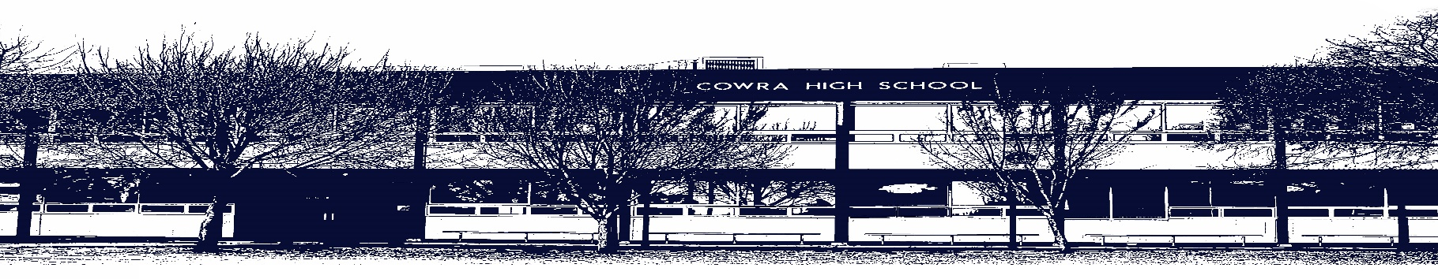

COWRA HIGH SCHOOL

Assessment Task Submission Policy

Submission of assessment tasks by students must follow faculty guidelines. There are basically four types of assessment tasks:

- In Class Assessment Tasks ~ these tasks are supervised by the class teacher and collected by the class teacher at the conclusion of the assessment task. It is the responsible of the student who miss in class assessment tasks to contact the Head Teacher of that faculty.

- Formal Examinations ~ at the conclusion of any formal examination the assessment task papers are to be collected and returned to the relevant faculty teacher.

- Major Projects / Pieces of Work ~ these items, due to their size, are usually kept in the appropriate faculty location. Major works and projects should be kept in safe locations that minimises the risk of damage. Any assessment task would be submitted directly to the teacher. A receipt for the task will be issued to students.

- Take Home Assessment Tasks ~ these are tasks that students are required to complete by a due date. Students should follow faculty submission guidelines regarding submission of these tasks.

Guidelines for the Submission of Assessment Tasks

- When an assessment task is issued, the information provided to students will include:
- a clear statement of what the task involves and what the expectations of the student are
- an explanation of the marking criteria / outcomes to be assessed
- the due date of submission
- an assessment task submission cover sheet ~ see attached

- Teachers should record the names of all students issued with the assessment task on a roll/class list and have the student acknowledge receipt of the assessment task by getting them to sign next to their name.

- Students must take their assessment task to the class teacher. They must be signed in on the class roll and keep their receipt

- All students must keep a copy of their assessment task.

Illness and Misadventure Appeals

If a student fails to submit an assessment task by the due date and has a legitimate reason than normal illness and misadventure procedures will apply.

REQUEST FOR ASSESSMENT EXTENSION PROCEDURE

Assessment extensions will only be granted in exceptional circumstances. All requests need to be made in writing using the extension request form. In seeking an extension discuss your request with your teacher/Head Teacher at least three (3) days before the due date with work already completed.

Forms for Illness/Misadventure and Extension can be accessed on the
Cowra High School Website.

