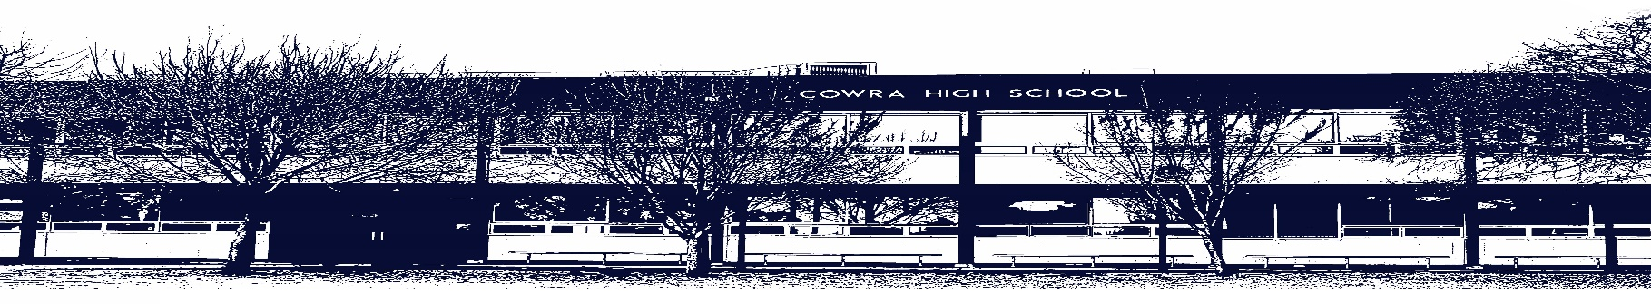

COWRA HIGH SCHOOL

ASSESSMENT TASK COVER SHEET

This sheet must be attached to the front of your Assessment Task and submitted to your class teacher on or before the due date.

Student’s Name: _________________________________________
Course: Year 11 Japanese Continuers
Assessment Task: My School on Display
Date Due: Tuesday 8th June 2021, Week 8 Term 2
Date Received: _______________
Extension granted _____ days
Other circumstances ~ documents attached

I certify:
- This assignment is entirely my own work and all borrowed material has been acknowledged
- The material contained in this assignment has not previously been submitted for assessment in any formal course of study
- I retain in my possession a copy of this assignment
- I understand that late assignments will be penalised unless an extension has been granted by Deputy Principal - Curriculum

Student’s Signature: ____________________________

-------------------------------------------------------------------------------------------------------------------------------
COWRA HIGH SCHOOL
Assessment Task (Student’s Copy)
Student’s Name: _________________________________________
Course: Year 11 Japanese Continuers
Teacher: Bates

Assessment Task received by: _________________________________________
Signature: _________________________________________
Date: ______________________ Time: ______________________

Please detach this if the Assessment Task has been handed in
to the office and give to student to keep for their own records.

COWRA HIGH SCHOOL
Year 11 Assessment Task
NAME: |  |  | CLASS: 11 |  |  | TEACHER: Mr Bates
COURSE: Japanese Continuers |  | TASK No: 2 |  |  | Unit: My Life, Family and School
DATE DUE: Tuesday 8th June 2021, Week 8 Term 2 |  |  |  |  |  | TIME DUE:  Multimodal: Tuesday 8th June  Reading: Tuesday 8th June
MARK:  /40 Reading  /20 Writing | WEIGHT:  10% Speaking  20% Listening |  |  | PRESENTATION: Multimodal presentation of Cowra High School to a Japanese audience and Topic Test
SYLLABUS OUTCOMES:

Writing
2.1 applies knowledge of language structures to create original text
2.2 composes informative, descriptive, reflective, persuasive or evaluative texts appropriate to context, purpose and/or audience
2.3 structures and sequences ideas and information
4.1 recognises and employs language appropriate to different social contexts

Reading
3.1 conveys the gist of texts and identifies specific information
3.2 summarises the main ideas
3.3 identifies the tone, purpose, context and audience
3.4 draws conclusions from or justifies an opinion
3.5 interprets, analyses and evaluates information
3.6 infers points of view, attitudes or emotions from language and context
4.2 identifies values, attitudes and beliefs of cultural significance
4.3 reflects upon significant aspects of languages and culture

DESCRIPTION OF TASK:

Reading (20%) 40 Marks

Students will complete a reading test that will focus on Free Time, Families and School. Students will need to read multiple texts and answer questions in English about them. Students may be requested to read a conversation, an announcement, an advertisement, a diary entry or an interview.

Writing (20%) 20 Marks

Students are to create a multimodal text that presents Cowra High School to a Japanese audience that are unfamiliar with the workings of the school.
Students are encouraged to research the school and discuss it in a professional manner, as the assessment task may be shown to Cowra’s sister school, Seikei Gakkouen 成蹊学校園 to assist in marking.

In order to complete this assessment task, students will need present the following aspects of the school:

- A small description of Cowra, the town and its location in Australia in relation to important landmarks. (200ji)
- An inclusive list of the subjects Cowra High offers to students (at least 15)
- A small list of additional opportunities or services (about 3) that Cowra High offers students with a small description (2 sentences)
- A “do and don’ts” of Cowra High School (rules)
- “5 surprising facts” that Japanese students would be surprised about that happen in Cowra (think differences between Australian and Japanese schools)

This multimodal presentation must be completely written in Japanese and is NOT to be completed in Microsoft PowerPoint or Google Slides. Google sites it recommended for this assessment task.

Writing Marking Criteria: 20 Marks (10%)

A variety of language structures and vocabulary is used throughout the assessment task that demonstrates a depth of understanding of the language and sophisticated use.  /10 | 1 2 3 4 5 6 7 8 9 10
The description of the town and school is accurate and understandable from a Japanese perspective  /4 | Limited  1 |  | Somewhat  2 |  | Competent  3 |  | Detailed  4
The subjects, “do’s and don’ts” and 5 surprising facts are detailed, relevant to the audiences and correctly communicated in Japanese.  /4 | Rarely  0 | Inconsistently  1 |  | Sometimes  2 |  | Mostly  3 |  | Consistently  4
Additional opportunities or services at Cowra High School are factual and competently communicated  /2 | Attempted  1 |  |  |  | Competently communicated  2
Comment:

/20

Reading: /40 (20%)
Each question is marked independently based on the criteria of the question. An individualised marking criteria with sample responses will be supplied to all candidates upon return of assessment task.

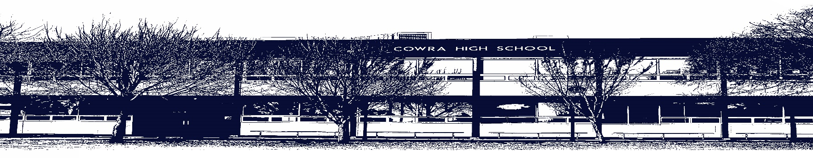

COWRA HIGH SCHOOL
Assessment Task Submission Policy

Submission of assessment tasks by students must follow faculty guidelines. There are basically four types of assessment tasks:

- In Class Assessment Tasks ~ these tasks are supervised by the class teacher and collected by the class teacher at the conclusion of the assessment task. It is the responsible of the student who miss in class assessment tasks to contact the Head Teacher of that faculty.

- Formal Examinations ~ at the conclusion of any formal examination the assessment task papers are to be collected and returned to the relevant faculty teacher.

- Major Projects / Pieces of Work ~ these items, due to their size, are usually kept in the appropriate faculty location. Major works and projects should be kept in safe locations that minimises the risk of damage. Any assessment task would be submitted directly to the teacher. A receipt for the task will be issued to students.

- Take Home Assessment Tasks ~ these are tasks that students are required to complete by a due date. Students should follow faculty submission guidelines regarding submission of these tasks.

Guidelines for the Submission of Assessment Tasks

- When an assessment task is issued, the information provided to students will include:
- a clear statement of what the task involves and what the expectations of the student are
- an explanation of the marking criteria / outcomes to be assessed
- the due date of submission
- an assessment task submission cover sheet ~ see attached

- Teachers should record the names of all students issued with the assessment task on a roll/class list and have the student acknowledge receipt of the assessment task by getting them to sign next to their name.

- Students must take their assessment task to the class teacher. They must be signed in on the class roll and keep their receipt

- All students must keep a copy of their assessment task.

Illness and Misadventure Appeals

If a student fails to submit an assessment task by the due date and has a legitimate reason than normal illness and misadventure procedures will apply.

REQUEST FOR ASSESSMENT EXTENSION PROCEDURE

Assessment extensions will only be granted in exceptional circumstances. All requests need to be made in writing using the extension request form. In seeking an extension discuss your request with your teacher/Head Teacher at least three (3) days before the due date with work already completed.

Forms for Illness/Misadventure and Extension can be accessed on the
Cowra High School Website.

