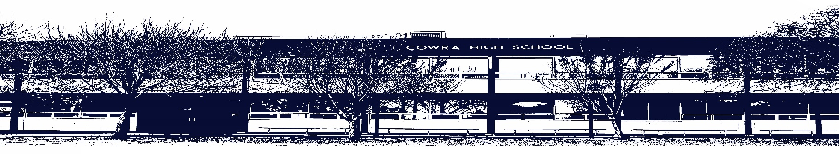

COWRA HIGH SCHOOL

ASSESSMENT TASK COVER SHEET

This sheet must be attached to the front of your Assessment Task and submitted to your class teacher on or before the due date.

Student’s Name: _________________________________________
Course: Year 11 Photography, Video and Digital Imaging
Assessment Task: Artmaking
Date Due: Friday 14th May 2021, Term 2 Week 4
Date Received: _______________
Extension granted _____ days
Other circumstances ~ documents attached

I certify:
- This assignment is entirely my own work and all borrowed material has been acknowledged
- The material contained in this assignment has not previously been submitted for assessment in any formal course of study
- I retain in my possession a copy of this assignment
- I understand that late assignments will be penalised unless an extension has been granted by Deputy Principal - Curriculum

Student’s Signature: ____________________________

-------------------------------------------------------------------------------------------------------------------------------
COWRA HIGH SCHOOL
Assessment Task (Student’s Copy)
Student’s Name: _________________________________________
Course: Year 11 Photography, Video and Digital Imaging
Teacher: I. Harnden

Assessment Task received by: _________________________________________
Signature: _________________________________________
Date: ______________________ Time: ______________________

Please detach this if the Assessment Task has been handed in
to the office and give to student to keep for their own records.

COWRA HIGH SCHOOL
Year 11 Assessment Task
NAME: |  | CLASS: Year 11 |  | TEACHER: I Harnden
COURSE: Photography, Video and Digital Imaging |  | TASK No: 2 |  | Unit: Film Making
DATE DUE: Friday 14th May 2021, Term 2 Week 4 |  | TIME DUE: 3:15pm
MARK: /25 | WEIGHT: 40% |  | PRESENTATION: Hand in & presentation
SYLLABUS OUTCOMES:
M1 - generates a characteristic style that is increasingly self-reflective in their photographic and/or video and/or digital practice
M2 - explores concepts of artist/photographer, still and moving works, interpretations of the world and audience response, in their making of still and/or moving works
M3 - investigates different points of view in the making of photographs and/or videos and/or digital images
M4 - generates images and ideas as representations/simulations in the making of photographs and/or videos and/or digital images
M5 - develops different techniques suited to artistic intentions in the making of photographs and/or videos and/or digital images
M6 - takes into account issues of Work Health and Safety in the making of photographs and/or videos and/or digital works
DESCRIPTION OF TASK:

You are required to produce a film with a duration of at least one minute. The film will be informed by your study of filmmaking techniques and programs developed in class. The film will mirror the camera angles and camera shots used in the music film Shallou "You and Me" The Nomad Series with a focus on using local subject matter within Cowra.

You will demonstrate the processes of pre-production, production and post- production. You will use the video camera to explore camera movement, camera angles & framing/shot types in chosen locations. You will also experiment with diegesis, which involves consideration of action/ interaction within the frame and syncing these all to the musical score. The existing music clip acts as a template to guide you in your techniques and interpretation of the
music film.

MARKING CRITERIA:

Marking criteria | Marks
• Demonstrates extensive knowledge and understanding of cinematography  • Displays comprehensive understanding of content, processes, concepts in video  • Critically analyses, synthesises and interprets research into music videos  • Demonstrates high–level competence in particular skills, processes in production and post-production  • Demonstrates high–level skills in critical judgement, reasoning, evaluation, problem solving and interpretation of the brief  • Demonstrates high–level skills in the experimentation of appropriate technologies such as Premiere Pro editing. | 21-25
• Demonstrates thorough knowledge and understanding of cinematography  • Displays detailed understanding of content, processes, concepts in video  • Analyses, synthesises and interprets research into music videos  • Demonstrates competence in particular skills, processes in production and post- production  • Demonstrates competent skills in critical judgement, reasoning, evaluation, problem solving and interpretation of the brief.  • Demonstrates competent skills in the experimentation of appropriate technologies such as Premiere Pro editing. | 16-20
• Demonstrates sound knowledge and understanding of cinematography  • Displays sound understanding of content, processes, concepts in video  • Interprets information into music videos  • Demonstrates sound ability in particular skills, processes in production and post production  • Demonstrates sound skills in judgement, reasoning, problem solving, interpretation of the brief  • Demonstrates sound skills in the experimentation of Premiere Pro | 11-15
• Demonstrates basic knowledge and understanding of cinematography  • Displays basic understanding of content, processes, concepts in video  • Interprets information into music videos  • Demonstrates basic ability in particular skills, processes in pre-production  • Demonstrates basic skills in judgement, reasoning, problem solving, interpretation of the brief  • Demonstrates basic skills in the experimentation of Premiere Pro | 6-10
• Demonstrates limited knowledge and understanding of cinematography  • Displays simple understanding of content, processes, concepts  • Interprets information  • Demonstrates limited ability in particular skills, processes  • Demonstrates limited skills in problem solving  • Demonstrates limited skills in the use of appropriate technologies | 1-5
• Non-submission | 0

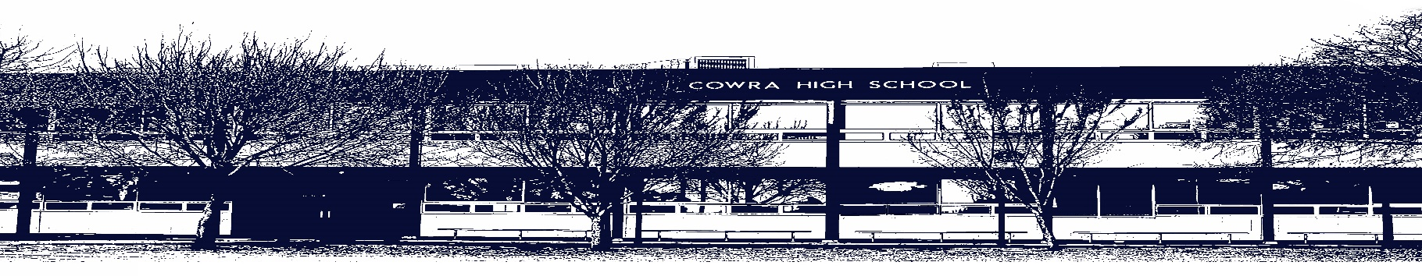

COWRA HIGH SCHOOL

Assessment Task Submission Policy

Submission of assessment tasks by students must follow faculty guidelines. There are basically four types of assessment tasks:

- In Class Assessment Tasks ~ these tasks are supervised by the class teacher and collected by the class teacher at the conclusion of the assessment task. It is the responsible of the student who miss in class assessment tasks to contact the Head Teacher of that faculty.

- Formal Examinations ~ at the conclusion of any formal examination the assessment task papers are to be collected and returned to the relevant faculty teacher.

- Major Projects / Pieces of Work ~ these items, due to their size, are usually kept in the appropriate faculty location. Major works and projects should be kept in safe locations that minimises the risk of damage. Any assessment task would be submitted directly to the teacher. A receipt for the task will be issued to students.

- Take Home Assessment Tasks ~ these are tasks that students are required to complete by a due date. Students should follow faculty submission guidelines regarding submission of these tasks.

Guidelines for the Submission of Assessment Tasks

- When an assessment task is issued, the information provided to students will include:
- a clear statement of what the task involves and what the expectations of the student are
- an explanation of the marking criteria / outcomes to be assessed
- the due date of submission
- an assessment task submission cover sheet ~ see attached

- Teachers should record the names of all students issued with the assessment task on a roll/class list and have the student acknowledge receipt of the assessment task by getting them to sign next to their name.

- Students must take their assessment task to the class teacher. They must be signed in on the class roll and keep their receipt

- All students must keep a copy of their assessment task.

Illness and Misadventure Appeals

If a student fails to submit an assessment task by the due date and has a legitimate reason than normal illness and misadventure procedures will apply.

REQUEST FOR ASSESSMENT EXTENSION PROCEDURE

Assessment extensions will only be granted in exceptional circumstances. All requests need to be made in writing using the extension request form. In seeking an extension discuss your request with your teacher/Head Teacher at least three (3) days before the due date with work already completed.

Forms for Illness/Misadventure and Extension can be accessed on the
Cowra High School Website.

