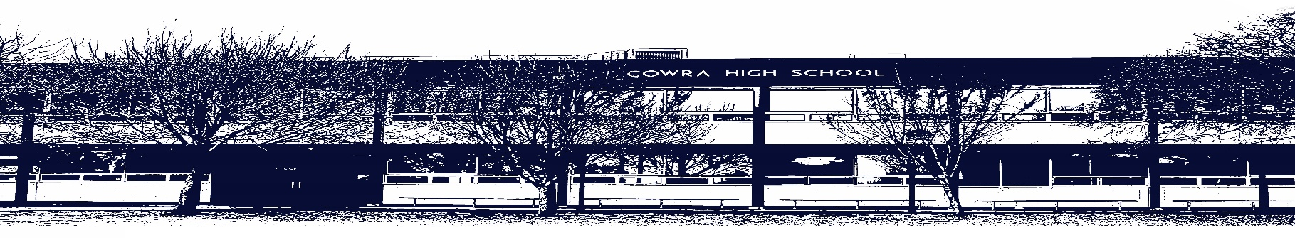

COWRA HIGH SCHOOL

ASSESSMENT TASK COVER SHEET

This sheet must be attached to the front of your Assessment Task and submitted to your class teacher on or before the due date.

Student’s Name: _________________________________________
Course: 11 Modern History
Assessment Task: 2: The Shaping of the Modern World and Historical Investigations
Date Due: Thursday 17th June 2021 (Term 2, Week 9)
Date Received: _______________
Extension granted _____ days
Other circumstances ~ documents attached

I certify:
- This assignment is entirely my own work and all borrowed material has been acknowledged
- The material contained in this assignment has not previously been submitted for assessment in any formal course of study
- I retain in my possession a copy of this assignment
- I understand that late assignments will be penalised unless an extension has been granted by Deputy Principal - Curriculum

Student’s Signature: ____________________________

-------------------------------------------------------------------------------------------------------------------------------
COWRA HIGH SCHOOL
Assessment Task (Student’s Copy)
Student’s Name: _________________________________________
Course: 11 Modern History
Teacher:

Assessment Task received by: _________________________________________
Signature: _________________________________________
Date: ______________________ Time: ______________________

Please detach this if the Assessment Task has been handed in
to the office and give to student to keep for their own records.
COWRA HIGH SCHOOL
Year 11 Assessment Task
NAME: |  |  | CLASS: 11MH |  |  | TEACHER:
COURSE: Year 11 Modern History |  | TASK No: 2 |  |  | Unit: The Shaping of the Modern World and Historical Investigations
DATE DUE: Thursday 17th June 2021 (Term 2, Week 9) |  |  |  |  |  | TIME DUE: End of period 3.
MARK: / 30 | WEIGHT: 30% |  |  | PRESENTATION: Source analysis and extended response
SYLLABUS OUTCOMES
A Student:
MH11-3 analyses the role of historical features, individuals, groups and ideas in shaping the past
MH11-5 examines the significance of historical features, people, ideas, movements, events and developments of the modern world
MH11-6 analyses and interprets different types of sources for evidence to support an historical account or argument
MH11-8 plans and conducts historical investigations and presents reasoned conclusions, using relevant evidence from a range of sources

DESCRIPTION OF TASK: Written source analysis and extended response

You are to select an area of personal interest related to World War 1. You will design a question to investigate and research, complete an analysis of relevant sources and present your findings as an extended response.

You may wish to select one of the following to research:
- aspects of society as revealed through sources (for example the role of women or children during the war, life on the Homefront)
- the cause and impact of a specific event during World War 1 (for example the entry of a country into the war or the impact of specific personalities or groups)
- the significance of a historical development (for example a change in technology or the development of specific warfare)
- the analysis of a historical debate (for example who was to blame for the start of the war)
- the contribution of a historical site to our understanding of the past (for example Gallipoli)
- the nature of social and cultural change as a result of the war (for example the right to vote)

There are 5 parts to this assessment task. Not all parts of the task have marks allocated, but all 5 parts need to be submitted as they demonstrate your ability to successfully complete a historical investigation.

- Topic Proposal
Complete the attached scaffold by the end of Week 5. The scaffold will assist you to explain the focus of your investigation, what you will research and where you will find relevant information. Your teacher will provide feedback and support to ensure your question is appropriately worded and that you have a range of resources to use to complete your investigation.

- Source Analysis (20 marks)
You will select 5 sources to support and drive your historical investigation. You will write a short explanation of each source using the scaffold provided. This explanation will include:
- nature of the source (what is it?)
- perspective (whose point of view?)
- reliability (can I trust it?)
- usefulness (what does it tell me?)

- Extended Response (10 marks)
You will answer your investigation question in an extended response (800 words or 2 typed pages). To answer your question, you should refer to the sources you have analysed and any other supplementary information that helps to answer your question.

- Reflection
You are to compose and submit a 200-word reflection on your learning throughout your historical investigation. Consider including the following aspects in your reflection:
- the process of planning your investigation
- your analysis of sources, including any problems related to the sources you selected
- how you selected and organised your information
- how you developed your conclusion or answered your investigation question
- what you enjoyed most about the topic you selected
- the most challenging aspect of the topic you selected.

- Bibliography
Include a bibliography that includes all resources used.

For books, journals and internet articles, use APA referencing. APA referencing records the author, year, title, edition and publisher. If you accessed your information via the internet, include the URL at the end.

Example of referencing a book or article
Gottschall, S., & Hamilton, H. (2021). Cowra High School: The Best School in the West (1st edition). Cambridge Press.

Example of referencing an internet site
Gottschall, S., & Hamilton, H. (retrieved on April 3rd, 2021). Cowra High School: The Best School in the West. https://www.cowrahighschool.madeupsite.com.au/updates/article

MARKING CRITERIA:

- Source Analysis (20 marks)

Criteria: | Mark:
- Makes a sophisticated judgement which demonstrates a thorough understanding of all five sources and their connection to the question.  - Demonstrates an accurate understanding of nature, perspective, reliability and usefulness in the context of the topic of investigation with a high level of accuracy for all five sources.  - Presents a well-structured, logical and cohesive analysis of sources using appropriate historical terms and concepts. | 17-20
- Makes a clear judgement which demonstrates a mostly accurate understanding of all five sources and their connection to the question.  - Demonstrates a mostly accurate understanding of nature, perspective, reliability and usefulness in the context of the topic of investigation with a high level of accuracy for all five sources.  - Presents a well-structured analysis of sources using appropriate historical terms and concepts. | 13-16
- Makes a clear judgement which demonstrates a mostly accurate understanding of the sources included, but does not clearly connect them to the question.  - Demonstrates an understanding of nature, perspective, reliability and usefulness in the context of the topic, but there are a number of inaccuracies in the analysis.  - Presents an analysis of sources using some appropriate historical terms and concepts. | 9-12
- Attempts to demonstrate an understanding of the sources included and provides a generalised connection to the question.  - Demonstrates some understanding of nature, perspective, reliability and usefulness in the context of the topic of investigation, but there are many inaccuracies in the analysis of sources.  - Presents an analysis of sources using limited historical terms and concepts. | 5-8
- Attempts to demonstrate an understanding of included sources, but there is no connection to the question.  - Demonstrates a limited understanding of nature, perspective, usefulness and reliability in the context of the topic.  - Limited historical terms and concepts used. | 1-4
- No attempt at source analysis completed. | 0
- Extended Response (10 marks)

Criteria: | Mark:
- The response demonstrates a comprehensive understanding of the issues raised in the question.  - The response includes extensive and accurate historical knowledge and understanding and includes relevant evidence and interpretation.  - Presents a well-structured, logical and cohesive response using appropriate historical terms and concepts. | 9-10
- The response demonstrates a sound understanding of the issues raised in the question.  - The response includes detailed and accurate historical knowledge and understanding and includes relevant evidence and interpretation.  - Presents a structured response using appropriate historical terms and concepts. | 7-8
- The extended response demonstrates an implied understanding of the issues raised in the question.  - The response includes relevant and accurate historical understanding but with little evidence or interpretation.  - Presents a semi-structured response using some historical terms and concepts. | 5-6
- Attempts to answer the question but presents a generalised, mostly relevant descriptive response.  - The response includes some appropriate historical terms and/or concepts.  - Response is not structured accurately. | 3-4
- Makes general statements in response to the question  - The response uses some historical terms and concepts.  - The response is not structured accurately. | 1-2
- No extended response completed. | 0

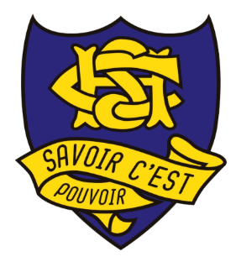 | 11 Modern History  Topic Proposal  Historical Investigation of World War One
Name: |  | Date submitted:
My research topic:
It is important to select a topic that incorporates an issue that will allow you to explore different historical perspectives and interpretations from historians.

My proposed question:
A good research question will focus your work and provide direction for your next steps. A good research question will set boundaries to help you figure out where to go next. It will help you to think about what evidence you need to collect.

Research methodology:
What sources have you identified to support you to answer your question? Are there particular books, articles or websites that you have found? List them here.

Comments on your preliminary investigation:
What have you found interesting? What has been easy so far? What has been challenging?

Feedback from teacher:

Date: |  | Topic approved: Yes / No

11 Modern History
Source Analysis
Historical Investigation of World War One
Source: Insert an image of your source here.

Citation: Include relevant details including name of author / publisher, title and year. |  | Reference: Include the URL / name of the book where you retrieved the source.
Nature of the source: | What is it? Is it a primary or secondary source? Where is it from?
Perspective: | Whose point of view? What options are evident in this source? Are any facts missing? Consider how the source is presented – why has the author presented it like this?
Reliability: | Can I trust it? Is this source consistent with other sources on the topic? Are there other sources that could support the information given in this source? Consider when and where the source was published – does this give the source credibility?
Usefulness: | What does it tell me? Is it relevant to what is being asked? Has the source revealed an insight into the question? Is the source useful in providing the information required to help answer the question?

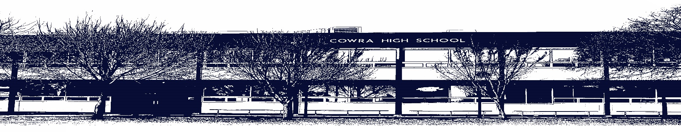

COWRA HIGH SCHOOL

Assessment Task Submission Policy

Submission of assessment tasks by students must follow faculty guidelines. There are basically four types of assessment tasks:

- In Class Assessment Tasks ~ these tasks are supervised by the class teacher and collected by the class teacher at the conclusion of the assessment task. It is the responsible of the student who miss in class assessment tasks to contact the Head Teacher of that faculty.

- Formal Examinations ~ at the conclusion of any formal examination the assessment task papers are to be collected and returned to the relevant faculty teacher.

- Major Projects / Pieces of Work ~ these items, due to their size, are usually kept in the appropriate faculty location. Major works and projects should be kept in safe locations that minimises the risk of damage. Any assessment task would be submitted directly to the teacher. A receipt for the task will be issued to students.

- Take Home Assessment Tasks ~ these are tasks that students are required to complete by a due date. Students should follow faculty submission guidelines regarding submission of these tasks.

Guidelines for the Submission of Assessment Tasks

- When an assessment task is issued, the information provided to students will include:
- a clear statement of what the task involves and what the expectations of the student are
- an explanation of the marking criteria / outcomes to be assessed
- the due date of submission
- an assessment task submission cover sheet ~ see attached

- Teachers should record the names of all students issued with the assessment task on a roll/class list and have the student acknowledge receipt of the assessment task by getting them to sign next to their name.

- Students must take their assessment task to the class teacher. They must be signed in on the class roll and keep their receipt

- All students must keep a copy of their assessment task.

Illness and Misadventure Appeals

If a student fails to submit an assessment task by the due date and has a legitimate reason than normal illness and misadventure procedures will apply.

REQUEST FOR ASSESSMENT EXTENSION PROCEDURE

Assessment extensions will only be granted in exceptional circumstances. All requests need to be made in writing using the extension request form. In seeking an extension discuss your request with your teacher/Head Teacher at least three (3) days before the due date with work already completed.

Forms for Illness/Misadventure and Extension can be accessed on the
Cowra High School Website.

