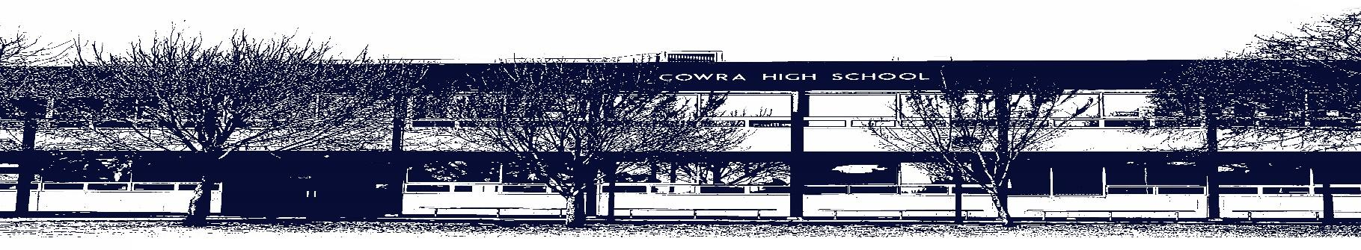

COWRA HIGH SCHOOL

ASSESSMENT TASK COVER SHEET

This sheet must be attached to the front of your Assessment Task and submitted to your class teacher on or before the due date.

Student’s Name: _________________________________________
Course: Year 8 AES
Assessment Task: Narrative – Genre Study – Gothic
Date Due: Monday Week 10 Term 1
Date Received: _______________
□ Extension granted _____ days
□ Other circumstances ~ documents attached

I certify:
- This assignment is entirely my own work and all borrowed material has been acknowledged
- The material contained in this assignment has not previously been submitted for assessment in any formal course of study
- I retain in my possession a copy of this assignment
- I understand that late assignments will be penalised unless an extension has been granted by Deputy Principal - Curriculum

Student’s Signature: ____________________________

✂-------------------------------------------------------------------------------------------------------------------------------
COWRA HIGH SCHOOL
Assessment Task (Student’s Copy)
Student’s Name: _________________________________________
Course: Year 8 - AES
Teacher: Burrell
Assessment Task received by: _________________________________________
Signature: _________________________________________
Date: ______________________ Time: ______________________

Please detach this if the Assessment Task has been handed in
to the office and give to student to keep for their own records.
COWRA HIGH SCHOOL
Year 8 - AES Assessment Task
NAME: |  |  | CLASS: 8P |  |  | TEACHER: Burrell
COURSE: Year 8 AES - English |  | TASK No: 1 |  |  | Unit: Genre Study: Gothic
DATE DUE: Monday 29th March, Week 10, Term 1 |  |  |  |  |  | TIME DUE: 3:15pm
MARK: /20 | WEIGHT: 25% |  |  | PRESENTATION: Imaginative Writing & Reflection
SYLLABUS OUTCOMES:

EN4-1A responds to and composes texts for understanding, interpretation, critical analysis, imaginative
expression and pleasure
EN4-2A effectively uses a widening range of processes, skills, strategies and knowledge for responding to
and composing texts in different media and technologies
EN4-3B uses and describes language forms, features and structures of texts appropriate to a range of
purposes, audiences and contexts
EN4-4B makes effective language choices to creatively shape meaning with accuracy, clarity and coherence
EN4-9E uses, reflects on and assesses their individual and collaborative skills for learning

DESCRIPTION OF TASK:

Part 1: Narrative

During this unit of work we have been exploring the elements of Gothic narratives – settings, characters and plots. We have also examined the way composers use descriptive language such as adverbs, adjectives and active verbs to create the atmosphere and tone typical of horror stories.

Use one of the images provided as the basis for the setting of an original Gothic narrative that will engage your audience.

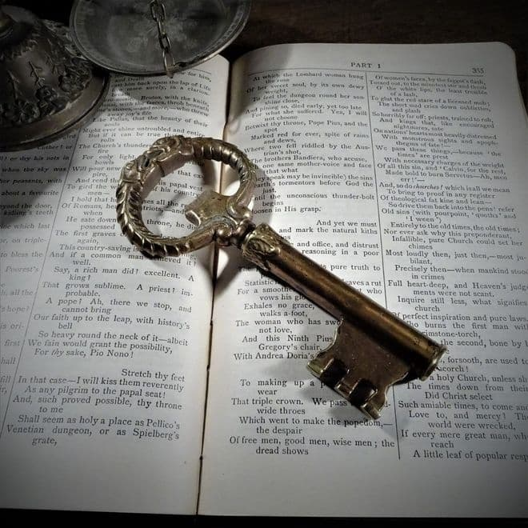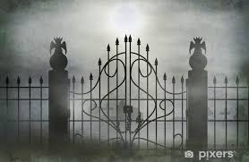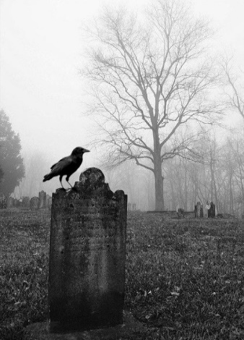

You may choose to subvert one or more of the conventions of the Gothic genre. Your story should adhere to a word limit of 750- 1000 words.

Part 2: Reflection

Complete the following questions that will help you reflect on your writing and its effectiveness.

Reflection Questions

1. What is the title of your story?
2. Summarise your story in no more than 4 sentences.
3. What parts of your narrative do you particularly like? Dislike? Why?
4. Identify THREE techniques you used. Be sure to include a quote.
5. Why are these effective techniques to use in your writing?
6. Comment on how your story fits into the genre studied. What texts influenced your work? In particular, was it the setting, characters or other features specific to your genre?

You will be assessed on your ability to:
- Incorporate elements of the Gothic genre into your story
- Use descriptive language to develop and maintain an appropriate atmosphere and tone
- Use appropriate language forms and features to communicate your ideas including paragraphs, correct use of direct speech, punctuation and spelling

Make sure you write a detailed plan that will assist you in the writing process. This should include an orientation, complication and resolution.

MARKING CRITERIA:

Mark | Criteria
17-20 | - Demonstrates an effective understanding of the Gothic genre throughout the story  - Demonstrates a highly developed ability to use elements of the Gothic genre  - Uses effective adjectives, similes and figurative language to convey meaning in an effective manner  - Organises, develops and expresses ideas skilfully, using correct spelling, grammar and punctuation  - Presents skilful responses that reflect on elements of writing and techniques used.
13-16 | - Demonstrates a sound understanding of the Gothic genre largely throughout the story.  - Demonstrate a consistent ability to use elements of the Gothic genre.  - Uses sound adjectives, similes and some figurative language to convey meaning  - Organises, develops and expresses ideas effectively, using correct spelling, grammar and punctuation  - Presents effective responses that reflect on elements of writing and techniques used.
9-12 | - Demonstrates adequate understanding of the Gothic genre in elements of the story.  - Demonstrates an ability to use some elements of the Gothic genre  - Uses basic attempts at figurative language  - Organises, develops and expresses ideas adequately  - Presents some responses that reflect on elements of writing and techniques used.
5 – 8 | - Demonstrates limited understanding of the Gothic genre.  - Little or no reflection on Gothic genre  - Minimal use of language devices  - Organises and expresses ideas in simple language  - Attempts to reflect on their work, although responses may be limited.
0 - 4 | - Attempts to compose a piece of writing with some relevance to the question  - Demonstrates limited control of language  - Presents a limited reflection

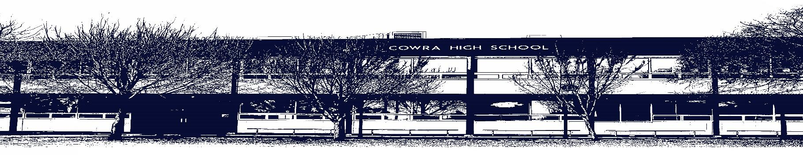

COWRA HIGH SCHOOL

Assessment Task Submission Policy

Submission of assessment tasks by students must follow faculty guidelines. There are basically four types of assessment tasks:

- In Class Assessment Tasks ~ these tasks are supervised by the class teacher and collected by the class teacher at the conclusion of the assessment task. It is the responsible of the student who miss in class assessment tasks to contact the Head Teacher of that faculty.

- Formal Examinations ~ at the conclusion of any formal examination the assessment task papers are to be collected and returned to the relevant faculty teacher.

- Major Projects / Pieces of Work ~ these items, due to their size, are usually kept in the appropriate faculty location. Major works and projects should be kept in safe locations that minimises the risk of damage. Any assessment task would be submitted directly to the teacher. A receipt for the task will be issued to students.

- Take Home Assessment Tasks ~ these are tasks that students are required to complete by a due date. Students should follow faculty submission guidelines regarding submission of these tasks.

Guidelines for the Submission of Assessment Tasks

- When an assessment task is issued, the information provided to students will include:
- a clear statement of what the task involves and what the expectations of the student are
- an explanation of the marking criteria / outcomes to be assessed
- the due date of submission
- an assessment task submission cover sheet ~ see attached

- Teachers should record the names of all students issued with the assessment task on a roll/class list and have the student acknowledge receipt of the assessment task by getting them to sign next to their name.

- Students must take their assessment task to the class teacher. They must be signed in on the class roll and keep their receipt

- All students must keep a copy of their assessment task.

Illness and Misadventure Appeals

If a student fails to submit an assessment task by the due date and has a legitimate reason than normal illness and misadventure procedures will apply.

REQUEST FOR ASSESSMENT EXTENSION PROCEDURE

Assessment extensions will only be granted in exceptional circumstances. All requests need to be made in writing using the extension request form. In seeking an extension discuss your request with your teacher/Head Teacher at least three (3) days before the due date with work already completed.

Forms for Illness/Misadventure and Extension can be accessed on the
Cowra High School Website.

