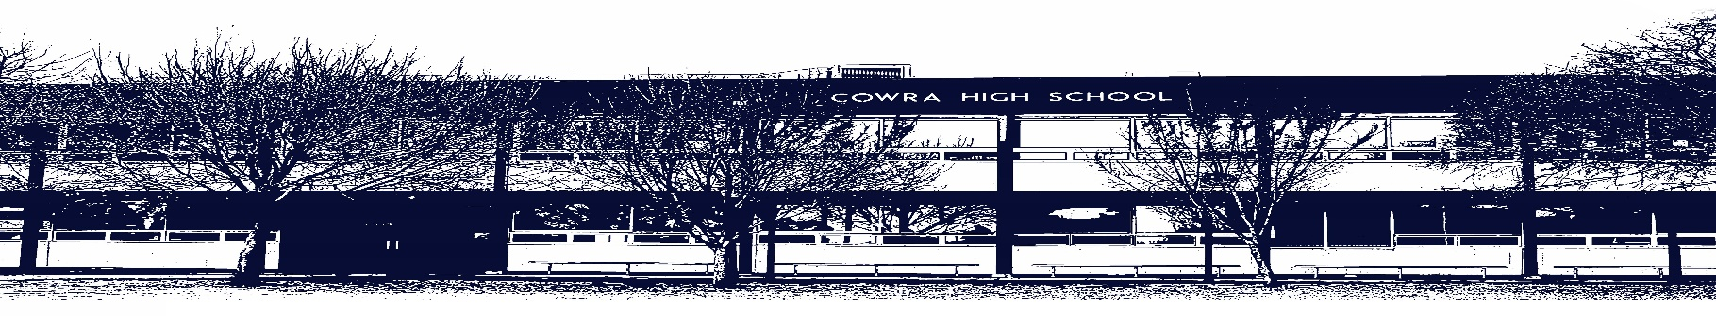

COWRA HIGH SCHOOL

ASSESSMENT TASK COVER SHEET

This sheet must be attached to the front of your Assessment Task and submitted to your class teacher on or before the due date.

Student’s Name: _________________________________________
Course: Japanese Elective
Assessment Task: Busy Life
Date Due: Week 8
Date Received: Week 6
Extension granted _____ days
Other circumstances ~ documents attached

I certify:
- This assignment is entirely my own work and all borrowed material has been acknowledged
- The material contained in this assignment has not previously been submitted for assessment in any formal course of study
- I retain in my possession a copy of this assignment
- I understand that late assignments will be penalised unless an extension has been granted by Deputy Principal - Curriculum

Student’s Signature: ____________________________

-------------------------------------------------------------------------------------------------------------------------------
COWRA HIGH SCHOOL
Assessment Task (Student’s Copy)
Student’s Name: _________________________________________
Course: _________________________________________
Teacher: _________________________________________

Assessment Task received by: _________________________________________
Signature: _________________________________________
Date: ______________________ Time: ______________________

Please detach this if the Assessment Task has been handed in
to the office and give to student to keep for their own records.

COWRA HIGH SCHOOL
Stage 5 Assessment Task 1
NAME: |  |  | CLASS: 7 |  |  | TEACHER: Mr Bates
COURSE: Japanese Elective |  | TASK No: 1 |  |  | Unit: Busy Life
DATE DUE: Week 8 |  |  |  |  |  | TIME DUE:  Written: First period in Week 8  Speaking: Second Period in Week 8
MARK:  Written: 10%  /69 Hiragana Speed Test  /30 Language  Speaking: 10%  /15 Speaking | WEIGHT:  20% |  |  | PRESENTATION: In-class test with aids  1-on-1 speaking task
SYLLABUS OUTCOMES: A Student:
1C manipulates Japanese in sustained interactions to exchange information, ideas and opinions, and make plans and negotiate
2C identifies and interprets information in a range of texts
3C evaluates and responds to information, opinions and ideas in texts, using a range of formats for specific contexts, purposes and audiences
5U demonstrates how Japanese pronunciation and intonation are used to convey meaning
6U demonstrates understanding of how Japanese writing conventions are used to convey meaning
DESCRIPTION OF TASK:
Students will complete an assessment task based on the Hiragana characters they have learned this term. They will complete this assessment in three parts.
Hiragana Karate /69
Students will complete a Hiragana Karate in class on the day of the test. Students are expected to know all Hiragana and will be marked on accuracy, not speed. Students may use their Hiragana Karate to help them complete their test.
Language /30
Students will listen and respond to questions spoken in Japanese and write answers in English about what they heard. Students will also need to read questions in Japanese and write answers in English about it. There will be one text in romaji and one text in hiragana
Students will need to know the following:
- How to complete a self-introduction, including name, nationality and suburb
- The meaning of kaか, waは, niに and karaから particles
- How to introduce an adult and a friend
- How to describe a person and adjectives in Japanese
- How to count to 20 for ages
- Describe someone’s hobby (Western and Japanese hobbies)
- Know the counter for people up to 10
- Understand Advanced hiragana rules, such as small っ, glides and long vowels

Speaking /15
Students will engage in a conversation and will be marked on their ability to speak in Japanese using correct intonation and pronunciation.
Students will be asked the following questions in Japanese and will be expected to respond politely using correct pronunciation and intonation.

Marking Criteria – Speaking | Correct answers will receive
Correct greeting used | 1 mark
Onamae wa nan desu ka | 2 marks  (1 mark for short version)
Doko kara kimashita ka | 2 marks  (1 mark each for country and nationality)
Doko ni sundeimasu ka | 2 marks  (1 mark for sentence, 1 mark for Japanese pronunciation of suburb)
(name+title) wa donna hito desu ka | 2 marks  (1 mark for sentence, 1 mark for two adjectives)
Nansai desu ka | 1 mark
Shumi wa nan desu ka | 2 marks  (1 mark for sentence, 1 for two hobbies)
Kazoku wa nannin desu ka | 2 marks  (1 mark for sentence, 1 mark for listing who is in the family)
Appropriate farewell at conclusion of task | 1 mark

MARKING CRITERIA:
Hiragana: /69
Students will be marked based on the accuracy of writing the character. Students will be given a chart to study for and reflect upon receiving their result.

Language /30
A Marking criteria will be issued to students on completion of the test for each individual question.

Speaking /15
The Marking criteria for speaking is included above with the questions to be asked to assist students in preparing their spoken response.

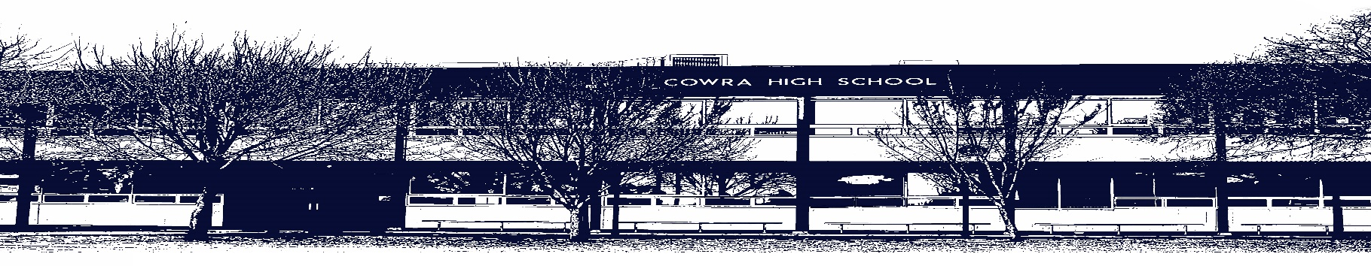

COWRA HIGH SCHOOL

Assessment Task Submission Policy

Submission of assessment tasks by students must follow faculty guidelines. There are basically four types of assessment tasks:

- In Class Assessment Tasks ~ these tasks are supervised by the class teacher and collected by the class teacher at the conclusion of the assessment task. It is the responsible of the student who miss in class assessment tasks to contact the Head Teacher of that faculty.

- Formal Examinations ~ at the conclusion of any formal examination the assessment task papers are to be collected and returned to the relevant faculty teacher.

- Major Projects / Pieces of Work ~ these items, due to their size, are usually kept in the appropriate faculty location. Major works and projects should be kept in safe locations that minimises the risk of damage. Any assessment task would be submitted directly to the teacher. A receipt for the task will be issued to students.

- Take Home Assessment Tasks ~ these are tasks that students are required to complete by a due date. Students should follow faculty submission guidelines regarding submission of these tasks.

Guidelines for the Submission of Assessment Tasks

- When an assessment task is issued, the information provided to students will include:
- a clear statement of what the task involves and what the expectations of the student are
- an explanation of the marking criteria / outcomes to be assessed
- the due date of submission
- an assessment task submission cover sheet ~ see attached

- Teachers should record the names of all students issued with the assessment task on a roll/class list and have the student acknowledge receipt of the assessment task by getting them to sign next to their name.

- Students must take their assessment task to the class teacher. They must be signed in on the class roll and keep their receipt

- All students must keep a copy of their assessment task.

Illness and Misadventure Appeals

If a student fails to submit an assessment task by the due date and has a legitimate reason than normal illness and misadventure procedures will apply.

REQUEST FOR ASSESSMENT EXTENSION PROCEDURE

Assessment extensions will only be granted in exceptional circumstances. All requests need to be made in writing using the extension request form. In seeking an extension discuss your request with your teacher/Head Teacher at least three (3) days before the due date with work already completed.

Forms for Illness/Misadventure and Extension can be accessed on the
Cowra High School Website.

