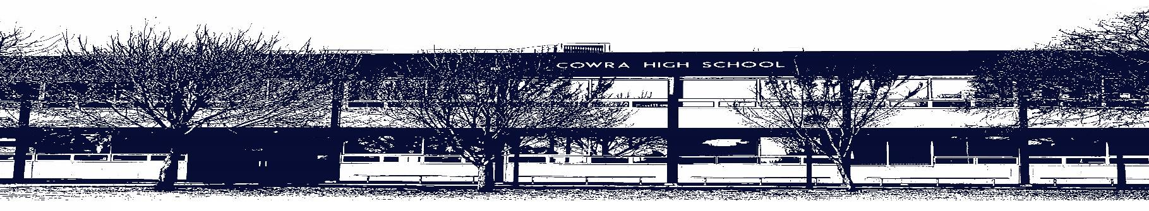

COWRA HIGH SCHOOL

ASSESSMENT TASK COVER SHEET

This sheet must be attached to the front of your Assessment Task and submitted to your class teacher on or before the due date.

Student’s Name: _________________________________________
Course: Stage 5 Mandatory History
Assessment Task: Cowra Breakout Field Study
Date Due: Friday 29th March, 2021
Date Received: _______________
□ Extension granted _____ days
□ Other circumstances ~ documents attached

I certify:
- This assignment is entirely my own work and all borrowed material has been acknowledged
- The material contained in this assignment has not previously been submitted for assessment in any formal course of study
- I retain in my possession a copy of this assignment
- I understand that late assignments will be penalised unless an extension has been granted by Deputy Principal - Curriculum

Student’s Signature: ____________________________

✂-------------------------------------------------------------------------------------------------------------------------------
COWRA HIGH SCHOOL
Assessment Task (Student’s Copy)
Student’s Name: _________________________________________
Course: _________________________________________
Teacher: _________________________________________
Assessment Task received by: _________________________________________
Signature: _________________________________________
Date: ______________________ Time: _____________________
Please detach this if the Assessment Task has been handed in
to the office and give to student to keep for their own records.

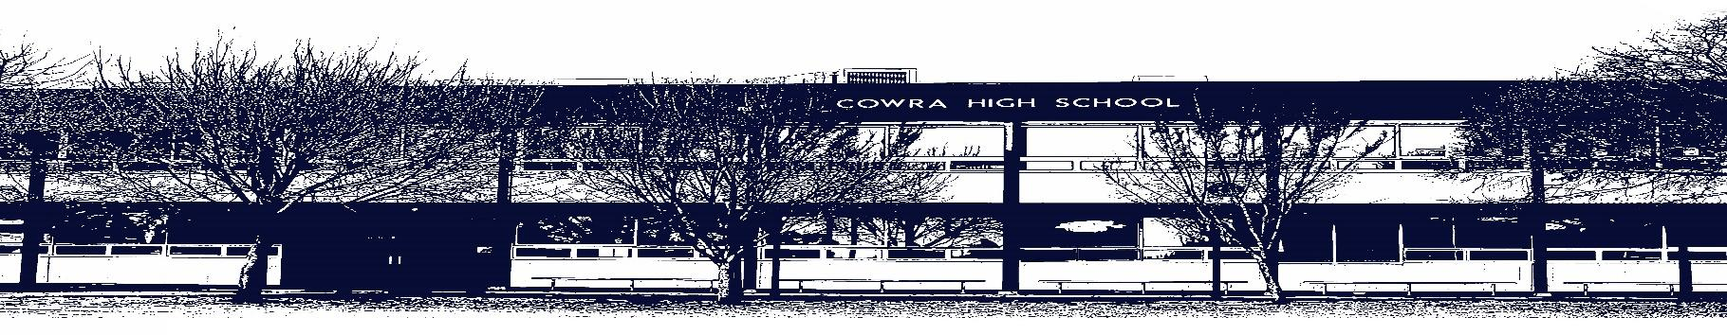

COWRA HIGH SCHOOL

Assessment Task Submission Policy

Submission of assessment tasks by students must follow faculty guidelines. There are basically four types of assessment tasks:

- In Class Assessment Tasks ~ these tasks are supervised by the class teacher and collected by the class teacher at the conclusion of the assessment task. It is the responsible of the student who miss in class assessment tasks to contact the Head Teacher of that faculty.

- Formal Examinations ~ at the conclusion of any formal examination the assessment task papers are to be collected and returned to the relevant faculty teacher.

- Major Projects / Pieces of Work ~ these items, due to their size, are usually kept in the appropriate faculty location. Major works and projects should be kept in safe locations that minimises the risk of damage. Any assessment task would be submitted directly to the teacher. A receipt for the task will be issued to students.

- Take Home Assessment Tasks ~ these are tasks that students are required to complete by a due date. Students should follow faculty submission guidelines regarding submission of these tasks.

Guidelines for the Submission of Assessment Tasks

- When an assessment task is issued, the information provided to students will include:
- a clear statement of what the task involves and what the expectations of the student are
- an explanation of the marking criteria / outcomes to be assessed
- the due date of submission
- an assessment task submission cover sheet ~ see attached

- Teachers should record the names of all students issued with the assessment task on a roll/class list and have the student acknowledge receipt of the assessment task by getting them to sign next to their name.

- Students must take their assessment task to the class teacher. They must be signed in on the class roll and keep their receipt

- All students must keep a copy of their assessment task.

Illness and Misadventure Appeals

If a student fails to submit an assessment task by the due date and has a legitimate reason than normal illness and misadventure procedures will apply.

REQUEST FOR ASSESSMENT EXTENSION PROCEDURE
Assessment extensions will only be granted in exceptional circumstances. All requests need to be made in writing using the extension request form. In seeking an extension, discuss your request with your teacher/Head Teacher at least three (3) days before the due date with work already completed.

Forms for Illness/Misadventure and Extension can be accessed on the Cowra High School Website.

COWRA HIGH SCHOOL
Year 10 History Assessment Task
NAME: |  |  | CLASS: |  |  | TEACHER:
COURSE: Mandatory History |  | TASK No: 1 |  |  | Unit: The Cowra Breakout
DATE DUE: Friday 1st May, 2020 |  |  |  |  |  | TIME DUE: 3:15pm
MARK: 60 | WEIGHT: 50% |  |  | PRESENTATION: Typed. Hard copy submitted, or submitted via email or Google Classroom
SYLLABUS OUTCOMES: A Student:

HT5.1 explains and assesses the historical forces and factors that shaped the modern world and Australia
HT5.2 sequences and explains the significant patterns of continuity and change in the development of the modern world and Australia
HT5.8 selects and analyses a range of historical sources to locate information relevant to an historical inquiry
HT5.9 applies a range of relevant historical terms and concepts when communicating an understanding of the past.

DESCRIPTION OF TASK:

You are to complete the Virtual Field Study attached.

MARKING CRITERIA:

As attached.

Name:_____________________________ Class:__________

Year 10 Mandatory History – Fieldwork Study Guide: The Cowra Breakout Site Study

This Study Guide will help you learn about the Cowra Breakout. Part A consists of twenty-seven questions, worth a total of 40 marks.
Part B is a Writing Task based on your fieldwork. This is worth 20 marks. Details are at the end of this guide.
This is an Assessment Task, worth 25% of your total mark.
Late submission as per Cowra High School Assessment Task Submission Policy, incurring a penalty of 10% per day, a mark of zero being recorded after 5 days.

As part of this study you will be using the sources provided. These sources are from the Cowra POW Campsite. You are encouraged to visit this site if you are able. However, all the information you will need to answer the questions is to be found in the sources provided.
The information from Part A will assist you in your Writing Task in Part B.

Part A: The Cowra POW Campsite
Using the sources provided, answer the questions in the spaces provided.

Source 1 - The Memorial Cairn
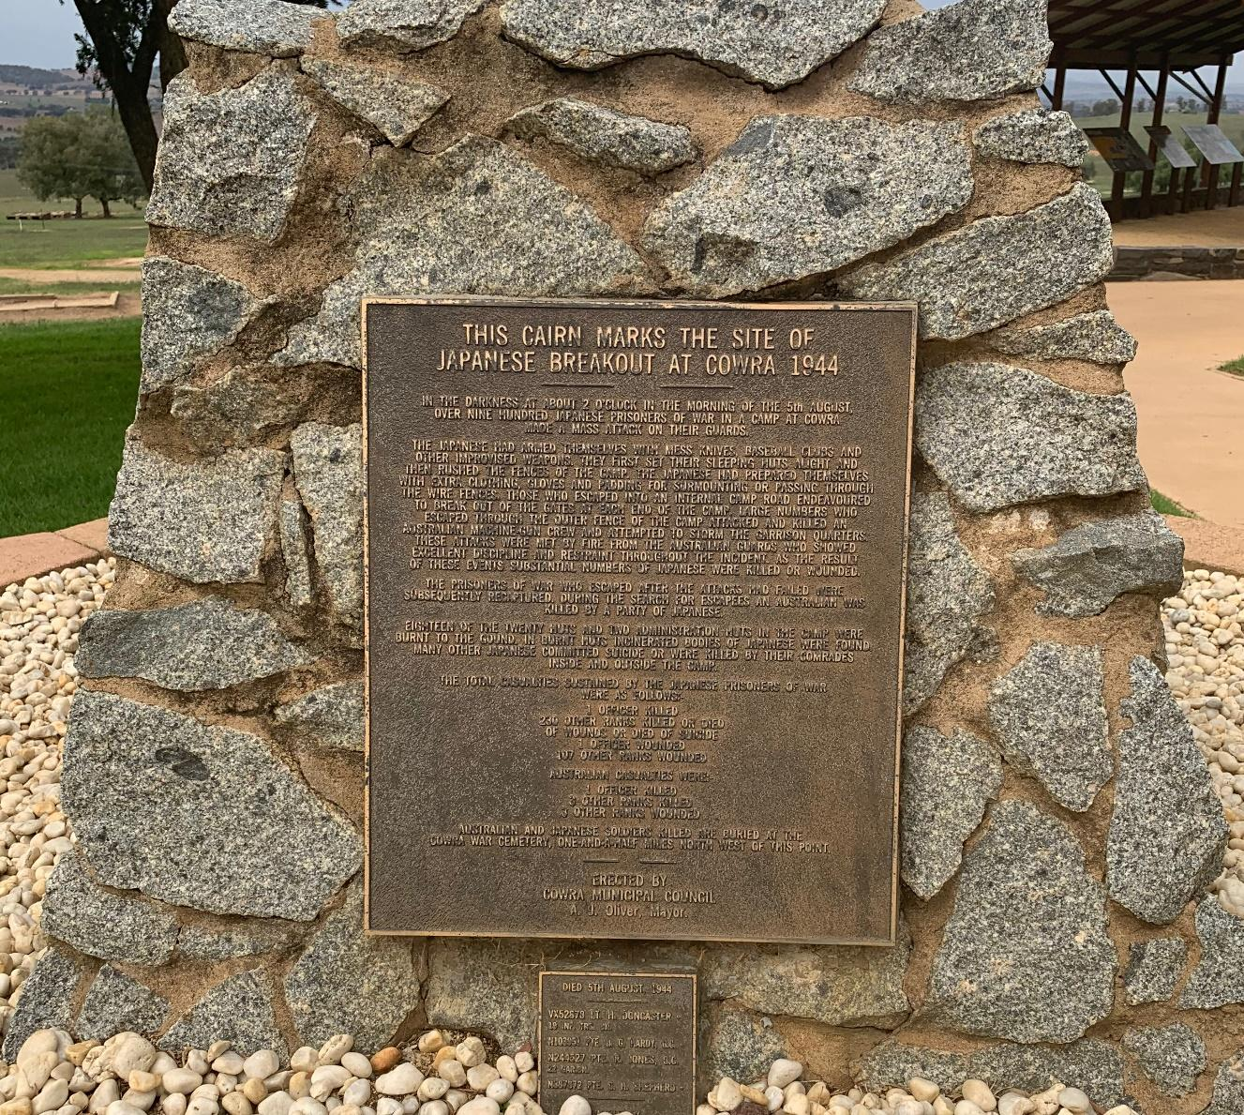

Marks
1) Give the time and date of the breakout? _____________________ 1
2) What did they use to get over the barbed wire fence? __________ 1
3) How many huts were burnt? _____________________________ 1

Source 2 – Prisoner of War Camp No12 (The Pavilion)
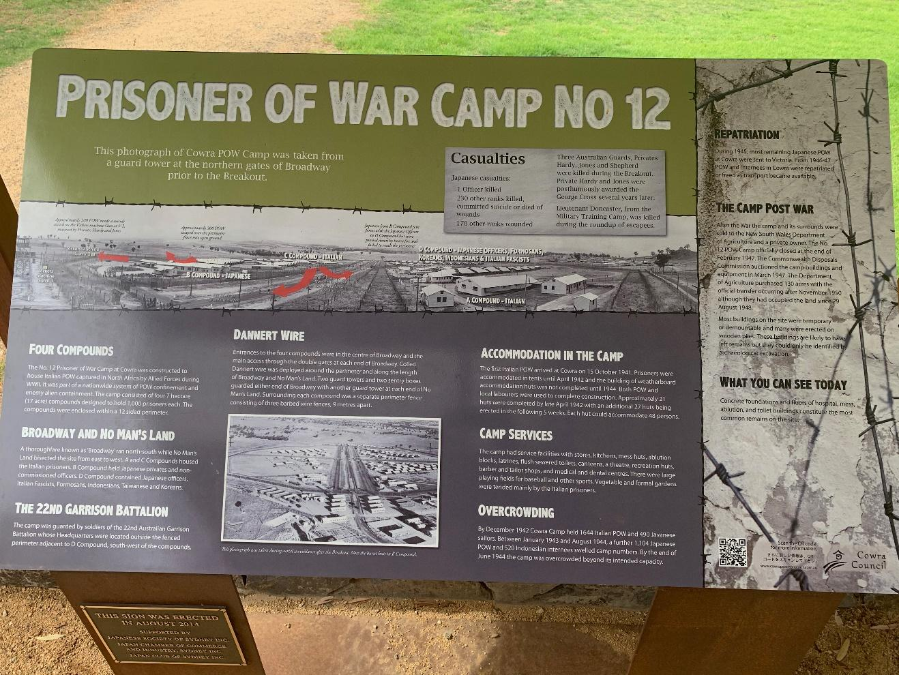

4) Which Australian garrison served at the camp? _____________ 1
5) List the four nationalities of POW. __________________________ 2
_____________________________________________________
6) How many compounds were there? ________________________ 1
7) How many prisoners was each compound designed to hold? 1
_____________________________________________________
_____________________________________________________
8) Name four of the camp services. __________________________ 2
_____________________________________________________

Source 3 – The Italians (The Pavilion)
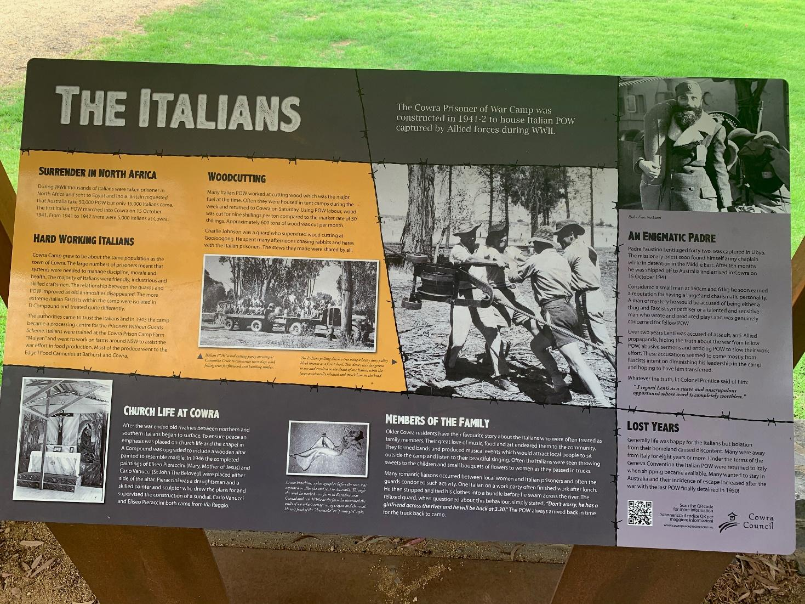
9) How many Italian POW came to Cowra from 1941-1947? 1
________________________________________________________
10) How were the Italian POW treated by the guards? Give the reasons 3
for this.
________________________________________________________
________________________________________________________
________________________________________________________
________________________________________________________
________________________________________________________
________________________________________________________

Source 4 – Unlikely Heroes (The Pavilion)
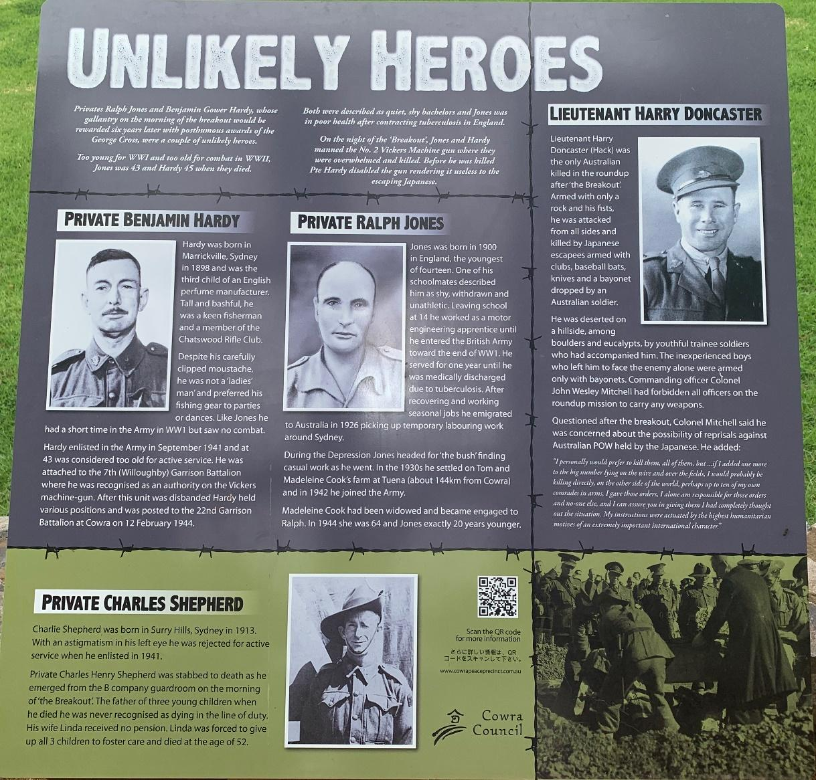
11) Why were Private Benjamin Hardy and Private Ralph Jones awarded
the George Cross? 1
_________________________________________________________
_________________________________________________________
12) How and when did Private Charles Shepherd die? 1
_________________________________________________________
13) Describe the circumstances surrounding Lieutenant Harry Doncaster’s 2
death.
_________________________________________________________
_________________________________________________________
__________________________________________________________
__________________________________________________________

Source 5 – Death Before Dishonour (The Pavilion)
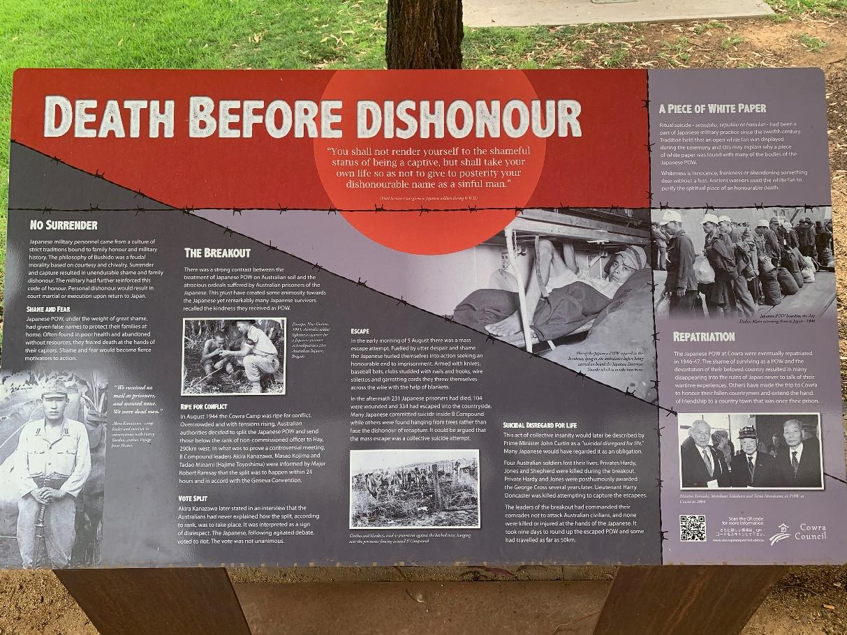
14) What is meant by the quote at the top of the panel? 1
_________________________________________________________
15) What caused rising tensions before the breakout? 2
_________________________________________________________
_________________________________________________________
_________________________________________________________
_________________________________________________________
16) What did Prime Minister John Curtain call the breakout? 1
_________________________________________________________
17) How did the repatriated Japanese deal with their experiences upon 2
their return home?
_________________________________________________________
_________________________________________________________
_________________________________________________________
_________________________________________________________

Source 6 – The First Escape
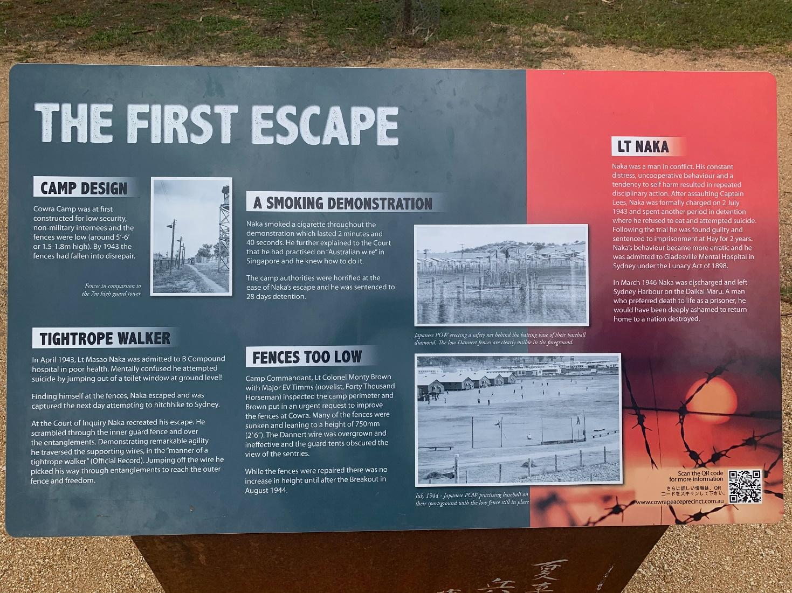

18) Outline the first escape attempt in 1943. 5
_________________________________________________________
_________________________________________________________
_________________________________________________________
_________________________________________________________
_________________________________________________________
_________________________________________________________
_________________________________________________________
_________________________________________________________

Source 7 – No Idle Hands
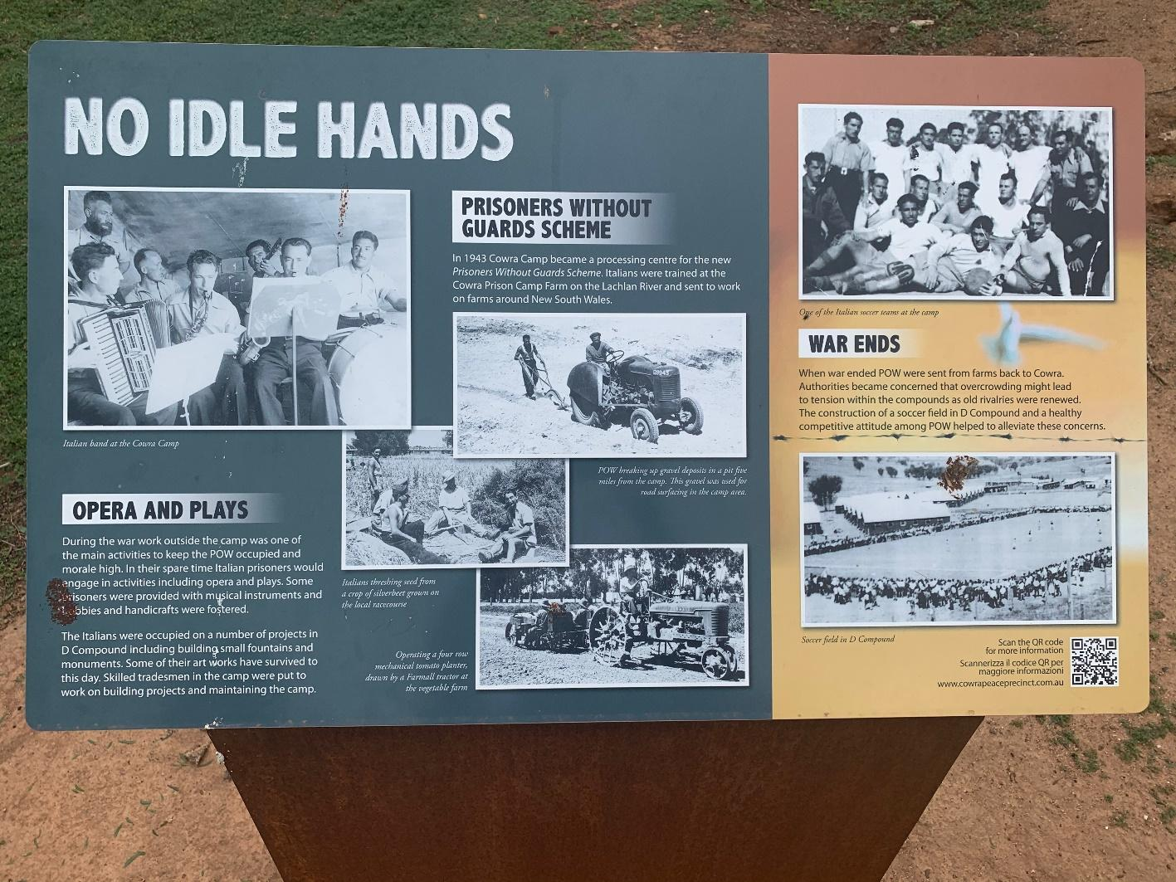

19) What were the two reasons given for why some prisoners worked
outside the camp?
_________________________________________________________ 2
_________________________________________________________
20) Name two other activities the Italians were involved in. 1
_________________________________________________________
_________________________________________________________
21) Outline the Prisoners Without Guards Scheme. 3
_________________________________________________________
_________________________________________________________
_________________________________________________________
_________________________________________________________

Source 8 – Broadway Escape Routes
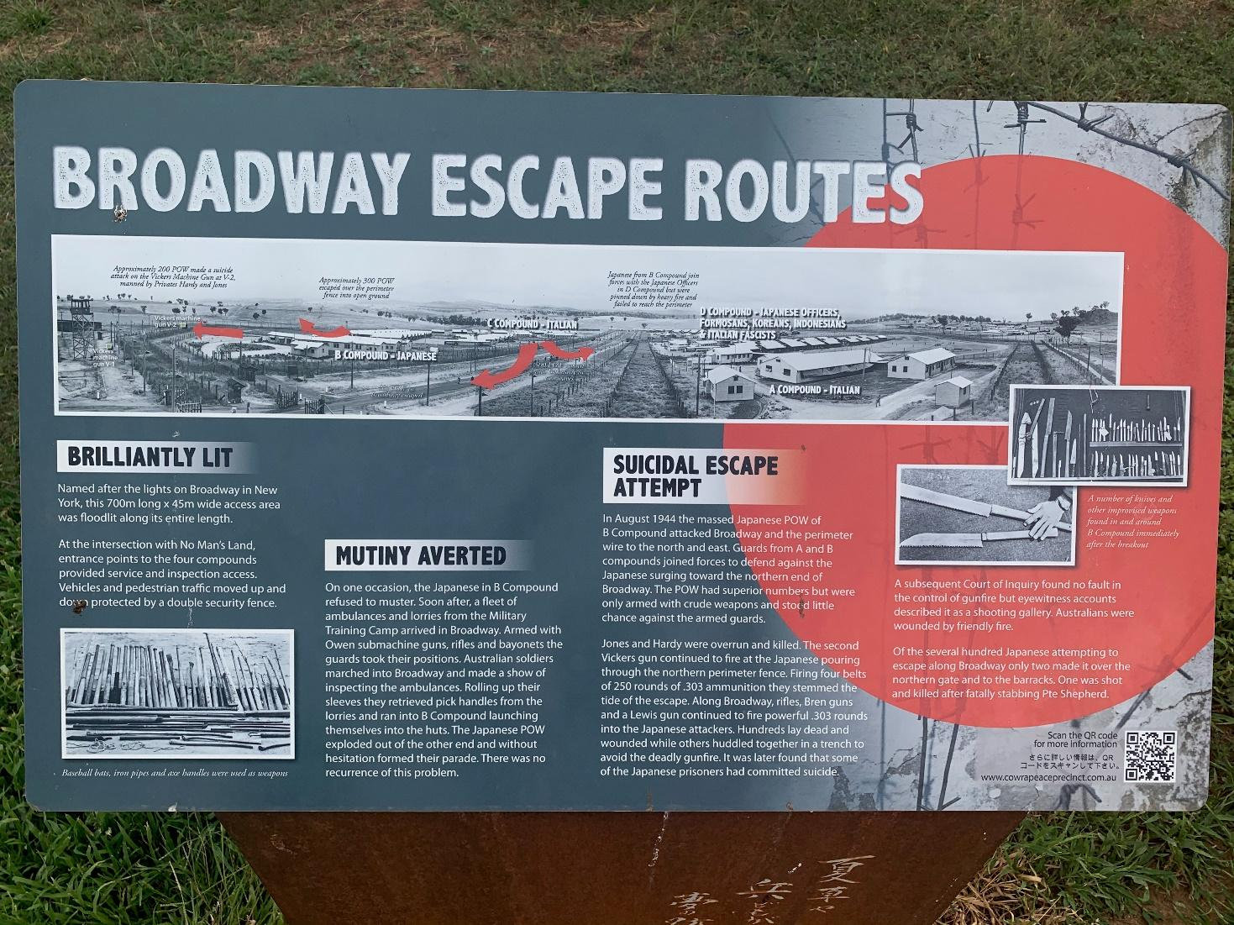
22) Why was Broadway so named? 1
__________________________________________________________
23) How was the mutiny averted? 2
__________________________________________________________
__________________________________________________________
__________________________________________________________
__________________________________________________________
24) What role did the Vickers guns play in the breakout attempt? 2
__________________________________________________________
__________________________________________________________
__________________________________________________________
__________________________________________________________

Name :__________________________________ Class:__________

Part B – Writing Task
Attach this cover sheet to your Writing Task and your answers to Part A.

Imagine you are the editor of Cowra’s local newspaper, The Cowra Guardian. Prepare a special edition to commemorate the anniversary of the Cowra Breakout. Work under the following headings, adding some of your own if you wish.
Layout of the camp
Prisoners
Events and immediate results of the breakout
Reasons behind the breakout
Road to reconciliation.
It may be useful to include a sketch map, a timeline of events and some ‘interviews’ with guards, prisoners and local personalities of the time.
Use your artistic talent and/or a logo to highlight the significance of this special edition. You may use photographs also.

Your work should take at least 2 pages and should not exceed 6 pages.
You will be assessed on:
- Interpreting and explaining the events and significance of the Cowra Breakout.
- Appropriate use of maps/diagrams/photos.
- Use and acknowledgement (Term 2, Week 1). No extensions will be given. Contact your teacher if you have a problem with this deadline.

Marking Criteria | Marks
- Provides a well-structured response that covers the events of the Cowra Breakout  - Shows a sophisticated understanding of the events and their significance  - Communicates detailed, accurate information about the event and its aftermath  - Visual material has been used appropriately and with insight  - Demonstrates accurate and correct use of spelling, punctuation and sentence structure | 17 - 20
- Provides a structured response that covers the events of the Cowra Breakout  - Shows a good understanding of the events and their significance  - Communicates accurate information about the event and its aftermath  - Visual material has been used appropriately  - Demonstrates correct use of spelling, punctuation and sentence structure | 13 - 16
- Provides a response that covers the events of the Cowra Breakout  - Shows a sound understanding of the events and their significance  - Communicates information about the event and its aftermath  - Visual material has been used  - Demonstrates some correct use of spelling, punctuation and sentence structure | 9 - 12
- Provides a limited response that covers the events of the Cowra Breakout  - Shows a limited understanding of the events and their significance  - Communicates limited information about the event and its aftermath  - Visual material may have been used  - Demonstrates limited correct use of spelling, punctuation and sentence structure | 5 - 8
- Identifies one or two events of the Cowra Breakout  - Shows minimal understanding of the events and their significance  - Communicates limited information about the event and its aftermath  - Visual material may have been used  - Demonstrates limited use of correct spelling, punctuation and sentence structure | 1 - 4

