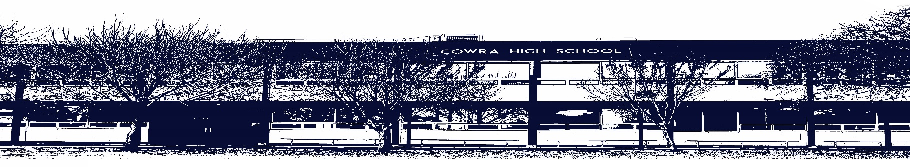

COWRA HIGH SCHOOL

ASSESSMENT TASK COVER SHEET

This sheet must be attached to the front of your Assessment Task and submitted to your class teacher on or before the due date.

Student’s Name: _________________________________________
Course: Stage 5 AES English
Assessment Task: Multimodal Assessment Task
Date Due: Monday 29th March, 2021 Week 10, Term 1
Date Received: _______________
Extension granted _____ days
Other circumstances ~ documents attached

I certify:
- This assignment is entirely my own work and all borrowed material has been acknowledged
- The material contained in this assignment has not previously been submitted for assessment in any formal course of study
- I retain in my possession a copy of this assignment
- I understand that late assignments will be penalised unless an extension has been granted by Deputy Principal - Curriculum

Student’s Signature: ____________________________

-------------------------------------------------------------------------------------------------------------------------------
COWRA HIGH SCHOOL
Assessment Task (Student’s Copy)
Student’s Name: _________________________________________
Course: Stage 5 AES English
Teacher: Rowston / Beattie

Assessment Task received by: _________________________________________
Signature: _________________________________________
Date: ______________________ Time: ______________________

Please detach this if the Assessment Task has been handed in
to the office and give to student to keep for their own records.
COWRA HIGH SCHOOL
Stage 5 Assessment Task
NAME: |  |  | CLASS: S5 AES |  |  | TEACHER: Rowston / Beattie
COURSE: Stage 5 English |  | TASK No: 1 |  |  | Unit: In My Own Words – Creative Non Fiction Writing
DATE DUE: Monday 29th March 2021 |  |  |  |  |  | TIME DUE: In class
MARK: /20 | WEIGHT: 25% |  |  | PRESENTATION: Multimodal Presentation (Creative Writing and Reflection)
SYLLABUS OUTCOMES:

EN5-2A effectively uses and critically assesses a wide range of processes, skills, strategies and knowledge for responding to and composing a wide range of texts in different media and technologies
EN5-3B selects and uses language forms, features and structures of texts appropriate to a range of purposes, audiences and contexts, describing and explaining their effects on meaning
EN5-4B effectively transfers knowledge, skills and understanding of language concepts into new and different contexts
EN5-6C investigates the relationships between and among texts
EN5-7D understands and evaluates the diverse ways texts can represent personal and public worlds
EN5-8D questions, challenges and evaluates cultural assumptions in texts and their effects on meaning
EN5-9E purposefully reflects on, assesses and adapts their individual and collaborative skills with increasing independence and effectiveness

DESCRIPTION OF TASK:

This term you have been studying a variety of examples of creative non fiction writing and as a result have drafted a variety of work that reflects your own identity, context and values. You have been invited to showcase your work for a website called ‘Young Voices’ and, as a result, this task requires you to publish TWO of your pieces onto a Google Site created by you.

Your website should include the following;
- A home page, which provides a definition of creative non fiction writing
- Elements such as colour, sound, images, and clips that enhance the overall presentation
- TWO of your pieces that are carefully drafted and edited. The pieces should be engaging, and carefully crafted to reflect the style and form.
- A reflection statement on ONE of your compositions which;
- Provides a brief synopsis of your story
- Explains how at least ONE text studied in class impacted and shaped the stylistic choices, language, and form of your piece.
- Identifies some of the techniques you used and explains why they are effective
- Comments on how the content studied in class has influenced your writing

You should assess the quality of each composition before publishing by considering the following;
- How did I effectively use language features and/ or form to engage the audience?
- In what ways did I vary my sentences, and control punctuation and grammar in order to enhance the meaning of my work?
- What creative writing strategies did I use in my composition? How did I refine skills in using these strategies?
- What additional readings assisted the development of my writing skills and techniques and how did they do this?

MARKING CRITERIA:

Marking Criteria | Marks
- Skilfully adheres to the requirements of each text type chosen and in doing so, presents TWO compositions of a high calibre.  - Skilfully uses language forms and features to shape their composition  - Skilfully organises and expresses ideas about their own personal context and experiences using language appropriate to audience and purpose.  - Composes a skilful digital resource that integrates elements including images, sound and video clips. | 17 - 20
- Effectively adheres to the requirements of each text type chosen and in doing so, presents TWO compositions of an excellent quality.  - Effectively uses language forms and features to shape their composition  - Effectively organises and expresses ideas about their own personal context and experiences using language appropriate to audience and purpose.  - Composes an effective digital resource that integrates elements including images, sound and video clips. | 13 - 16
- Soundly adheres to the requirements of each text type chosen  - Soundly uses language forms and features to shape their own personal representation  - Soundly organises and expresses ideas about their own personal context and experiences using language appropriate to audience and purpose.  - Composes a sound digital resource that integrates elements including images, sound and video clips. | 9 - 12
- Attempts to adhere to the requirements of each text type chosen  - Attempts to use language forms and features to shape their own personal representation  - Attempts to organise and expresses ideas about their own personal context and experiences using language appropriate to audience and purpose.  - Attempts to compose a digital resource that integrates elements including images, sound and video clips. | 5 - 8
- Little to no adherence to the requirements of each text type chosen  - Little or no use of language forms and features to shape the writing  - Little to no organisation and expression of ideas about their own personal context and experiences using language appropriate to audience and purpose.  - Limited digital resource. | 1 - 4
- Presents nothing of relevance to the task. | 0

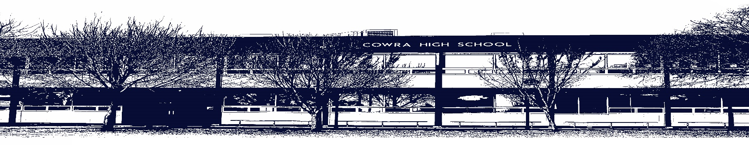

COWRA HIGH SCHOOL

Assessment Task Submission Policy

Submission of assessment tasks by students must follow faculty guidelines. There are basically four types of assessment tasks:

- In Class Assessment Tasks ~ these tasks are supervised by the class teacher and collected by the class teacher at the conclusion of the assessment task. It is the responsible of the student who miss in class assessment tasks to contact the Head Teacher of that faculty.

- Formal Examinations ~ at the conclusion of any formal examination the assessment task papers are to be collected and returned to the relevant faculty teacher.

- Major Projects / Pieces of Work ~ these items, due to their size, are usually kept in the appropriate faculty location. Major works and projects should be kept in safe locations that minimises the risk of damage. Any assessment task would be submitted directly to the teacher. A receipt for the task will be issued to students.

- Take Home Assessment Tasks ~ these are tasks that students are required to complete by a due date. Students should follow faculty submission guidelines regarding submission of these tasks.

Guidelines for the Submission of Assessment Tasks

- When an assessment task is issued, the information provided to students will include:
- a clear statement of what the task involves and what the expectations of the student are
- an explanation of the marking criteria / outcomes to be assessed
- the due date of submission
- an assessment task submission cover sheet ~ see attached

- Teachers should record the names of all students issued with the assessment task on a roll/class list and have the student acknowledge receipt of the assessment task by getting them to sign next to their name.

- Students must take their assessment task to the class teacher. They must be signed in on the class roll and keep their receipt

- All students must keep a copy of their assessment task.

Illness and Misadventure Appeals

If a student fails to submit an assessment task by the due date and has a legitimate reason than normal illness and misadventure procedures will apply.

REQUEST FOR ASSESSMENT EXTENSION PROCEDURE

Assessment extensions will only be granted in exceptional circumstances. All requests need to be made in writing using the extension request form. In seeking an extension discuss your request with your teacher/Head Teacher at least three (3) days before the due date with work already completed.
Forms for Illness/Misadventure and Extension can be accessed on the
Cowra High School Website.

