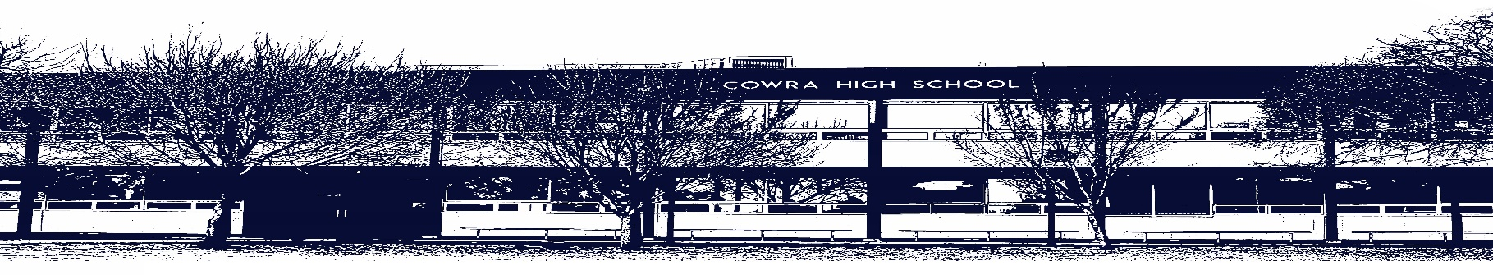

COWRA HIGH SCHOOL

ASSESSMENT TASK COVER SHEET

This sheet must be attached to the front of your Assessment Task and submitted to your class teacher on or before the due date.

Student’s Name: _________________________________________
Course: Stage 5 Music
Assessment Task: Assessment Task 1 - Performance
Date Received: 04/03/2021
Date Due: 22/03/2021

Extension granted _____ days
Other circumstances ~ documents attached

I certify:
- This assignment is entirely my own work and all borrowed material has been acknowledged
- The material contained in this assignment has not previously been submitted for assessment in any formal course of study
- I retain in my possession a copy of this assignment
- I understand that late assignments will be penalised unless an extension has been granted by Deputy Principal - Curriculum

Student’s Signature: ____________________________

-------------------------------------------------------------------------------------------------------------------------------
COWRA HIGH SCHOOL
Assessment Task (Student’s Copy)
Student’s Name: _________________________________________
Course: Stage 5 Music
Teacher: K. Smith & D. Hughes

Assessment Task received by: _________________________________________
Signature: _________________________________________
Date: ______________________ Time: ______________________
Please detach this if the Assessment Task has been handed in
to the office and give to student to keep for their own records.
COWRA HIGH SCHOOL
Stage 5 Assessment Task 1
NAME: |  |  | CLASS: Stage 5 Music |  |  |  | TEACHER: D Hughes, K Smith
COURSE: Stage 5 Music |  | TASK No: 1 |  |  |  | Unit: Australian Music
DATE DUE: 22/03/2021 |  |  |  | Time Due: In Class
MARK: /25 | WEIGHT: 25% |  |  |  | PRESENTATION: Performance
SYLLABUS OUTCOMES:
5.1 Performs repertoire with increasing levels of complexity in a range of musical styles demonstrating an understanding of the musical concepts
5.2 Performs repertoire in a range of styles and genres demonstrating interpretation of musical notation and the application of different types of technology
5.3 Performs music selected for study with appropriate stylistic features demonstrating solo and ensemble awareness
DESCRIPTION OF TASK:

- Prepare and perform a piece of music of your own choosing from the topic ‘Australian Music’.
- Your piece must be composed/written by an Australian artist/band of your choosing.
- The maximum performance time is 5 minutes.
- The piece will be presented in class time.
- You may perform by yourself, with a backing track, or in a group.
- You will be marked on your ability to show technical skill on your instrument, show self-expression, and your confidence in your performance.
- Evaluation: Following the performance, you will complete an evaluation sheet of your performance.

Stage 5 Music Performance Assessment 1, Term 1
Name
Due: 22/03/2017
Outcomes -5.1 – Performs repertoire with increasing levels of complexity, 5.2 – Performs repertoire in a range of styles, 5.3 – Performs music displaying solo or ensemble skills.
Task - To play a piece of your own choice. You may play by yourself or as part of an ensemble (in a group).
Criteria - You will be marked on your ability to:
- Display technique skill on your instrument/voice to the best of your ability.
- Performs with appropriate musical expression.
- Performs with confidence.
- Write an evaluation of your performance.
Evaluation
Were you nervous?
______________________________________________________________________________________________________________________________________________________________________________________________
How did the nerves affect the performance?
______________________________________________________________________________________________________________________________________________________________________________________________
What were you happy with?
_____________________________________________________________________________________________________________________________________________________________________________________________________________________________________________________________________________________________
What would you like to improve?
____________________________________________________________________________________________________________________________________________________________________________________________________________________________________________________________________________________________________________________________________________________________________________________________
How could change how you prepare for a performance to give a better performance next time?
_____________________________________________________________________________________________________________________________________________________________________________________________________________________________________________________________________________________________
Overall I rate my performance as being (from 1, which requires a lot of work, to 15, which is excellent)
1 | 2 | 3 | 4 | 5 | 6 | 7 | 8 | 9 | 10 | 11 | 12 | 13 | 14 | 15

Performance /15 Evaluation /5 Total /20
Performance Examination:

Criteria | 5 marks | 4 marks | 3 marks | 2 marks | 1 mark
Instrumental Skill (playing the correct notes in the correct time, performs for a substantial length of time) | -Full length piece: 3 to 5 minutes  -Performs with fluency and clarity | -3 minute piece  -Many moments of fluency, clarity and facility demonstrated | -2 minute piece  -Some problems sustaining fluency and facility  -Performs without assistance | -Short 1 minute piece  -Many fluency and pulse issues  -Performs without assistance, or one or two moments of assistance | -Short 30 second piece  -No evidence of fluency or steady pulse  -Performs with assistance
Instrumental Technique (good technique on your instrument/voice) | Highly Accomplished use of instrumental/vocal techniques | Accomplished use of instrumental/vocal techniques | Sound use of instrumental/vocal techniques | Basic use of instrumental/vocal techniques | Limited use of instrumental/vocal techniques
Musial Expression (performs the music expressively) | -Extensive and appropriate use of dynamic variety  -Accomplished use of phrasing and articulation  -Attempts to make the piece your own | -Appropriate use of a variety of dynamics  -Evidence of phrasing and articulation  -Attempts to make the piece your own | -Uses appropriate dynamics for the style of the piece inconsistently  -Some evidence of phrasing and articulation. | -Some dynamic variety evident  –Limited use of phrasing | -No dynamic variety evident  -No evidence of phrasing
Confidence | -Highly accomplished performance technique and flair  -Very well prepared  -Performs with flair for class | -Many moments of flair  -Accomplished performance technique  -Performs for class or with flair for small group | -Sound performance technique  -Evidence of preparation for performance for small group or performs with flair for teacher | -Basic performance technique  -Some evidence of preparation for performance  -Performs for teacher | -Limited performance technique  -Little to no evidence of preparation for performance  -Performs for teacher
Evaluation | -Highly detailed evaluation demonstrating an extensive understanding of both the strengths and weaknesses of the performance | -Detailed evaluation demonstrating thorough understanding of both the strengths and weaknesses of the performance | -Evaluation demonstrates a sound understanding of the strengths and weaknesses of the performance | -Evaluation demonstrates a basic understanding of strengths and/or weaknesses of the performance | -Evaluation demonstrates a limited understanding of the strengths and/or weaknesses of the performance

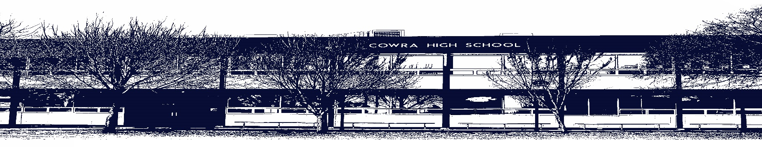

COWRA HIGH SCHOOL

Assessment Task Submission Policy

Submission of assessment tasks by students must follow faculty guidelines. There are basically four types of assessment tasks:

- In Class Assessment Tasks ~ these tasks are supervised by the class teacher and collected by the class teacher at the conclusion of the assessment task. It is the responsible of the student who miss in class assessment tasks to contact the Head Teacher of that faculty.

- Formal Examinations ~ at the conclusion of any formal examination the assessment task papers are to be collected and returned to the relevant faculty teacher.

- Major Projects / Pieces of Work ~ these items, due to their size, are usually kept in the appropriate faculty location. Major works and projects should be kept in safe locations that minimises the risk of damage. Any assessment task would be submitted directly to the teacher. A receipt for the task will be issued to students.

- Take Home Assessment Tasks ~ these are tasks that students are required to complete by a due date. Students should follow faculty submission guidelines regarding submission of these tasks.

Guidelines for the Submission of Assessment Tasks

- When an assessment task is issued, the information provided to students will include:
- a clear statement of what the task involves and what the expectations of the student are
- an explanation of the marking criteria / outcomes to be assessed
- the due date of submission
- an assessment task submission cover sheet ~ see attached

- Teachers should record the names of all students issued with the assessment task on a roll/class list and have the student acknowledge receipt of the assessment task by getting them to sign next to their name.

- Students must take their assessment task to the class teacher. They must be signed in on the class roll and keep their receipt

- All students must keep a copy of their assessment task.

Illness and Misadventure Appeals

If a student fails to submit an assessment task by the due date and has a legitimate reason than normal illness and misadventure procedures will apply.

REQUEST FOR ASSESSMENT EXTENSION PROCEDURE

Assessment extensions will only be granted in exceptional circumstances. All requests need to be made in writing using the extension request form. In seeking an extension discuss your request with your teacher/Head Teacher at least three (3) days before the due date with work already completed.

Forms for Illness/Misadventure and Extension can be accessed on the
Cowra High School Website.

