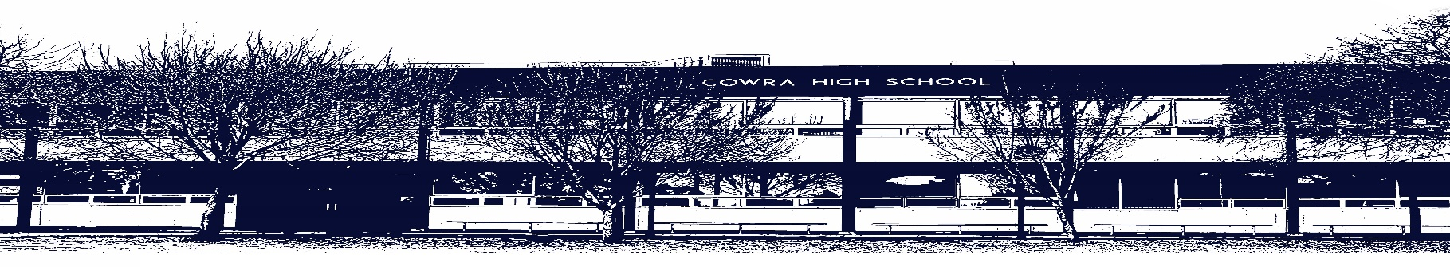

COWRA HIGH SCHOOL

ASSESSMENT TASK COVER SHEET

This sheet must be attached to the front of your Assessment Task and submitted to your class teacher on or before the due date.

Student’s Name: _________________________________________
Course: Year 10 English
Assessment Task: Essay – Power Play
Date Due: Monday 29th March, 2021 Week 10
Date Received: _______________
Extension granted _____ days
Other circumstances ~ documents attached

I certify:
- This assignment is entirely my own work and all borrowed material has been acknowledged
- The material contained in this assignment has not previously been submitted for assessment in any formal course of study
- I retain in my possession a copy of this assignment
- I understand that late assignments will be penalised unless an extension has been granted by Deputy Principal - Curriculum

Student’s Signature: ____________________________

-------------------------------------------------------------------------------------------------------------------------------
COWRA HIGH SCHOOL
Assessment Task (Student’s Copy)
Student’s Name: _________________________________________
Course: Year 10 English
Teacher: Perkins / Sullivan / Tait

Assessment Task received by: _________________________________________
Signature: _________________________________________
Date: ______________________ Time: ______________________

Please detach this if the Assessment Task has been handed in
to the office and give to student to keep for their own records.

COWRA HIGH SCHOOL
Year 10 Assessment Task
NAME: |  |  | CLASS: |  |  | TEACHER:
COURSE: Year 10 English |  | TASK No: 1 |  |  | Unit: Power Play - Shakespeare
DATE DUE: Monday 29th March 2021 |  |  |  |  |  | TIME DUE: In Class
MARK: /20 | WEIGHT: 25% |  |  | PRESENTATION: Extended Response - Essay
SYLLABUS OUTCOMES:

EN5-1A responds to and composes increasingly sophisticated and sustained texts for understanding, interpretation, critical analysis, imaginative expression and pleasure
EN5-3B selects and uses language forms, features and structures of texts appropriate to a range of purposes, audiences and contexts, describing and explaining their effects on meaning
EN5-5C thinks imaginatively, creatively, interpretively and critically about information and increasingly complex ideas and arguments to respond to and compose texts in a range of contexts
EN5-7D understands and evaluates the diverse ways texts can represent personal and public worlds

DESCRIPTION OF TASK:

Over the course of the term, you have been studying a Shakespearean play. Using the knowledge you have acquired from reading and analysing the way Shakespeare has constructed these representations, answer the following question:

“There are many characters who possess power in Macbeth but none so destructive as Macbeth himself.” (Macbeth)

Do you agree with this statement? Provide evidence from the play to support your answer.

Or

“In what way does the feud between the families drive the action of the play?”
(Romeo and Juliet)

Provide evidence from the play to support your answer. Use the guide below to help shape your answer. Your essay should be approx. 750 – 1000 words

- Begin by planning your answer – make a list of arguments for or against this question.
- Find examples from the play that support your arguments
- List examples of Shakespearean techniques that further support your arguments and show HOW eg a soliloquy, iambic pentameter etc.

You will be assessed on your ability to:
- Express your ideas clearly using appropriate language.
- Engage with the text and your understanding of the characters, themes and techniques of the text or other elements appropriate to the topic. Shakespearean techniques are especially important.
- Use appropriate textual examples to support your arguments.

MARKING CRITERIA:

Mark | Criteria
A  17 - 20 | - Demonstrates a well developed understanding of the distinctive qualities of power in the play  - Reflects perceptively on ideas and dramatic techniques  - Uses sophisticated textual examples to support arguments  - Organises, develops and expresses ideas skilfully
B  13 - 16 | - Demonstrates sound understanding of the distinctive qualities of power in the play.  - Reflects thoughtfully on ideas and dramatic techniques  - Uses effective textual examples to support arguments.  - Organises, develops and expresses ideas effectively
C  9 – 12 | - Demonstrates adequate understanding of power in the play  - Reflects on ideas and dramatic techniques  - Uses basic textual examples to support ideas  - Organises, develops and expresses ideas appropriately
D  5 – 8 | - Demonstrates limited understanding of power in the play  - Little or no reflection on ideas and dramatic techniques  - Basic textual references  - Organises and expresses ideas in simple language with a limited appropriateness
E  0 - 4 | - Demonstrates elementary understanding of the play  - Response may be limited  - Elementary use of language  - Little textual reference

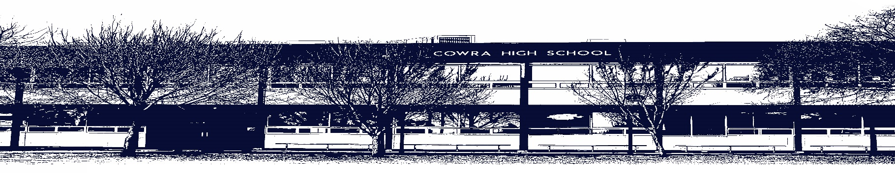

COWRA HIGH SCHOOL

Assessment Task Submission Policy

Submission of assessment tasks by students must follow faculty guidelines. There are basically four types of assessment tasks:

- In Class Assessment Tasks ~ these tasks are supervised by the class teacher and collected by the class teacher at the conclusion of the assessment task. It is the responsible of the student who miss in class assessment tasks to contact the Head Teacher of that faculty.

- Formal Examinations ~ at the conclusion of any formal examination the assessment task papers are to be collected and returned to the relevant faculty teacher.

- Major Projects / Pieces of Work ~ these items, due to their size, are usually kept in the appropriate faculty location. Major works and projects should be kept in safe locations that minimises the risk of damage. Any assessment task would be submitted directly to the teacher. A receipt for the task will be issued to students.

- Take Home Assessment Tasks ~ these are tasks that students are required to complete by a due date. Students should follow faculty submission guidelines regarding submission of these tasks.

Guidelines for the Submission of Assessment Tasks

- When an assessment task is issued, the information provided to students will include:
- a clear statement of what the task involves and what the expectations of the student are
- an explanation of the marking criteria / outcomes to be assessed
- the due date of submission
- an assessment task submission cover sheet ~ see attached

- Teachers should record the names of all students issued with the assessment task on a roll/class list and have the student acknowledge receipt of the assessment task by getting them to sign next to their name.

- Students must take their assessment task to the class teacher. They must be signed in on the class roll and keep their receipt

- All students must keep a copy of their assessment task.

Illness and Misadventure Appeals

If a student fails to submit an assessment task by the due date and has a legitimate reason than normal illness and misadventure procedures will apply.

REQUEST FOR ASSESSMENT EXTENSION PROCEDURE

Assessment extensions will only be granted in exceptional circumstances. All requests need to be made in writing using the extension request form. In seeking an extension discuss your request with your teacher/Head Teacher at least three (3) days before the due date with work already completed.

Forms for Illness/Misadventure and Extension can be accessed on the
Cowra High School Website.

