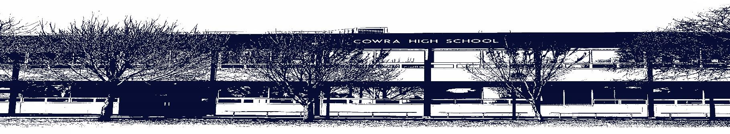

COWRA HIGH SCHOOL

ASSESSMENT TASK COVER SHEET

This sheet must be attached to the front of your Assessment Task and submitted to your class teacher on or before the due date.

Student’s Name: _________________________________________
Course: Stage 4 English – P Class
Assessment Task: Power of Poetry
Date Due: Monday Week 10, Term 1
Date Received: _______________
□ Extension granted _____ days
□ Other circumstances ~ documents attached

I certify:
- This assignment is entirely my own work and all borrowed material has been acknowledged
- The material contained in this assignment has not previously been submitted for assessment in any formal course of study
- I retain in my possession a copy of this assignment
- I understand that late assignments will be penalised unless an extension has been granted by Deputy Principal - Curriculum

Student’s Signature: ____________________________

✂-------------------------------------------------------------------------------------------------------------------------------
COWRA HIGH SCHOOL
Assessment Task (Student’s Copy)
Student’s Name: _________________________________________
Course: Stage 4 English – P Class
Teacher: Perkins

Assessment Task received by: _________________________________________
Signature: _________________________________________
Date: ______________________ Time: ______________________

Please detach this if the Assessment Task has been handed in
to the office and give to student to keep for their own records.
COWRA HIGH SCHOOL
Stage 4 Assessment Task
NAME: |  |  | CLASS: |  |  | TEACHER: Perkins
COURSE: Stage 4 AES English |  | TASK No: 1 |  |  | Unit: Power of Poetry
DATE DUE: Monday Week 10, Term 1 (29th March 2021) |  |  |  |  |  | TIME DUE: In class
MARK: 20 | WEIGHT: 25% |  |  | PRESENTATION: Extended response and  analysis
SYLLABUS OUTCOMES:

- EN4-1A responds to and composes texts for understanding, interpretation, critical analysis, imaginative expression and pleasure
- EN4-2A effectively uses a widening range of processes, skills, strategies and knowledge for responding to and composing texts in different media and technologies
- EN4-3B uses and describes language forms, features and structures of texts appropriate to a range of purposes, audiences and contexts
- EN4-4B makes effective language choices to creatively shape meaning with accuracy, clarity and coherence
- EN4-9E uses, reflects on and assesses their individual and collaborative skills for learning

DESCRIPTION OF TASK:

During this unit you have been looking at the power of poetry, specifically the way in which composers use techniques to communicate information, ideas and feelings. Additionally, you have come to understand how words invite associations (connotations) from readers.

Your task is to select a suitable poem for analysis using the step up scaffold;

- Annotate the poem finding the techniques used by the poet, identifying the way in which meaning is communicated.

- Use the STEP UP scaffold to help you deconstruct the poem further.

- Using all your analysis from above, write an extended response that addresses the following question;

How effectively has the poet created meaning in the poem you have chosen?

Your response should be 500-750 words.

You will be assessed on your ability to:

- analyse a poem correctly, identifying the techniques used by the composer
- communicate your ideas about a poem
- be able to discuss effectively the techniques used and their effects

ANALYSING POETRY – STEP UP
STEP UP is an acronym that should help you remember how to deconstruct and discuss a poem. The example studied in class should also help you.

S Subject Matter
The subject matter is the underlying content of the poem. You should identify this in your opening paragraph.

T Theme
The theme of the poem is the message that the poem conveys to the reader. Is it the injustice of war? Does the poem explore the destruction of the environment?

E Emotions
Many poems engage the emotions of the reader in order to draw the reader into the subject matter. Poets often use imagery and other poetic devices such as metaphors and similes, to invite this emotional response.

P Poetic devices
Looking at how poetic devices have been used is important. It helps you understand the images that the poet wants to create and the meaning that they want to convey.

U You
This element of poetry deconstruction demands your response. How are you as the reader meant to feel about the poem?

P Purpose
The purpose of the poem is the reason why the poem was written.

MARKING CRITERIA:

Mark | Criteria
A  17 - 20 | - Demonstrates a sophisticated understanding of the techniques used in the poem selected.  - Reflects perceptively on how meaning is created through the techniques employed by the composer.  - Uses sophisticated textual examples to support discussion  - Organises, develops and expresses ideas skilfully, using correct spelling, grammar and punctuation
B  13 - 16 | - Demonstrates a sound understanding of the techniques used in the poem selected.  - Reflects thoughtfully on how meaning is created through the techniques employed by the composer.  - Uses sound textual examples to support discussion  - Organises, develops and expresses ideas skilfully, using correct spelling, grammar and punctuation
C  9 – 12 | - Demonstrates adequate understanding of the techniques used in the poem selected.  - Reflects on how meaning is created through techniques  - Uses basic textual examples to support ideas  - Organises, develops and expresses ideas adequately
D  5 – 8 | - Demonstrates limited understanding of the techniques used in the poem selected.  - Little or no reflection on how meaning is created  - Basic to minimal textual references  - Organises and expresses ideas in simple language
E  0 - 4 | - Demonstrates elementary understanding of the techniques  - Response may be limited  - Elementary use of language  - Little textual reference

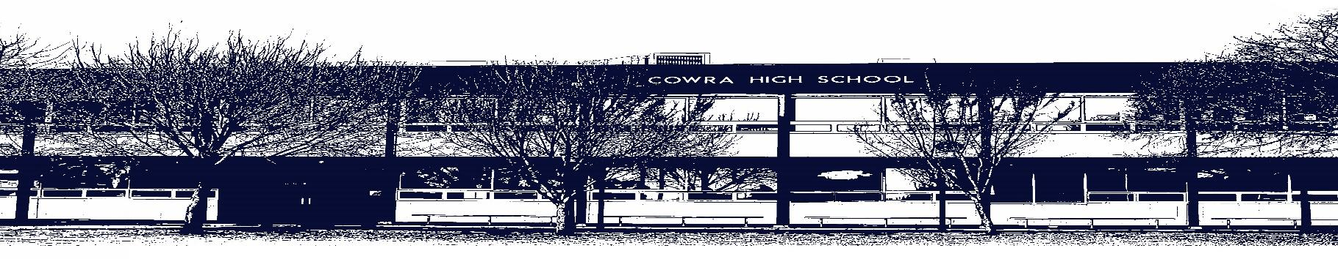

COWRA HIGH SCHOOL

Assessment Task Submission Policy

Submission of assessment tasks by students must follow faculty guidelines. There are basically four types of assessment tasks:

- In Class Assessment Tasks ~ these tasks are supervised by the class teacher and collected by the class teacher at the conclusion of the assessment task. It is the responsible of the student who miss in class assessment tasks to contact the Head Teacher of that faculty.

- Formal Examinations ~ at the conclusion of any formal examination the assessment task papers are to be collected and returned to the relevant faculty teacher.

- Major Projects / Pieces of Work ~ these items, due to their size, are usually kept in the appropriate faculty location. Major works and projects should be kept in safe locations that minimises the risk of damage. Any assessment task would be submitted directly to the teacher. A receipt for the task will be issued to students.

- Take Home Assessment Tasks ~ these are tasks that students are required to complete by a due date. Students should follow faculty submission guidelines regarding submission of these tasks.

Guidelines for the Submission of Assessment Tasks

- When an assessment task is issued, the information provided to students will include:
- a clear statement of what the task involves and what the expectations of the student are
- an explanation of the marking criteria / outcomes to be assessed
- the due date of submission
- an assessment task submission cover sheet ~ see attached

- Teachers should record the names of all students issued with the assessment task on a roll/class list and have the student acknowledge receipt of the assessment task by getting them to sign next to their name.

- Students must take their assessment task to the class teacher. They must be signed in on the class roll and keep their receipt

- All students must keep a copy of their assessment task.

Illness and Misadventure Appeals

If a student fails to submit an assessment task by the due date and has a legitimate reason than normal illness and misadventure procedures will apply.

REQUEST FOR ASSESSMENT EXTENSION PROCEDURE

Assessment extensions will only be granted in exceptional circumstances. All requests need to be made in writing using the extension request form. In seeking an extension discuss your request with your teacher/Head Teacher at least three (3) days before the due date with work already completed.

Forms for Illness/Misadventure and Extension can be accessed on the
Cowra High School Website.

