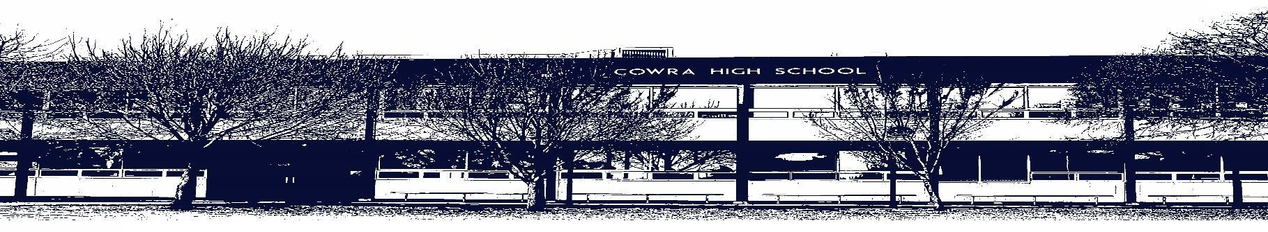

COWRA HIGH SCHOOL

ASSESSMENT TASK COVER SHEET

This sheet must be attached to the front of your Assessment Task and submitted to your class teacher on or before the due date.

Student’s Name: _________________________________________
Course: Year 7 English
Assessment Task: Power of Poetry
Date Due: Monday Week 10, Term 1
Date Received: _______________
□ Extension granted _____ days
□ Other circumstances ~ documents attached

I certify:
- This assignment is entirely my own work and all borrowed material has been acknowledged
- The material contained in this assignment has not previously been submitted for assessment in any formal course of study
- I retain in my possession a copy of this assignment
- I understand that late assignments will be penalised unless an extension has been granted by Deputy Principal - Curriculum

Student’s Signature: ____________________________

✂-------------------------------------------------------------------------------------------------------------------------------
COWRA HIGH SCHOOL
Assessment Task (Student’s Copy)
Student’s Name: _________________________________________
Course: Year 7 English
Teacher: Burrell / Sullivan / Tait

Assessment Task received by: _________________________________________
Signature: _________________________________________
Date: ______________________ Time: ______________________

Please detach this if the Assessment Task has been handed in
to the office and give to student to keep for their own records.
COWRA HIGH SCHOOL
Year 7 Assessment Task
NAME: |  |  | CLASS: |  |  | TEACHER:
COURSE: Year 7 English |  | TASK No: 1 |  |  | Unit: Power of Poetry
DATE DUE: Monday 29th March, Week 10 Term 1 |  |  |  |  |  | TIME DUE: In Class
MARK: 20 | WEIGHT: 25% |  |  | PRESENTATION: Poetry Analysis
SYLLABUS OUTCOMES:

EN4-1A responds to and composes texts for understanding, interpretation, critical analysis, imaginative expression and pleasure
EN4-2A effectively uses a widening range of processes, skills, strategies and knowledge for responding to and composing texts in different media and technologies
EN4-3B uses and describes language forms, features and structures of texts appropriate to a range of purposes, audiences and contexts
EN4-4B makes effective language choices to creatively shape meaning with accuracy, clarity and coherence
EN4-9E uses, reflects on and assesses their individual and collaborative skills for learning
DESCRIPTION OF TASK:

During this unit, you have been looking at the power of poetry and the way in which composers use techniques to communicate information, ideas and feelings. You have also come to understand how words invite associations (connotations) in readers.
Your task is to find a poem (which you select yourself (and seek approval from your teacher) or use one of the attached poems) and analyse it to find the language techniques used by the composer.
You must submit the annotated poem and the following questions to your teacher for marking by the due date.

You are to answer the following questions in full sentences;

- Annotate the poem by highlighting the techniques used by the composer (3 marks)
- What is the structure of the poem? (1 mark)
- What do you think are the main themes and ideas in the poem? How do you know this? (3 marks)
- In your opinion, what is the most effective technique used and why? (3 marks)
- How would you assess the quality of the poem? What do you see as the strengths and weaknesses of the poems? (5 marks)
- How is imagery and symbolism used in the poem? (2 marks)
- What impact does this have on the reader? (3 marks)

You will be assessed on your ability to:

- analyse a poem correctly, identifying the techniques used by the composer
- communicate your ideas about a poem
- be able to discuss the techniques used and their effects
Storming the Desert

By John Tomlin

No more dumb bombs

for DEATH —

they're smart now.

Had an education

on how to seek out

that little extracurricular

bit of flesh

and sear it RED.

They're not dumb any more —

BOMBS —

"we produce smart

ones now"

finely honed by

intelligences

as precise

as their

own

intelligent enough

to round corners

wait at red lights

enter shelters

where

dumb women

dumb children

dumb men

dumb elders

hide

and burn to

steaming tar

their totally

unintelligent

flesh.

She Dwelt among the Untrodden Ways
By William Wordsworth
She dwelt among the untrodden ways
Beside the springs of Dove,
A Maid whom there were none to praise
And very few to love:

A violet by a mossy stone
Half hidden from the eye!
—Fair as a star, when only one
Is shining in the sky.

She lived unknown, and few could know
When Lucy ceased to be;
But she is in her grave, and, oh,
The difference to me!

To Margo
by Gavin Ewart

In life’s rough-and-tumble
you’re the crumble on my apple crumble
and the fairy on my Christmas tree!
In life’s death-and-duty
you’ve the beauty of the Beast’s own Beauty—
I feel humble as a bumble-bee!

In life’s darkening duel
I’m the lighter, you’re the lighter fuel—
And the tide that sways my inland sea!
In life’s meet-and-muster
you’ve the lustre of a diamond cluster—
a blockbuster — just a duster, me!

The Tale of Custard the Dragon
By Ogden Nash

Belinda lived in a little white house,
With a little black kitten and a little gray mouse,
And a little yellow dog and a little red wagon,
And a realio, trulio, little pet dragon.

Now the name of the little black kitten was Ink,
And the little gray mouse, she called her Blink,
And the little yellow dog was sharp as Mustard,
But the dragon was a coward, and she called him Custard.

Custard the dragon had big sharp teeth,
And spikes on top of him and scales underneath,
Mouth like a fireplace, chimney for a nose,
And realio, trulio, daggers on his toes.

Belinda was as brave as a barrel full of bears,
And Ink and Blink chased lions down the stairs,
Mustard was as brave as a tiger in a rage,
But Custard cried for a nice safe cage.

Belinda tickled him, she tickled him unmerciful,
Ink, Blink and Mustard, they rudely called him Percival,
They all sat laughing in the little red wagon
At the realio, trulio, cowardly dragon.

Belinda giggled till she shook the house,
And Blink said Week! , which is giggling for a mouse,
Ink and Mustard rudely asked his age,
When Custard cried for a nice safe cage.

Suddenly, suddenly they heard a nasty sound,
And Mustard growled, and they all looked around.
Meowch! cried Ink, and Ooh! cried Belinda,
For there was a pirate, climbing in the winda.

Pistol in his left hand, pistol in his right,
And he held in his teeth a cutlass bright,
His beard was black, one leg was wood;
It was clear that the pirate meant no good.

Belinda paled, and she cried, Help! Help!
But Mustard fled with a terrified yelp,
Ink trickled down to the bottom of the household,
And little mouse Blink strategically mouseholed.

But up jumped Custard, snorting like an engine,
Clashed his tail like irons in a dungeon,
With a clatter and a clank and a jangling squirm
He went at the pirate like a robin at a worm.

The pirate gaped at Belinda's dragon,
And gulped some grog from his pocket flagon,
He fired two bullets but they didn't hit,
And Custard gobbled him, every bit.

Belinda embraced him, Mustard licked him,
No one mourned for his pirate victim
Ink and Blink in glee did gyrate
Around the dragon that ate the pyrate.

But presently up spoke little dog Mustard,
I'd been twice as brave if I hadn't been flustered.
And up spoke Ink and up spoke Blink,
We'd have been three times as brave, we think,
And Custard said, I quite agree
That everybody is braver than me.

Belinda still lives in her little white house,
With her little black kitten and her little gray mouse,
And her little yellow dog and her little red wagon,
And her realio, trulio, little pet dragon.

Belinda is as brave as a barrel full of bears,
And Ink and Blink chase lions down the stairs,
Mustard is as brave as a tiger in a rage,
But Custard keeps crying for a nice safe cage.

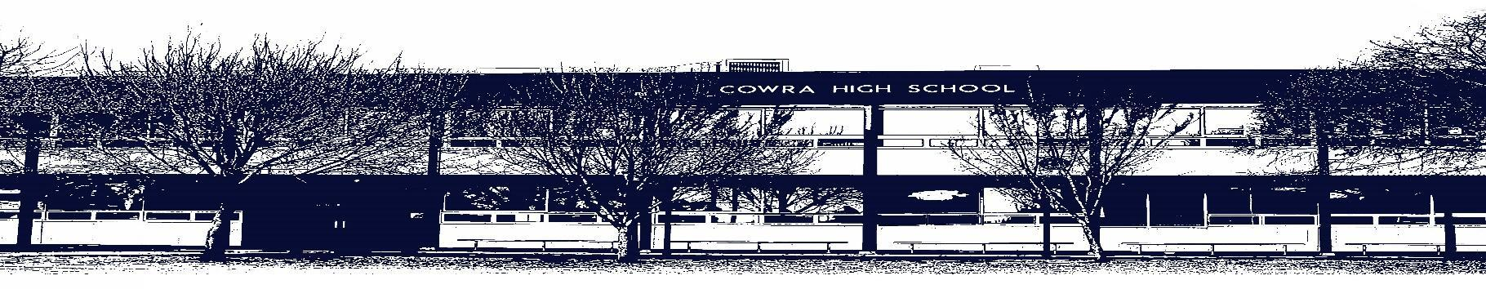

COWRA HIGH SCHOOL

Assessment Task Submission Policy

Submission of assessment tasks by students must follow faculty guidelines. There are basically four types of assessment tasks:

- In Class Assessment Tasks ~ these tasks are supervised by the class teacher and collected by the class teacher at the conclusion of the assessment task. It is the responsible of the student who miss in class assessment tasks to contact the Head Teacher of that faculty.

- Formal Examinations ~ at the conclusion of any formal examination the assessment task papers are to be collected and returned to the relevant faculty teacher.

- Major Projects / Pieces of Work ~ these items, due to their size, are usually kept in the appropriate faculty location. Major works and projects should be kept in safe locations that minimises the risk of damage. Any assessment task would be submitted directly to the teacher. A receipt for the task will be issued to students.

- Take Home Assessment Tasks ~ these are tasks that students are required to complete by a due date. Students should follow faculty submission guidelines regarding submission of these tasks.

Guidelines for the Submission of Assessment Tasks

- When an assessment task is issued, the information provided to students will include:
- a clear statement of what the task involves and what the expectations of the student are
- an explanation of the marking criteria / outcomes to be assessed
- the due date of submission
- an assessment task submission cover sheet ~ see attached

- Teachers should record the names of all students issued with the assessment task on a roll/class list and have the student acknowledge receipt of the assessment task by getting them to sign next to their name.

- Students must take their assessment task to the class teacher. They must be signed in on the class roll and keep their receipt

- All students must keep a copy of their assessment task.

Illness and Misadventure Appeals

If a student fails to submit an assessment task by the due date and has a legitimate reason than normal illness and misadventure procedures will apply.

REQUEST FOR ASSESSMENT EXTENSION PROCEDURE

Assessment extensions will only be granted in exceptional circumstances. All requests need to be made in writing using the extension request form. In seeking an extension discuss your request with your teacher/Head Teacher at least three (3) days before the due date with work already completed.

Forms for Illness/Misadventure and Extension can be accessed on the
Cowra High School Website.

