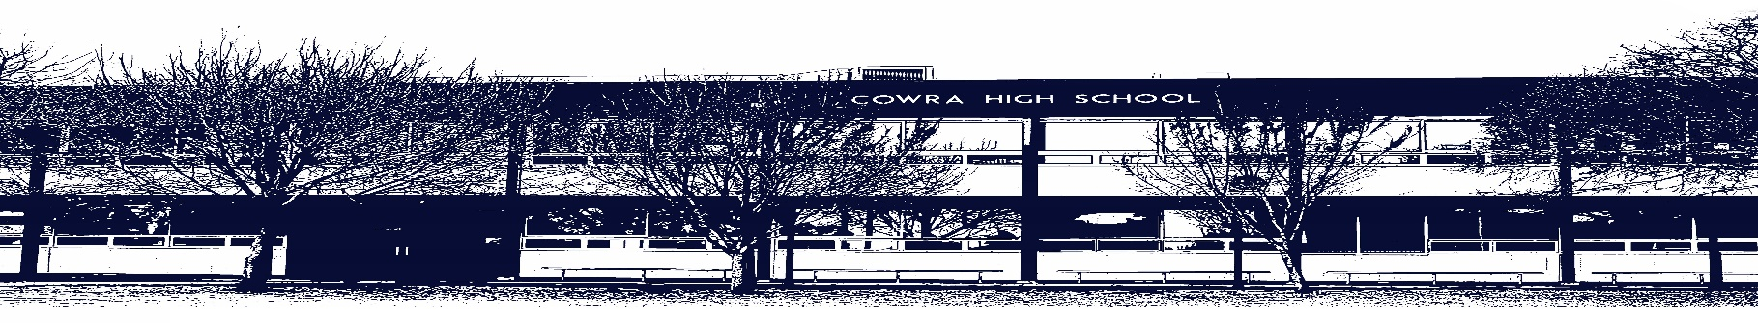

COWRA HIGH SCHOOL

ASSESSMENT TASK COVER SHEET

This sheet must be attached to the front of your Assessment Task and submitted to your class teacher on or before the due date.

Student’s Name: _________________________________________
Course: Year 9 English
Assessment Task: Monday 29th March, Week 10 Term 1
Date Due: _______________
Date Received: _______________
Extension granted _____ days
Other circumstances ~ documents attached

I certify:
- This assignment is entirely my own work and all borrowed material has been acknowledged
- The material contained in this assignment has not previously been submitted for assessment in any formal course of study
- I retain in my possession a copy of this assignment
- I understand that late assignments will be penalised unless an extension has been granted by Deputy Principal - Curriculum

Student’s Signature: ____________________________

-------------------------------------------------------------------------------------------------------------------------------
COWRA HIGH SCHOOL
Assessment Task (Student’s Copy)
Student’s Name: _________________________________________
Course: Year 9 English
Teacher: Sullivan / Burrell / Perkins

Assessment Task received by: _________________________________________
Signature: _________________________________________
Date: ______________________ Time: ______________________

Please detach this if the Assessment Task has been handed in
to the office and give to student to keep for their own records.

COWRA HIGH SCHOOL
Year 9 Assessment Task
NAME: |  |  | CLASS: |  |  | TEACHER:
COURSE: Year 9 English |  | TASK No: 1 |  |  | Unit: Imagined Worlds
DATE DUE: Monday 29th March 2021, Week 10 |  |  |  |  |  | TIME DUE: In class
MARK: /20 | WEIGHT: 25% |  |  | PRESENTATION: Imaginative Writing and Reflection Statement
SYLLABUS OUTCOMES:

EN5-1A responds to and composes increasingly sophisticated and sustained texts for understanding, interpretation, critical analysis, imaginative
expression and pleasure
EN5-3B selects and uses language forms, features and structures of texts appropriate to a range of purposes, audiences and contexts, describing
and explaining their effects on meaning
EN5-4B effectively transfers knowledge, skills and understanding of language concepts into new and different contexts
EN5-5C thinks imaginatively, creatively, interpretively and critically about information and increasingly complex ideas and arguments to respond to and
compose texts in a range of contexts
EN5-9E purposefully reflects on, assesses and adapts their individual and collaborative skills with increasing independence and effectiveness

DESCRIPTION OF TASK:

Part 1: Creative Writing

Use your imagination to compose a creative story (narrative) that will engage your audience. You should choose the genre that your class studied (fantasy, science fiction, crime, teen fiction etc.) Your narrative should demonstrate;
- The conventions of your chosen genre
- Represent a world that is not your own
- Be carefully edited
- Employ a variety of engaging language techniques to enhance your narrative

Your composition should be around 750 words.

Part 2: Reflection Statement

Compose a reflection statement that outlines your creative choices and the process you undertook in composing your narrative.

Using the ALARM scaffold attached to guide you, your reflection statement should;
- Provide a brief synopsis of your story and how it relates to the concept of Imagined Worlds
- Difficulties you encountered and solutions you found
- Techniques you used and why they are effective
- Comment on how your story fits into the genre studied. What texts influenced your work? In particular was it the setting, characters or other features specific to your genre?

MARKING CRITERIA:

Imaginative Writing and Reflection Statement

Mark | Criteria
A  17 - 20 | - Follows the conventions and structure of the narrative text type  - Demonstrates skilful control of language appropriate to audience, purpose, context and narrative type. Writing style has flair.  - Short story is highly original and highly imaginative.  - Presents a skilful statement that reflects on elements of writing and techniques used.
B  13 - 16 | - Follows the conventions and structure of the narrative text type  - Demonstrates well developed control of language appropriate to audience, purpose, context and narrative type. Writing style has moments of flair.  - Short story is original and imaginative.  - Presents an effective statement that reflects on elements of writing and techniques used
C  9 – 12 | - Follows the basic conventions and structure of the narrative text type  - Demonstrates control of language appropriate to audience, purpose, context and narrative type.  - Short story is original and has moments of imagination.  - Presents a statement that reflects on elements of writing and techniques used
D  5 – 8 | - Attempts to follow the conventions and structure of the narrative text type  - Demonstrates adequate control of language appropriate to audience, purpose, context and narrative type.  - Short story has moments of originality, may be cliché.  - Attempts to present a statement that reflects on elements of writing and techniques used
E  0 - 4 | - May not be an appropriate text type.  - Demonstrates elementary control of language  - Short story may not be original.  - Presents a limited reflection statement

ALARM Scaffold for Reflection Statement

NAME & DEFINE
Name your story and give a synopsis of your story

DESCRIBE
How have you represented this (what genre)? What structure did you use? How does it relate to Imagined Worlds?

EXPLAIN
What is the purpose of your story? Why have you represented the world in this way?

ANALYSE
What techniques did you employ? How did they enhance your imaginative writing?
Support with specific examples and quotes.

CRITICALLY ANALYSE
Conclusion you can make about the effectiveness of the techniques. What is the intended mood/tone and how is this shaped by the techniques.

EVALUATE/CONCLUDE
Make a judgement on how successful you have been in achieving the aims and the purpose of your narrative.

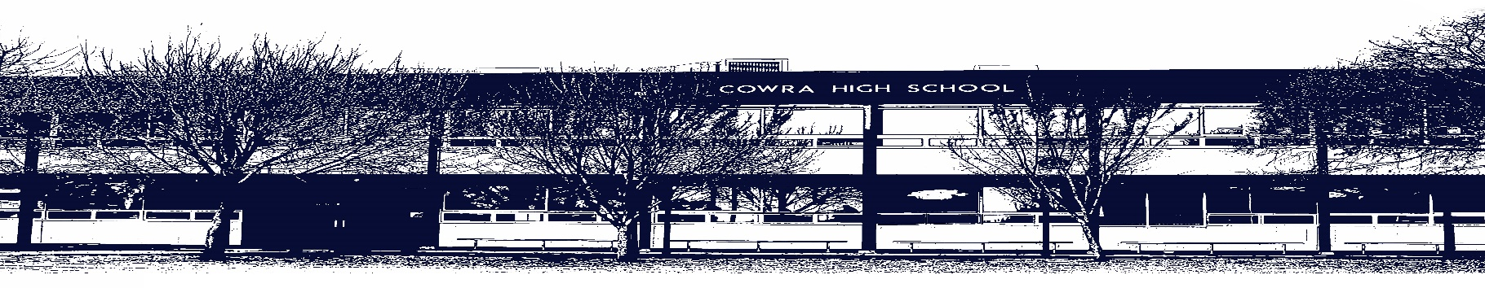

COWRA HIGH SCHOOL

Assessment Task Submission Policy

Submission of assessment tasks by students must follow faculty guidelines. There are basically four types of assessment tasks:

- In Class Assessment Tasks ~ these tasks are supervised by the class teacher and collected by the class teacher at the conclusion of the assessment task. It is the responsible of the student who miss in class assessment tasks to contact the Head Teacher of that faculty.

- Formal Examinations ~ at the conclusion of any formal examination the assessment task papers are to be collected and returned to the relevant faculty teacher.

- Major Projects / Pieces of Work ~ these items, due to their size, are usually kept in the appropriate faculty location. Major works and projects should be kept in safe locations that minimises the risk of damage. Any assessment task would be submitted directly to the teacher. A receipt for the task will be issued to students.

- Take Home Assessment Tasks ~ these are tasks that students are required to complete by a due date. Students should follow faculty submission guidelines regarding submission of these tasks.

Guidelines for the Submission of Assessment Tasks

- When an assessment task is issued, the information provided to students will include:
- a clear statement of what the task involves and what the expectations of the student are
- an explanation of the marking criteria / outcomes to be assessed
- the due date of submission
- an assessment task submission cover sheet ~ see attached

- Teachers should record the names of all students issued with the assessment task on a roll/class list and have the student acknowledge receipt of the assessment task by getting them to sign next to their name.

- Students must take their assessment task to the class teacher. They must be signed in on the class roll and keep their receipt

- All students must keep a copy of their assessment task.

Illness and Misadventure Appeals

If a student fails to submit an assessment task by the due date and has a legitimate reason than normal illness and misadventure procedures will apply.

REQUEST FOR ASSESSMENT EXTENSION PROCEDURE

Assessment extensions will only be granted in exceptional circumstances. All requests need to be made in writing using the extension request form. In seeking an extension discuss your request with your teacher/Head Teacher at least three (3) days before the due date with work already completed.

Forms for Illness/Misadventure and Extension can be accessed on the
Cowra High School Website.

