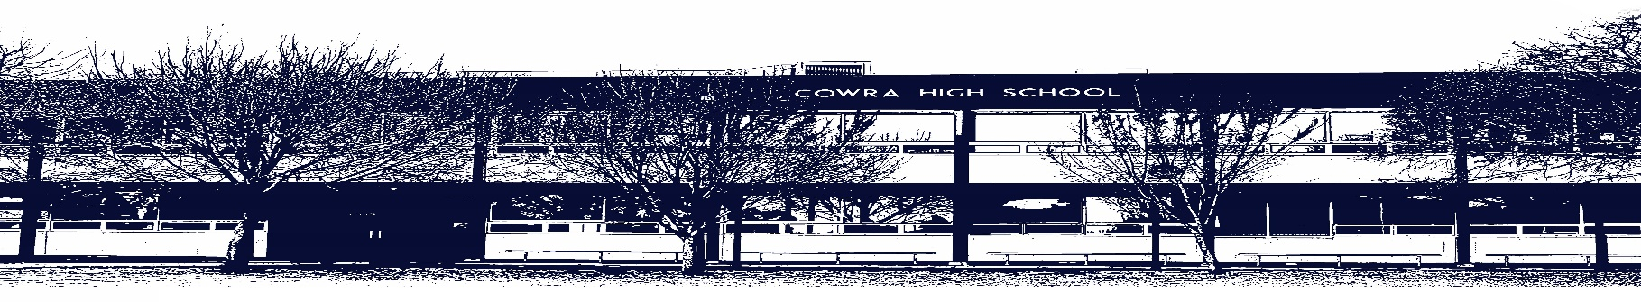

COWRA HIGH SCHOOL

ASSESSMENT TASK COVER SHEET

This sheet must be attached to the front of your Assessment Task and submitted to your class teacher on or before the due date.

Student’s Name: _________________________________________
Course: Industrial Technology Metal
Assessment Task: Project/Folio
Date Due: 1st April 2021
Date Received: 15th March 2021
Extension granted _____ days
Other circumstances ~ documents attached

I certify:
- This assignment is entirely my own work and all borrowed material has been acknowledged
- The material contained in this assignment has not previously been submitted for assessment in any formal course of study
- I retain in my possession a copy of this assignment
- I understand that late assignments will be penalised unless an extension has been granted by Deputy Principal - Curriculum

Student’s Signature: ____________________________

-------------------------------------------------------------------------------------------------------------------------------
COWRA HIGH SCHOOL
Assessment Task (Student’s Copy)
Student’s Name: _________________________________________
Course: Industrial Technology Metal
Teacher: Newbery

Assessment Task received by: _________________________________________
Signature: _________________________________________
Date: ______________________ Time: ______________________

Please detach this if the Assessment Task has been handed in
to the office and give to student to keep for their own records.

COWRA HIGH SCHOOL
Year 9 Assessment Task
NAME: Project/Folio |  | CLASS: Metal |  |  |  | TEACHER: Newbery
COURSE: Industrial Technology Stage 5 |  |  | TASK No: 1 |  | Unit: “G” Clamp Project/Folio
DATE DUE: 01/04/21 |  |  |  |  |  | TIME DUE: 3:15PM
MARK: /30 | WEIGHT: 25% |  |  | PRESENTATION: Practical/Online
SYLLABUS OUTCOMES: A Student:

IND5-1 identifies, assesses, applies and manages the risks and WHS issues associated with the use of a range of tools, equipment, materials, processes and technologies.
IND5-3 identifies, selects and uses a range of hand and machine tools, equipment and processes to produce quality practical projects.
IND5-8 evaluates products in terms of functional, economic, aesthetics and environmental qualities and quality of construction.
IND5-6 identifies and participates in collaborative work practices in the learning environment
IND5-5 selects, interprets and applies a range of suitable communication techniques in the, development, planning, production and presentation of ideas and projects.

DESCRIPTION OF TASK:

You will be assessed on the completion of the “Tool Box” practical project in class.
- Techniques
  - The accuracy of all measurements and marking out
  - The ability and skill level used to create a right angle corner joint, spot welding skills
  - You are required to work independently on project work after viewing the demonstration and reading supporting material.
- Documentation
  - Project Folio
(See template in Google Classroom)
- Design
  - Use the elements of design to create a balance between functional and aesthetic qualities in your project.
- WHS and risk Management.
  - Demonstrate your ability to use safe work practices and maintain a clean work environment.
- Workplace Communication Skills
  - You will be assessed on your conduct in the workshop (including observation of WHS requirements)
  - Your correct use of industry terminology and jargon.

MARKING CRITERIA:

Mark | Project/WHS | Folio
20-18 | The Student has:  - Completed high quality joints and produced a finished quality project on or before the due date, displaying superior skill when working with metal in the workshop  - Effectively applied design principles in the modification, development, and production of the project.  - Displayed in all processes an acute sense of safety that manages the risks and OHS issues associated with the use of a range of materials, hand tools, machine tools and processes using PPE and safe working methods  - Worked co-operatively with the surrounding people and kept on-task. | The Student has:  - Folio demonstrates an extensive knowledge & application of suitable communication techniques.  - Folio extensively demonstrates ALL areas stated in above task.  - Student has used advanced industry terminology and jargon.
17-14 | - Made strong, accurate joints and produced a quality project on or before the due date, displaying skill when working with metal in the workshop  - Successfully applied design principles in the modification, development, and production of projects  - Displays good sense of safety that manages the risks and WHS issues associated with the use of a range of materials, hand tools, machine tools and processes using PPE and safe working methods  - Worked co-operatively with the surrounding people and kept on-task most of the time | - Folio demonstrates a thorough knowledge & application of suitable communication techniques.  - Folio thoroughly demonstrates ALL areas stated in above task.  - Student has used accurate industry terminology
13 - 10 | - Produced strong joints and a completed project, displaying developing skill when working with metal in the workshop  - Applied some design principles in the modification, development, and production of projects  - Displayed an acceptable sense of safety that manages the risks and WHS issues associated with the use of a range of materials, hand tools, machine tools and processes using PPE and safe working methods  - Worked co-operatively with the surrounding people and managed to be on task regularly | - Folio demonstrates a sound knowledge & application of suitable communication techniques.  - Folio demonstrates a sound understanding of ALL areas stated in above task.  - Student has used sound industry terminology
9 - 5 | - Produced a project, displaying developing abilities when working with metal in the workshop  - To work towards applying design principles in the modification, development, and production of projects  - Demonstrated some safety management of the risks and WHS issues associated with the use of a range of materials, tools and processes using PPE  - Worked co-operatively with the surrounding people | - Folio demonstrates a basic knowledge & application of suitable communication techniques.  - Folio demonstrates a basic understanding of ALL areas stated in above task.  - Student has used basic industry terminology
4 - 1 | - Produced little or no work contributing towards a project  - Unsuccessfully applied design principles in the modification, development, and production of projects  - Displayed minimal safety methods when working with materials, tools and other people  - Trouble staying on task | - Folio demonstrates a limited knowledge & application of suitable communication techniques.  - Folio demonstrates a limited understanding of ALL areas stated in above task.  - Student has used limited industry terminology
Mark | /20 | /10

Teacher Comment:

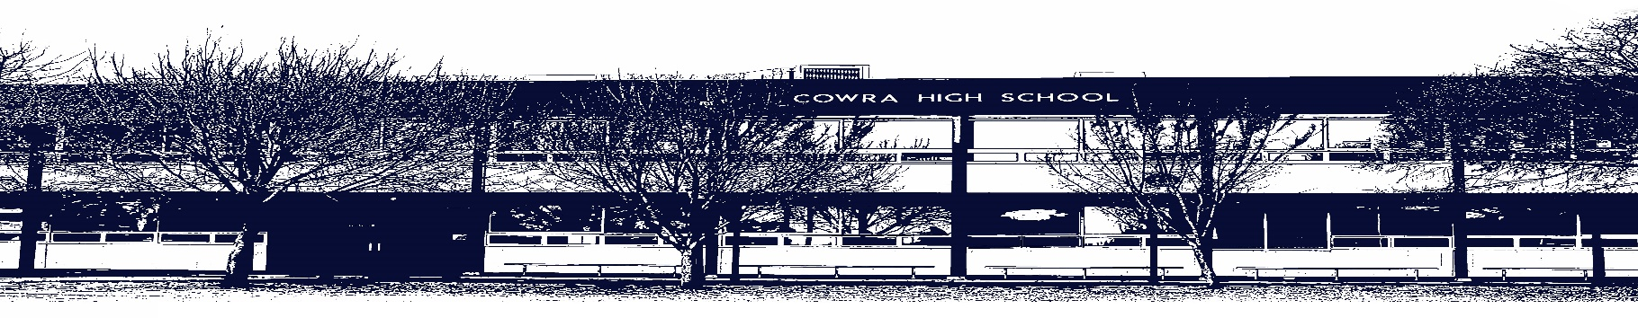

COWRA HIGH SCHOOL

Assessment Task Submission Policy

Submission of assessment tasks by students must follow faculty guidelines. There are basically four types of assessment tasks:
- In Class Assessment Tasks ~ these tasks are supervised by the class teacher and collected by the class teacher at the conclusion of the assessment task. It is the responsible of the student who miss in class assessment tasks to contact the Head Teacher of that faculty.

- Formal Examinations ~ at the conclusion of any formal examination the assessment task papers are to be collected and returned to the relevant faculty teacher.

- Major Projects / Pieces of Work ~ these items, due to their size, are usually kept in the appropriate faculty location. Major works and projects should be kept in safe locations that minimises the risk of damage. Any assessment task would be submitted directly to the teacher. A receipt for the task will be issued to students.

- Take Home Assessment Tasks ~ these are tasks that students are required to complete by a due date. Students should follow faculty submission guidelines regarding submission of these tasks.
Guidelines for the Submission of Assessment Tasks
- When an assessment task is issued, the information provided to students will include:
- a clear statement of what the task involves and what the expectations of the student are
- an explanation of the marking criteria / outcomes to be assessed
- the due date of submission
- an assessment task submission cover sheet ~ see attached

- Teachers should record the names of all students issued with the assessment task on a roll/class list and have the student acknowledge receipt of the assessment task by getting them to sign next to their name.

- Students must take their assessment task to the class teacher. They must be signed in on the class roll and keep their receipt

- All students must keep a copy of their assessment task.
Illness and Misadventure Appeals
If a student fails to submit an assessment task by the due date and has a legitimate reason than normal illness and misadventure procedures will apply.
REQUEST FOR ASSESSMENT EXTENSION PROCEDURE
Assessment extensions will only be granted in exceptional circumstances. All requests need to be made in writing using the extension request form. In seeking an extension discuss your request with your teacher/Head Teacher at least three (3) days before the due date with work already completed.
Forms for Illness/Misadventure and Extension can be accessed on the
Cowra High School Website.

