COWRA HIGH SCHOOL

ASSESSMENT TASK COVER SHEET

This sheet must be attached to the front of your Assessment Task and submitted to your class teacher on or before the due date.

Student’s Name: _________________________________________
Course: _________________________________________
Assessment Task: _________________________________________
Date Due: _______________
Date Received: _______________
Extension granted _____ days
Other circumstances ~ documents attached

I certify:
- This assignment is entirely my own work and all borrowed material has been acknowledged
- The material contained in this assignment has not previously been submitted for assessment in any formal course of study
- I retain in my possession a copy of this assignment
- I understand that late assignments will be penalised unless an extension has been granted by Deputy Principal - Curriculum

Student’s Signature: ____________________________

-------------------------------------------------------------------------------------------------------------------------------
COWRA HIGH SCHOOL
Assessment Task (Student’s Copy)
Student’s Name: _________________________________________
Course: _________________________________________
Teacher: _________________________________________

Assessment Task received by: _________________________________________
Signature: _________________________________________
Date: ______________________ Time: ______________________

Please detach this if the Assessment Task has been handed in
to the office and give to student to keep for their own records.

Cowra High School

STAGE 5 COMMERCE ASSESSMENT TASK
NAME : |  |  |  |  |  | CLASS : |  | Stage 5 |  | TEACHER : |  |  | S Johnstone
COURSE : |  | Commerce |  |  | TASK NO : |  | 3 |  | UNIT : |  | Purchasing a Car
DATE DUE : |  |  | 21/05/2021 |  |  | TIME DUE : |  |  | 3.15pm
MARK : | /20 |  |  | WEIGHT : | 25% | PRESENTATION: Google Slides
SYLLABUS OUTCOMES: A student:
5.1 applies consumer and financial concepts and terminology in a variety of contexts
5.2 analyses the rights and responsibilities of individuals in a range of consumer and financial contexts
5.4 analyses key factors affecting commercial decisions
5.5 evaluates options for solving commercial problems and issues
5.6 monitors and modifies the implementation of plans designed to solve commercial problems and issues
5.7 researches and assesses commercial information using a variety of sources
5.8 explains commercial information using a variety of forms
5.9 works independently to meet individual goals within specified timelines

DESCRIPTION OF TASK:

Use the internet, newspaper or local car dealership to find a car for sale between $10000 and $20000. Use this car as the basis to compile a report on purchasing this car as per the attached guidelines.

Google class code – b4zbbwo

MARKING CRITERIA:

See attached criteria

YEAR 10 COMMERCE ASSESSMENT
BUYING A CAR
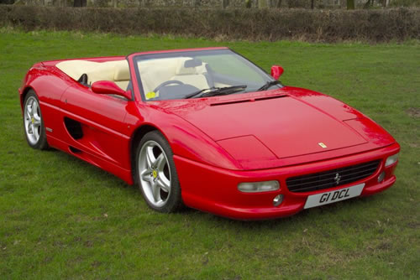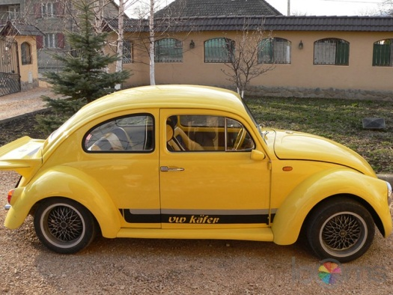
Find a car for sale between the value of $10000 and $20000. Try and choose a car that you really like. You may use the internet, newspaper or local car yards to locate a car.
Use the car you have selected to base the remainder of this assignment on.
- Give a detailed written description of the car you have selected. You should include an image of the car here.
- Explain in your own words the reasons why you selected this car.
- Assume you have saved a 20% deposit for this car and you need to borrow the rest. How much will you need to borrow in dollars?
- Compare the loan terms of 2 different financial institutions. This would include;
- The name of the financial institution.
- How much you would borrow.
- How long you would take to repay the loan.
- The annual percentage interest rate.
- Monthly (or fortnightly) repayments.
- The total cost of the loan.
- State which of the above financial institutions you would borrow the money from and give reasons why.
- Calculate the fixed costs of owning this car for the first year. This will include;
- Registration.
- Compulsory Third Party Person insurance (Green Slip).
- Either Comprehensive or Third Party Property insurance.
- Depreciation of 15%.
- Loan repayments for the first year.
- Calculate the variable costs of running this car for 15000km in the first year. This will include;
- Petrol, using this cars average fuel consumption and current petrol prices.
- Maintenance (a service every 15000km).
- Tyres (assume a life of 60000km for a set of tyres).
- Unexpected costs (budget for this).
- Prepare a personal weekly budget to see whether you can afford this car. Assume you earn $40000 gross per year. Your budget should include the following items (some will need an educated guess);
- Gross income.
- Net income (after tax)
- Rent.
- Food.
- Electricity and gas bill.
- Social expenses.
- Unexpected expenses.
- Fixed car costs (use previous calculation).
- Variable car costs (use previous calculation).
- Savings (or over spending!).
- Would you be able to afford this car? Explain why or why not.

Marking guidelines:
- Clearly describes car to be purchased with reasons for selection and a clear image of car  - Presents a comprehensive proposal on how this car will be financed  - Presents comprehensive information on fixed and variable costs of owning this car  - Presents an accurate and detailed budget to determine car affordability  - Presents a sustained and logical response using relevant commerce terms and concepts | 17-20
- Describes car to be purchased with reasons for selection and a clear image of car  - Presents a detailed proposal on how this car will be financed  - Presents detailed information on fixed and variable costs of owning this car  - Presents an accurate budget to determine car affordability  - Presents a sustained and logical response using relevant commerce terms and concepts | 13-16
- Outlines car to be purchased with reasons for selection and a clear image of car  - Presents some proposals on how this car will be financed  - Presents some information on fixed and variable costs of owning this car  - Presents a budget to determine car affordability  - Presents a logical response using some commerce terms and concepts | 9-12
- Basic outline of car to be purchased with an image of car  - Presents a basic proposal on how this car will be financed  - Presents basic information on the costs of owning this car  - Presents basic information to determine car affordability  - Presents a basic response using some commerce terms and concepts | 5-8
- May make reference to car to be purchased  - Presents an elementary proposal on how the car will be financed  - Presents elementary information on some costs of car ownership  - Presents elementary information on some aspects of car affordability  - Presents an elementary response using some commerce terms and concepts | 1-4

Student name: ___________________________________________
Comment ________________________________________________________________________________________________________________________________________________________________________________________________________________________________________________________________________________________________________________________________________________________________________________________________________________________________________________________________________________________________________________________

COWRA HIGH SCHOOL

Assessment Task Submission Policy

Submission of assessment tasks by students must follow faculty guidelines. There are basically four types of assessment tasks:

- In Class Assessment Tasks ~ these tasks are supervised by the class teacher and collected by the class teacher at the conclusion of the assessment task. It is the responsible of the student who miss in class assessment tasks to contact the Head Teacher of that faculty.

- Formal Examinations ~ at the conclusion of any formal examination the assessment task papers are to be collected and returned to the relevant faculty teacher.

- Major Projects / Pieces of Work ~ these items, due to their size, are usually kept in the appropriate faculty location. Major works and projects should be kept in safe locations that minimises the risk of damage. Any assessment task would be submitted directly to the teacher. A receipt for the task will be issued to students.

- Take Home Assessment Tasks ~ these are tasks that students are required to complete by a due date. Students should follow faculty submission guidelines regarding submission of these tasks.

Guidelines for the Submission of Assessment Tasks

- When an assessment task is issued, the information provided to students will include:
- a clear statement of what the task involves and what the expectations of the student are
- an explanation of the marking criteria / outcomes to be assessed
- the due date of submission
- an assessment task submission cover sheet ~ see attached

- Teachers should record the names of all students issued with the assessment task on a roll/class list and have the student acknowledge receipt of the assessment task by getting them to sign next to their name.

- Students must take their assessment task to the class teacher. They must be signed in on the class roll and keep their receipt

- All students must keep a copy of their assessment task.

Illness and Misadventure Appeals

If a student fails to submit an assessment task by the due date and has a legitimate reason than normal illness and misadventure procedures will apply.

REQUEST FOR ASSESSMENT EXTENSION PROCEDURE

Assessment extensions will only be granted in exceptional circumstances. All requests need to be made in writing using the extension request form. In seeking an extension discuss your request with your teacher/Head Teacher at least three (3) days before the due date with work already completed.

Forms for Illness/Misadventure and Extension can be accessed on the
Cowra High School Website.

