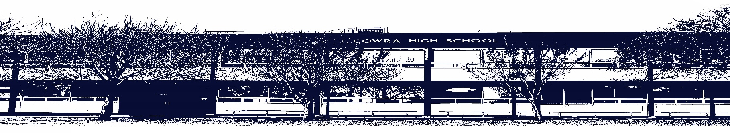

COWRA HIGH SCHOOL

ASSESSMENT TASK COVER SHEET

This sheet must be attached to the front of your Assessment Task and submitted to your class teacher on or before the due date.

Student’s Name: _________________________________________
Course: International Studies
Assessment Task: Task 2: Typed Report 25%
Date Due: 17/5/2021
Date Received: _______________
Extension granted _____ days
Other circumstances ~ documents attached

I certify:
- This assignment is entirely my own work and all borrowed material has been acknowledged
- The material contained in this assignment has not previously been submitted for assessment in any formal course of study
- I retain in my possession a copy of this assignment
- I understand that late assignments will be penalised unless an extension has been granted by Deputy Principal - Curriculum

Student’s Signature: ____________________________

-------------------------------------------------------------------------------------------------------------------------------
COWRA HIGH SCHOOL
Assessment Task (Student’s Copy)
Student’s Name: _________________________________________
Course: _________________________________________
Teacher: _________________________________________

Assessment Task received by: _________________________________________
Signature: _________________________________________
Date: ______________________ Time: ______________________

Please detach this if the Assessment Task has been handed in
to the office and give to student to keep for their own records.

COWRA HIGH SCHOOL
Year 9/10 Assessment Task
NAME: |  |  | CLASS: International Studies |  |  | TEACHER: Mrs Mugridge
COURSE: International Studies |  | TASK No: 2 |  |  | Unit: Gender and Culture
DATE DUE: Monday Week 5, 17 May |  |  |  |  |  | TIME DUE: 3.15pm
MARK: /25 | WEIGHT: 25% |  |  | PRESENTATION: Typed Report
SYLLABUS OUTCOMES: A Student:

IS-7: recognises bias and stereotypes
IS-9: evaluates culturally significant issues, events and scenarios from a variety of perspectives
IS-10: applies understanding of cultural differences when communicating across cultures
IS-12: selects and uses a range of written, visual and oral forms, to describe, analyse and communicate about cultures

DESCRIPTION OF TASK:
In class we will be learning about the role culture plays in gender roles within society. As a class we will be investigating various primary research methodologies in preparation for this task and using these as investigation tools for our study.

There are two sections for this assessment:
- Choose and design one type of research methodology that would assist you in developing your understanding on how culture informs particular gender roles within specific societies.
- Undertake this research methodology and complete the research to develop an understanding on gender roles within your chosen culture. Once you have completed the research you will need to use the information you have gathered to answer the following questions:
- What did you learn about gender roles from undertaking the research?
- Was there a better way of finding out the information?
- Would you do the research differently if you did it again?
- Would you achieve the same results if you undertook the research through a different medium?
- What potential bias and stereotypes were identified in the research?
- How might you avoid the bias and stereotypes that emerged when completing the research again in the future?

MARKING CRITERIA:
Criteria  If you do this: | Mark
- Sophisticatedly designs an appropriate research methodology that provides insightful information on the gender roles within a particular culture.  - Insightfully evaluates the gender roles from a variety of perspectives successfully recognizing the societal contexts that have influenced these views  - Sophisticatedly articulates a deep understanding of the potential bias and stereotypes presented in their research/through their research methodology | 22-25
- Perceptively designs an appropriate research methodology that provides detailed information on the gender roles within a particular culture.  - Accurately evaluates the gender roles from a variety of perspectives clearly recognizing the societal contexts that have influenced these views  - Clearly articulates a thorough understanding of the potential bias and stereotypes presented in their research/through their research methodology | 17-21
- Clearly designs an appropriate research methodology that provides information on the gender roles within a particular culture.  - Evaluates the gender roles from a variety of perspectives recognizing the societal contexts that have influenced these views  - Articulates a sound understanding of the potential bias and stereotypes presented in their research/through their research methodology | 11-16
- Designs a research methodology that provides some information on the gender roles within a particular culture.  - Evaluates gender roles from a perspective, attempting to recognizing the societal contexts that have influenced these views  - Identifies some understanding of the potential bias and stereotypes presented in their research/through their research methodology | 5-10
- Designs a research methodology that provides limited information on the gender roles within a particular culture.  - May or may not attempt to evaluates gender roles from a perspective, may or may not attempt to recognizing the societal contexts that have influenced these views  - May or may not identify limtied understanding of the potential bias and stereotypes presented in their research/through their research methodology | 0-4

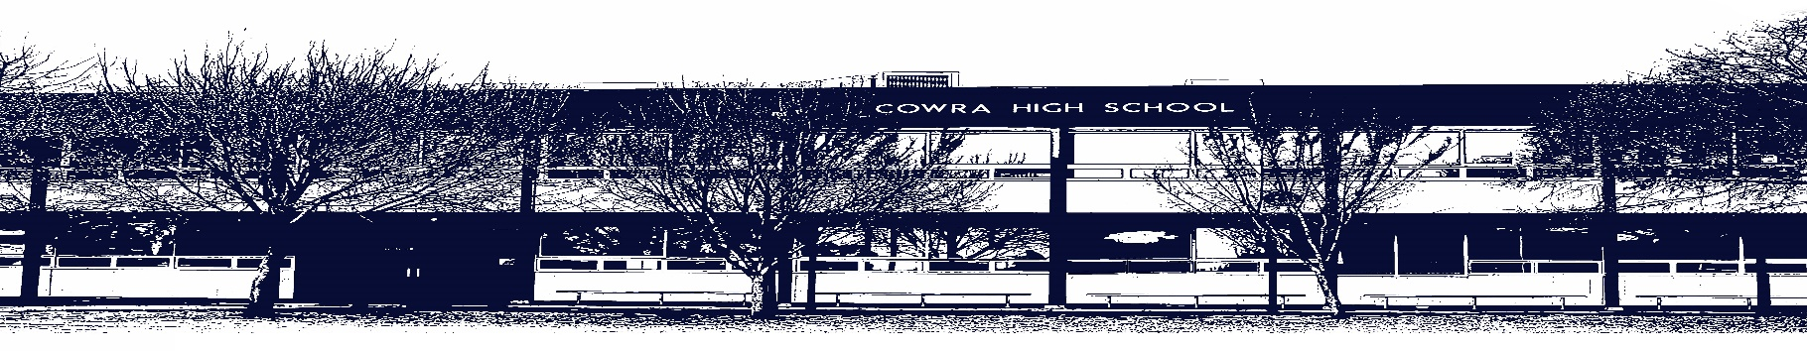

COWRA HIGH SCHOOL

Assessment Task Submission Policy

Submission of assessment tasks by students must follow faculty guidelines. There are basically four types of assessment tasks:

- In Class Assessment Tasks ~ these tasks are supervised by the class teacher and collected by the class teacher at the conclusion of the assessment task. It is the responsible of the student who miss in class assessment tasks to contact the Head Teacher of that faculty.

- Formal Examinations ~ at the conclusion of any formal examination the assessment task papers are to be collected and returned to the relevant faculty teacher.

- Major Projects / Pieces of Work ~ these items, due to their size, are usually kept in the appropriate faculty location. Major works and projects should be kept in safe locations that minimises the risk of damage. Any assessment task would be submitted directly to the teacher. A receipt for the task will be issued to students.

- Take Home Assessment Tasks ~ these are tasks that students are required to complete by a due date. Students should follow faculty submission guidelines regarding submission of these tasks.

Guidelines for the Submission of Assessment Tasks

- When an assessment task is issued, the information provided to students will include:
- a clear statement of what the task involves and what the expectations of the student are
- an explanation of the marking criteria / outcomes to be assessed
- the due date of submission
- an assessment task submission cover sheet ~ see attached

- Teachers should record the names of all students issued with the assessment task on a roll/class list and have the student acknowledge receipt of the assessment task by getting them to sign next to their name.

- Students must take their assessment task to the class teacher. They must be signed in on the class roll and keep their receipt

- All students must keep a copy of their assessment task.

Illness and Misadventure Appeals

If a student fails to submit an assessment task by the due date and has a legitimate reason than normal illness and misadventure procedures will apply.

REQUEST FOR ASSESSMENT EXTENSION PROCEDURE

Assessment extensions will only be granted in exceptional circumstances. All requests need to be made in writing using the extension request form. In seeking an extension discuss your request with your teacher/Head Teacher at least three (3) days before the due date with work already completed.

Forms for Illness/Misadventure and Extension can be accessed on the
Cowra High School Website.

