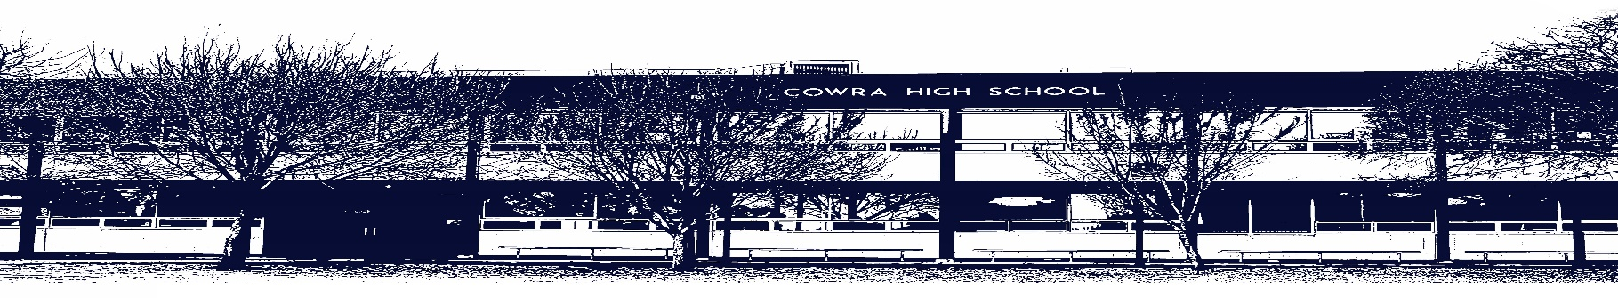

COWRA HIGH SCHOOL

ASSESSMENT TASK COVER SHEET

This sheet must be attached to the front of your Assessment Task and submitted to your class teacher on or before the due date.

Student’s Name: _________________________________________
Course: Stage 5 Japanese Year A
Assessment Task: Daily Routine
Date Due: 21/06/2021
Date Received: 7/06/2021
Extension granted _____ days
Other circumstances ~ documents attached

I certify:
- This assignment is entirely my own work and all borrowed material has been acknowledged
- The material contained in this assignment has not previously been submitted for assessment in any formal course of study
- I retain in my possession a copy of this assignment
- I understand that late assignments will be penalised unless an extension has been granted by Deputy Principal - Curriculum

Student’s Signature: ____________________________

-------------------------------------------------------------------------------------------------------------------------------
COWRA HIGH SCHOOL
Assessment Task (Student’s Copy)
Student’s Name: _________________________________________
Course: Stage 5 Japanese
Teacher: Bates

Assessment Task received by: _________________________________________
Signature: _________________________________________
Date: ______________________ Time: ______________________

Please detach this if the Assessment Task has been handed in
to the office and give to student to keep for their own records.

COWRA HIGH SCHOOL
Stage 5 Assessment Task
NAME: |  |  | CLASS: 9+10 |  |  | TEACHER: Mr Bates
COURSE: Japanese |  | TASK No: 2 |  |  | Unit: Daily Routine
DATE DUE: 21/06/2021 |  |  |  |  |  | TIME DUE:  Writing: 21/06/2021  Speaking: 22/06/2021 or 24/06/2021
MARK:  /55 | WEIGHT:  10% Communicating  10% Understanding |  |  | PRESENTATION: In-class test  Speaking Role-play
SYLLABUS OUTCOMES:

1C - manipulates Japanese in sustained interactions to exchange information, ideas and opinions, and make
plans and negotiate
4C - identifies and interprets information in a range of texts
5U - applies Japanese pronunciation and intonation patterns
6U - demonstrates understanding of key aspects of Japanese writing conventions
7U - applies features of Japanese grammatical structures and sentence patterns to convey information and ideas
8U - identifies variations in linguistic and structural features of texts
9U - identifies that language use reflects cultural ideas, values and beliefs

Task Description:
Written Test (15%): The written exam will test your knowledge of content covered so far this year, with an emphasis on the content covered in the topic “Daily Routine”. The written exam will have 3 sections – listening (5%), reading (5%) and writing (5%). Questions may be: multiple choice, true/false, short answer in Japanese or English, translation from Japanese-English or English-Japanese, or extended response in Japanese.

In addition to content covered in previous units, you must know (in Japanese):
- Vocabulary for describing daily routine (nouns and associated verbs and the correct sentence pattern, e.g. Time にActivity を Verb、TimeにPlaceにVerb of movement, including adding more details such as means of transport (Transportで).
- Days of the week, time to the hour, half hour and 5 and 10 minute intervals.
- How to sequence activities using words such as そして、それから
Speaking Test (5%): You will participate in a 3-5 minute conversation with your teacher and answer questions about yourself (e.g. age, family, hobbies, daily routine – see questions provided at end). The conversation will be recorded for marking and feedback purposes. There are set questions for this task and you will be given time in class to assist with preparation.
Marking Criteria:
You will be assessed on your ability to:
- Speak at a reasonable speed with clear and accurate pronunciation
- Select appropriate vocabulary and structures relevant to the questions asked
- Accurately use a wide range of vocabulary and structures
- Sequence and connect your ideas logically using a range of structures and words
Writing – Marking Guidelines | Mark
Conveys information logically and effectively  Uses a wide range of relevant vocabulary and structures accurately  Uses the correct language/script throughout (i.e. hiragana, kanji, rōmaji where required),  Uses genkouyoushi accurately | 9-10
Conveys information logically and clearly  Uses relevant vocabulary and structures which are mostly accurate but may have occasional minor errors in spelling or particles  Uses the correct language/script throughout the text with minor errors or omissions.  Uses genkouyoushi accurately with only minor errors | 7-8
Conveys information satisfactorily with some sequencing of information  Uses relevant vocabulary and structures which are generally accurate but contain errors in spelling or word order.  Uses the correct language/script throughout most of the text, but with multiple errors and/or omissions.  Uses genkouyoushi accurately with only minor errors | 5-6
Conveys only basic information which may not be sequenced logically  Uses a limited number of structures and a limited range of relevant vocabulary  Uses structures and/or vocabulary inaccurately  May not use genkouyoushi correctly  May not use the correct language/script throughout, with text written mostly or completely in rōmaji.  Writes only in rōmaji (maximum mark of 3 regardless of overall quality) | 3-4
Lacks basic information  Has many problems in accuracy of structures and vocabulary  Uses some isolated words and phrases relevant to the task  Use of the correct language/script is limited  May not use genkouyoushi correctly | 1-2
Non attempt | 0
Marking Guidelines
Speaking – Marking Guidelines | Mark
Is fluent and has correct pronunciation throughout  Uses structures accurately  Uses a wide range of relevant vocabulary  Uses a wide variety of strategies to connect sentences and ideas. | 9-10
Is quite fluent with only a few pauses and has correct pronunciation with only a few inaccuracies  Uses structures which are generally accurate  Uses relevant vocabulary  Uses a number of different strategies to connect sentences and ideas. | 7-8
Occasionally quite fluent but pauses between sentences  Has some problems in pronunciation  Uses some structures accurately but other are inaccurate  Uses some relevant vocabulary  Uses limited strategies to connect sentences and ideas.  I quite repetitive | 5-6
Lacks fluency with pauses between concepts within sentences  Has several problems in pronunciation  Uses a limited number of structures  Uses a limited range of relevant vocabulary  Does not connect sentences and ideas | 3-4
Lacks fluency  Has many problems in pronunciation  Uses some isolated words and phrases relevant to the task | 1-2
Non attempt | 0

Listening and Reading: 10% (/16 and /19)
Students will receive a marking guideline when receiving their results as each question’s criteria is differentiated in the tasks

Speaking Questions

- おなまえは何ですか。(What is your name?)
- 何才ですか。(How old are you?)
- どこにすんでいますか。(Where do you live?)
- ごかぞくは何人ですか。(How many people are in your family)
- (person)はどんな人ですか。x2 (What kind of person is…..?)
- 何時におきますか。(What time do you wake up?)
- おきてから、何をしますか。（What do you do after you wake up?)
- まい日あさごはんをたべますか。(Do you eat breakfast everyday?)
- なんで学校に行きますか。(How do you get to school everyday?)
- 何時にうちにかえりますか。(What time do you return home?)
- 何時にばんごはんをたべますか。(What time do you eat dinner?)
- ばんごはんのあとで、何をしますか。(What do you do after dinner?)
- シャワーをあびますか。OR 15 (Do you have a shower?)
- おふろにはいりますか。OR 14 (Do you have a bath?)
- 何時にねますか。(What time do you go to sleep?)
Note: you should try to go beyond just answering the question where possible and add extra detail, e.g. adjectives, sequence of events, etc.

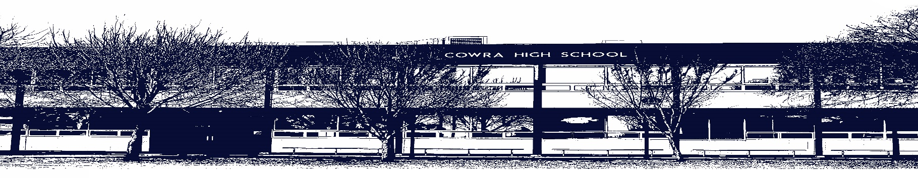

COWRA HIGH SCHOOL

Assessment Task Submission Policy

Submission of assessment tasks by students must follow faculty guidelines. There are basically four types of assessment tasks:

- In Class Assessment Tasks ~ these tasks are supervised by the class teacher and collected by the class teacher at the conclusion of the assessment task. It is the responsible of the student who miss in class assessment tasks to contact the Head Teacher of that faculty.

- Formal Examinations ~ at the conclusion of any formal examination the assessment task papers are to be collected and returned to the relevant faculty teacher.

- Major Projects / Pieces of Work ~ these items, due to their size, are usually kept in the appropriate faculty location. Major works and projects should be kept in safe locations that minimises the risk of damage. Any assessment task would be submitted directly to the teacher. A receipt for the task will be issued to students.

- Take Home Assessment Tasks ~ these are tasks that students are required to complete by a due date. Students should follow faculty submission guidelines regarding submission of these tasks.

Guidelines for the Submission of Assessment Tasks

- When an assessment task is issued, the information provided to students will include:
- a clear statement of what the task involves and what the expectations of the student are
- an explanation of the marking criteria / outcomes to be assessed
- the due date of submission
- an assessment task submission cover sheet ~ see attached

- Teachers should record the names of all students issued with the assessment task on a roll/class list and have the student acknowledge receipt of the assessment task by getting them to sign next to their name.

- Students must take their assessment task to the class teacher. They must be signed in on the class roll and keep their receipt

- All students must keep a copy of their assessment task.

Illness and Misadventure Appeals

If a student fails to submit an assessment task by the due date and has a legitimate reason than normal illness and misadventure procedures will apply.

REQUEST FOR ASSESSMENT EXTENSION PROCEDURE

Assessment extensions will only be granted in exceptional circumstances. All requests need to be made in writing using the extension request form. In seeking an extension discuss your request with your teacher/Head Teacher at least three (3) days before the due date with work already completed.

Forms for Illness/Misadventure and Extension can be accessed on the
Cowra High School Website.

