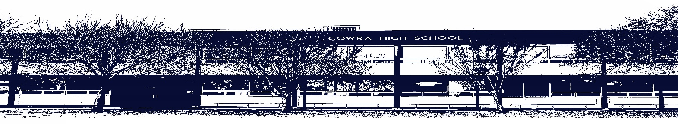

COWRA HIGH SCHOOL

ASSESSMENT TASK COVER SHEET

This sheet must be attached to the front of your Assessment Task and submitted to your class teacher on or before the due date.

Student’s Name: _________________________________________
Course: Stage 4 Visual Arts
Assessment Task: Artmaking
Date Due: _______________
Date Received: _______________
Extension granted _____ days
Other circumstances ~ documents attached

I certify:
- This assignment is entirely my own work and all borrowed material has been acknowledged
- The material contained in this assignment has not previously been submitted for assessment in any formal course of study
- I retain in my possession a copy of this assignment
- I understand that late assignments will be penalised unless an extension has been granted by Deputy Principal - Curriculum

Student’s Signature: ____________________________

-------------------------------------------------------------------------------------------------------------------------------
COWRA HIGH SCHOOL
Assessment Task (Student’s Copy)
Student’s Name: _________________________________________
Course: _________________________________________
Teacher: _________________________________________

Assessment Task received by: _________________________________________
Signature: _________________________________________
Date: ______________________ Time: ______________________

Please detach this if the Assessment Task has been handed in
to the office and give to student to keep for their own records.

COWRA HIGH SCHOOL
Stage 5 Assessment Task
NAME: |  | CLASS: Stage 5 |  | TEACHER: I Harnden
COURSE: Visual Arts |  | TASK No: 1 |  | Unit: Back to Front
DATE DUE: 27th May 2021 |  | TIME DUE: Week 5, Term 2 Monday
MARK: /25 | WEIGHT: 30% |  | PRESENTATION: Hand in & presentation
SYLLABUS OUTCOMES: A Student:
5.1 develops range and autonomy in selecting and applying visual arts conventions and procedures to make artworks
5.2makes artworks informed by their understanding of the function of and relationships between artist – artwork – world – audience
5.3 makes artworks informed by an understanding of how the frames affect meaning
5.4 investigates the world as a source of ideas, concepts and subject matter in the visual arts
5.5 makes informed choices to develop and extend concepts and different meanings in their artworks

DESCRIPTION OF TASK: Students are required to produce a large-scale drawing of a back to front portrait of a loved one alongside experimental sketches. The drawings should be informed by the student’s study of portraiture and drawing techniques.
This task will have a focus on the Cultural Frame.

Students look at drawing techniques such as cross-hatching, shading, stippling, smudging, washes, and sgraffito through the study of selected artists.

Students revise previous study of drawing and new contemporary examples.
Students focus on the frames particularly the Cultural Frame - Art Elements and Principles- to create their own portrait.

- Presentation of a resolved drawing
- Presentation of experimental sketches
- Technical use of materials and representation of the students intentions
- Identifies the frames explored during the making of the portrait
- Explains how identity informs the drawing
- A title and artist statement

MARKING CRITERIA:

Artmaking  Marking criteria | Marks
• Demonstrates a sound understanding of the relationships between  portraiture and the conceptual framework (artwork, artist, world, audience)  • Explores conventions in making two dimensional drawings  - Investigates ways of developing layers of meaning in their artwork  - Explores materials and techniques in ways that support intentions  - Interprets class work, notes, portraiture research in sophisticated ways | 21-25
- Demonstrates some understanding of the relationships between portraiture and the conceptual framework (artwork, artist, world, audience)  - Attempts some exploration of conventions in making two dimensional drawings  - Attempts some investigation of developing layers of meaning in their artwork  - Explores some materials and techniques in ways that support intentions  - Interprets class work, notes and portraiture research in basic ways | 16-20
- Demonstrates basic understanding of the relationships between  portraiture and the conceptual framework (artwork, artist, world, audience)  - Basic exploration of conventions in making two dimensional drawings  - Attempts basic meaning in their artworks  - Uses materials and techniques in ways that sometimes support intentions  - Includes class work, notes and portraiture research | 11-15
• Demonstrates limited understanding of the relationships between the  portraiture and the conceptual framework (artwork, artist, world, audience)  • Limited exploration of conventions in making two dimensional drawings  - Attempts some meaning in their artwork  - Explores some materials and techniques in obvious ways  - Includes some reference to class work and portraiture research | 6-10
• Attempts to understand the relationships between portraiture and the  conceptual framework (artwork, artist, world, audience)  - Shows very little interest in using materials and techniques  • Little reference to class work and portraiture | 1-5

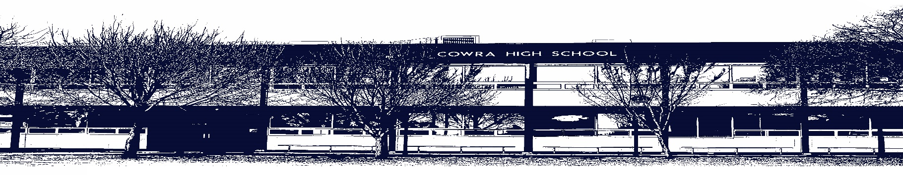

COWRA HIGH SCHOOL

Assessment Task Submission Policy

Submission of assessment tasks by students must follow faculty guidelines. There are basically four types of assessment tasks:

- In Class Assessment Tasks ~ these tasks are supervised by the class teacher and collected by the class teacher at the conclusion of the assessment task. It is the responsible of the student who miss in class assessment tasks to contact the Head Teacher of that faculty.

- Formal Examinations ~ at the conclusion of any formal examination the assessment task papers are to be collected and returned to the relevant faculty teacher.

- Major Projects / Pieces of Work ~ these items, due to their size, are usually kept in the appropriate faculty location. Major works and projects should be kept in safe locations that minimises the risk of damage. Any assessment task would be submitted directly to the teacher. A receipt for the task will be issued to students.

- Take Home Assessment Tasks ~ these are tasks that students are required to complete by a due date. Students should follow faculty submission guidelines regarding submission of these tasks.

Guidelines for the Submission of Assessment Tasks

- When an assessment task is issued, the information provided to students will include:
- a clear statement of what the task involves and what the expectations of the student are
- an explanation of the marking criteria / outcomes to be assessed
- the due date of submission
- an assessment task submission cover sheet ~ see attached

- Teachers should record the names of all students issued with the assessment task on a roll/class list and have the student acknowledge receipt of the assessment task by getting them to sign next to their name.

- Students must take their assessment task to the class teacher. They must be signed in on the class roll and keep their receipt

- All students must keep a copy of their assessment task.

Illness and Misadventure Appeals

If a student fails to submit an assessment task by the due date and has a legitimate reason than normal illness and misadventure procedures will apply.

REQUEST FOR ASSESSMENT EXTENSION PROCEDURE

Assessment extensions will only be granted in exceptional circumstances. All requests need to be made in writing using the extension request form. In seeking an extension discuss your request with your teacher/Head Teacher at least three (3) days before the due date with work already completed.

Forms for Illness/Misadventure and Extension can be accessed on the
Cowra High School Website.

