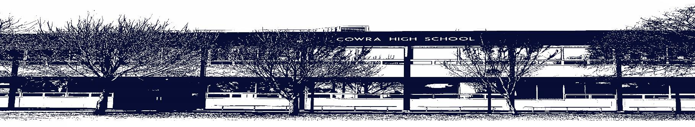

COWRA HIGH SCHOOL

ASSESSMENT TASK COVER SHEET

This sheet must be attached to the front of your Assessment Task and submitted to your class teacher on or before the due date.

Student’s Name: _________________________________________
Course: ___Technology Mandatory___________________
Assessment Task: __Recycled Material portfolio and Project_____
Date Due: _____________
Date Received: _______________
□ Extension granted _____ days
□ Other circumstances ~ documents attached

I certify:
- This assignment is entirely my own work and all borrowed material has been acknowledged
- The material contained in this assignment has not previously been submitted for assessment in any formal course of study
- I retain in my possession a copy of this assignment
- I understand that late assignments will be penalised unless an extension has been granted by Deputy Principal - Curriculum

Student’s Signature: ____________________________

✂-------------------------------------------------------------------------------------------------------------------------------
COWRA HIGH SCHOOL
Assessment Task (Student’s Copy)
Student’s Name: _________________________________________
Course: _________________________________________
Teacher: _________________________________________

Assessment Task received by: _________________________________________
Signature: _________________________________________
Date: ______________________ Time: ______________________

Please detach this if the Assessment Task has been handed in
to the office and give to student to keep for their own records.
COWRA HIGH SCHOOL
Year 7 Assessment Task
NAME: |  |  | CLASS: 8TM5 |  |  | TEACHER: Bates
COURSE: Technology Mandatory |  | TASK No: 1 |  |  | Unit: Recycled Materials
DATE DUE: Week 6 Friday |  |  |  |  |  | TIME DUE:3.15pm
MARK: 10 | WEIGHT: 25% |  |  | PRESENTATION: Project and folio
SYLLABUS OUTCOMES: A Student:
TE4-1DP designs, communicates and evaluates innovative ideas and creative solutions to authentic problems or opportunities
TE4-2DP plans and manages the production of designed solutions
TE4-3DP selects and safely applies a broad range of tools, materials and processes in the production of quality projects
TE4-4DP designs algorithms for digital solutions and implements them in a general-purpose programming language
TE4-9MA investigates how the characteristics and properties of tools, materials and processes affect their use in designed solutions

DESCRIPTION OF TASK:

Students design and produce a project using recycled materials as a medium. Students document their design process in a design folio.
Design folio is a booklet- attached.

MARKING CRITERIA:

 | 5-4 | 2-3 | 0-1
Product | Product has a great design (aesthetics), manufactured using a high standard of safe work practices and uses a variety of recycled materials. End product is completed. | Product has a good design, manufactured using safe work practices and includes at least one recycled material. End product is complete. | Product has a simple design, manufactured using limited safe work practices and uses no recycled materials. End product is not complete.
Folio | Students design folio details their design (design sketch), procedure (steps) and evaluation to a high standard. | Students design folio details their design (design sketch), procedure (steps) and evaluation to a sound standard. | Students design folio details their design (design sketch), procedure (steps) and evaluation to a limited standard.

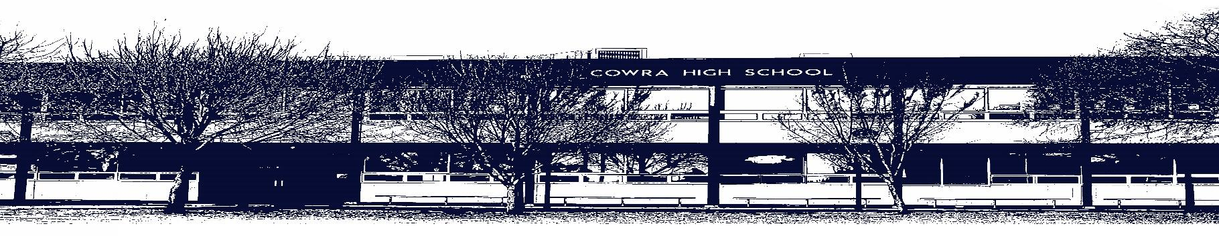

COWRA HIGH SCHOOL

Assessment Task Submission Policy

Submission of assessment tasks by students must follow faculty guidelines. There are basically four types of assessment tasks:

- In Class Assessment Tasks ~ these tasks are supervised by the class teacher and collected by the class teacher at the conclusion of the assessment task. It is the responsible of the student who miss in class assessment tasks to contact the Head Teacher of that faculty.

- Formal Examinations ~ at the conclusion of any formal examination the assessment task papers are to be collected and returned to the relevant faculty teacher.

- Major Projects / Pieces of Work ~ these items, due to their size, are usually kept in the appropriate faculty location. Major works and projects should be kept in safe locations that minimises the risk of damage. Any assessment task would be submitted directly to the teacher. A receipt for the task will be issued to students.

- Take Home Assessment Tasks ~ these are tasks that students are required to complete by a due date. Students should follow faculty submission guidelines regarding submission of these tasks.

Guidelines for the Submission of Assessment Tasks

- When an assessment task is issued, the information provided to students will include:
- a clear statement of what the task involves and what the expectations of the student are
- an explanation of the marking criteria / outcomes to be assessed
- the due date of submission
- an assessment task submission cover sheet ~ see attached

- Teachers should record the names of all students issued with the assessment task on a roll/class list and have the student acknowledge receipt of the assessment task by getting them to sign next to their name.

- Students must take their assessment task to the class teacher. They must be signed in on the class roll and keep their receipt

- All students must keep a copy of their assessment task.

Illness and Misadventure Appeals

If a student fails to submit an assessment task by the due date and has a legitimate reason than normal illness and misadventure procedures will apply.

REQUEST FOR ASSESSMENT EXTENSION PROCEDURE

Assessment extensions will only be granted in exceptional circumstances. All requests need to be made in writing using the extension request form. In seeking an extension discuss your request with your teacher/Head Teacher at least three (3) days before the due date with work already completed.

Forms for Illness/Misadventure and Extension can be accessed on the
Cowra High School Website.

