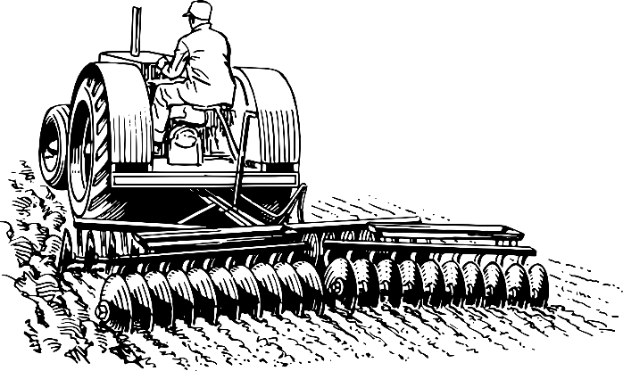
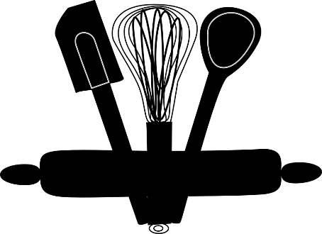
Technology Mandatory

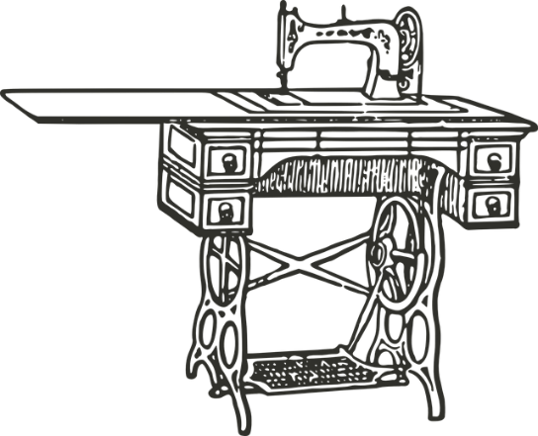
Portfolio
2021

Topic: Felt Monster
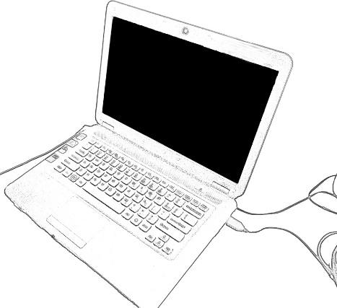
Name:

Technology Mandatory

Through the study of Technology Mandatory, students develop the capacity for action and a critical appreciation of the processes through which technologies evolve and how they contribute to society. Knowledge and understanding of technological content is developed through pedagogical approaches, such as project and problem-based learning. Through the production of innovative solutions to contextually relevant problems, students are provided with opportunities to use a variety of thinking strategies, embrace new concepts and learn through trialing, testing and refining ideas. The practical nature of Technology Mandatory engages students in design and production activities as they develop safe practices and refine skills working with varied materials and production technologies. These authentic learning experiences provide students with a sense of satisfaction and are the foundation for life-long learning.

Topic Overview:
In this topic students will learn about Textile materials, using felt to design and produce a soft toy. Students will learn about the design process as well as practical components of sewing, including hand sewing and machine sewing.

Outcomes
TE4-1DP designs, communicates and evaluates innovative ideas and creative solutions to authentic problems or opportunities
TE4-2DP plans and manages the production of designed solutions
TE4-3DP selects and safely applies a broad range of tools, materials and processes in the production of quality projects
TE4-4DP designs algorithms for digital solutions and implements them in a general-purpose programming language
TE4-9MA investigates how the characteristics and properties of tools, materials and processes affect their use in designed solutions

Tasks:
Portfolio: you are required to complete this portfolio including all aspects of the design process
Practical Task: Students will apply the design process to design and produce a quality Felt Monster

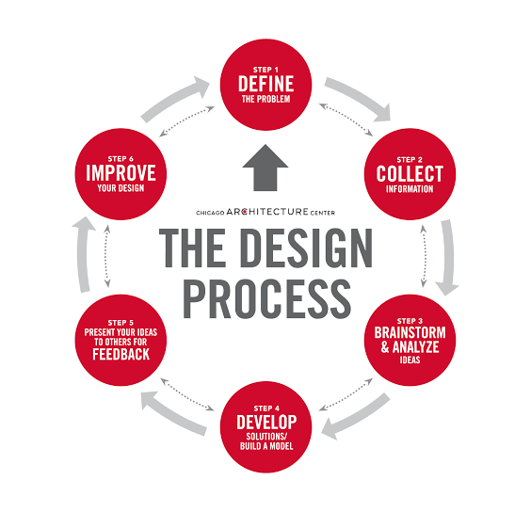

The Design Process

Design Brief
Design Brief- to design a soft toy that would suit a child: using the basic monster template provided.

What do I need to do?
Use a template to design a monster.
Cut out and sew felt to produce a monster, using stuffing

Research questions
- What is felt?

- How do I hand sew?
Draw a picture:

Design!
What design did you choose?
Sketch your design:

Does it meet the design brief? Can you make it? Is it too easy/hard?

Product Steps:

What are the steps you took to make your felt monster? Draw each step!

Step 1:

Step 2:

Step 3:

Step 4:

Step 5:

Step 6:

Step 7:

Evaluation!!!

What did you like most about learning to make a felt monster?

What diod you enjoy the least?

Do you think your design worked well? Would it be suitable to a child?

What new skills did you learn in this project?

If you could design another soft toy- what would you like to make?

