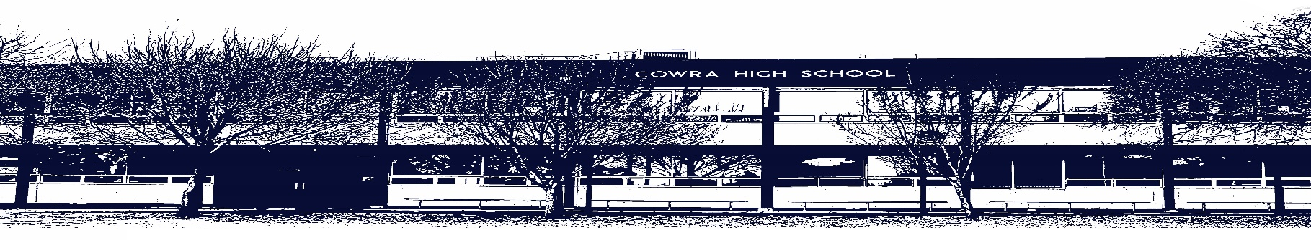

COWRA HIGH SCHOOL

ASSESSMENT TASK COVER SHEET

This sheet must be attached to the front of your Assessment Task and submitted to your class teacher on or before the due date.

Student’s Name: _________________________________________
Course: Stage 4 - Year 7P English
Assessment Task: Multimodal Assessment Task
Date Due: Monday Week 10, 21st June 2021
Date Received: _______________
Extension granted _____ days
Other circumstances ~ documents attached

I certify:
- This assignment is entirely my own work and all borrowed material has been acknowledged
- The material contained in this assignment has not previously been submitted for assessment in any formal course of study
- I retain in my possession a copy of this assignment
- I understand that late assignments will be penalised unless an extension has been granted by Deputy Principal - Curriculum

Student’s Signature: ____________________________

-------------------------------------------------------------------------------------------------------------------------------
COWRA HIGH SCHOOL
Assessment Task (Student’s Copy)
Student’s Name: _________________________________________
Course: Stage 4 – Year 7 English
Teacher: Perkins

Assessment Task received by: _________________________________________
Signature: _________________________________________
Date: ______________________ Time: ______________________

Please detach this if the Assessment Task has been handed in
to the office and give to student to keep for their own records.

COWRA HIGH SCHOOL
Stage 4 – Year 7 Assessment Task
NAME: |  |  | CLASS: 7P |  |  | TEACHER: Perkins
COURSE: Year 7 English |  | TASK No: 2 |  |  | Unit: Indigenous Voices
DATE DUE: Monday 21st June 2021 Week 10 |  |  |  |  |  | TIME DUE: 3:15pm
MARK: /20 | WEIGHT: 25% |  |  | PRESENTATION: Google Slide Presentation
SYLLABUS OUTCOMES:

EN4-2A effectively uses a widening range of processes, skills, strategies and knowledge for responding to and composing texts in different media and technologies
EN4-4B makes effective language choices to creatively shape meaning with accuracy, clarity and coherence
EN4-5C thinks imaginatively, creatively, interpretively and critically about information, ideas and arguments to respond to and compose texts
EN4-7D demonstrates understanding of how texts can express aspects of their broadening world and their relationships within it
EN4-8D identifies, considers and appreciates cultural expression in texts

DESCRIPTION OF TASK:

During this unit of work you have been studying Indigenous Voices through exploration of a variety of texts. Your task is to select one of these texts and create a google slide presentation.

You must identify a culture/subculture that you would like to write about before beginning your presentation. Feel free to select any culture with which you may be familiar or indeed any that you are interested in creating your presentation on. Examples may include our local First Nation or any other First Nations People, Asian Indigenous peoples, Ancient Indigenous Peoples

Your presentation should be designed to inform the viewer all about the culture and how it connects to the unit. Your presentation should include the following;

- A brief summary of the culture you have selected
- A brief summary of the text you have selected
- A summary of the techniques used in your texts, including specific examples and quotes
- A description of how the culture and text fits into the topic Indigenous Voices
- Why this text is valued

The texts you could select from include;
- ‘My Place’ by Nadia Wheatley
- ‘Walking The Boundaries’ by Jackie French
- ‘Dustechoes’
- Or texts studied within your class – as discussed with your teacher.

Use the following information to ensure that your google slide is presented accurately

- Use a google slide/ power point template
- Include a title and concluding slide
- It is best practice to use more slides, with less content per slide, if at all possible. One idea per slide and have no more that 3 – 6 bullet points
- Use a font that is easy to read such as Arial, Times New Roman or Verdana. No fancy fonts.
- Limit the use of animations and transitions
- Use colour, symbolism and motif
- Use images and other resources: these can add variety and interest. You could embed links to websites, include music, images or even short video clips that enhance your dot points
- Dark text on a light background is best
- Every bullet is followed by a capital letter – be sure to edit your presentation carefully

MARKING CRITERIA

Mark | Criteria
17 - 20 | - Composes an effective digital resource that integrates elements such as images, sound and video clips.  - Effectively analyses text through careful selection of relevant examples and quotes  - Demonstrates skilful control of language & structure appropriate to audience, purpose, context and form. Slide is carefully edited.
13 - 16 | - Composes a sound digital resource that integrates elements such as images, sound and video clips.  - Analyses text through careful selection of relevant examples and quotes  - Demonstrates skilful control of language & structure appropriate to audience, purpose, context and form. Slide is edited.
9 – 12 | - Composes an adequate digital resource  - Uses basic textual examples to support ideas  - Organises, develops and expresses ideas appropriately, some editing required
5 – 8 | - Demonstrates limited understanding the text  - Little or no reflection on the techniques used  - Basic textual references  - Organises and expresses ideas in simple language with a limited appropriateness
0 - 4 | - Demonstrates elementary understanding of the text  - Elementary use of language  - Little textual reference

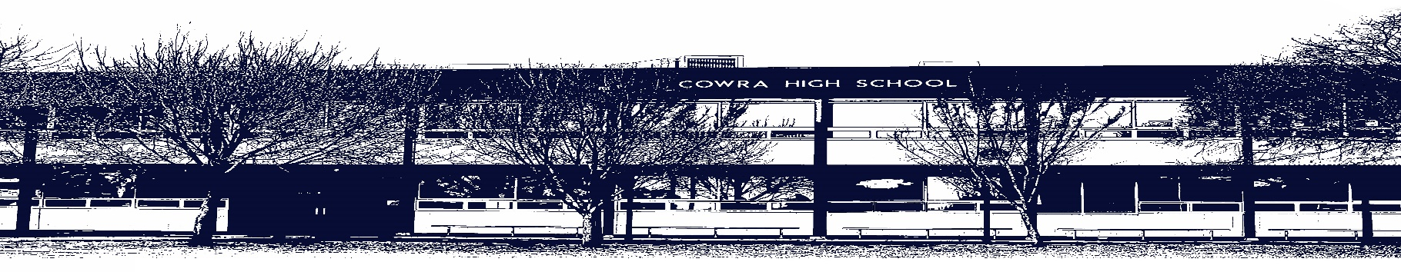

COWRA HIGH SCHOOL

Assessment Task Submission Policy

Submission of assessment tasks by students must follow faculty guidelines. There are basically four types of assessment tasks:

- In Class Assessment Tasks ~ these tasks are supervised by the class teacher and collected by the class teacher at the conclusion of the assessment task. It is the responsible of the student who miss in class assessment tasks to contact the Head Teacher of that faculty.

- Formal Examinations ~ at the conclusion of any formal examination the assessment task papers are to be collected and returned to the relevant faculty teacher.

- Major Projects / Pieces of Work ~ these items, due to their size, are usually kept in the appropriate faculty location. Major works and projects should be kept in safe locations that minimises the risk of damage. Any assessment task would be submitted directly to the teacher. A receipt for the task will be issued to students.

- Take Home Assessment Tasks ~ these are tasks that students are required to complete by a due date. Students should follow faculty submission guidelines regarding submission of these tasks.

Guidelines for the Submission of Assessment Tasks

- When an assessment task is issued, the information provided to students will include:
- a clear statement of what the task involves and what the expectations of the student are
- an explanation of the marking criteria / outcomes to be assessed
- the due date of submission
- an assessment task submission cover sheet ~ see attached

- Teachers should record the names of all students issued with the assessment task on a roll/class list and have the student acknowledge receipt of the assessment task by getting them to sign next to their name.

- Students must take their assessment task to the class teacher. They must be signed in on the class roll and keep their receipt

- All students must keep a copy of their assessment task.

Illness and Misadventure Appeals

If a student fails to submit an assessment task by the due date and has a legitimate reason than normal illness and misadventure procedures will apply.

REQUEST FOR ASSESSMENT EXTENSION PROCEDURE

Assessment extensions will only be granted in exceptional circumstances. All requests need to be made in writing using the extension request form. In seeking an extension discuss your request with your teacher/Head Teacher at least three (3) days before the due date with work already completed.

Forms for Illness/Misadventure and Extension can be accessed on the
Cowra High School Website.

