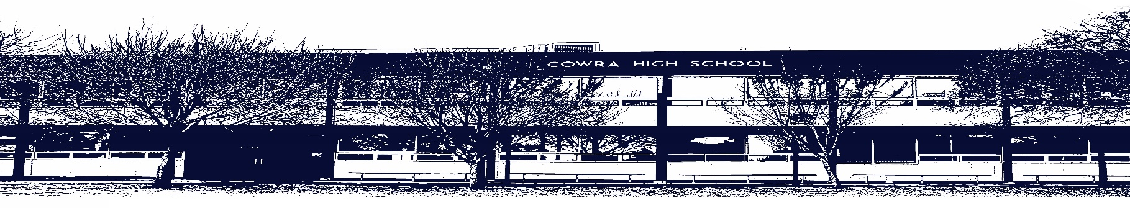

COWRA HIGH SCHOOL

ASSESSMENT TASK COVER SHEET

This sheet must be attached to the front of your Assessment Task and submitted to your class teacher on or before the due date.

Student’s Name: _________________________________________
Course: _________________________________________
Assessment Task: _________________________________________
Date Due: _______________
Date Received: _______________
Extension granted _____ days
Other circumstances ~ documents attached

I certify:
- This assignment is entirely my own work and all borrowed material has been acknowledged
- The material contained in this assignment has not previously been submitted for assessment in any formal course of study
- I retain in my possession a copy of this assignment
- I understand that late assignments will be penalised unless an extension has been granted by Deputy Principal - Curriculum

Student’s Signature: ____________________________

-------------------------------------------------------------------------------------------------------------------------------
COWRA HIGH SCHOOL
Assessment Task (Student’s Copy)
Student’s Name: _________________________________________
Course: _________________________________________
Teacher: _________________________________________

Assessment Task received by: _________________________________________
Signature: _________________________________________
Date: ______________________ Time: ______________________

Please detach this if the Assessment Task has been handed in
to the office and give to student to keep for their own records.

Cowra High School

Stage 4 ASSESSMENT TASK
NAME : |  |  |  |  |  | CLASS : |  | 7A |  | TEACHER : |  |  | Mr J
COURSE : |  | Stage 4 Geography |  |  | TASK NO : |  | 2 |  | UNIT : |  | Landscapes and Landforms
DATE DUE : |  |  | May 21st |  |  | TIME DUE : |  |  | 3.15pm
MARK : | /20 |  |  | WEIGHT : | 50% | PRESENTATION: |  |  |  |  |  | Optional
SYLLABUS OUTCOMES: A student:
GE4-1 locates and describes the diverse features and characteristics of a range of places and environments
GE4-2 describes processes and influences that form and transform places and environments
GE4-4 examines perspectives of people and organisations on a range of geographical issues
GE4-5 discusses management of places and environments for their sustainability
GE4-7 acquires and processes geographical information by selecting and using geographical tools for inquiry
GE4-8 communicates geographical information using a variety of strategies
DESCRIPTION OF TASK:
- You are required to write a report on one Australian natural World Heritage Site and one non-Australian cultural World Heritage Site. For each site you are required to;
- name and locate the site (including both a map and words)
- explain why it is considered by UNESCO to be a worthy natural/cultural site
- present at least two clear images of the site
- justify why the site should be ‘protected for all people, for all time’
- Additionally you are required to identify a site that you consider worthy of world heritage status nomination. For your identified site you are required to;
- name and locate the site (including both a map and words)
- explain why UNESCO should consider this site as a possible future natural or cultural world heritage site
- present at least two clear images of the site
- justify why it should be ‘protected for all people, for all time’

You may be allocated some class time in order to plan your assessment but it will predominantly be completed in your own time.

MARKING CRITERIA:
- Demonstrates an extensive knowledge and understanding of the location and features of World Heritage Sites  - Demonstrates an extensive knowledge and understanding of why sites are considered to be natural or cultural World Heritage Sites  - Displays extensive knowledge and understanding of why World Heritage Sites should be ‘protected for all people, for all time’  - Displays sophisticated skills in selecting and processing geographical information and images | 17-20
- Demonstrates a thorough knowledge and understanding of the location and features of World Heritage Sites  - Demonstrates a thorough knowledge and understanding of why sites are considered to be natural or cultural World Heritage Sites  - Displays thorough knowledge and understanding of why World Heritage Sites should be ‘protected for all people, for all time’  - Displays high level skills in selecting and processing geographical information and images | 13-16
- Demonstrates a sound knowledge and understanding of the location and features of World Heritage Sites  - Demonstrates a sound knowledge and understanding of why sites are considered to be natural or cultural World Heritage Sites  - Displays sound knowledge and understanding of why World Heritage Sites should be ‘protected for all people, for all time’  - Displays sound level skills in selecting and processing geographical information and images | 9-12
- Demonstrates a basic knowledge and understanding of the location and features of World Heritage Sites  - Demonstrates a basic knowledge and understanding of why sites are considered to be natural or cultural World Heritage Sites  - Displays basic knowledge and understanding of why World Heritage Sites should be ‘protected for all people, for all time’  - Displays basic level skills in selecting and processing geographical information and images | 5-8
- Demonstrates elementary knowledge and understanding of the location and features of World Heritage Sites  - Demonstrates elementary knowledge and understanding of why sites are considered to be natural or cultural World Heritage Sites  - Displays elementary knowledge and understanding of why World Heritage Sites should be ‘protected for all people, for all time’  - Displays elementary level skills in selecting and processing geographical information and images | 1-4
- Non-attempt | 0

Google Classroom Code – ugsjacp

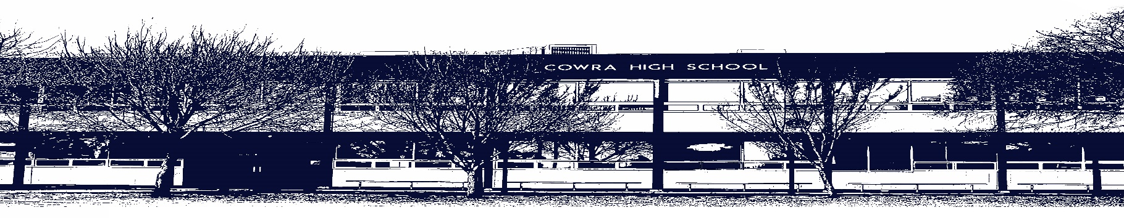

COWRA HIGH SCHOOL

Assessment Task Submission Policy

Submission of assessment tasks by students must follow faculty guidelines. There are basically four types of assessment tasks:

- In Class Assessment Tasks ~ these tasks are supervised by the class teacher and collected by the class teacher at the conclusion of the assessment task. It is the responsible of the student who miss in class assessment tasks to contact the Head Teacher of that faculty.

- Formal Examinations ~ at the conclusion of any formal examination the assessment task papers are to be collected and returned to the relevant faculty teacher.

- Major Projects / Pieces of Work ~ these items, due to their size, are usually kept in the appropriate faculty location. Major works and projects should be kept in safe locations that minimises the risk of damage. Any assessment task would be submitted directly to the teacher. A receipt for the task will be issued to students.

- Take Home Assessment Tasks ~ these are tasks that students are required to complete by a due date. Students should follow faculty submission guidelines regarding submission of these tasks.

Guidelines for the Submission of Assessment Tasks

- When an assessment task is issued, the information provided to students will include:
- a clear statement of what the task involves and what the expectations of the student are
- an explanation of the marking criteria / outcomes to be assessed
- the due date of submission
- an assessment task submission cover sheet ~ see attached

- Teachers should record the names of all students issued with the assessment task on a roll/class list and have the student acknowledge receipt of the assessment task by getting them to sign next to their name.

- Students must take their assessment task to the class teacher. They must be signed in on the class roll and keep their receipt

- All students must keep a copy of their assessment task.

Illness and Misadventure Appeals

If a student fails to submit an assessment task by the due date and has a legitimate reason than normal illness and misadventure procedures will apply.

REQUEST FOR ASSESSMENT EXTENSION PROCEDURE

Assessment extensions will only be granted in exceptional circumstances. All requests need to be made in writing using the extension request form. In seeking an extension discuss your request with your teacher/Head Teacher at least three (3) days before the due date with work already completed.

Forms for Illness/Misadventure and Extension can be accessed on the
Cowra High School Website.

