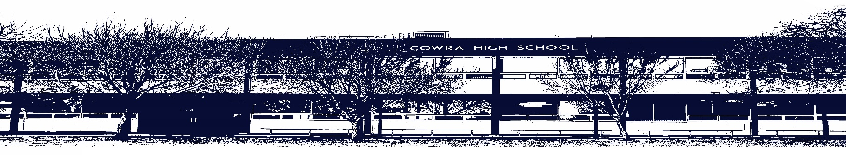

COWRA HIGH SCHOOL

ASSESSMENT TASK COVER SHEET

This sheet must be attached to the front of your Assessment Task and submitted to your class teacher on or before the due date.

Student’s Name: _________________________________________
Course: Japanese
Assessment Task: Talking about your Friends
Date Due: Week 7 Term 2
Date Received: Week 5 Term 2
Extension granted _____ days
Other circumstances ~ documents attached

I certify:
- This assignment is entirely my own work and all borrowed material has been acknowledged
- The material contained in this assignment has not previously been submitted for assessment in any formal course of study
- I retain in my possession a copy of this assignment
- I understand that late assignments will be penalised unless an extension has been granted by Deputy Principal - Curriculum

Student’s Signature: ____________________________

-------------------------------------------------------------------------------------------------------------------------------
COWRA HIGH SCHOOL
Assessment Task (Student’s Copy)
Student’s Name: _________________________________________
Course: Year 7 Japanese
Teacher: Mr Bates

Assessment Task received by: _________________________________________
Signature: _________________________________________
Date: ______________________ Time: ______________________

Please detach this if the Assessment Task has been handed in
to the office and give to student to keep for their own records.

COWRA HIGH SCHOOL
Stage 4 Assessment Task
NAME: |  |  | CLASS: 7 |  |  | TEACHER: Mr Bates
COURSE: Japanese |  | TASK No: 2 |  |  | Unit: Talking about Friends and Hobbies
DATE DUE: Week 7 in timetabled Japanese lesson |  |  |  |  |  | TIME DUE:  Written: First period in Week 7  Speaking: Second Period in Week 7
MARK:  Speaking /12  Understanding Test /111 | WEIGHT:  25% |  |  | PRESENTATION: In-class test with aids  1-on-1 speaking task
SYLLABUS OUTCOMES:
1C manipulates Japanese in sustained interactions to exchange information, ideas and
opinions, and make plans and negotiate
2C identifies and interprets information in a range of texts
3C organises and responds to information and ideas in texts for different audiences
4U applies a range of linguistic structures to compose texts in Japanese, using a range of formats
for different audiences
5U demonstrates how Japanese pronunciation and intonation are used to convey meaning
7U applies features of Japanese grammatical structures and sentence patterns to convey information
and idea
8U analyses linguistic, structural and cultural features in a range of texts
DESCRIPTION OF TASK:

Understanding Test (20%) /111

The written exam will test your knowledge of content covered in the unit “My Friends”. The written exam will have 3 sections – listening (5%), reading (5%), and writing (10%). Questions may be: multiple choice, true/false, short answer in Japanese or English, translation from Japanese-English or English-Japanese, or extended response in Japanese.

You must know:
- Content from Unit 1
- Be able to write a self-introduction
- All hiragana including voiced sounds, small tsu and glides
- How to introduce friends and adults
- Numbers from 1-20
- How to ask and answer questions about age, personality and hobbies (non-traditional only)
- Vocabulary for adjectives and hobbies (non-traditional only)

Speaking: 5% /12

Students will be asked the following questions and will have to answer all of them in Japanese.

Marking Criteria – Speaking | Correct answers will receive
Correct greeting used | 1 mark
Onamae wa nan desu ka  (what’s your name?) | 2 marks  (1 mark for short version)
Nansai desu ka  (how old are you?) | 1 mark
Doko kara kimashita ka  (where are you from?) | 2 marks  (1 mark each for country and nationality)
Doko ni sundeimasu ka  (where do you live?) | 2 marks  (1 mark for sentence, 1 mark for Japanese pronunciation of suburb)
Anata wa donna hito desu ka  (what kind of person are you?) | 2 marks  (1 mark for 1 adjective, 2 marks for 2)
Shumi wa nan desu ka  (what’s your hobby?) | 1 mark
Appropriate farewell at conclusion of task | 1 mark

MARKING CRITERIA:

Speaking: Students to see the criteria above.

Language: a marking criteria will be issued to students on completion of the test for each individual question.

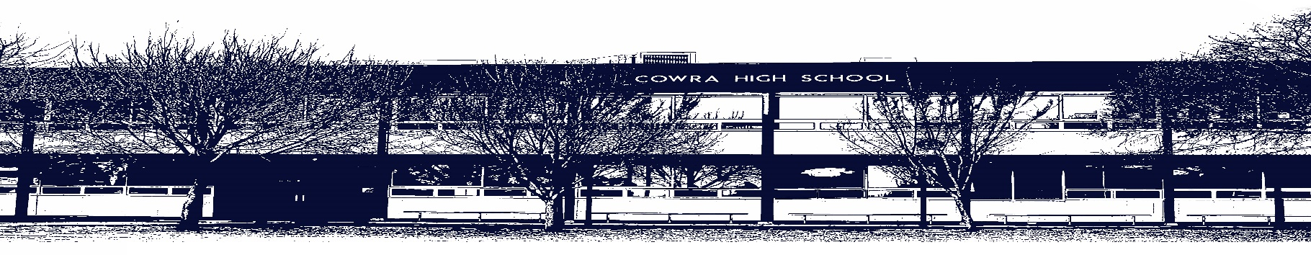

COWRA HIGH SCHOOL

Assessment Task Submission Policy

Submission of assessment tasks by students must follow faculty guidelines. There are basically four types of assessment tasks:

- In Class Assessment Tasks ~ these tasks are supervised by the class teacher and collected by the class teacher at the conclusion of the assessment task. It is the responsible of the student who miss in class assessment tasks to contact the Head Teacher of that faculty.

- Formal Examinations ~ at the conclusion of any formal examination the assessment task papers are to be collected and returned to the relevant faculty teacher.

- Major Projects / Pieces of Work ~ these items, due to their size, are usually kept in the appropriate faculty location. Major works and projects should be kept in safe locations that minimises the risk of damage. Any assessment task would be submitted directly to the teacher. A receipt for the task will be issued to students.

- Take Home Assessment Tasks ~ these are tasks that students are required to complete by a due date. Students should follow faculty submission guidelines regarding submission of these tasks.

Guidelines for the Submission of Assessment Tasks

- When an assessment task is issued, the information provided to students will include:
- a clear statement of what the task involves and what the expectations of the student are
- an explanation of the marking criteria / outcomes to be assessed
- the due date of submission
- an assessment task submission cover sheet ~ see attached

- Teachers should record the names of all students issued with the assessment task on a roll/class list and have the student acknowledge receipt of the assessment task by getting them to sign next to their name.

- Students must take their assessment task to the class teacher. They must be signed in on the class roll and keep their receipt

- All students must keep a copy of their assessment task.

Illness and Misadventure Appeals

If a student fails to submit an assessment task by the due date and has a legitimate reason than normal illness and misadventure procedures will apply.

REQUEST FOR ASSESSMENT EXTENSION PROCEDURE

Assessment extensions will only be granted in exceptional circumstances. All requests need to be made in writing using the extension request form. In seeking an extension discuss your request with your teacher/Head Teacher at least three (3) days before the due date with work already completed.

Forms for Illness/Misadventure and Extension can be accessed on the
Cowra High School Website.

