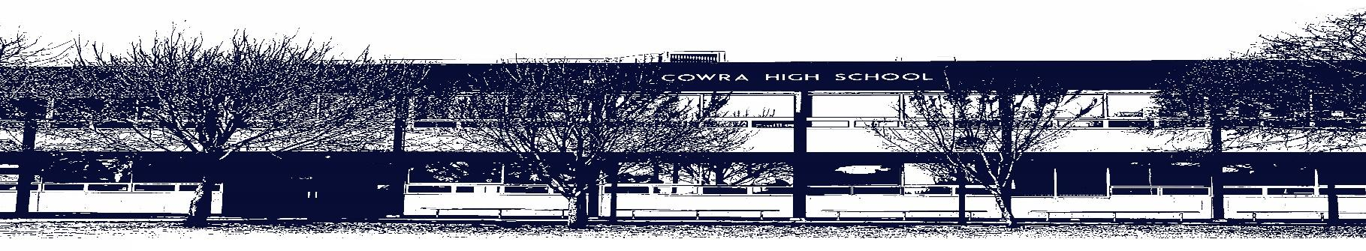

COWRA HIGH SCHOOL

ASSESSMENT TASK COVER SHEET

This sheet must be attached to the front of your Assessment Task and submitted to your class teacher on or before the due date.

Student’s Name: _________________________________________
Course: Stage 4 Music – Year 7
Assessment Task: Assessment Task 2 – Film Music Composition on Soundtrap
Date Due: 17/05/2021
Date Received: 03/05/2021
□ Extension granted _____ days
□ Other circumstances ~ documents attached

I certify:
- This assignment is entirely my own work and all borrowed material has been acknowledged
- The material contained in this assignment has not previously been submitted for assessment in any formal course of study
- I retain in my possession a copy of this assignment
- I understand that late assignments will be penalised unless an extension has been granted by Deputy Principal - Curriculum

Student’s Signature: ____________________________

✂-------------------------------------------------------------------------------------------------------------------------------
COWRA HIGH SCHOOL
Assessment Task (Student’s Copy)
Student’s Name: _________________________________________
Course: Stage 4 Music – Year 7
Teacher: Hughes / Smith

Assessment Task received by: _________________________________________
Signature: _________________________________________
Date: ______________________ Time: ______________________

Please detach this if the Assessment Task has been handed in
to the office and give to student to keep for their own records.

COWRA HIGH SCHOOL
Year 7 Assessment Task
NAME: |  |  | CLASS: 7 Music |  |  | TEACHER: D Hughes, K Smith
COURSE: Stage 4 Music |  | TASK No: 2 |  |  | Unit: Program and Film Music
DATE DUE: 17/05/2021, Week 5 Term 2
MARK: /20 | WEIGHT: 50% |  |  | PRESENTATION: Soundtrap
SYLLABUS OUTCOMES:

4.4 Demonstrates an understanding of musical concepts through exploring, experimenting, improvising, organising, arranging and composing.

4.5 Notates compositions using traditional and/or non-traditional notation.

4.6 Experiments with different forms of technology in the composition process.

4.10 Identifies the use of technology in the music selected for study, appropriate to the musical context

DESCRIPTION OF TASK:

Over the course of this Program and Film Music topic we have been analysing the music from several film scenes. Your task is to select a scene from those provided to you on google classroom. Using Soundtrap, you are to create a composition that is suitable for ONE of the following film scenes:

- Exciting chase scene (Zootopia)

- Triumphant scene (Kung Fu Panda)

- Romantic scene (Up)

- Suspense and Emotion (The Lion King)

You must:
- Create a composition that is suitable for your chosen scene.
- Create a composition that goes the entire length of the scene (make sure you time it).
- Include at least ONE crescendo (a gradual increase in volume).
- Include a minimum of 7 layers throughout your composition.
- Vary the tempo (speed) of your composition.
- Vary the dynamics (volume level).
NOTE: You will be working on this task in class in weeks 3, 4 and 5. You will need headphones to work on this task. You may use school headphones, or bring in your own.

Marking Criteria:
- Creates a highly coherent composition appropriate to the visual stimulus.  - Demonstrates a detailed understanding of the concepts of music (speed, dynamics etc.) and a detailed level of manipulation of these concepts appropriate to the scene depicted.  - Demonstrates a detailed knowledge of the capabilities of music technology (Soundtrap) | A  17 - 20
- Creates a coherent composition appropriate to the visual stimulus.  - Demonstrates an accomplished understanding of the concepts of music (speed, dynamics etc.) and an accomplished level of manipulation of these concepts appropriate to the scene depicted.  - Demonstrates an accomplished knowledge of the capabilities of music technology (Soundtrap) | B  13 - 16
- Creates a sound composition with some link to the visual stimulus.  - Demonstrates a sound understanding of the concepts of music (speed, dynamics etc.) and a sound level of manipulation of these concepts appropriate to the scene depicted.  - Demonstrates a sound knowledge of the capabilities of music technology (Soundtrap) | C  9 - 12
- Creates a basic composition with little link to the visual stimulus.  - Demonstrates a basic understanding of the concepts of music (speed, dynamics etc.) and a basic level of manipulation of these concepts appropriate to the scene depicted.  - Demonstrates a basic knowledge of the capabilities of music technology (Soundtrap) | D  5 - 8
- Creates a limited composition with no link to the visual stimulus.  - Demonstrates a limited understanding of the concepts of music (speed, dynamics etc.) and a limited level of manipulation of these concepts appropriate to the scene depicted.  - Demonstrates a limited knowledge of the capabilities of music technology (Soundtrap) | E  1 - 4
- No attempt at task | 0

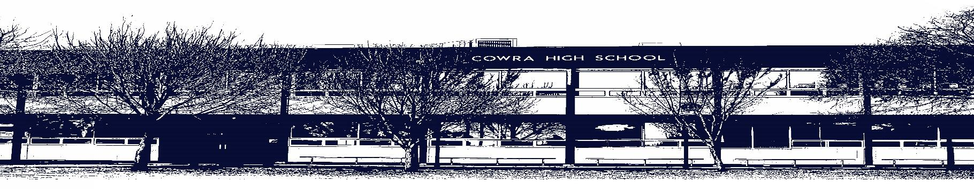

COWRA HIGH SCHOOL

Assessment Task Submission Policy

Submission of assessment tasks by students must follow faculty guidelines. There are basically four types of assessment tasks:

- In Class Assessment Tasks ~ these tasks are supervised by the class teacher and collected by the class teacher at the conclusion of the assessment task. It is the responsible of the student who miss in class assessment tasks to contact the Head Teacher of that faculty.

- Formal Examinations ~ at the conclusion of any formal examination the assessment task papers are to be collected and returned to the relevant faculty teacher.

- Major Projects / Pieces of Work ~ these items, due to their size, are usually kept in the appropriate faculty location. Major works and projects should be kept in safe locations that minimises the risk of damage. Any assessment task would be submitted directly to the teacher. A receipt for the task will be issued to students.

- Take Home Assessment Tasks ~ these are tasks that students are required to complete by a due date. Students should follow faculty submission guidelines regarding submission of these tasks.

Guidelines for the Submission of Assessment Tasks

- When an assessment task is issued, the information provided to students will include:
- a clear statement of what the task involves and what the expectations of the student are
- an explanation of the marking criteria / outcomes to be assessed
- the due date of submission
- an assessment task submission cover sheet ~ see attached

- Teachers should record the names of all students issued with the assessment task on a roll/class list and have the student acknowledge receipt of the assessment task by getting them to sign next to their name.

- Students must take their assessment task to the class teacher. They must be signed in on the class roll and keep their receipt

- All students must keep a copy of their assessment task.

Illness and Misadventure Appeals

If a student fails to submit an assessment task by the due date and has a legitimate reason than normal illness and misadventure procedures will apply.

REQUEST FOR ASSESSMENT EXTENSION PROCEDURE

Assessment extensions will only be granted in exceptional circumstances. All requests need to be made in writing using the extension request form. In seeking an extension discuss your request with your teacher/Head Teacher at least three (3) days before the due date with work already completed.

Forms for Illness/Misadventure and Extension can be accessed on the
Cowra High School Website.

