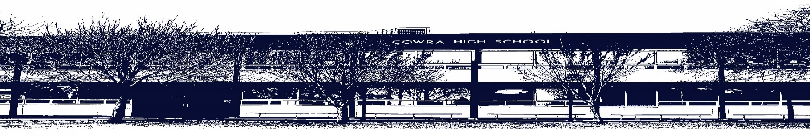
te

COWRA HIGH SCHOOL

ASSESSMENT TASK COVER SHEET

This sheet must be attached to the front of your Assessment Task and submitted to your class teacher on or before the due date.

Student’s Name: _________________________________________
Course: Year 7 Visual Arts
Assessment Task: Artmaking
Date Due: Monday Week 6, Term 2
Date Received: _______________
Extension granted _____ days
Other circumstances ~ documents attached

I certify:
- This assignment is entirely my own work and all borrowed material has been acknowledged
- The material contained in this assignment has not previously been submitted for assessment in any formal course of study
- I retain in my possession a copy of this assignment
- I understand that late assignments will be penalised unless an extension has been granted by Deputy Principal - Curriculum

Student’s Signature: ____________________________

-------------------------------------------------------------------------------------------------------------------------------
COWRA HIGH SCHOOL
Assessment Task (Student’s Copy)
Student’s Name: _________________________________________
Course: Year 7 Visual Arts
Teacher: I Harnden

Assessment Task received by: _________________________________________
Signature: _________________________________________
Date: ______________________ Time: ______________________

Please detach this if the Assessment Task has been handed in
to the office and give to student to keep for their own records.

COWRA HIGH SCHOOL
Stage 4 – Year 7 Assessment Task
NAME: |  | CLASS: Stage 4 |  | TEACHER: I Harnden
COURSE: Visual Arts |  | TASK No: 2 |  | Unit: Pupil Pots
DATE DUE: 24th May 2021 |  | TIME DUE: Week 6, Term 2, during class
MARK: /25 | WEIGHT: 35% |  | PRESENTATION: Submit a collection of works developed during semester
SYLLABUS OUTCOMES:

4.1 uses a range of strategies to explore different artmaking conventions and procedures to make artworks
4.2 explores the function of and relationships between artist – artwork – world – audience
4.3 makes artworks that involve some understanding of the frames
4.4 recognises and uses aspects of the world as a source of ideas, concepts and subject matter in the visual arts
4.5 investigates ways to develop meaning in their artworks
4.6 selects different materials and techniques to make artworks

DESCRIPTION OF TASK:

PART A - ARTMAKING

You will design and create a ceramic planter pot. The pot must be the face of a character, real or imagined. You are to use a variety of clay building techniques developed in class, and refine your skills during your lessons under the guidance of your teacher. Your ceramic pot will communicate knowledge about feelings and emotions via use of expression and clay building choices.

PART B - VISUAL ARTS PROCESS DIARY

Submit your VAPD (All your classwork and experiments) alongside your ceramic sculpture for this assessment. The VAPD must demonstrate your knowledge about clay vocabulary.

MARKING CRITERIA:
Artmaking | Marks
- Explores a variety of ceramic clay building tools and techniques  - Investigates ways of communicating feelings and emotions through their artwork  - Experiments and interprets class work, notes and ceramic research in sophisticated ways in their VAPD. All classwork is complete and detailed. | 21-25
- Attempts some exploration of ceramic clay building tools and techniques  - Attempts some investigation of communicating feelings and emotions through their artwork  - Experiments and interprets class work, notes and ceramic research in sound ways. Some classwork is complete and detailed. | 16-20
- Basic exploration of ceramic clay building tools and techniques  - Attempts basic communication of feelings and emotions through their artwork  - Includes some class work, notes and ceramic research | 11-15
- Limited exploration of ceramic clay building tools and techniques  - Limited attempt at using clay to communicate feelings and emotions  - Includes limited reference to class work and ceramic research | 6-10
- Shows very little interest in using ceramic tools and techniques  - Little to no reference to class work | 1-5
- Non-submission | 0

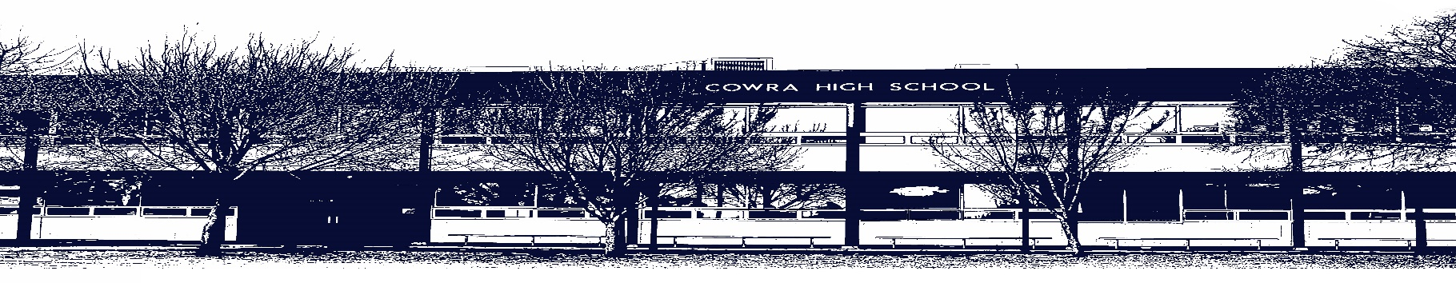

COWRA HIGH SCHOOL
Assessment Task Submission Policy

Submission of assessment tasks by students must follow faculty guidelines. There are basically four types of assessment tasks:

- In Class Assessment Tasks ~ these tasks are supervised by the class teacher and collected by the class teacher at the conclusion of the assessment task. It is the responsible of the student who miss in class assessment tasks to contact the Head Teacher of that faculty.

- Formal Examinations ~ at the conclusion of any formal examination the assessment task papers are to be collected and returned to the relevant faculty teacher.

- Major Projects / Pieces of Work ~ these items, due to their size, are usually kept in the appropriate faculty location. Major works and projects should be kept in safe locations that minimises the risk of damage. Any assessment task would be submitted directly to the teacher. A receipt for the task will be issued to students.

- Take Home Assessment Tasks ~ these are tasks that students are required to complete by a due date. Students should follow faculty submission guidelines regarding submission of these tasks.

Guidelines for the Submission of Assessment Tasks

- When an assessment task is issued, the information provided to students will include:
- a clear statement of what the task involves and what the expectations of the student are
- an explanation of the marking criteria / outcomes to be assessed
- the due date of submission
- an assessment task submission cover sheet ~ see attached

- Teachers should record the names of all students issued with the assessment task on a roll/class list and have the student acknowledge receipt of the assessment task by getting them to sign next to their name.

- Students must take their assessment task to the class teacher. They must be signed in on the class roll and keep their receipt

- All students must keep a copy of their assessment task.

Illness and Misadventure Appeals
If a student fails to submit an assessment task by the due date and has a legitimate reason than normal illness and misadventure procedures will apply.

REQUEST FOR ASSESSMENT EXTENSION PROCEDURE

Assessment extensions will only be granted in exceptional circumstances. All requests need to be made in writing using the extension request form. In seeking an extension discuss your request with your teacher/Head Teacher at least three (3) days before the due date with work already completed.

Forms for Illness/Misadventure and Extension can be accessed on the
Cowra High School Website.

