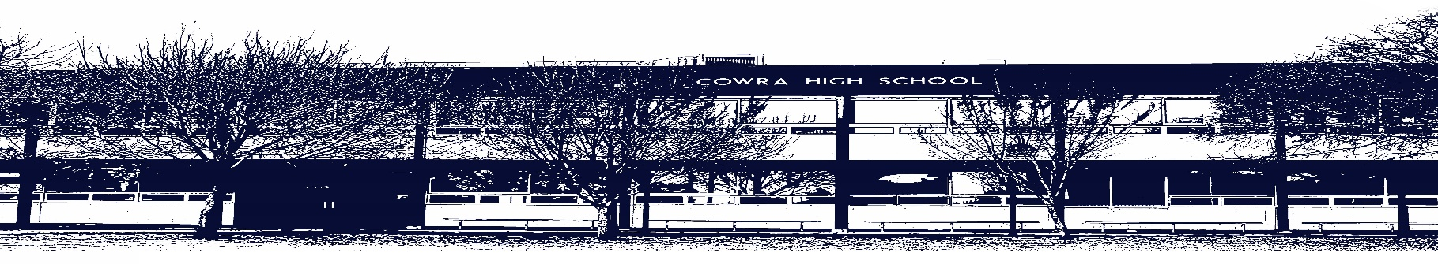

COWRA HIGH SCHOOL

ASSESSMENT TASK COVER SHEET

This sheet must be attached to the front of your Assessment Task and submitted to your class teacher on or before the due date.

Student’s Name: _________________________________________
Course: Stage 4 - Year 8P English
Assessment Task: Extended Response
Date Due: Monday Week 10, 21st June 2020
Date Received: _______________
Extension granted _____ days
Other circumstances ~ documents attached

I certify:
- This assignment is entirely my own work and all borrowed material has been acknowledged
- The material contained in this assignment has not previously been submitted for assessment in any formal course of study
- I retain in my possession a copy of this assignment
- I understand that late assignments will be penalised unless an extension has been granted by Deputy Principal - Curriculum

Student’s Signature: ____________________________

-------------------------------------------------------------------------------------------------------------------------------
COWRA HIGH SCHOOL
Assessment Task (Student’s Copy)
Student’s Name: _________________________________________
Course: Stage 4 – Year 7 English
Teacher: Keefe / Burrell

Assessment Task received by: _________________________________________
Signature: _________________________________________
Date: ______________________ Time: ______________________

Please detach this if the Assessment Task has been handed in
to the office and give to student to keep for their own records.

COWRA HIGH SCHOOL
Stage 4 – Year 8P Assessment Task
NAME: |  |  | CLASS: |  |  | TEACHER: Keefe / Burrell
COURSE: 8P English |  | TASK No: 2 |  |  | Unit: Genre Study - Fantasy
DATE DUE: Monday 21st June 2020, Week 10 |  |  |  |  |  | TIME DUE: 3:15pm
MARK: /20 | WEIGHT: 25% |  |  | PRESENTATION: Extended Response
SYLLABUS OUTCOMES:

EN4-1A responds to and composes texts for understanding, interpretation, critical analysis, imaginative expression
and pleasure
EN4-3B uses and describes language forms, features and structures of texts appropriate to a range of purposes, audiences and contexts
EN4-4B makes effective language choices to creatively shape meaning with accuracy, clarity and coherence
EN4-5C thinks imaginatively, creatively, interpretively and critically about information, ideas and arguments to respond to and compose texts
EN4-7D demonstrates understanding of how texts can express aspects of their broadening world and their relationships within it

DESCRIPTION OF TASK:

You will write and submit a formal essay demonstrating an understanding of the ‘fantasy’ genre in response to the following question:

How does the novel you have studied in class reflect elements of
the fantasy genre such as characters, plots, settings and themes?

Respond to this question with detailed reference to the novel.

This essay should be no more than 1,000 words.

In this task, you will be marked on your ability to:
- Identify and explain elements of the fantasy genre in your set text.
- Provide relevant detailed references to the set text to support points.
- Structure a formal essay.
- Write with clarity and control of expression, including spelling, grammar and punctuation.

MARKING CRITERIA

Marking Criteria | Mark
- Accurately identifies and skilfully explains various elements of the fantasy genre in the set text.  - Consistently provides relevant detailed references to the set text to support points.  - Writes in the structure of a formal essay, including clear sequencing and paragraphs.  - Writes with clarity and control of expression, including consistently accurate spelling, grammar and punctuation. | 17 - 20
- Accurately identifies and effectively explains various elements of the fantasy genre in the set text.  - Provides relevant detailed references to the set text to support points.  - Writes mostly in the structure of a formal essay, including clear paragraphs.  - Writes with clear expression, including mostly accurate spelling, grammar and punctuation. | 13 - 16
- Identifies and explains some elements of the fantasy genre in the set text.  - Provides relevant references to the set text to support points.  - Writes with some of the structure of a formal essay, including clear paragraphs.  - Writes with mostly clear expression. Possibly minor recurrent difficulties with spelling, grammar and/or punctuation. | 9 - 12
- Identifies some elements of fantasy in the set text. Possibly has difficulty elaborating on these.  - Provides general references to the set text to support points. Possibly too reliant on recount.  - Writes with some sense of sequence and/or purpose. Possibly significant difficulties with essay structure and paragraphing.  - Writes with some clear expression. Possibly significant recurrent difficulties with spelling, grammar and/or punctuation. | 5 - 8
- Has difficulty identifying elements of fantasy in the set text.  - Provides general details about the set text to support points. Possibly includes a brief recount.  - Writes with little of sequence and/or purpose. Possibly very brief.  - Shows numerous significant and recurrent difficulties with spelling, grammar and/or punctuation. | 1 - 4
- Presents nothing or relevance to the task. | 0

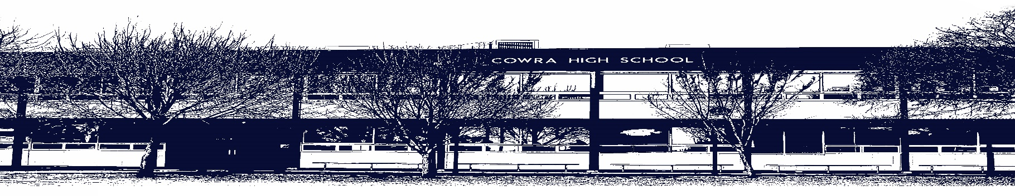

COWRA HIGH SCHOOL

Assessment Task Submission Policy

Submission of assessment tasks by students must follow faculty guidelines. There are basically four types of assessment tasks:

- In Class Assessment Tasks ~ these tasks are supervised by the class teacher and collected by the class teacher at the conclusion of the assessment task. It is the responsible of the student who miss in class assessment tasks to contact the Head Teacher of that faculty.

- Formal Examinations ~ at the conclusion of any formal examination the assessment task papers are to be collected and returned to the relevant faculty teacher.

- Major Projects / Pieces of Work ~ these items, due to their size, are usually kept in the appropriate faculty location. Major works and projects should be kept in safe locations that minimises the risk of damage. Any assessment task would be submitted directly to the teacher. A receipt for the task will be issued to students.

- Take Home Assessment Tasks ~ these are tasks that students are required to complete by a due date. Students should follow faculty submission guidelines regarding submission of these tasks.

Guidelines for the Submission of Assessment Tasks

- When an assessment task is issued, the information provided to students will include:
- a clear statement of what the task involves and what the expectations of the student are
- an explanation of the marking criteria / outcomes to be assessed
- the due date of submission
- an assessment task submission cover sheet ~ see attached

- Teachers should record the names of all students issued with the assessment task on a roll/class list and have the student acknowledge receipt of the assessment task by getting them to sign next to their name.

- Students must take their assessment task to the class teacher. They must be signed in on the class roll and keep their receipt

- All students must keep a copy of their assessment task.

Illness and Misadventure Appeals

If a student fails to submit an assessment task by the due date and has a legitimate reason than normal illness and misadventure procedures will apply.

REQUEST FOR ASSESSMENT EXTENSION PROCEDURE

Assessment extensions will only be granted in exceptional circumstances. All requests need to be made in writing using the extension request form. In seeking an extension discuss your request with your teacher/Head Teacher at least three (3) days before the due date with work already completed.

Forms for Illness/Misadventure and Extension can be accessed on the
Cowra High School Website.

