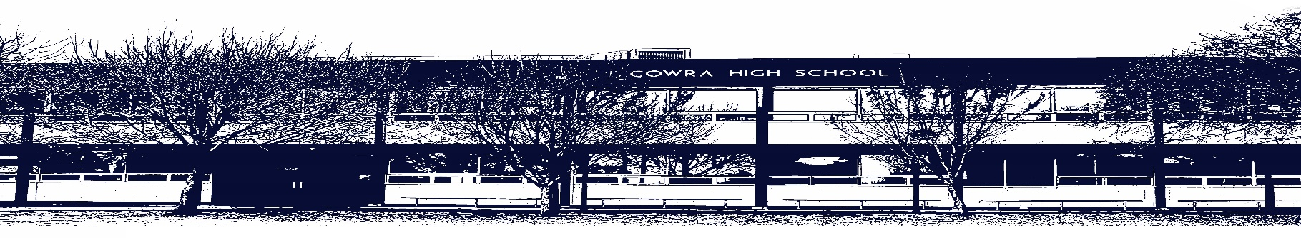

COWRA HIGH SCHOOL

ASSESSMENT TASK COVER SHEET

This sheet must be attached to the front of your Assessment Task and submitted to your class teacher on or before the due date.

Student’s Name: _________________________________________
Course: Stage 4 - Year 8 English
Assessment Task: Extended Response
Date Due: Monday Week 10, 21st June 2021
Date Received: _______________
Extension granted _____ days
Other circumstances ~ documents attached

I certify:
- This assignment is entirely my own work and all borrowed material has been acknowledged
- The material contained in this assignment has not previously been submitted for assessment in any formal course of study
- I retain in my possession a copy of this assignment
- I understand that late assignments will be penalised unless an extension has been granted by Deputy Principal - Curriculum

Student’s Signature: ____________________________

-------------------------------------------------------------------------------------------------------------------------------
COWRA HIGH SCHOOL
Assessment Task (Student’s Copy)
Student’s Name: _________________________________________
Course: Stage 4 – Year 8 English
Teacher: Tait / Sullivan / Beattie

Assessment Task received by: _________________________________________
Signature: _________________________________________
Date: ______________________ Time: ______________________

Please detach this if the Assessment Task has been handed in
to the office and give to student to keep for their own records.

COWRA HIGH SCHOOL
Stage 4 – Year 8 Assessment Task
NAME: |  |  | CLASS: 8 |  |  | TEACHER: Tait/Sullivan/Beatie
COURSE: Year 8 English |  | TASK No: 2 |  |  | Unit: Oh the Places You’ll Go
DATE DUE: Monday 21st June, Week 10 |  |  |  |  |  | TIME DUE: 3:15pm
MARK: /20 | WEIGHT: 25% |  |  | PRESENTATION: Essay
SYLLABUS OUTCOMES:

EN4-1A responds to and composes texts for understanding, interpretation, critical analysis, imaginative
expression and pleasure
EN4-3B uses and describes language forms, features and structures of texts appropriate to a range of purposes, audiences and contexts
EN4-4B makes effective language choices to creatively shape meaning with accuracy, clarity and coherence
EN4-5C thinks imaginatively, creatively, interpretively and critically about information, ideas and arguments to respond to and compose texts
EN4-7D demonstrates understanding of how texts can express aspects of their broadening world and their relationships within it

DESCRIPTION OF TASK:

Throughout this term, you have been studying Oh the Places You’ll Go in the form of either a novel study or through visual texts. To show your understanding of the text your class studied, you are to compose an essay that addresses the following question;

‘The qualities of each character and their relationships enable them to overcome hardship.’
Do you agree? In your response make reference to specific examples from your prescribed text.

Prescribed Texts;
- 8A – Trash by Andy Mulligan
- 8B – Bridge to Terabithia by Katherine Paterson
- 8C – Uncanny by Paul Jennings / Round the Twist TV series

Your essay should be approximately 500 – 700.

You will be assessed on your ability to;

- Express your ideas clearly using appropriate language, as well as correct spelling, punctuation and grammar
- Demonstrate an understanding of characters and themes
- Use appropriate textual examples to support your arguments

MARKING CRITERIA:

Mark | Criteria
A  17 - 20 | - Demonstrates a sophisticated understanding of how characters are portrayed and discusses the impact that they have on our understanding of a text  - Reflects perceptively on how meaning is created through characters and the messages they deliver  - Uses sophisticated textual examples and narrative techniques to support discussion  - Organises, develops and expresses ideas skilfully, using correct spelling, grammar and punctuation
B  13 - 16 | - Demonstrates an effective understanding of how characters are portrayed and describes the impact that they have on our understanding of a text  - Reflects thoughtfully on how meaning is created through characters and mentions messages they deliver  - Uses effective textual examples to support discussion  - Organises, develops and expresses ideas effectively, using correct spelling, grammar and punctuation
C  9 – 12 | - Demonstrates sound understanding of how characters are portrayed and the impact that they have on our understanding of a text  - Reflects on how meaning is created through characters  - Uses basic textual examples to support ideas  - Organises, develops and expresses ideas adequately
D  5 – 8 | - Demonstrates limited understanding of how characters are portrayed and the impact they have on our understanding of a text  - Little or no reflection on how meaning is created through characters  - Basic to minimal textual references  - Organises and expresses ideas in simple language
E  0 - 4 | - Demonstrates elementary understanding of the characters in the text  - Response may be limited  - Elementary use of language  - Little textual reference

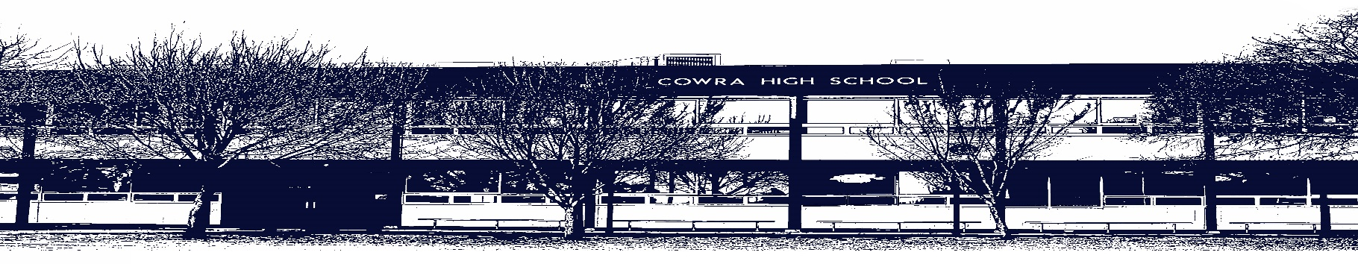

COWRA HIGH SCHOOL

Assessment Task Submission Policy

Submission of assessment tasks by students must follow faculty guidelines. There are basically four types of assessment tasks:

- In Class Assessment Tasks ~ these tasks are supervised by the class teacher and collected by the class teacher at the conclusion of the assessment task. It is the responsible of the student who miss in class assessment tasks to contact the Head Teacher of that faculty.

- Formal Examinations ~ at the conclusion of any formal examination the assessment task papers are to be collected and returned to the relevant faculty teacher.

- Major Projects / Pieces of Work ~ these items, due to their size, are usually kept in the appropriate faculty location. Major works and projects should be kept in safe locations that minimises the risk of damage. Any assessment task would be submitted directly to the teacher. A receipt for the task will be issued to students.

- Take Home Assessment Tasks ~ these are tasks that students are required to complete by a due date. Students should follow faculty submission guidelines regarding submission of these tasks.

Guidelines for the Submission of Assessment Tasks

- When an assessment task is issued, the information provided to students will include:
- a clear statement of what the task involves and what the expectations of the student are
- an explanation of the marking criteria / outcomes to be assessed
- the due date of submission
- an assessment task submission cover sheet ~ see attached

- Teachers should record the names of all students issued with the assessment task on a roll/class list and have the student acknowledge receipt of the assessment task by getting them to sign next to their name.

- Students must take their assessment task to the class teacher. They must be signed in on the class roll and keep their receipt

- All students must keep a copy of their assessment task.

Illness and Misadventure Appeals

If a student fails to submit an assessment task by the due date and has a legitimate reason than normal illness and misadventure procedures will apply.

REQUEST FOR ASSESSMENT EXTENSION PROCEDURE

Assessment extensions will only be granted in exceptional circumstances. All requests need to be made in writing using the extension request form. In seeking an extension discuss your request with your teacher/Head Teacher at least three (3) days before the due date with work already completed.

Forms for Illness/Misadventure and Extension can be accessed on the
Cowra High School Website.

