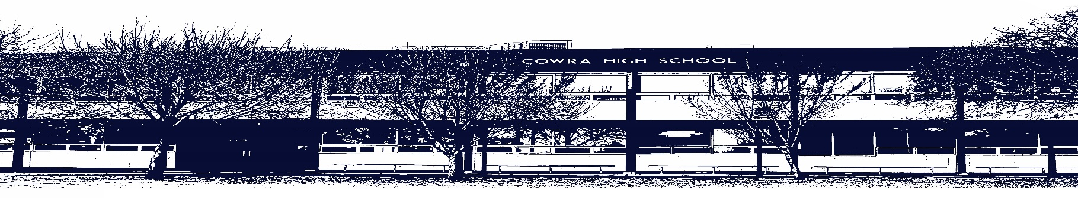

COWRA HIGH SCHOOL

ASSESSMENT TASK COVER SHEET

This sheet must be attached to the front of your Assessment Task and submitted to your class teacher on or before the due date.

Student’s Name: _________________________________________
Course: _________________________________________
Assessment Task: _________________________________________
Date Due: _______________
Date Received: _______________
Extension granted _____ days
Other circumstances ~ documents attached

I certify:
- This assignment is entirely my own work and all borrowed material has been acknowledged
- The material contained in this assignment has not previously been submitted for assessment in any formal course of study
- I retain in my possession a copy of this assignment
- I understand that late assignments will be penalised unless an extension has been granted by Deputy Principal - Curriculum

Student’s Signature: ____________________________

-------------------------------------------------------------------------------------------------------------------------------
COWRA HIGH SCHOOL
Assessment Task (Student’s Copy)
Student’s Name: _________________________________________
Course: _________________________________________
Teacher: _________________________________________

Assessment Task received by: _________________________________________
Signature: _________________________________________
Date: ______________________ Time: ______________________

Please detach this if the Assessment Task has been handed in
to the office and give to student to keep for their own records.

Cowra High School

STAGE 4 ASSESSMENT TASK
NAME : |  |  |  |  |  | CLASS : |  | 8C |  | TEACHER : |  |  | Miss Barrett
COURSE : |  | Stage 4 Geography |  |  | TASK NO : |  | 2 |  | UNIT : |  | Interconnectedness
DATE DUE : |  |  | Wednesday 19th May |  |  | TIME DUE |  |  | 3.15pm
MARK : | /20 |  |  | WEIGHT:50% |  | PRESENTATION: |  |  |  |  |  | Google Slides
SYLLABUS OUTCOMES: A student:
GE4-2 describes processes and influences that form and transform places and environments
GE4-3 explains how interactions and connections between people, places and environments result in change
GE4-4 examines perspectives of people and organisations on a range of geographical issues
GE4-5 discusses management of places and environments for their sustainability
GE4-7 acquires and processes geographical information by selecting and using geographical tools for inquiry
GE4-8 communicates geographical information using a variety of strategies
DESCRIPTION OF TASK:
Make a report, using Google Slides, on the connections between Australia and another country of your choice. Your report should focus on four different connections chosen from the list below:
- Travel/Tourism
- Trade
- Migration
- Sport
- Technology
- Production and Consumption
Your report should include the following:
- A map clearly labelled, showing the location of Australia and your country of choice.
- An explanation of why you chose this particular country with specific reference to connectedness.
- Details on specific links, including data where appropriate, between Australia and your chosen country in each of the four connections you have chosen to research.
- An assessment of the pros and cons for Australia, as a result of each of the four connections you have chosen to research.
- At least one image representing each of the four connections you have researched.
MARKING CRITERIA:
- Clearly names and locates Australia and another country to report on  - Provides a detailed justification of country choice with detailed references to connectedness between the two countries  - Presents comprehensive information on the specific links, including data, between both countries across four separate connections  - Provides a comprehensive assessment of the pros and cons for Australia, resulting from four connections reported on  - Presents at least one labelled image representing each of the connections reported on | 17-20
- Names and locates Australia and another country to report on  - Provides a clear justification of country choice with clear references to connectedness between the two countries  - Presents detailed information on the specific links, including data, between both countries across four separate connections  - Provides a detailed assessment of the pros and cons for Australia, resulting from four connections reported on  - Presents one labelled image representing each of the connections reported on | 13-16
- Names and locates Australia and another country to report on  - Provides some justification of country choice with some references to connectedness between the two countries  - Presents some information on specific links between both countries across four separate connections  - Provides some assessment of the pros and cons for Australia, resulting from four connections reported on  - Presents one labelled image representing each of the connections reported on | 9-12
- Names and locates Australia and another country to report on  - Provides a basic justification of country choice with a reference to connectedness between the two countries  - Presents basic information on specific links between both countries across up to four separate connections  - Provides limited assessment of the pros and/or cons for Australia, resulting from up to four connections reported on  - Presents one labelled image representing each of the connections reported on | 5-8
- Names or locates Australia and another country to report on  - May provide some justification of country choice  - Presents elementary information on links between both countries across up to four separate connections  - May provide an assessment of the pros and/or cons for Australia, resulting from up to four connections reported on  - Presents an image of Australia’s connections | 1-4
- Not attempted | 0

Student name:

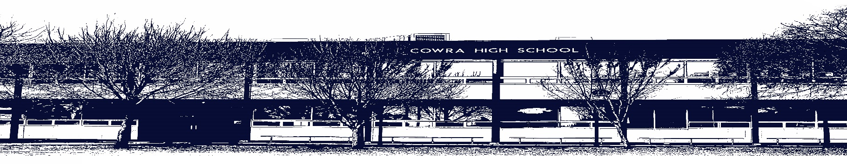

COWRA HIGH SCHOOL

Assessment Task Submission Policy

Submission of assessment tasks by students must follow faculty guidelines. There are basically four types of assessment tasks:

- In Class Assessment Tasks ~ these tasks are supervised by the class teacher and collected by the class teacher at the conclusion of the assessment task. It is the responsible of the student who miss in class assessment tasks to contact the Head Teacher of that faculty.

- Formal Examinations ~ at the conclusion of any formal examination the assessment task papers are to be collected and returned to the relevant faculty teacher.

- Major Projects / Pieces of Work ~ these items, due to their size, are usually kept in the appropriate faculty location. Major works and projects should be kept in safe locations that minimises the risk of damage. Any assessment task would be submitted directly to the teacher. A receipt for the task will be issued to students.

- Take Home Assessment Tasks ~ these are tasks that students are required to complete by a due date. Students should follow faculty submission guidelines regarding submission of these tasks.

Guidelines for the Submission of Assessment Tasks

- When an assessment task is issued, the information provided to students will include:
- a clear statement of what the task involves and what the expectations of the student are
- an explanation of the marking criteria / outcomes to be assessed
- the due date of submission
- an assessment task submission cover sheet ~ see attached

- Teachers should record the names of all students issued with the assessment task on a roll/class list and have the student acknowledge receipt of the assessment task by getting them to sign next to their name.

- Students must take their assessment task to the class teacher. They must be signed in on the class roll and keep their receipt

- All students must keep a copy of their assessment task.

Illness and Misadventure Appeals

If a student fails to submit an assessment task by the due date and has a legitimate reason than normal illness and misadventure procedures will apply.

REQUEST FOR ASSESSMENT EXTENSION PROCEDURE

Assessment extensions will only be granted in exceptional circumstances. All requests need to be made in writing using the extension request form. In seeking an extension discuss your request with your teacher/Head Teacher at least three (3) days before the due date with work already completed.

Forms for Illness/Misadventure and Extension can be accessed on the
Cowra High School Website.

