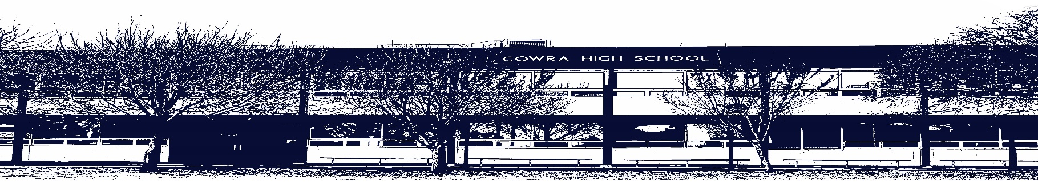

COWRA HIGH SCHOOL

ASSESSMENT TASK COVER SHEET

This sheet must be attached to the front of your Assessment Task and submitted to your class teacher on or before the due date.

Student’s Name: _________________________________________
Course: _________________________________________
Assessment Task: _________________________________________
Date Due: _______________
Date Received: _______________
Extension granted _____ days
Other circumstances ~ documents attached

I certify:
- This assignment is entirely my own work and all borrowed material has been acknowledged
- The material contained in this assignment has not previously been submitted for assessment in any formal course of study
- I retain in my possession a copy of this assignment
- I understand that late assignments will be penalised unless an extension has been granted by Deputy Principal - Curriculum

Student’s Signature: ____________________________

-------------------------------------------------------------------------------------------------------------------------------
COWRA HIGH SCHOOL
Assessment Task (Student’s Copy)
Student’s Name: _________________________________________
Course: _________________________________________
Teacher: _________________________________________

Assessment Task received by: _________________________________________
Signature: _________________________________________
Date: ______________________ Time: ______________________

Please detach this if the Assessment Task has been handed in
to the office and give to student to keep for their own records.

Cowra High School

Stage 5 ASSESSMENT TASK
NAME : |  |  |  |  |  | CLASS : |  | 10 |  | TEACHER : |  |  | S Johnstone
COURSE : |  | Stage 5 Geography |  |  | TASK NO : |  | 1 |  | UNIT : |  | Human Wellbeing
DATE DUE : |  |  | Friday November 13th |  |  | TIME DUE : |  |  | 3.15pm
MARK : | /20 |  |  | WEIGHT : | 50% | PRESENTATION: |  |  |  |  |  | Google Slides
SYLLABUS OUTCOMES: A student:

GE5-1 Explains the diverse features and characteristics of a range of places and environment
GE5-2 Explains processes and influences that form and transform places and environments
GE5-6 Analyses differences in human wellbeing and ways to improve human wellbeing
GE5-7 Acquires and processes geographical information by selecting and using appropriate and relevant geographical tools for inquiry
GE5-8 Communicates geographical information to a range of audiences using a variety of strategies

Description of task;

- Report on Australia’s current Foreign Aid program. You should include information on why Australia provides aid to other nations, which nations Australia provide aid to, and how much aid is provided by Australia in total as both a $ amount and as a % of GDP.
- Choose a country that is a current recipient of Australian foreign aid. Locate this country using both a map and words. Report on how much aid this country is receiving from Australia, how the aid is being used (objectives) and some progress or achievements (outcomes) as a result of this aid.
- Compare the level of development between Australia and the nation you have chosen above. You should report on development indicators such as life expectancy, literacy rates, GNI per capita, ecological footprints, the happy planet index and the human development index. Your comparison should include numerical data and an explanation of what that data actually means.
- Reflection. Outline your thoughts on Australia’s foreign aid program. Is it a worthwhile program? Should we provide more or less aid to developing nations? How do we compare to the foreign aid spending of other developed nations? Justify your thoughts.

Some useful websites include;
- Dfat.gov.au
- CIA World Factbook
- The Happy Planet Index
- The Human Development Index

MARKING CRITERIA:
- Demonstrates extensive knowledge and understanding of Australia’s Foreign Aid program.  - Demonstrates extensive knowledge and understanding of a current recipient of Australian foreign aid, the uses to which the aid is put to, and positive outcomes of this aid.  - Displays sophisticated skills to select, process and communicate effectively a variety of development indicators in relation to TWO nations.  - Uses an extensive range of strategies to reflect on, and justify changes to, Australia’s foreign aid program. | 17-20
- Demonstrates thorough knowledge and understanding of Australia’s Foreign Aid program.  - Demonstrates thorough knowledge and understanding of a current recipient of Australian foreign aid, the uses to which the aid is put to, and positive outcomes of this aid.  - Displays high level skills to select, process and communicate effectively a variety of development indicators in relation to TWO nations.  - Uses a broad range of strategies to reflect on, and justify changes to, Australia’s foreign aid program. | 13-16
- Demonstrates sound knowledge and understanding of Australia’s Foreign Aid program.  - Demonstrates sound knowledge and understanding of a current recipient of Australian foreign aid, the uses to which the aid is put to, and positive outcomes of this aid.  - Displays sound skills to select, process and communicate effectively a variety of development indicators in relation to TWO nations.  - Uses a range of strategies to reflect on, and justify changes to, Australia’s foreign aid program. | 9-12
- Demonstrates basic knowledge and understanding of Australia’s Foreign Aid program.  - Demonstrates basic knowledge and understanding of a current recipient of Australian foreign aid, the uses to which the aid is put to, and positive outcomes of this aid.  - Displays basic skills to select, process and communicate effectively a variety of development indicators in relation to TWO nations.  - Uses a range of strategies to reflect on, and justify changes to, Australia’s foreign aid program. | 5-8
- Demonstrates elementary knowledge and understanding of Australia’s Foreign Aid program.  - Demonstrates elementary knowledge and understanding of a current recipient of Australian foreign aid, the uses to which the aid is put to, and positive outcomes of this aid.  - Displays elementary skills to select, process and communicate effectively a variety of development indicators in relation to TWO nations.  - Uses a limited range of strategies to reflect on, and justify changes to, Australia’s foreign aid program. | 1-4
- Non-attempt | 0

Teacher’s comment:
______________________________________________________________________________________________________________________________________________ _____________________________________________________________ _________________________________________________________________________________________________________________________________________

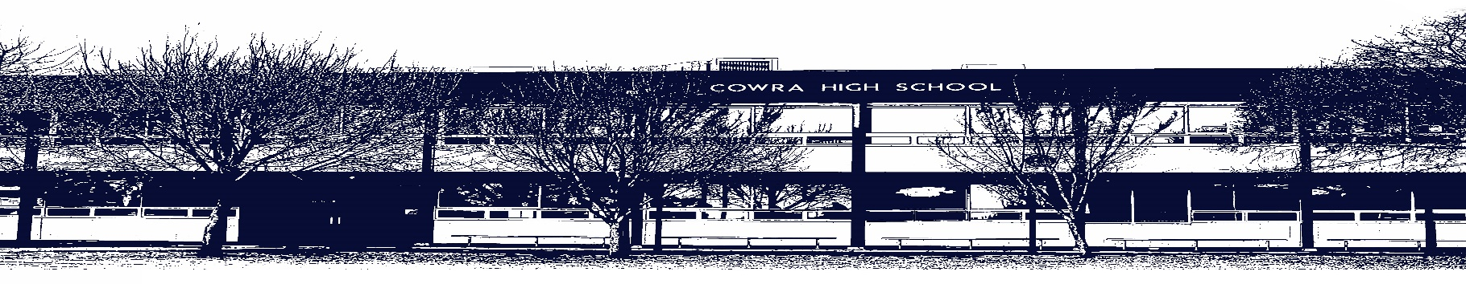

COWRA HIGH SCHOOL

Assessment Task Submission Policy

Submission of assessment tasks by students must follow faculty guidelines. There are basically four types of assessment tasks:

- In Class Assessment Tasks ~ these tasks are supervised by the class teacher and collected by the class teacher at the conclusion of the assessment task. It is the responsible of the student who miss in class assessment tasks to contact the Head Teacher of that faculty.

- Formal Examinations ~ at the conclusion of any formal examination the assessment task papers are to be collected and returned to the relevant faculty teacher.

- Major Projects / Pieces of Work ~ these items, due to their size, are usually kept in the appropriate faculty location. Major works and projects should be kept in safe locations that minimises the risk of damage. Any assessment task would be submitted directly to the teacher. A receipt for the task will be issued to students.

- Take Home Assessment Tasks ~ these are tasks that students are required to complete by a due date. Students should follow faculty submission guidelines regarding submission of these tasks.

Guidelines for the Submission of Assessment Tasks

- When an assessment task is issued, the information provided to students will include:
- a clear statement of what the task involves and what the expectations of the student are
- an explanation of the marking criteria / outcomes to be assessed
- the due date of submission
- an assessment task submission cover sheet ~ see attached

- Teachers should record the names of all students issued with the assessment task on a roll/class list and have the student acknowledge receipt of the assessment task by getting them to sign next to their name.

- Students must take their assessment task to the class teacher. They must be signed in on the class roll and keep their receipt

- All students must keep a copy of their assessment task.

Illness and Misadventure Appeals

If a student fails to submit an assessment task by the due date and has a legitimate reason than normal illness and misadventure procedures will apply.

REQUEST FOR ASSESSMENT EXTENSION PROCEDURE

Assessment extensions will only be granted in exceptional circumstances. All requests need to be made in writing using the extension request form. In seeking an extension discuss your request with your teacher/Head Teacher at least three (3) days before the due date with work already completed.

Forms for Illness/Misadventure and Extension can be accessed on the
Cowra High School Website.

