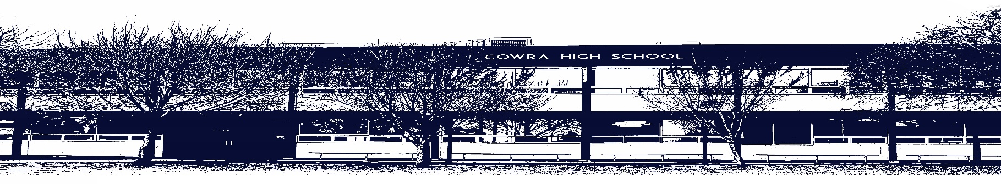

COWRA HIGH SCHOOL

ASSESSMENT TASK COVER SHEET

This sheet must be attached to the front of your Assessment Task and submitted to your class teacher on or before the due date.

Student’s Name: _________________________________________
Course: Stage 5 - Year 9 English
Assessment Task: Multimodal Assessment Task
Date Due: Monday Week 10, 21st June 2020
Date Received: _______________
Extension granted _____ days
Other circumstances ~ documents attached

I certify:
- This assignment is entirely my own work and all borrowed material has been acknowledged
- The material contained in this assignment has not previously been submitted for assessment in any formal course of study
- I retain in my possession a copy of this assignment
- I understand that late assignments will be penalised unless an extension has been granted by Deputy Principal - Curriculum

Student’s Signature: ____________________________

-------------------------------------------------------------------------------------------------------------------------------
COWRA HIGH SCHOOL
Assessment Task (Student’s Copy)
Student’s Name: _________________________________________
Course: Stage 5 – Year 9 English
Teacher: Sullivan / Burrell / Keefe / Perkins

Assessment Task received by: _________________________________________
Signature: _________________________________________
Date: ______________________ Time: ______________________

Please detach this if the Assessment Task has been handed in
to the office and give to student to keep for their own records.

COWRA HIGH SCHOOL
Stage 5 – Year 9 Assessment Task
NAME: |  |  | CLASS: |  |  | TEACHER: Sullivan/Keefe/Burrell/ Perkins
COURSE: Year 9 English |  | TASK No: 2 |  |  | Unit: Cultural Connectedness
DATE DUE: Monday 21st June 2020, Week 10 |  |  |  |  |  | TIME DUE: 3:15pm
MARK: /20 | WEIGHT: 25% |  |  | PRESENTATION: Multimodal Presentation
SYLLABUS OUTCOMES:

EN5-2A effectively uses and critically assesses a wide range of processes, skills, strategies and knowledge for
responding to and composing a wide range of texts in different media and technologies
EN5-3B selects and uses language forms, features and structures of texts appropriate to a range of purposes,
audiences and contexts, describing and explaining their effects on meaning
EN5-4B effectively transfers knowledge, skills and understanding of language concepts into new and different
contexts
EN5-6C investigates the relationships between and among texts
EN5-7D understands and evaluates the diverse ways texts can represent personal and public worlds
EN5-8D questions, challenges and evaluates cultural assumptions in texts and their effects on meaning

DESCRIPTION OF TASK:

This term you have been looking at how various composers connect with their culture and explored the focus question “We all see the world differently. How do you see it?” In order to address this question, you are going to create a series of posts that will be titled ‘Humans of Cowra’. You may present these posts as either a blog or as a google site.

In total you need to create THREE posts under the heading “We all see the world differently. How do you see it?” One post should be your own response, and two others should be from people you interview. To begin this task, your teacher will show you the website Humans of New York. You will then need to develop a series of questions which you ask to the people of Cowra. (Each post should be approx. 250 – 300 words).

The steps you will need to take are;
- View the Humans of New York website with your teacher
- Create a series of interview questions that have approval from your teacher ready to interview people of your choosing.
- Interview your candidates
- Photograph your interviewee if they give you permission. We suggest using Google Keep here. Your teacher will show you how easy it is to take the image and put it into your document.
- Write up their response and include an image (maximum 300 words per piece). Remember it should not be presented in an interview format, but rather a reflection on how they see the world and view their culture. You need to create three posts in total.
MARKING CRITERIA

Mark | Criteria
17 - 20 | - Follows the conventions and structure of the text type effectively.  - Demonstrates effective control of language appropriate to audience, purpose and context which addresses the focus question. Writing style has flair.  - Uses effective language forms and features to communicate ideas including paragraphs, correct use of direct speech, punctuation and spelling.
13 - 16 | - Follows the conventions and structure of the text type soundly.  - Demonstrates sound control of language appropriate to audience, purpose and context which addresses the focus question.  - Uses sound language forms and features to communicate ideas including paragraphs, correct use of direct speech, punctuation and spelling.
9 – 12 | - Follows the basic conventions and structure of the text type adequately.  - Demonstrates adequate control of language appropriate to audience, purpose, context and narrative type.  - Uses language forms and features to communicate ideas including paragraphs, correct use of direct speech, punctuation and spelling.
5 – 8 | - Attempts to follow the conventions and structure of the text type  - Demonstrates limited control of language appropriate to audience, purpose, context and narrative type.  - Uses language forms and features to communicate ideas including paragraphs, correct use of direct speech, punctuation and spelling, but with errors.
0 - 4 | - May not be an appropriate text type.  - Demonstrates elementary control of language  - Many errors in terms of punctuation, spelling and paragraphing.

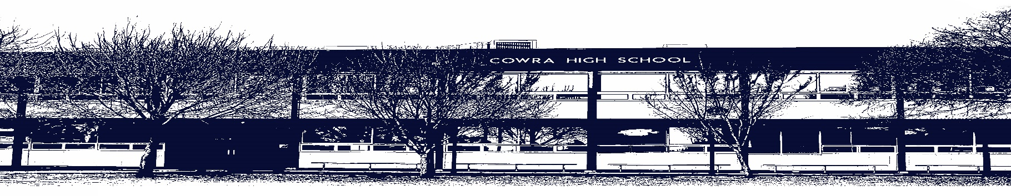

COWRA HIGH SCHOOL

Assessment Task Submission Policy

Submission of assessment tasks by students must follow faculty guidelines. There are basically four types of assessment tasks:

- In Class Assessment Tasks ~ these tasks are supervised by the class teacher and collected by the class teacher at the conclusion of the assessment task. It is the responsible of the student who miss in class assessment tasks to contact the Head Teacher of that faculty.

- Formal Examinations ~ at the conclusion of any formal examination the assessment task papers are to be collected and returned to the relevant faculty teacher.

- Major Projects / Pieces of Work ~ these items, due to their size, are usually kept in the appropriate faculty location. Major works and projects should be kept in safe locations that minimises the risk of damage. Any assessment task would be submitted directly to the teacher. A receipt for the task will be issued to students.

- Take Home Assessment Tasks ~ these are tasks that students are required to complete by a due date. Students should follow faculty submission guidelines regarding submission of these tasks.

Guidelines for the Submission of Assessment Tasks

- When an assessment task is issued, the information provided to students will include:
- a clear statement of what the task involves and what the expectations of the student are
- an explanation of the marking criteria / outcomes to be assessed
- the due date of submission
- an assessment task submission cover sheet ~ see attached

- Teachers should record the names of all students issued with the assessment task on a roll/class list and have the student acknowledge receipt of the assessment task by getting them to sign next to their name.

- Students must take their assessment task to the class teacher. They must be signed in on the class roll and keep their receipt

- All students must keep a copy of their assessment task.

Illness and Misadventure Appeals

If a student fails to submit an assessment task by the due date and has a legitimate reason than normal illness and misadventure procedures will apply.

REQUEST FOR ASSESSMENT EXTENSION PROCEDURE

Assessment extensions will only be granted in exceptional circumstances. All requests need to be made in writing using the extension request form. In seeking an extension discuss your request with your teacher/Head Teacher at least three (3) days before the due date with work already completed.

Forms for Illness/Misadventure and Extension can be accessed on the
Cowra High School Website.

